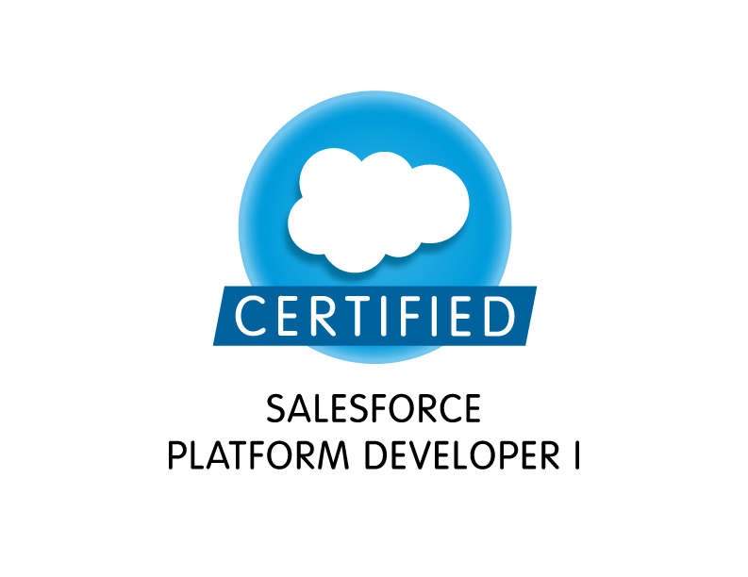
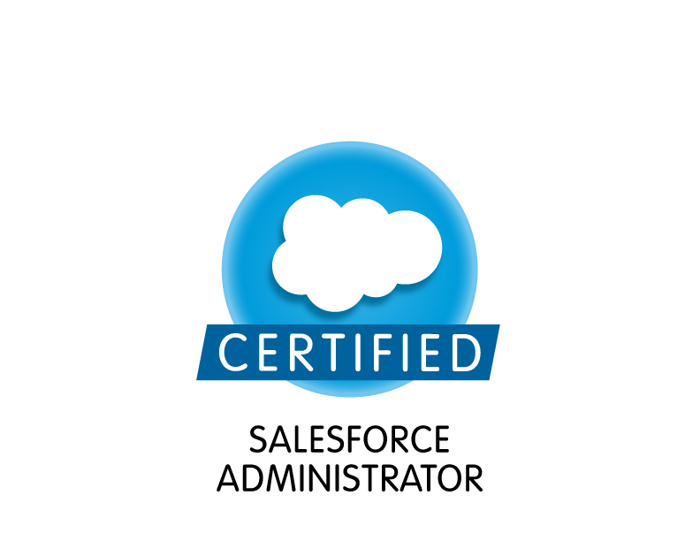

Deva
Certified Salesforce Developer
deva.sfdc7@gmail.com
7245678914
www.linkedin.com/in/deva-ram-a94a94200/

Professional Summary:
- 7+years of professional experience as a developer in IT industry with around 6+ years of experience in Salesforce CRM platform as a certified Salesforce Developer and admin in Salesforce.com
- Experience in Analysis, Design, Development, Administration, Configuration, Implementation and Support of Salesforce CRM based on Apex Language and leveraging Force.com Platform.
- Experience gathering, analyzing and documenting the business requirements to a BRD for Salesforce.com Implementations.
- Worked closely with business users in improving their business processes using SFDC Applications.
- Experience in working across various SFDC implementations covering Sales Cloud, Service Cloud &App-exchange applications.
- Experience working in fast paced Agile Environment involving in Daily Scrum, Spring Grooming and planning sessions.
- Experience in SFDC development using visual force pages, visual force components AJAX Tool kit, SOQL, and SOSL.
- Experience in System Integration using SOAP and REST based Web Services API to internal applications and legacy systems.
- Proficiency in SFDC Administrative tasks like creating Profiles, Roles, Users, Page Layouts, Email Services, Approvals, Workflows, Tasks and Actions, Reports, Dashboards.
- Experience designing the entities like Custom Objects, creating the Relationships/ Junction Objects like Master-Child, Lookups, Entity relationship data model, Pages, Classes and Interfaces on Salesforce.com Platform.
- Experience in working on Eclipse IDE with Force.com plug-in to develop Triggers, Test Methods, Test Classes/Controllers and Visualforce pages etc.
- Experienced in use of Standard and Custom Controllers of Visualforce in development of custom Salesforce pages as required by business requirements.
- Proficient knowledge of Governor limits. Experienced in optimization of existing code in accordance with the Governor limits.
- Experience using Force.com Web Services API and integrated with Legacy systems (Siebel) in real time.
- Proficient in Data Migration from Traditional Applications to Salesforce.com using Data Loader Utility.
- Experience in Data Migration using out of the box Apex Data Loader.
- Proficient in creating profiles and implementation of Role Hierarchies for system security design.
- Deployment experience using Force.com IDE and Change sets as well as hands on Sandbox management experience.
- Extensive experience in Salesforce.com Setup, Configuration, Customization, Administration, Data Migration and Integration tools like Apex Data Loader, Work Bench.
- Expert in preparing functional and technical design documents.
- Experience in scripting languages like HTML, DHTML, XML, JavaScript and Software applications like Dreamweaver, Microsoft Word, Excel, PowerPoint and SharePoint.
- Excellent communication and inter-personal skills; accustomed to working in both large and small teams.
certifications:
- Salesforce Platform Developer Certification (DEV 401)
- Salesforce.com Certified Administrator

Technical skills:
CRM Tools: Salesforce.com, Sales Cloud, Service Cloud, Marketing Cloud, Chatter, Communities, Service Console.
Salesforce Technologies: Apex, SOQL, SOSL, Visual Force (Pages & Components), Triggers, Batch Apex.
Data migration Tools: Apex Data Loader, Custom Import wizard, ETL Tool.
Deployment Tools: Change Sets, Force.com IDE, Force.com Migration Tool (ANT), Work Bench, Jenkins.
SDLC Methodologies: Agile, Scrum, Waterfall, Spiral, RUP.
Salesforce API Tools: Force.com Migration Tool (ANT), Force.com IDE –Eclipse.
Programming Languages: C, Java, Apex, Visualforce pages, XML, HTML5/4, CSSS3/2, JavaScript, jQuery.
Web Services: REST and SOAP API
Databases: SQL, PL/SQL, Oracle 12c/11g/10g/9i, SQL Server 2016/2012/2008/2005, MySQL.
Version control systems: SVN, Git, GitHub, CVS.
Mobile Application Tools: SalesForce1, Interface Builder.
Other Tools: Microsoft Office, Microsoft Visio, JIRA, Jitter bit, Demand tools, Apttus CPQ

Professional experience:
State of Texas – Austin, TX Jan 2018 –Till Date
Role: Salesforce Developer
Responsibilities:
- Implemented Salesforce Service cloud, Case management and Entitlement management, High volume customer portal, Partner portal, Visual force sites for business support and technical support for its channel customers.
- Worked closely with the product owner in building up new stories.
- Developed custom code for Salesforce.com application.
- Worked with External objects in Salesforce which is another feature introduced with Lightening components.
- Used Force.com platform for developing feature rich and user-friendly Visual force pages for enhancing Salesforce UI.
- Used Salesforce.com developer toolkit including Apex Classes, Controllers and Triggers, Visual force pages, Force.com IDE, Migration Tool, Web Services API for the application.
- Designed, and deployed the Custom objects, Entity-Relationship data model, validation rules on the objects and tabs, Page layouts, Custom tabs, Components, Visual Force Pages to suit to the needs of the application.
- Played a Key role in a gradual transition of company's applications from Salesforce Classic to Lightning Experience.
- Replaced all standard buttons and actions with Quick Actions or Lightning Components.
- Participated in client status meetings, requirements gathering sessions, Design Sessions, Release meetings and daily status meetings.
- Worked on Batch apex, Apex sharing rules as per the functional needs of the application.
- Implemented Salesforce Chatter for internal users and status updated on various activities.
- Managed the database for the team's region and performed basic administration.
- Reviewed Code and Developed Visualforce Pages, Apex Classes, Apex Triggers and other Apex Components.
- Manage customers with profiles, permission sets, roles, and sharing rules in customer portal.
- Performed customizations for the application with Salesforce CPQ.
- Created Server-side Apex Controllers for Salesforce Lightning components to lightning and record pages.
- Integrated the SOAP and REST based Web Services for extracting the data from external systems to display in the pages of salesforce.com.
- Developed batch processes to load data from external systems to the Org.
- Worked on Eclipse, Developer Console, Anonymous blocks development tools for developing, debugging and testing of Apex classes, Visualforce pages, triggers and test classes.
- Managing Sandbox, presenting UAT demos, updating Managers about custom requests from sales people.
- Used Sandbox for testing and Eclipse and Deployment Change Sets for code deployment and worked with Tortoise SVN.
- Migrated applications from Sandbox to Production using Migration Tools like Force.com IDE, Jenkins, Eclipse and Change Sets.

Environment: Workflow & Approvals, Reports, Custom Objects, Custom Tabs, SOQL, SOSL, SOAP, WSDL & RESTful Web Services, Saleforce.com platform, Apex, Agile Methodology, Sandbox data loading, CPQ, Workflow rules, Eclipse, Java, Visualforce, Data Loader, Email Services, Security Controls, Visualforce Controllers, Visualforce pages, Jenkins, SVN, Oracle 12c.

Lucid Motors – San Francisco, California Mar 2017 – Dec 2017
Role: Salesforce Developer/Administrator
Responsibilities:
- Developed Apex Classes and Apex triggers to meet the functional needs of the Application.
- Designed Web Pages and Controller classes using Visualforce and Apex.
- Worked with External objects in Salesforce which is another feature introduced with lightening components
- Developed Lightning Apps using Lightning Design System for Salesforce1.
- Formatted and migrated the user data into Lightning Experience. Tested the Lightning components for small set of test users.
- Created Lightning components and added Design Parameters from Lightning Design System(LDS) that gives a better look.
- Created Visualforce Pages to provide UI to the custom objects.
- Designed and developed Standard Controllers and Custom Controllers with Controller extentions and worked on Paginations.
- Customized Lightning components which were built using JavaScript on client side and Apex on server side.
- Implemented Wave Analytics to replace/augment SFDC reporting.
- Retrieved customer data from third party APIs and migrated the data to be displayed on Salesforce Lightning Components.
- Implemented wave analytics platform by enabling wave, assigning permission set licenses, and then creating and assigning permission sets
- Responsible for Data load operations using Force.com Apex Data Loader.
- Performed Apttus CPQ related configuration for product setup, approval rules, process builder and flows.
- Used force.com that connect interact Salesforce with lotus notes to insert contacts and add the emails and to also integrate the chatter at the same time.
- Installed Apps from AppExchange, Configured and maintained user Security Permissions in compliance with organizational needs.
- Managed various release deployments using Force.com Migration ANT tool and Change Sets for components migration across various sandbox and production environments.
- Worked on Validation Rules, Workflows, and approval processes.
- Integrated Litmus and Salesforce Marketing Cloud to create more effective emails.
- Worked on Salesforce Marketing Cloud data product, DMP activating and unifying the data to strengthen consumer relationships.
- Developed Test cases for Unit Testing of the Mappings and was also involved in the Integration Testing.

Environment: Saleforce.com platform, Apex, Agile Methodology Apex Data Loader, Visualforce, REST and SOAP API integrations, SOSL, SOQL, CPQ, CSS, MS Excel, Sandbox, Lighting Controller, Service Cloud, Marketing Cloud, Migration ANT, Litmus, Data Loader, S-Controls and HTML.

PNC – Brecksville, Ohio Aug 2016 – Feb 2017

Role: Salesforce Developer/Administrator

Responsibilities:
- Designed, developed and deployed Visualforce Pages, Apex Classes, Controller Classes and Apex Triggers for various functional needs in the application.
- Designed and deployed Custom tabs, validation rules, Approval Processes and Auto-Response Rules for automating business logic.
- Created workflow rules and defined related tasks, email alerts, field updates and time triggered tasks to implement business logic.
- Implemented pick lists, lookups, master detail relationships, validation and formula fields to the custom objects.
- Worked on customization of Visualforce to have lightening experience for desktop and mobile applications.
- Enabled Aura Framework, by adding Aura Attributes and Aura Handlers for Events to focus on Logic and Interactions in Lightning Applications
- Created templates, approval processes, approval page layouts and defined approval actions on them to automate the processes.
- Used SOQL & SOSL for data manipulation needs of the application using platform database objects.
- Used field level security along with page layouts to manage access to certain fields.
- Used Data loader to load the records on to the force.com platform.
- Worked on CRM integration for managing of the customer information and marketing of the products.
- Worked with Setup Audit Trail to gather information about client usage and then Migrated Accounts, Leads, Contacts, Opportunities and sales data from external systems into Salesforce.com instance using Data Loader.
- Worked on Product data management for maintaining the standards and quality controls.
- Implemented Salesforce Development Cycle covering Sales Cloud, Service Cloud, Call Center, Chatter & App-exchange applications.
- Involved in Unit Testing, for the customizations and developments done during the project.
- Used the sandbox for testing and migrated the code to the deployment instance after testing.
- Involved with Salesforce.com Premier Support and handled the support cases with the help Salesforce.com support.

Environment: SOAP, WSDL & RESTful Web Services. Saleforce.com platform, Apex, Agile Methodology, Visualforce, Data Loader, Workflow & Approvals, Reports, Custom Objects, Custom Tabs, SOQL, SOSL, Email Services, Security Controls, Visualforce Controllers, Visualforce pages, Sandbox data loading, CPQ, Workflow rules, Eclipse, Java.

HPE - Sacramento, CA Nov 2015 - Aug 2016
Role: Salesforce Developer
Responsibilities:

- Used Apex Data types, Variables, Expressions, Assignment statements, Conditional statements, Loops, SOSL, SOQL queries, Locking statements, Transactional control to invoke Apex triggers.
- Reviewed all development stories, follow up user access related changes with development and raise access related design concerns to prevent potential operational overhead.
- Created Visual Force Pages to display search based record sets and paginated using Standard Set Controller methods.
- Responsible for adding App Exchange applications, which is especially used to generate rewards automatically based on predefined conditions.
- Performed Deployment related tasks during Go Live using Force.com IDE deployment and Change Sets to accomplish code push.
- Created various Custom Reports for standard objects as well as custom objects to give complete detail overview of Customer (Account) Orders, Renewal Forecasting, and Customer Balance Report.
- Provided development, implementation, and updating focusing on Sales cloud and Service cloud.
- Created various Custom Objects, Custom Settings, Custom Labels, Validation rules, Record types, Custom Tabs, Workflow rules, assignment rules and approval process.
- Configured Service cloud to prevent irrelevant and sensitive data from being displayed
- Efficiently worked on customizing with standard Salesforce.com objects like Accounts, Contacts, Leads, Cases and Opportunities using Apex.
- Developed various Custom Reports, Dashboards and deployed them for different business users based on security.
- Refresh the sandboxes in regular intervals and deploy the code into production.
- Wrote SOQL and SOSL statements within custom controllers, extensions and triggers.
- Supported the Data migration activities using out of the box Data Loader.

Environment: Salesforce.com Enterprise Edition, Pages, Data Loader, Service Cloud Console, Reports, Custom Objects, Custom Tabs, Security Controls, Data Management, Profiles, Page Layout, Validation Rules.

Healthfirst – New York City, NY Nov 2014 – Oct 2015
Role: Salesforce.com Developer
Responsibilities:
- Performed detailed analysis of business and technical requirements and designed the solution by customizing various standard objects of Salesforce.com (SFDC) and other platform-based technologies like Visualforce, force.com API, and web services.
- Followed agile methodology for implementing the Application.
- Created and maintained fields, views, custom objects and other salesforce.com objects and functions.
- Worked on advanced fields like Picklists, dependent picklists, validation rules for custom objects.
- Maintain security models in sales tools, including roles, profiles, and sharing rules.
- Defined lookup and master-detail relationships on the objects and created junction objects to establish connectivity among objects.
- Administered Salesforce setup functions for new users, roles, profiles, enforced security controls, permission settings and implemented sharing rules, Role hierarchies, Record level permissions to provide data access among different users.
- Customized Page layouts for Opportunity, Contacts and Accounts depending upon user Roles, and Groups.
- Configured Creating Roles, Security Access, Profiles, Email Services, Page Layouts, Field Dependencies, Workflow Alerts, Actions, Approval Processes, Process Builder.
- Created Email Templates and Mail Merging Templates and was involved in doing the mail merge for different standard and custom objects.
- Worked on generating Reports, dashboards, customizing the reports and analyzing the reports in Salesforce.
- Used Community Builder to easily customize the communities.
- Developed Apex Classes and Apex Triggers for various functional needs in the application.
- Developed and maintained Visualforce pages, custom components with responsive design using bootstrap.
- Implemented the requirements on Salesforce.com platform and Force.com IDE Plug-in using Eclipse.
- Implemented Salesforce Lightning Components for small set of users for customizing reports and dashboards.
- Debug Apex scripts using Debug Logs and System Log Console to catch Exceptions and execute Governors and Limits.
- Integrated the Application with Salesforce.com with using SOAP and REST web services API.
- Worked on Force.com Explorer for querying Salesforce database using SOQL and SOSL queries and Data Loader for insert, update, and bulk import or export of data.

Environment: Salesforce.com platform, sales cloud, Apex, Lightning, Process builder, Workflows & Approvals, Reports, Custom objects, Custom Tabs. Apex Language, Visual Force, SOQL, SOSL, Data Loader, Web Services API, HTML, Java

ByteAlpha Solutions, India June 2013 – July 2014

Role: Java Developer
Responsibilities:

- Used Adapters to take the data from Database (Legacy systems) and sending to Synch engine readable format
- Involved in Development of call outs for WBC product using Cramer UI
- Involved in JSP files modifications & called SOAP services for BT wholesale WLR3 customer validation
- Resolved the issues in integration and supported for IVVT team
- Involved in Unit test plan preparation & rework
- Involved in documenting the application.

Environment: Java, JSP, EJB, LDAP, XML, DB2, Star Team, Windows 2000, UNIX (VM ware)

