**Ahamed Khan Y**

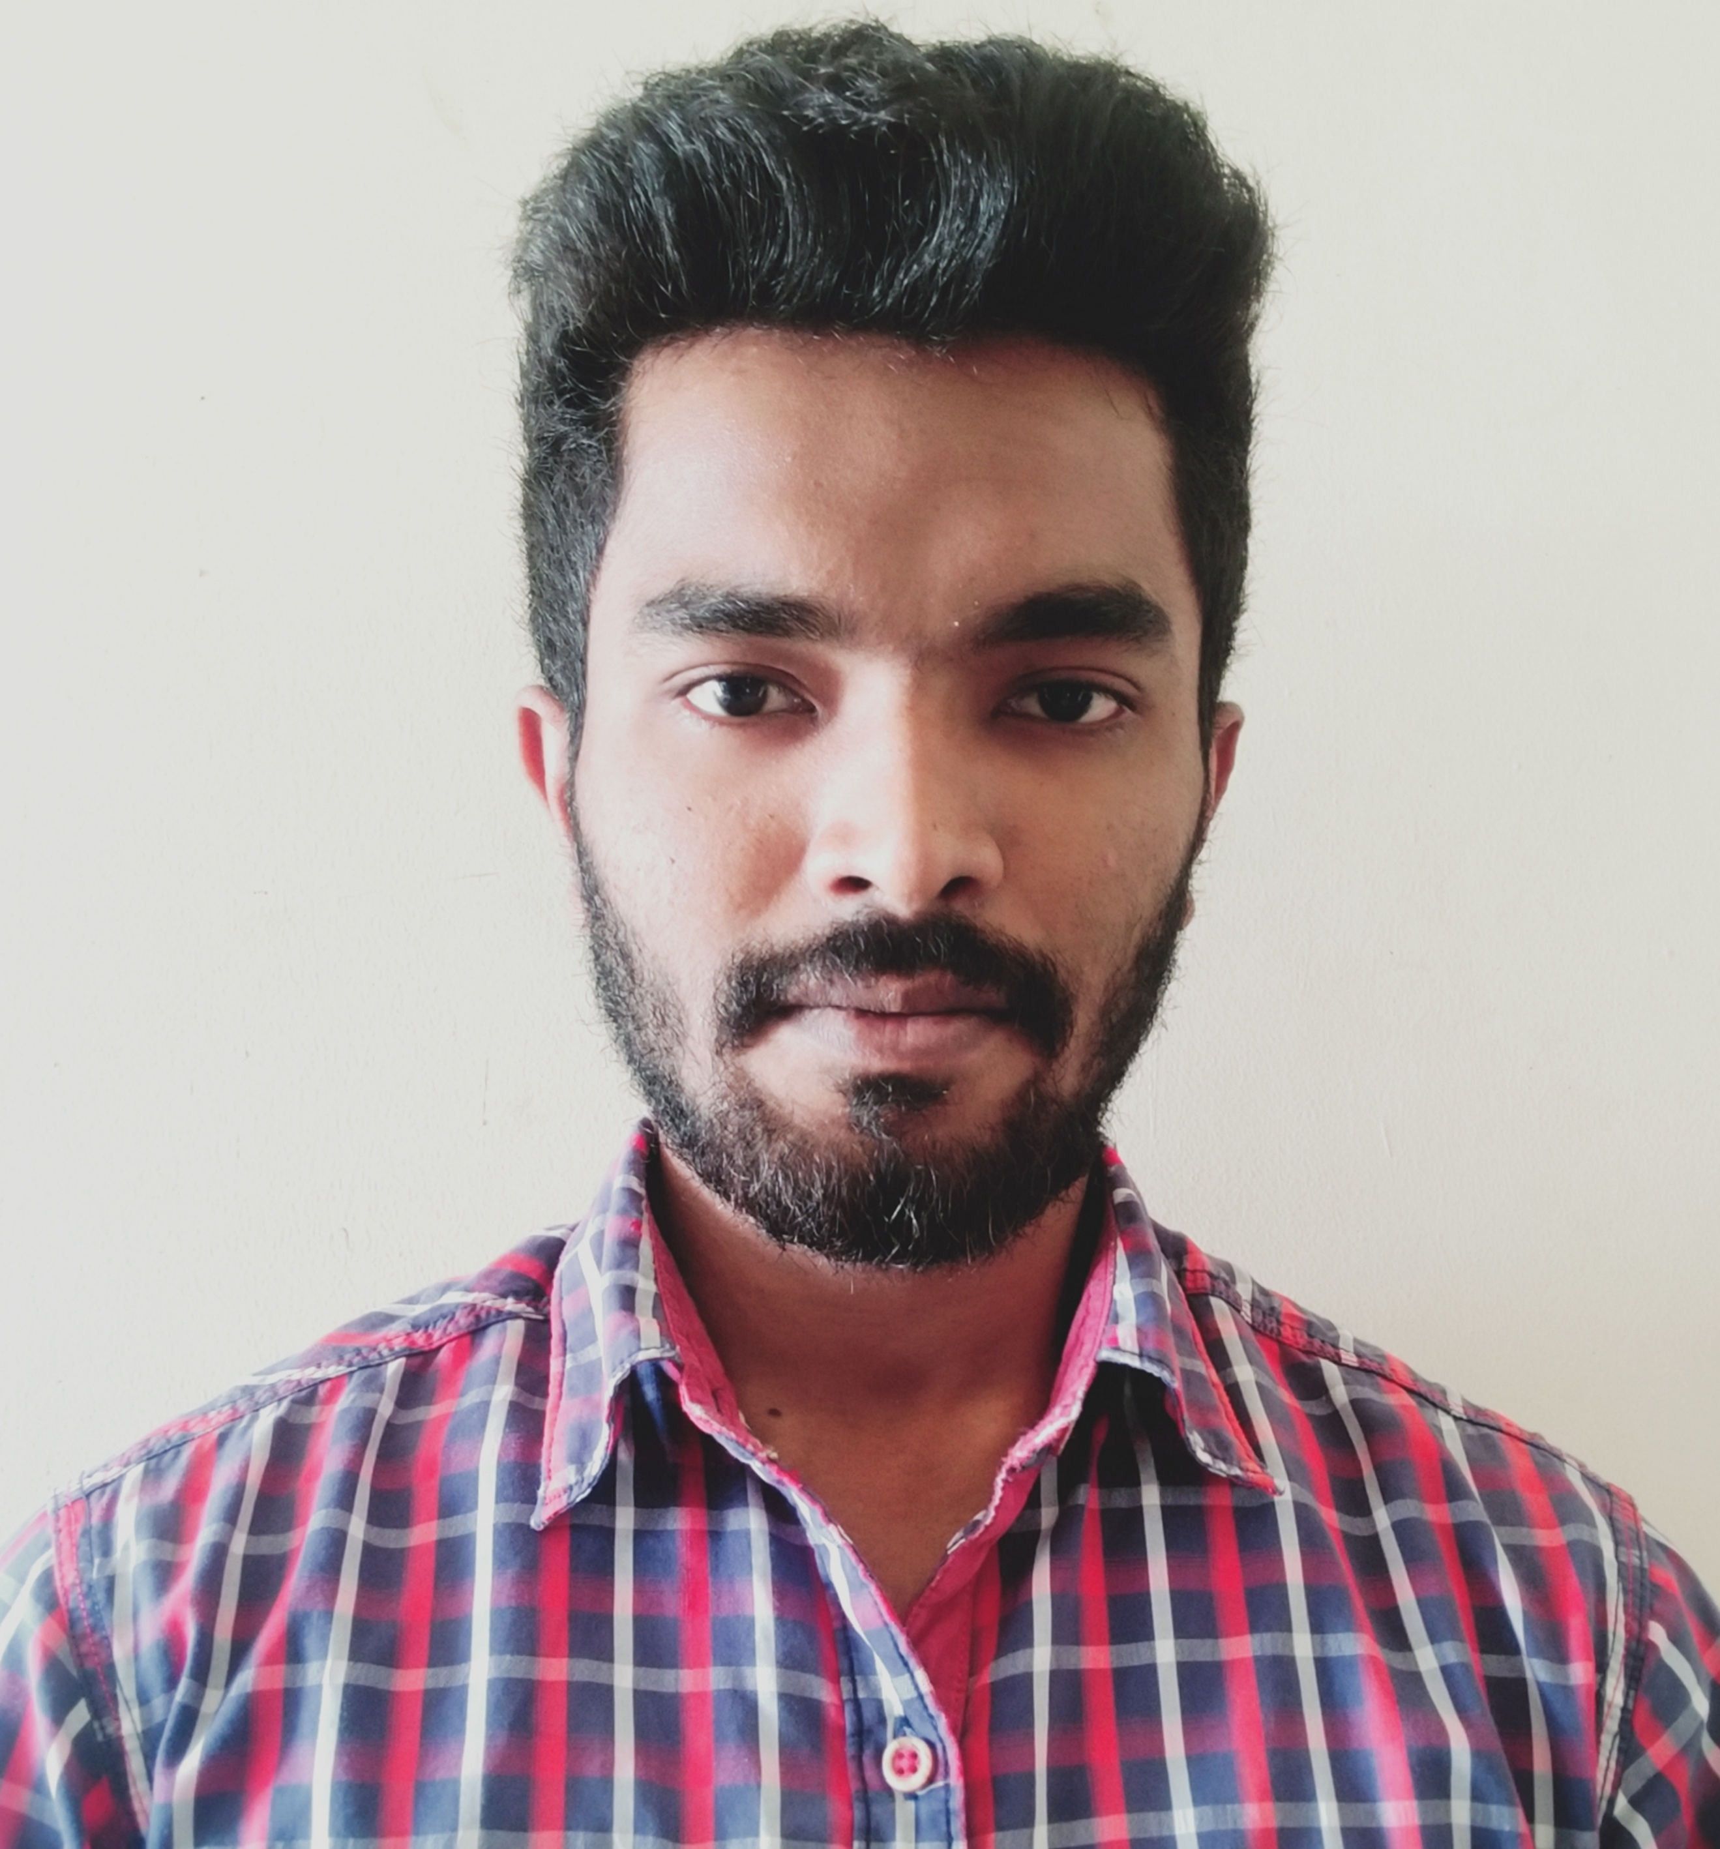

**Email : ahamedkhan.yk@gmail.com**

**9790981095**

|  |  |
| --- | --- |
| **Title:** | Associate Consultant |
| **Location:** | Chennai, India. |
| **Languages:** | English , Hindi, Tamil, Urdu. |

# Experience Summary

1. **Company name:** Capgemini

**Duration:** 3 years (March, 2018 to till Date).

**Position:** Software Developer

**KEY SKILLS:** *Sound knowledge on J2EE, SPRING MVC, Java Micro services*

Technical

|  |  |
| --- | --- |
| **Operating System** | Windows |
| **Database** | Oracle, MySQL, Mongo DB |
| **Message Broker** | RabbitMQ |
| **Tools** | Jira, TFS, Source tree, Eclipse IDE, TOAD, Spring Tool Suite |
| **Web Technology** | Spring MVC, Spring Boot |
| **Architecture** | Micro Services |
| **Web Tools** | HTML5, CSS3, JavaScript |
| **Languages** | Java, SQL, PL/SQL, Junit |

Functional

|  |  |
| --- | --- |
| **Soft Skills** | * Good communication skills * Team player |

# Experience

|  |  |  |
| --- | --- | --- |
| **01** | **Type of Industry:** | **Forecasting the data for Spare Parts Management (SPM)** |
|  | **Project Description:** | This project is based on SPM(Spare Parts Management). SPM is a tool used to forecast the data for managing the Spare parts in Aircraft maintenance. This data used for forecasting is provided by the application, PDL(Planning Data Layer), which allows the user to add, update, delete and view the data manually through UI and this data is processed applying business logics in the back-end and stored in inbound tables using Spring MVC. The data in inbound tables(PDL tables) is transformed to outbound tables(SPM tables, from which data is used by SPM tool) using PL/SQL. It is a highly secured application where developers won’t be able to work with original data, instead we work with masked data.  The PDL Application using Spring MVC was later migrated to Microservices architecture using Spring Boot named as One PDL Application. In this application there is one service which fetch the data from source systems and publish it to a messaging queue which is then taken up by the other services as input data and these services process the data applying business logics and store in inbound tables using Spring Boot. Now another service move the data from inbound tables to outbound tables. |
|  | **Role:** | Java Backend Developer |
|  | **Project Duration:** | June 2018 to till Date. |
|  | **Responsibilities:** | 1. To develop Screens for the user to fetch the data and do several operations in UI with the validations provided in user requirement.  2. Solve the bugs produced by the testing team.  3. We work in Agile model, where we work in sprint of two weeks duration and complete the assigned tasks on time and update the TFS tool and also JIRA tool.  4. Completing the deliverables following coding standard using Code Reviews and checklist. Also Source Tree is used to push and pull the code daily in remote branch in Git to prevent it from destruction of code.  5. Once the task is completed, we send the merge request using GIT lab to merge the code in client’s environment.  6. Worked closely with the client/OSC to discuss various ideas/solutions, issues and timelines.  7. Participated in requirement gathering through various meetings and interactions with the client and onsite as required. |
|  | **Software / Languages:** | Java/J2EE(Microservices) primary skills, JBoss, Spring Boot, MySQL Server, Oracle, Pl/SQL |
|  | **Special Tools:** | Toad, Junit, Git, TFS , Jira, Source tree. |

# Training, Certifications & Affiliation

* Completed J2EE course at L&D Capgemini, Mumbai well versed with all concepts.

# Published & Presented / Awards

* Star Performer Award (at Organization Level) in December 2018.

# Higher Education

B.E in Electronics and Communication Engineering at Saveetha Engineering College, Thandalam, Kancheepuram (Percentage: 65).