SAKSHI

DWIVEDI

Salesforce , Apttus

Project Engineer

Wipro Technologies, Pune

PROFILE

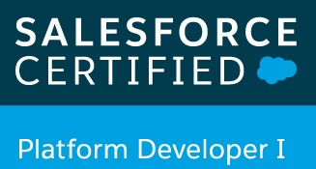 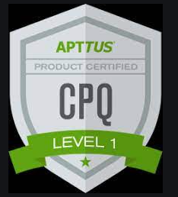

* Currently working as Project Engineer in Wipro technologies for Philips.
* Knowledge about Salesforce configurations and customization both in classic and lightning experience.
* Working into Apttus and Salesforce integration.
* Have worked as a Salesforce and System Administrator into application support hence well versed with the 24x7 support and understand the importance of communication and documentation.

CONTACT

☎ +91-9131007189

✉ [https://www.linkedin.com/in/sakshi-dwivedi- 930aa89b/](https://www.linkedin.com/in/sakshi-dwivedi-%20%20930aa89b/)

✉ [sdwivedi031@gmail.com](mailto:sdwivedi031@gmail.com)

SKILLS

EXPERIENCE

**Feb / 2017 - Dec / 2020 ( Qlik : Role -SME):**

* Worked as a Salesforce.com Administrator in the organization.
* Administrate and Customize salesforce.com application based on the user needs.
* Worked on Reports and Dashboards.
* Worked on data migration from databases to SFDC using Data Loader.
* Handled Salesforce CPQ related issues.
* Create Custom objects, fields and triggers.
* Worked on Workflow, Process Builder, Profiles, Permission sets, Sharing Settings, Object Relationships, Data Loader.
* Worked on setting up of Single Sign On for production and sandboxes.
* Resolving all the technical queries and issues with Salesforce configurations.
* Handling real time Incidents, Requests, Major Incident, Systems Incident and Change Request.

**Jan / 2021 – To Present (Philips – Apttus Modelor):**

* Salesforce and Apttus integration.
* Working as Apttus CPQ Admin for the product configuration as per the requirements.
* Handling Data Validation for Cart configuration.
* Good understanding of the constraint rules, product configuration etc with hands on SOQL query usage for data export and import .
* Configuring the products, bundles, multilevel bundles, in Salesforce platform.
* Associating the product to the category. Associating the option to the bundles. Configuring the product groups. Product and Category visibility.
* Creating and Maintaining Attribute like creating the product attribute custom fields, formula fields, roll-up summary fields, attribute fields and Associating the attribute group to a product.
* Managing the price list and price list items like creating the pricelist, creating price rule/ruleset and pricelist items. Associating the price list with categories.   
  Viewing and publishing favorite configurations for a price list.

• Salesforce Classic and Lightning.

• Salesforce Customization.

• Apttus CPQ 201 Admin Certified.

• PD1 Certified

EDUCATION

Bachelor of Engineering (Hons.)

2011-2015

Completed B.E with 7.57 CGPA in Electronics and

Communication Engineering from RGPV-Bhopal

(MP)

Bachelor of Engineering (Hons.)

2011-2015

Completed B.E with 7.6 CGPA in Electronics and

Communication Engineering from RITS-Bhopal

PERSONAL INFORMATION

(MP)

DOB:03/01/1993

Hometown: Bhopal (MP)

Adaptable | Gregarious | Quick learner| Classical Dancer | Leadership |Self- motivated

Learner.

DOB:06/07/1993

Hometown: Bhopal (MP)