Vinay

Ramu
Senior Consultant
Profile  I am highly passionate to learn new technologies and master them. With my 14 years of experience into CRM domain, actively involved in discussions with end users and business analysts. Help with digital transformation of the business scenarios by implementing complex CRM business processes on the Salesforce, CPQ, and Siebel platforms. I possess communication and interpersonal skill and consulted by clients in many geographical regions in multi-cultural work environments. I have been part of implementing projects on Salesforce across Sales Cloud, Service Cloud, Force.com platform and several AppExchange apps.  Contact  PHONE:  +65-84201494  WEBSITE:  LinkedIn  GitHub  EMAIL:  vinay.ramu1@gmail.com  Hobbies  Reading  Music  Table Tennis |  | EDUCATION  Bachelor of Engineering in Computer Science [Visvesvaraya Technological University India]  2000 - 2004  WORK EXPERIENCE  Equinix, Inc. - Senior Consultant  Project: Partner Direct Quoting  Oct 2019–Till Date  Partner Direct Quoting is the project that enables channel partners with mechanism to raise budgetary quote in a self-service portal. Channel partners will now have all the quoting facility on the self-service portal, and they need not have to depend on partner account manager for each product price. Implementation has community cloud app for partners and CPQ for quoting functionality.  Worked as senior developer in the community cloud and CPQ implementation.  Equinix, Inc. - Senior Consultant  Project: ECO Sales  Oct 2013–Sep 2019  Subject Matter Expert in Sales Cloud, Service Cloud & Order Management with focus on fulfilling business processes. Our industry application focused on selling and managing products that at the data center location(more like to telecom industry and real estate).  Extensive experience in Apex Classes, SOQL, Trigger, Visualforce, Flow, Process Builder, Data loader, Metadata API, Bulk API, Webservices, SOAP, REST, JSON and Lightning Components.  Working on current CPQ implementation for partner community users.  Experience in deployment using Eclipse, Visual Studio, Change set and ANT.  Deloitte Consulting – Technology Consultant  Jun 2011–Sep 2013  Projects: Canon & Baxter  Provide technology solution to the client Canon in the following areas.  Scheduling – Field service engineer will be assigned to various activities associated with a service request, closely integrated with ORS.  Parts – Tracking the required parts to resolve a service request.  Workforce Management – The process of managing the field engineer data and geo coding the addresses using vanilla Siebel functionality with minor customizations.  Mobile Applications - Field Service professionals, users can update sales opportunities, review account and activity information, access calendar and contact details, order and track parts, respond to service requests, and send correspondence.  Accenture – Senior Software Engineer  Apr 2010–Jun 2011  Worked with client Telefonica (Spanish Telecom Company) for Order Management solutions in Industry of Telecommunication and have experience interacting with Spanish functional team.  Oracle – Consultant  Mar 2007–Apr 2010  Worked on replacing existing Oracle Partner Network used by worldwide partners to enroll for various partner programs based on which they would receive entitlements and privileges.  Symphony Services – Test Engineer  Mar 2005–Apr 2010  Worked with Siebel standard product team on core areas like Installation and Deployment.  certifications  - Salesforce Certified Platform Developer I  - Salesforce Certified Administrator  - Siebel Core Consultant  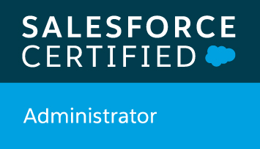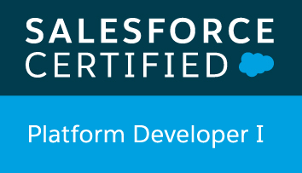  SKILLS

