Muhammed Nuhas

 amnuhas@gmail.com | 9947644685

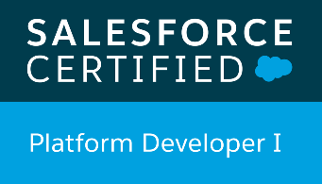 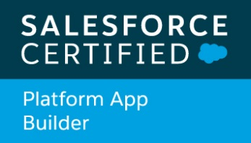 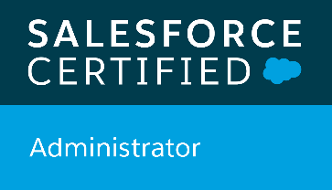

 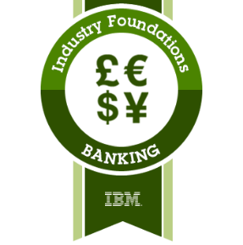 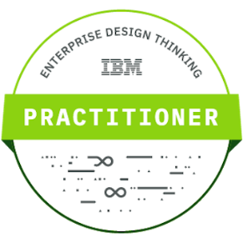

# Profile Summary

* 6 years and 10 months of overall IT experience.
* Possess 6 years of design and development experience in Salesforce with expertise in Configuration and Customization.
* Possess 2.5 years of vlocity products implementation experience.
* Worked on **Banking and Telecom Industry** and involved in Salesforce CRM

Implementations.

* Currently Leading a project – Salesforce Lightning Aura
* Working for Salesforce Integrations with external systems using Rest, SOAP and Bulk API.
* Working for solution design and Leading the development activities on Salesforce Lightning Platform
* Worked on vlocity implementation projects for different Clients such as Three, T-mobile, Verizon etc.
* Good Knowledge in Vlocity Components such as Omniscript, DataRaptors etc.
* Experienced in Vlocity CPQ, EPC and CLM Models.
* Have good experience in Salesforce CRM Release Management Activities.
* Strong knowledge about Bitbucket, SVN, Github etc in order to use for Release activities.
* Experience in database and data Integration skills(Informatica Cloud).
* Have been involved in Data migration from one salesforce org to another
* Conversant with Agile delivery framework
* Gained in depth knowledge and hands-on experience in Apex programming and user interface using Visualforce, data loader, Apex triggers and other tools
* Involved 3 years in **Telecom Industry** Projects and looking to work more to gain good knowledge.
* Very good team player who can take up tasks and deliver on time.
* Quick learner to acquire new skills and adaptable for being plugged in any Team..
* Passioned to learn about Telecom functional based knowledge such as Product/Pricing, Order Management, CLM etc.

# Education

B.E in Electronics and Communication

VSB Engineering College, Karur, TamilNadu

Year of Completion – 2013

# Skills

* Salesforce.com
* Apex Programming
* API Development
* Vlocity Implementation
* Bitbucket/Git
* Informatica Cloud
* SQL Server
* Salesforce Aura Implementation
* Salesforce LWC
* HTML,JS,CSS

# Certifications and Trainings

* Salesforce Administrator
* Salesforce Platform App Builder
* Salesforce Platform Developer 1
* Vlocity Certified Developer
* Vlocity CPQ Essentials
* IBM Industry Foundation Badge
* IBM Enterprise Design Thinking Badge

# Work Experience

IBM India Pvt Ltd India - March 2014 to Nov 2018

Verizon Data Services India - Dec 2018 to Till Date

# Projects

1. Client: Verizon Data Services India

Role: Tech Lead

Project: Status Central

Duration: Dec 2019 – Till Date

The objective of this project is to design a new User Interface of all Customers Status Information for Verizon Sales Rep inside the Salesforce and migrate all functionalities from existing system to Salesforce. Status Central is about a reporting application of all Customers Journey and their related status on specific interactions such as Quotes, Orders etc.

Contributed:

* Taking the leadership of all Development activities provided by Team.
* Implementing all requirements in full and full Aura lightning platform.
* Taking the liberty to provide solution design on specific requirements needed by business.
* Advising the team to use best practices and suggesting best approach on Coding perspective.
* Taking full responsibility of delivering things on each Monthly Enterprise release.
* Bringing the reusability and dynamic approach into the implementations by using all salesforce lightning advantages.
* Gathering all queries from Team on requirements and get it answered from business for a smooth deployment process.
* Experience the Agile methodology and making sure to get things from the team based on the needs.
* Using base of LWC to add reusable advantages on specific requirements such as event monitoring, error logging etc.
* All salesforce new features are being used to give a better performance such as Platform Events, Event handling, etc.
* Led the team to deliver the items on three entity functionalities till now such as Orders, Quotes and OCC Orders.

**Modules/Tools**

* Salesforce
* Aura
* LWC
* Apex
* GIT

1. Client: Verizon Data Services India

Role: Lead Developer

Project: BOS [Business Office Solutions]

Duration: Dec 2018 – Oct 2019

The objective of this project is to design a new User Interface for Verizon Customers Order Journey in customer portal and provide a Customer support system as well using Salesforce CRM and Vlocity .

Contributed:

* Implemented the business requirements with Salesforce CRM and Vlocity .
* Worked on Different Community portals such as Guest User, Customer etc.
* Implemented Ui design using Vlocity Customization with Vlocity Templates and Omniscripts.
* Designed the Client products using Vlocity Product Modal.
* Migrated Omniscripts into Visualforce in order to avoid Vlocity Template Limitations.
* Availed Vlocity Inbuilt CPQ APis in order to get the required Data from Salesforce.
* Been part of delivering the Complete User Interface for an Order journey.
* Provided different Apex Solutions in order to handle complex logics in Order status processing.

**Modules/Tools**

* Salesforce
* Apex
* Vlocity
* Omniscript
* Vlocity Template
* Integration Procedure
* Data Raptor
* GIT
* Bit Bucket

1. Client: T-mobile

Role: Senior Application Developer

Duration: June 2018 – Nov 2018

The objective of this project is to move the Contract Life Cycle Model to Vlocity for T Mobile, a Telecom company in US and help them configure their products using Vlocity product Model. And use Vlocity CLM Model for Dynamic Document Template Generation and Contract Approval Process.

Responsibilities:

* Implementing the solution with Salesforce CRM and Vlocity by understanding the business requirement
* Collaborate with Onsite Team, and Discuss about Design approach of User Stories.
* Provide estimation to the User Stories based on the technical efforts to be taken.
* Attend Scrum Calls and provide valuable inputs/blockers to the Team based on the received Solution design.
* Understand the Product Model of the Client and Implement it in Vlocity.
* Understand the Existing Contract Line Management functionality, and Develop the same based on Vlocity CLM Model and make use of all advantages.
* Learn Vlocity CLM Model and Provide the comments about advantage/risk factors during the implementation.
* Understand Vlocity Hybrid CPQ Cart and Make to reuse the functionality in the current User stories.
* Understand and Trial the Vlocity CPQ APIs, then provide the comments about the usage and limitations on it.
* Understand Vlocity features such as Catalog, Contract Types, Contract Line Items etc and make use of these features for the requirement.
* Investigate and develop the Custom Approval Process flow instead of using Salesforce out of Box Approval Process.
* Implement the Custom UI Product Cart using Vlocity features such as Omniscript, Template, DataRaptor, Integration Procedures etc.
* Configure and Provide Expecting Data Json to the UI Developers as per the Vlocity Template compatibility.
* Integrate all the components including Vlocity Templates developed by UI Team in the Omniscript and Complete the UI Flow end to end.
* Understand the Docusign Signature feature in Vlocity and make use of it in Document Template.
* Develop Dynamic Document Generation using Vlocity CLM.
* Understand all Contract Flows such as Create, Update, Amend, Addendum etc and Provide the flow chart of technical design.
* Provide sessions to the UI Developers about the Vlocity CPQ APIS and explain them about usage of that from Vlocity Template angular json.
* Understand Vlocity PriceList Mechanism and Associate that with each products.
* Implement the Dynamic Approval Process by using Salesforce and Vlocity.
* Advise the Team about Salesforce best Practices and Provide suggestions for each implementation in Salesforce.
* Raise the Case or discuss with Vlocity support Team if any blockers on the development with Vlocity features .
* Configure Contract Line Management Flow (CLM) in Vlocity Model.
* Develop Dataraptors, Omniscripts, Vlocity Templates for Custom UI Cart Configuration based on wireframes.
* Configure the products based on Vlocity EPC Model.
* Deploy Vlocity Data Package from one Org to another.

**Modules/Tools**

* Vlocity EPC & CLM
* Data Raptor
* Omni Scripts
* Document Template
* DocuSign
* Apex

1. Client: H3G UK

Role: Senior Application Developer

Duration: Jan 2017 – Jun 2018

The objective of this project is design a salesforce CRM for 3 Mobile, a Telecom company in UK and help them move out from legacy CRM to Salesforce CRM. And integrate all the existing down system with salesforce using vlocity a managed package on salesforce.

Contributed:

* Implemented the solution with Salesforce CRM and Vlocity by understanding the business requirement .
* Involved the daily scrum calls and technical sessions to have an open discussion on User Stories.
* Learned Telecom Industry basics and understood the functionality of User stories.
* Gone through Vlocity Training including Developer and CPQ Essentials.
* Understood Vlocity Telecommunication Package base and made use of the features in the project.
* Understood the Sightline, a managed package and Made use of it for release planning, iteration planning, the ability to schedule all or parts of requirements from release backlog, and the ability to manage other QA activities.
* Worked for Integration Team that is responsible for developing interface Classes using APIs, and provide to UI developers.
* Understood Salesforce Security mechanism and Connected Apps functionality, provided efficient security for each integration of end systems with Salesforce CRM.
* Understood the JSON and XML Structure of Communication and worked it with that is coming from down stream systems.
* Designed various batch process to consume large volume of data coming from end systems.
* Discussed with the representatives from the Down Stream systems and understood the functionality and data flow.
* Understood the existing product structure and its complexity, and developed utility classes to support for configuring the existing product structure in vlocity model.
* Understood Order to Asset Management in Vlocity and made use of the Vlocity Object Type, Bundles, Field Mapper etc.
* Understood Vlocity Dataraptor, Omniscript and Integration Procedures and used as part of requirement.
* Collaborated with Onsite UI resources and provided the support by creating the salesforce customizations.
* Worked as an Only resource from Offshore for the Onsite DevOps Team that is responsible to manage all release activities and sightline Tool management.
* Served as single person for responsible to version the codes for each developers into Bitbucket using Source Tree middleware.
* Advised and provided suggestions to the Team to improve the code quality and best practices.
* Given sessions to the Offshore Team about the release management and basics of SCM Process.
* Learned Rest, SOAP and BULK APIs in salesforce and developed the interface classes using APIs.
* Provided Support and given sessions about the functionality of the user stories to the QA Team during SIT and UAT phase.
* Involved directly to the deployment activities of Salesforce and Vlocity Components from one org to another.
* Learned and used the Deployment Tools such as Force-dev-tool, Vlocity Build, Ant migration Tool etc.
* Served as single person at Offshore, responsible for Sandbox refresh after the release and User Creation for each one.
* Develop the external Integration using Rest, SOAP and Bulk API.
* Being Part of Release Management Team and involving all kind of release activities.
* Create Batch Apex, Utility Classes, Triggers based on requirements.
* Review the Developer’s codes and advise the best practices.
* Deploy Vlocity Data Package from one Org to another

**Modules/Tools**

* Vlocity
* Data Raptor
* Connected Apps
* Omni Scripts
* FieldMapper
* Integration Procedure
* GIT/BitBucket
* Force-dev-tool
* Ant Migration Tool
* SourceTree
  + SOAP/REST

.

1. Client: American Express

Role: Application Developer

Duration: March 2014 – Dec 2016

Contributed:

* Implemented the solution with Salesforce CRM by understanding the business requirement.
* Provided Support in Data migration activities from legacy system to Salesforce Org .
* Implemented the Data Integration Jobs using Informatica Cloud.
* Created Classes, Objects, Fields, Workflows etc in Salesforce CRM as part of Data Migration requirement.
* Cleansed the Legacy Data using SQL server and Provide the CSV Files for Migration .
* Managed the Code versioning using SVN and other release activities.

**Modules/Tools**

* Salesforce
* Apex
* Data Loader
* Informatica Cloud
* SQL Server
* SVN