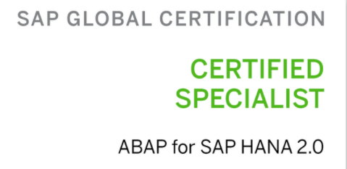 Resume 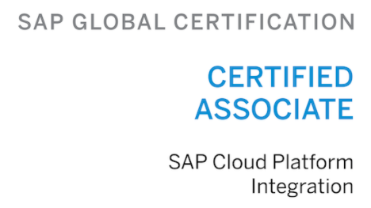

Rattaiah Garnepudi Mail : rattaiah.gsap@gmail.com
SAP ABAP On HANA Consultant Mobile : 9490855157

CAREER OBJECTIVE

Looking forward to continuing my career in an ERP-SAP environment, where I can utilize my Experience and skills in contributing effectively to the success of the organization and for improvement of my skill and Career.

EXPERIENCE SUMMARY
- Overall SAP ABAP experience,7+ years’ experience in SAP ABAP.
- Present Working as a SAP ABAP On HANA Consultant in PepsiCo Project (IBM - Hyderabad).
- Having 5+ Year’s Of experience SAP ABAP on HANA Implementation Project.
- Working on Agile methodology and sprint environment.
- Excellent Debugging and monitoring capabilities.
- Gained good exposure Requirement Study, Analysis, Design, Development, Testing.
- Good Experience in RICEF and ABAP on HANA, good on OO ABAP Development’s.
- Experienced in creating Data Dictionary objects Custom tables and Custom structures, Reports.
- Worked on Smartforms, Adobe Forms, Scripts.
- Worked on HANA Modeling, ABAP ON HANA CDS and Proxy.
- Data Conversions with migration tools like BDC, BAPI and IDOCS.
- Modularization techniques: Includes, Subroutines and Function modules.
- Experienced Module Pool Programs and Designed Screens in Screen Painter and Menu Painter.
- Strong experience in normal, ALV reports (Classical & Interactive) With OO ABAP.
- Data Conversions with migration tools like Batch Data Communication.
- Worked on interfaces BAPI, RFC’s, IDOC, BODS, SPROXY.
- Worked on SPAU, SPDD for system upgrades, implementing OSS Notes.
- Worked on BRF Plus’s and Good Knowledge AMDP’s.

EDUCATION
- Master of Business Administration (MBA) from JNTU (2008-2010), Kakinada.

EMPLOYMENT DETAILS
- Currently Working with IBM India Pvt. Ltd. -Hyderabad Sep -2018 to Till Date.

CERTIFICATION DETAILS
- SAP Certified Development Specialist - ABAP for SAP HANA 2.0.
- SAP Certified Development Associate - SAP Cloud Platform Integration.

SKILL SET
- Data Dictionary : Data Element, Structure, Append Structure, TMG, Index Creation.
- Reports : Classical, Interactive and ALV Reporting, Object Oriented ABAP.
- Forms : Smart forms and Scripts, Adobe Forms.
- Data Transfer : Using Batch Data Communication, BAPIs, Data Source, RFC's, IDocs.
- UI Programming : Developed application using Module Pool Programming.
- Enhancements : BAPIs, BADIs, Spots, Exits.
- ABAP HANA : HANA Modelling,CDS,AMDP ,O Data Services, SProxy.
- BRFPlus : BRF Tables,Functions,Structures.
- Proxy : SXMB_MONI,Proxy Structures,Sproxy.

PROJECT PROFILE
PROJECT#1:
  - Company : IBM
  - Location : Hyderabad
  - Client : Pfizer Pharma
  - Role : Application Developer
  - Duration : Jan-2023 to Till Date
Description: Pfizer Pharma.
Produces medicines and vaccines for immunology, oncology, cardiology, endocrinology, and neurology. The company's largest products by sales are the Pfizer–BioNTech COVID-19 vaccine
Responsibilities:
Involved Migration and S4 Hana Implementation.

PROJECT#2:
  - Company : IBM
  - Location : Hyderabad
  - Client : PepsiCo
  - Role : SAP ABAP On HANA Application Developer
  - Duration : Sep-2018 to Jan2023
Description: PepsiCo, Inc.
is an American multinational food, snack, and beverage corporation headquartered in Harrison, New York, in the hamlet of Purchase. PepsiCo has interests in the manufacturing, marketing, and distribution of grain-based snack foods, beverages, and other products.
Achievements :
- Got all the Quarter’s best performer awards 4 times in the 2020 year.
- Got More objects Delivered PIC Winner Award in the Year 2020 in PepsiCo Team.
- Got Best Performer of the Year Award from the Technical side Entire PepsiCo Team.
Responsibilities:
- Estimation, scheduling and tracking the requirements and FSD’s.
- Following the Sprint and Agile Methodology for completion of the Objects.
- Involved in the Code review process.
- Involved in the Entire requirements process end to end to complete the requirements.
- Reviewing the functional specification and coordinating with functional team to gain an understanding of the requirement.
- Preparing the Technical specification based on the functional specification.
- Objects modification/development as per the project schedule.
- Reviewing the ABAP programs to ensure efficiency and fine-tuning where necessary.
- Perform the ATC Checks and solve the ATC errors. Prepare Unit Testing documents.
- Doing walk through unit testing and test cases of the objects before delivery.
- Worked in Interfaces and Reports with BODS and Proxy Teams.
- Worked on Enhancements-BADI, Implicit and Explicit Enhancements.
- Worked on IDOCs from scratch and BAPI’s.
- Worked on Module pool programs and ALV Reports and Adobe Forms and Smart forms.
- Worked on HANA CDS and O Data Services.
- BRFPlus Tables, Proxy structures, SXMB_MONI.
PROJECT#3:
- Company : CAPGEMINI – Mumbai and Bangalore Locations
- Client : BAYER
- Role : Consultant
- Duration : May-2016 to Sep-2018
Description: Bayer AG: is a German multinational, pharmaceutical and life sciences company. It is headquartered in Leverkusen, human and veterinary pharmaceuticals; consumer healthcare products; agricultural chemicals and biotechnology products.
Responsibilities:
- Getting the requirement from the Functionals and providing the analysis.
- Worked on Production issues, analysis and explaining logics to the functional consultants.
- Developed, changed Reports Normal, Interactive reports based on client requirements.
- Developed and changed Smartforms Based on requirements.
- Worked on Enhancements and IDocs related issues.
- Created Custom tables and added Custom fields in existing tables and Created TMG.
- Worked on Module pool programs and reports smartforms, scripts, IDocs, reports..
- Created Custom tables and added Custom fields in existing tables and Created TMG.

PROJECT#4:
- Company : Tata Technologies(Tara Softtech) – Mumbai Location
- Client : Tata Motors
- Role : Consultant
- Duration : Jul-2015 to May-2016
Description:Tata Motors Limited (formerly TELCO, short for Tata Engineering and Locomotive Company) is an Indian multinational automotive manufacturing company headquartered in Mumbai, Maharashtra, India.
Responsibilities:
- Worked on Production Incidents (issues) and explaining logics to the functional consultants.
- Developed/changed Reports Normal and Interactive reports based on client requirements.
- Prepared and changed Smartforms Based on Client requirements.
- Uploading data through BDC, BAPI’s and Created RFC.
- Developed Smartforms and changed existing smartforms and scripts.
- Created Custom tables and added Custom fields in existing tables and Created TMG.
- Worked on Module pool programs and reports.
- Worked on feasibility of the requirements before development.
Crown Solution - 30-May-2012 to 27-Dec-2013 as Sr IT HR Recruitment.
Teamware Solution - 14-Feb-2011 to 27-May-2012 as Talent Acquisition IT HR Recruitment.
Personal Details:
Name | Rattaiah Garnepudi
Contact No | 9490855157
Current Location | Hyderabad

