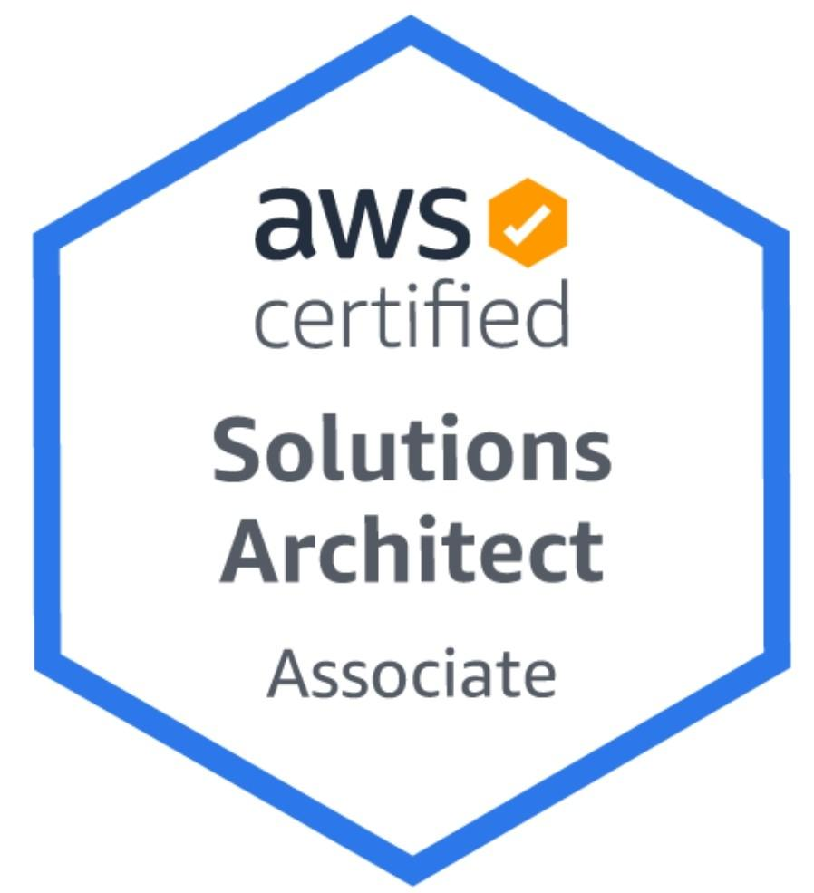

**LOGESH S**

Mobile: +91 8838088904 / +91 8754307991

Email: logeshsuresh67@gmail.com

**JOB OBJECTIVE**

Seeking an opportunity to work in an established organization in order to effectively use and enhance my technical, conceptual and human skills for self-development and growth of the company

**PROFILE SUMMARY**

* 3+ years of experience in system and network administration, managing server infrastructure.
* In Depth knowledge of AWS Cloud services like Storage, EC2, IAM, VPC, SQS.
* Hands on experience in deployment of utilities using Shell Scripting to automate process.
* Strong problem solving skills with logical thinking, confident decision making based on experience and technical skill enabling effective solutions that positively impact customer satisfaction & operational costs.

**PROFESSIONAL CERTIFICATION**

**March 2020**: Completed AWS Certified Solutions Architect – Associate Certification with score of **845**.

**PROFESSIONAL EXPERIENCE**

**Senior Systems Engineer**

**Cognizant Technology Solutions: March 2017 – till date**

* Worked on Amazon Web services ( EC2, , IAM, VPC , S3, Cloudfront , IAM , RDS , Route 53, CloudWatch, SNS )
* Good Understanding of ELB, security groups, NACL, NAT, firewall and Route 53.
* Log Analysis and providing data for a weekly and monthly report to senior management.
* Experience with Monitoring tools such as Cloud Watch.
* Worked on Tripwire Enterprise Software managing and Monitoring Servers on Daily basis.
* Handled Incident Management and Reporting activities in Tripwire.

**Consultant**

**Sutherland Global Services: July’15 to September’16**

* Provided Voice Support for the out-of-warranty customers of a huge computer manufacturing MNC.
* Pitching various post warranty plans to the customers, convincing them to buy any one service and resolving the technical issues concerned with either Networking or Hardware or Software.
* Gained experience on various Operating Systems such as Windows (XP, Vista, 7, 8, 8.1 and 10), Android and Chromebook.

**ROLE DESCRIPTION**

**AWS**

* Managing IAM Users groups and policies in AWS console.
* Creating and Providing S3 bucket access to the users based on request
* Setup/Managing Databases on Amazon RDS. Monitoring servers through Amazon CloudWatch, SNS.
* Creating/Managing DNS records on Amazon Route 53.
* Creating/Managing AMI/Snapshots/Volumes, Upgrade/downgrade AWS resources (CPU, Memory, EBS)
* Deploying EC2 instance and Resources Bills.
* IAM User and Group administration.
* Managing IAM roles and user account policies in providing AWS console access and Programmatic access.
* Implementing AWS Infrastructure services like EC2, VPC.
* Configuring Auto scaling and ELB.

**TRIPWIRE**

* Performing periodic scans against the configurations implemented across Unix & Windows servers using Tripwire tool
* Generating reports and sharing results with the customers on Monthly basis.
* Preparing remediation reports for the servers less than 70% score in tripwire reporting tool.
* Monitoring Service Now ticketing tool and performing requested adhoc scans
* Downloading and importing new Policies in the consoles.
* Implementing Rules and Conditions in console.
* Removing licenses and Monitoring of servers in Tripwire application

**SKILLS**

* **Tools:** Amazon Web Services, Tripwire.
* **Scripting Languages:** Shell, Python scripts (basic).

**ACADEMIC BACKGROUND**

* **B.E. in ECE :** Coimbatore Institute of Engineering and Technology, Anna University (2012-2016): **CGPA- 61%**
* **HSC**: Kikani Matric higher secondary school, Coimbatore (2011) (Matriculation- 69%)
* **SSLC**: Kikani Matric higher secondary school, Coimbatore (2009) (Matriculation- 81%)

**PERSONAL DETAILS**

* **Date of Birth:** 6th June 1994
* **Languages Known:** English & Tamil
* **Address:** No 53, Nadu Veethi , Veerapandi , Coimbatore - 641019
* **Current Salary:** 4.16 Lakhs PA
* **Notice Period:** 60 days from the date of resignation submission

**DECLARATION**

The Above furnished information is true to the best of my knowledge

Thanks for your patience and effort to look through my profile.

**Place : Coimbatore**

**Date : 14 October 2020**

**Logesh S**