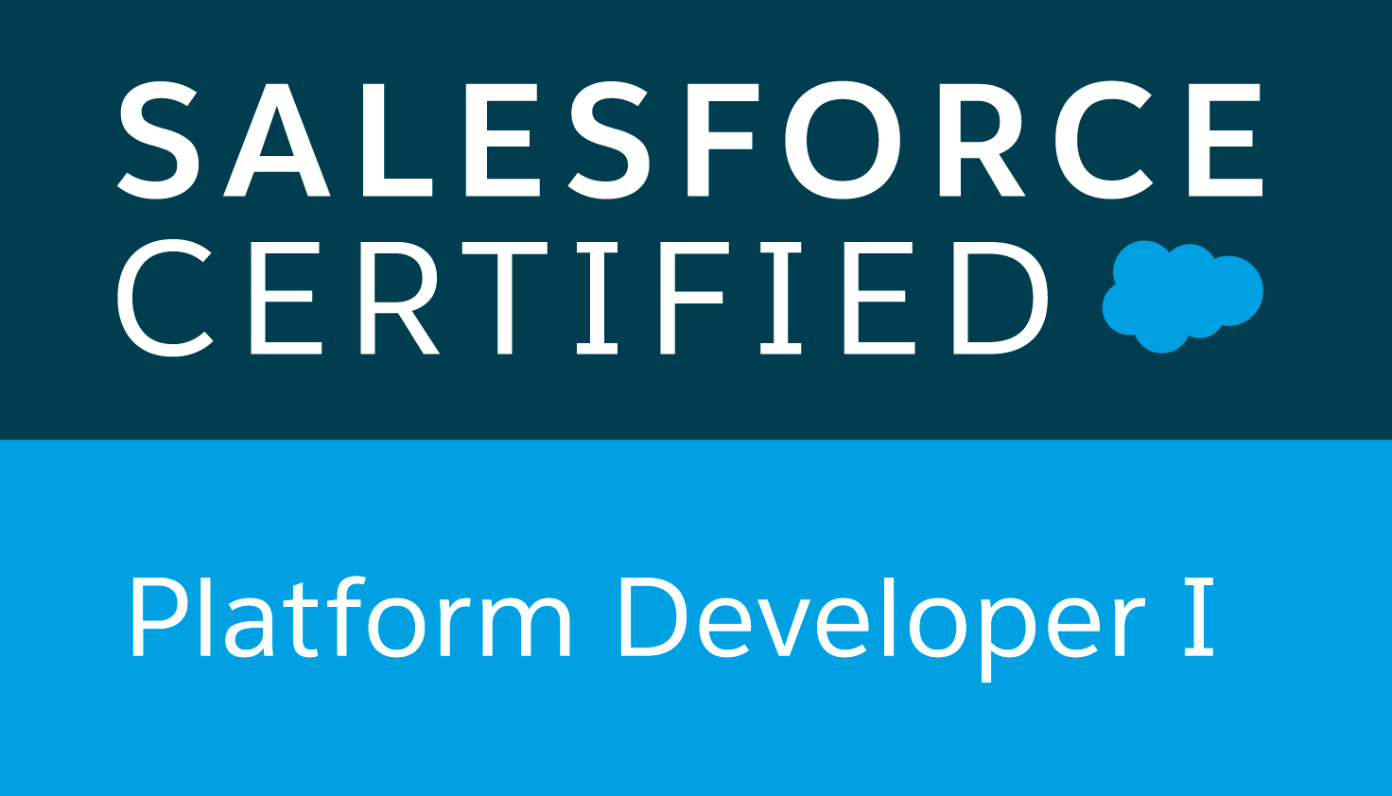  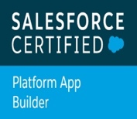

**Yamini**

**Moblie: 732-624-6648**

[**yaminisf01@gmail.com**](mailto:yaminisf01@gmail.com)

**Salesforce Developer**

**PROFESSIONAL SUMMARY:**

* **8+** years of professional experience in working on software application Development, Configuration, Administration, Testing and Implementation.
* Worked on **Salesforce Administrative** tasks such as configuring profiles, roles, users, page layouts, Org-Wide default, sharing rules, work flow rules, approval process, reports, dashboards, standard and custom objects.
* Have good understanding and experience in writing **Apex classes, Test classes, Triggers**, using Salesforce Object Query Language (**SOQL**), Salesforce Object Search Language (**SOSL**) and Data Manipulation Language to fulfil the business needs.
* Extensive Experience in configuration and customizing of **Service Max** using SFM Transactions, SFM Wizards, Group wide & Org wide profile settings, and **Dispatch console** according to the customer requirements and deploying Service Max objects across various orgs required.
* Experience in working with various salesforce.com standard objects like Accounts, Contacts, Opportunities, Leads, Campaigns, Reports and Dashboards.
* Experience in the process of migration from Classic to Lightning environment and enhancing all the existing Visual force pages and make them compatible with Salesforce Lightning.
* Have experience in using **Salesforce Lightning inspector** to debug the lightning components.
* Strong knowledge and experience of working in teams implementing **Agile methodologies**.
* Have experience and good knowledge on **Salesforce Lightning configuration and customization** to have better look and feel of the Salesforce application.
* Experienced in developing Lightning pages and components using aura framework, lightning design system, lightning data services, and events.
* Specialist in writing the **Apex code** by following the best practices so that the code abides by the Governor rules of Salesforce.
* Possess comprehensive understanding on SFDC full life cycle implementation experience with **Service Cloud, Sales Cloud**, and Force.com Platform.
* Good knowledge and experience with Salesforce Service Cloud, Sales Cloud and having good understanding of Salesforce Campaign Objects.
* Good knowledge of Salesforce web services in integrating Salesforce with other technologies using **SOAP, REST** and Bulk API's.
* Extensive Experience in configuration of Mobile and Offline requirements using **FSA** app.
* Experience in Creating **Nintex Drawloop Documents** and use excel as middleware to develop complex business requirements.
* Strong experience with SFDC configuration, customization, programming APEX Triggers, and implementing new instances of Salesforce.com.
* Have good experience in writing complex Work Flow Rules as per the business requirement.
* Have a good understanding on working with **Process Builders**, and **Flows**.
* Experience in data migration from Legacy Systems using **Data Loader**.
* Experience in Lead and Case management using **Web-to-Lead, Web-to-Case, Email-to-Case** features.
* Re-structured custom objects, Master-detail relationships between objects to better suit the organization's business needs
* Knowledge in Integrating Salesforce.com with other internal/external applications using SOAP and REST based web services.
* Performed unit testing for the customizations and developments done during the project.
* Have good knowledge on how to set up, create and customize communities in **salesforce community cloud**.
* Have experience on creating Lightning Web Components using events, lightning design systems, lightning data services base components and other **LWC** properties in VS Code.
* Have a good understanding of Asynchronous operation like **Future Methods, Queueable Apex, Batch Apex and Scheduled Apex** to implement bulk DML operations.
* Have a good understanding and experience in customizing **Visualforce pages** using standard controllers, custom controllers, and extensions.
* Have good knowledge and understanding on how to develop **Lightning Web Components**, using events, and other properties in VS code.
* Have good knowledge on how to use **GitHub, ANT tool, Data Loader, Data import wizard, and Data export wizard**.
* Committed to excellence, self-motivator, quick-learner, team player, and a prudent developer with strong problem solving, analytical skills and communication skills.

**CERTIFICATIONS:**

* Platform Developer 1
* Platform App Builder
* Salesforce Administrator

**EDUCATION:**

* JNTU
  + Bachelor of Technology, Electronics and Communication Engineering

**TECHNICAL SKILLS:**

|  |  |  |
| --- | --- | --- |
| Operating Systems |  | Windows |
| Programming Languages |  | Apex, Visualforce, C, Java |
| Scripting Languages |  | Java Script |
| Web Development languages |  | HTML, Cascading Style Sheets |
| Tools |  | Data Loader, Ant, MS Office, MS Excel, VS Code |
| CRM Product |  | Salesforce.com |
| Force.com Configuration |  | SFDC Standard Object Configuration, Custom Object Development, Field Creation, Page Layout creation/editing, Related List Customization, Record Types, Field Level and Object Level Security, Workflow Rules, Reports, Dashboards, Formula Fields and Cross Object Formula Fields, Overall User Management. |
| ETL/Integration Tools |  | Apex Data Loader, Force.com Workbench. |

**WORK EXPERIENCE:**

**Client: Nissan North America, TN Feb’ 2019 – Till date**

**Role: Salesforce Developer**

**Responsibilities:**

* Performed the role of SFDC developer, lightning developer and interacted with various business user groups for gathering the requirements for Salesforce.com, Lightning and CRM implementation.
* Following Agile Methodology, Performed detailed analysis of business and technical requirements and designed the solution by customizing various standard objects of Salesforce.com (SFDC).
* Created Workflow Rules to automate Tasks, Email Alerts, Field Updates, time-dependent actions and Outbound API Messages.
* Designed, and developed Apex Classes, Apex Triggers, and Test Classes for various functional needs in the application.
* Used SOQL & SOSL with consideration to Governor Limits for data manipulation needs of the application using platform database objects.
* Worked on configuring Data Loader, uploading data in CSV files into Salesforce.com, checking for the correctness of the data.
* Created templates, approval processes, approval page layouts and defined approval actions on them to automate the processes.
* Created multiple Lightning Components, added CSS and Design Parameters that makes the Lightning component look and feel better.
* Involved on creating Lightning Pages using Lightning App Builder.
* Worked on Reports and Dashboards in Salesforce Classic and Salesforce Lightning.
* Used Salesforce Lightning to delivers a modern, smart experience across every device.
* Worked effectively to ensure that the data is protected and is made available to the authorized users by customizing the user Roles, Role hierarchies, Profiles and Sharing settings and Permission Sets.
* Involved in data mapping and migration of data from legacy systems to Salesforce.com Objects and fields.
* Worked on various Salesforce.com standard objects like Accounts, Contacts, Cases, Reports and Dashboards.
* Have good experience in using VS Code for developing lightning components, Lightning Web Components and writing apex classes.
* Involved in designing few functionlaities using Lightning Web Components as part of business requirement.
* Worked on creating Lightning Web Components using events, lightning design system, lightning data services base components, and other LWC properties in VS code.
* Used GIT for version controlling system and used source tree as an UI to perform the code push/push operations.

**Environment:** Salesforce.com, Apex Classes, Triggers, SOSL, SOQL, Service Cloud, Sales Cloud, Data Migration, Salesforce Lightning, Data Loader, Custom Objects, Custom Tabs, Roles, Profiles, Reports, Picklists, Accounts, Email Alerts and Windows.

**Client: Juno Therapeutics, WA Dec’2017 - Jan’2019**

**Role: Salesforce Developer/Administrator**

**Responsibilities:**

* Developed Lightning components and Lightning apps to provide better and more interactive interfaces to end users.
* Added Lightning Component to Lighting Pages and Record Pages. Have worked on Apex classes, Visualforce Pages, Controller classes and Apex Triggers for various functional needs in the application.
* Developed various Visualforce Pages, Apex Triggers to include extra functionality and wrote Apex Classes and Controller to provide functionality to the visual pages.
* Used Data Loader to bulk load leads data into Salesforce.com from other databases and CSV files.
* Migrating the pages from classic to lightning.
* Reengineered APEX code already in production to optimize trigger based transactions for performance and speed as well as to work seamlessly with governor limits.
* Used SOQL & SOSL with consideration to Governor Limits for data manipulation needs of the application using platform database objects.
* Provided ongoing salesforce.com maintenance and administration services including periodic data cleansing, custom objects, workflows.
* Developed the Lightning App, Lightning Components, and Lightning Pages using the Lightning App Builder.
* Created the email templates to be used in Workflows, Assignment Rules and Auto Response Rules related to Lead Management module.
* Experience working in service cloud, supporting cases, developed workflows and triggers for automated case resolution
* Deployed applications from sandbox to sandbox/production using ant migration tool, and Change Set.
* Experienced using Salesforce Lightning UI. Created Lightning Apps combining Lightning Design System, Lightning App Builder and Lightning Component features.
* Enabled Aura Framework, by adding Aura Attributes and Aura Handlers for Events to focus on Logic and Interactions in Lightning Applications.
* Used Salesforce Lightning inspector to debug the lightning components during the development process.
* Worked on cereating Lightning Quick actions and Global actions for lightning record page and home pages.

**Environment:** Saleforce.com platform, Lightning, Apex Language, Visual Force Pages, Custom Component, Custom Controllers, Workflow & Approvals, Custom Tabs, Page Layouts , Email Services, service cloud, Security Controls, HTML, Web Services, Reports, Sandbox, ETL tools, sandbox, Ant, Changeset.

**Client: GE Health Care, IL Sep’2016 – Nov’2017**

**Role: Salesforce Developer**

**Responsibilities:**

* Worked on Salesforce Administrative tasks like creating Custom objects, Fields, Page layouts, Workflow rules, Validation rules, and Approval process, Roles, Profiles and Users etc.
* Worked on creating permission sets and sharing rules to grant extra access to a specific group or user based on the requirement.
* Worked on Creating Drawloop Documents and used excel as middleware to make different user requirements done easily.
* Having good understanding of Asynchronous operation like Future Methods, Queueable Apex, Batch Apex and Scheduled Apex to implement bulk DML operations.
* Having good experience in writing triggers and apex code to automate the process where required.
* Proficient in designing of FSA requirements such as creating view SFMs, SFM Formulas, SFM Searches, Output documents, Download & Advanced download criteria, and other business requirements to achieve same functionality as online.
* Performed customization of ServiceMax Dispatch Console’s Work Order Grid, Scheduler, Map and also create Service teams and Technicians.
* Developed ServiceMax output documents for FSA to work in offline as per business requirement.
* Created various SFM Transactions, SFM Wizards and assigned appropriate permissions for them using profile settings and App permissions.
* Developed applications using Apex Controller, Visual Force pages and Service Max.
* Created/Introduced new Record Types on Various Objects.
* Developed and configured Dashboards, Report Folders, Report Types for different user profiles based on the need in the organization.
* Developed some functionalities using lightning components, events, tokens, and lightning data services as part of business requirement.
* Involved in deploying code across environments using inbound, outbound change sets and ANT tool.

**Environment:** Salesforce.com CRM Application Platform, Force.com, Apex Triggers, Apex Data Loader, SOQL, SOSL, Lightning Design system, Lightning components, Custom Objects, Tabs, Page Layouts, Workflows, Service Max, Nintex Drawloops.

**Avon Technologies, India June’2013 – Aug’2016**

**Role: Java Developer**

**Responsibilities:**

* Worked closely with software developers on feature specifications and design.
* Designed and executed thorough test plans from developer feature specifications.
* Correlated with programmers to identify, resolve, and verify the resolution of software bugs.
* Worked with JSP, ColdFusion run-time code, and Dreamweaver UltraDev's JavaScript extensibility layer while testing features on nine different operating systems.
* Contributed to J2EE development by writing Servlets, JSP, participated in navigation and functionality testing and validating using java script.
* Developed UI by using Applets.
* Developed Custom tag Libraries, which will pass the data to the JSP pages.
* Developed user personalized dashboard, which facilitates the user to save his/her interested report pages along with related notes.
* Worked on cached graph and data refreshing and optimized by using threads.
* Tested and developed server-side helper classes and Servlets.
* Stored procedures and triggers are written for the database module.
* Developed EJBs (Service Beans, Entity Beans), JSP Tags.

**Environment:** JDK 1.2.2, Java Servlets, JSP, EJB, XML, XSL, Oracle, Windows NT, Solaris, Red Hat Linux, Hibernate, Design Patterns.