Name: Sujan Guha
Email: sujan.guha2017@gmail.com Phone:+91 9874796753
Address: Kolkata
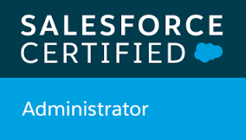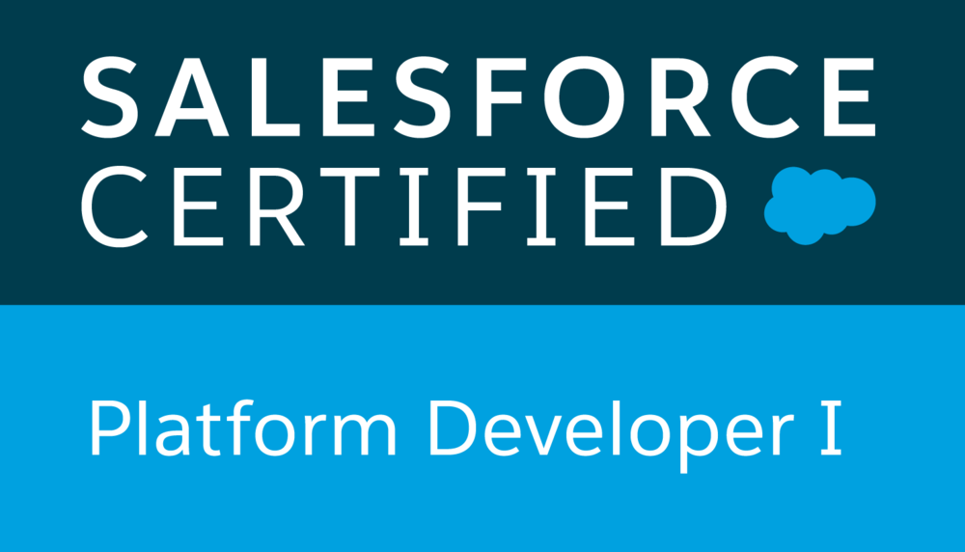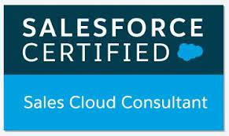

Professional Summary
- Having 3 years of experience in developing and implementing applications on Force.com Platform.
- 3x certified salesforce certifications
- Prepared High-Level and technical design documents
- Developed Proof of Concepts, design prototypes for requirements and design validations with the stakeholders.
- Worked on fitment analysis for categorization of all requirements according to complexity and implementation feasibility in Salesforce platform.
- Conducted breakout sessions with other teams to resolve design conflicts and address concerns.
- Demonstrated out of the box Salesforce capabilities and proposed business process changes to take full advantage of Salesforce capabilities.
- Development of various functionalities by using point and click capabilities and Force.com features.
- Hands on with Code scan tool.
- Experience with Sales Cloud, Experience Cloud.
- Experience with Salesforce lightning Components development.
- Experience on Lightning Design system, Aura Framework, Controllers, Style and Design.
- Hands on with Lighting App builder and Social Sign On, External Identity, Login Flows.
- Having experience on communities.
- Hands on experience on developing the Lighting web components.
- Hands on Experience with Reports and Dashboards development.
- Having extensive work experience in Apex Programming, Visual force pages, Components, REST and SOAP Web Services, HTTP Callouts, Triggers, Workflows, Integration.
- Hands on Experience on Salesforce Configuration like Users, Profiles, Roles, Workflow Rules, Validation Rules, Permission sets, Relation Ship, Formula fields.
- Hands on writing Batch Apex, Schedule Apex and Dynamic Apex classes based on the requirements.
- Having work experience on HTML, jQuery and Node JS.

Skills Profile
Technical
Operating System | Windows 10
Environment | Salesforce
Languages | Apex Classes, Visual Force Pages, Visual force components, Lighting Components, Lightning Web Components, Apex Triggers, Batch Classes, Webservices, Rest API, Soap API, Reports and Dashboards development, HTTP Callouts, CSS,HTML.
Sales force Technologies | Visual Force Pages/Components, Apex Web Services, Apex Triggers, Batch Apex, Apex Handler/Controller class, Workflow & Approvals, Reports and Dashboards, Custom Controllers, Validation Rules, Custom Objects, Custom Settings, Custom Metadata, Login Flows, Community, Lighting Page/ Components, Lightning Web Components.
Salesforce Tools | Visual Studio Code, ANT Data migration tool, Informatica cloud, Data Loader, Workbench
Certifications | Salesforce.com Certified Administrator.  Salesforce.com Certified Platform Developer I.

Professional Experience
Organization Name | Cognizant
Client Name | Allergan
Project Name | AMI
Project Duration (From & To in Month/Year Format) | 03/2019 -02/2020
Role/Title | Salesforce Developer
Work Location | Kolkata
Project Description | The client is an American pharmaceutical company. where we developing various business needs for them. There we used to do territory management. generating reports and dashboards and Various development/enhancement activities. The end user of the application are client sales team.
Responsibilities | - Involved in Business Requirements gathering and Validated them with Client needs and requirement.  - Detail Technical document preparations for each branch of the project.  - Developed and maintained REST Web services for the portal.  - Developed Complex apex class and triggers for various business needs, by writing the helper classes for the triggers.  - Unit testing of each functionality developed through Apex.  - Deployments and moving components from one environment to another environment using Migration tools like ANT and VS Code.  - Developed Visualforce Page/Component and apex controller class.  - Worked on different community portals which are used for branding purpose.  - Worked on Knowledge articles.  - Worked on Complex Data Loading, Validating using tools Data Loader, Oracle SQL Developer, Informatica.  - Prepared automated reports and also prepared dashboards for Client Sales team.  - Prepared Unit Test Scripts, Regression Test scripts for developed modules.  - Worked on code refactoring for previously developed modules.
Languages | Apex Controller Classes, Apex Triggers, Batch Classes, Test Classes, Rest API, Visualforce Page/Component, Lightning Page/Component, Apex

Organization Name | Cognizant
Client Name | Allergan-Abbvie
Project Name | Allergan Medical Institute
Project Duration (From & To in Month/Year Format) | 03/2020 - 08/2020
Role/Title | Salesforce Developer
Work Location | Kolkata
Project Description | The client is an American pharmaceutical company. where we developed Community portal for Branding of the pharmaceutical products. The Community Portal is used by the doctors(End Users) to gather knowledge about the pharmaceutical products that are manufactured by our client. The End users of the portal are able to contribute content regarding the products as well. There we developed different Portal Pages and Various development/enhancement activities. The end user of the application are external users. The data is then gathered by the client sales team.
Responsibilities | - Involved in Business Requirements gathering and Validated them with Client needs and requirement.  - Developed Proof of Concepts, design prototypes for requirements and design validations with the stakeholders.  - Developed communities for branding purpose.  - Developed custom Visualforce Page/components for Community.  - Developed Apex Controller, Apex Trigger, Apex Handler, Batch class for supporting the business logic.  - Unit testing of each functionality developed through Apex for maximum code coverage.  - Implemented content management for the end users of the Application.  - Enabled Salesforce Content Delivery feature for publishing articles and display articles on the Portal.  - Prepared Technical Design Documents, Training Documents for Client side as well as for other internal teams.
Languages | HTML, CSS, JQuery, Javascript, Apex Batch Class, Apex Controller class, Apex Triggers, Visualforce Page/Component, Test Class.

Organization Name | Cognizant
Client Name | Viatris
Project Name | Viatris Multichannel
Project Duration (From & To in Month/Year Format) | 08/2020 - 03/2021
Role/Title | Software Developer
Work Location | Kolkata
Project Description | The client is an American pharmaceutical company. where we developing various business needs for them. There we have implemented and configured integrations for consent management and capturing customer information from 15 existing Brand websites. Various development/enhancement activities were performed to implement the business logic.
Responsibilities | - Involved in Business Requirements gathering and Validated them with Client needs and requirement internally as well as with other vendors.  - Developed Proof of Concepts, design prototypes for requirements and design validations with the stakeholders.  - Developed Rest API integration for for consent management and capturing customer information from 15 existing Brand websites.  - Developed SOCIAL SIGN ON for external customers.  - Implemented/Configured community and worked on External Identity  - Implemented O-AUTH using Login Flows for the SDFC System Admin.  - Integrated SFDC org with Marketing Cloud for Campaign management purpose.  - Configured C360 Orchestrator for C360 DM and SFDC integration.  - Developed Node JS Rest API integration with SFDC for performing Proof of Concepts and Deployed the Web Application in Heroku Platform.  - Developed Apex Controller, Apex Trigger, Apex Handler, Batch class for supporting the business logic.  - Unit testing of each functionality developed through Apex for maximum code coverage.  - Developed Lightning Web Components for Proof of Concept.  - Deploying components to PROD using change sets, VS code.
Languages | Apex Batch Class, Apex Web service class , Apex Triggers, Apex Handler, Test Class class, Login Flows, Managed Packages.

Organization Name | Cognizant
Client Name | Zoetis
Project Name | Zoetis
Project Duration (From & To in Month/Year Format) | 04/2021 -06/2021
Role/Title | Salesforce Developer
Work Location | Kolkata
Project Description | The client is an American pharmaceutical company. where we developing various business needs for them.
Responsibilities | - Involved in Business Requirements gathering and Validated them with Client needs and requirement.  - Detail Technical document preparations for each branch of the project.  - Fixed UI related issues in Lightning web components  - Developed Complex apex class and triggers for various business needs, by writing the helper classes for the triggers.  - Unit testing of each functionality developed through Apex.  - Deployments and moving components from one environment to another environment using Migration tools like ANT and VS Code.  - Worked on Knowledge articles.  - Worked on Complex Data Loading, Validating using tools Data Loader.  - Prepared automated reports and also prepared dashboards for Client Sales team.  - Prepared Unit Test Scripts, Regression Test scripts for developed modules.  - Worked on code refactoring for previously developed modules.
Languages | Apex Controller Classes, Apex Trigger, Apex Test Class, Visualforce Page/Component, Lightning Web Component.
Organization Name | Infosys Limited
Client Name | JCI
Project Name | JCI
Project Duration (From & To in Month/Year Format) | 06/2021 Present
Role/Title | Salesforce Developer
Work Location | Bangalore
Project Description | The client is an American Retail/Manufacturer. where we developing various business needs for them. Worked in various enhancement related activities.
Responsibilities | - Involved in Business Requirements gathering and Validated them with Client needs and requirement.  - Detail Technical document preparations for each branch of the project.  - Developed Lightning web components/Lightning aura components to override standard action.  - Developed Complex apex class and triggers for various business needs, by writing the helper classes for the triggers.  - Created validation rules.  - Created Approval Process as per business requirement.  - Created email templates for approval process.  - Unit testing of each functionality developed through Apex.  - Deployments and moving components from one environment to another environment using Migration tools like ANT and VS Code, changesets, Azure, GIT.  - Worked on Complex Data Loading, Validating using tools Data Loader.  - Prepared automated reports and also prepared dashboards for Client Sales team.  - Prepared Unit Test Scripts, Regression Test scripts for developed modules.  - Worked on code refactoring for previously developed modules.
Languages | Apex Controller Classes, Apex Trigger, Apex Test Class, lightning aura component, Lightning Web Component, approval process.

Training and Seminars

I have attended salesforce lightning web components, Javascript, SFDC C360 training held internally.

Education
Course of Study | Specialization | Name of University/Board | Year of Completion
B.Tech | Computer Science and Engineering | Maulana Abul Kalam Azad University of Technology(WBUT) | 2018
Higher Secondary |  | WBBSE | 2014
Secondary |  | WBCHSE | 2012

Professional Organizations
Prior Work Experience Details
Organizations Name | Designation | Dates of Employment |  | Location (City & State) | Explanation for Interruption / gap  (If Any)
Organizations Name | Designation | From  (DD-MON-YYYY) | To  (DD-MON-YYYY) | Location (City & State) | Explanation for Interruption / gap  (If Any)
Cognizant Technology Solutions | Programmer  Analyst | 28- Nov- 2018 | 26-JUNE-2021 | Kolkata
Infosys Limited | Associate Consultant | 28-JUNE-2021 | Present | Bangalore

