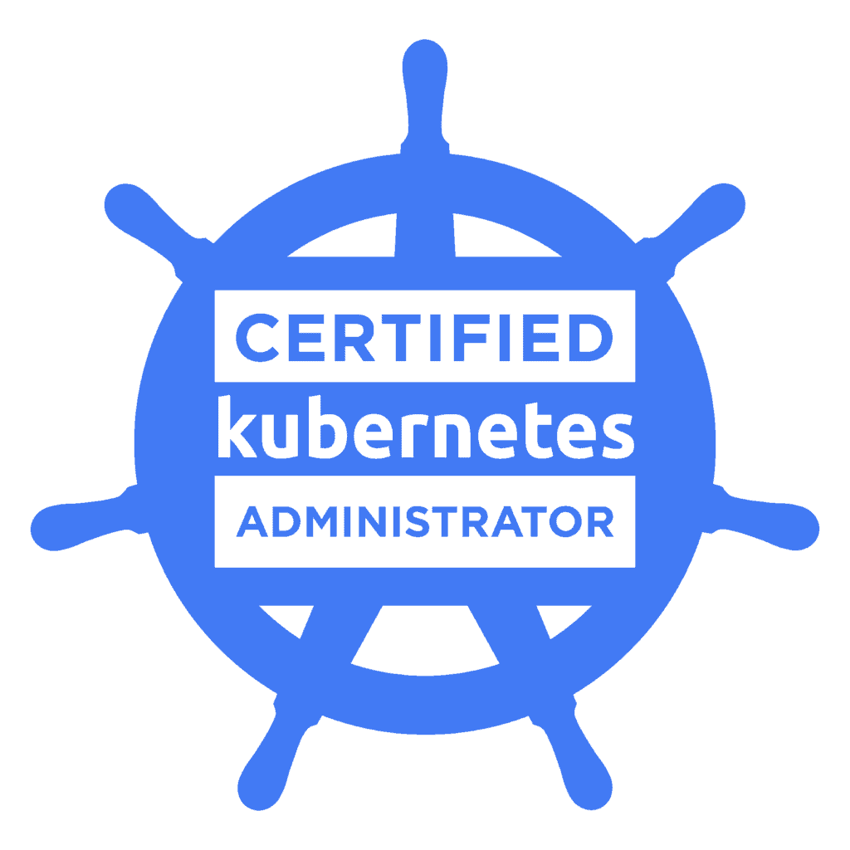
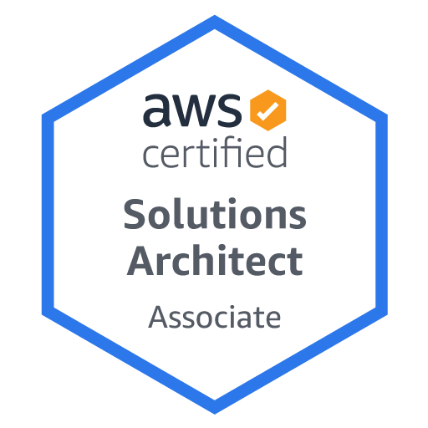
Manikanta Kumar

Sr. Aws Cloud, DevOps Engineer
Manikantakumar099@gmail.com
984-464-1238

PROFESSIONAL SUMMARY:

Over 7 years of sheer IT experience in Infrastructure Automation and Designing, Developing Hybrid cloud with strong technical Background working as Cloud DevOps Engineer.

- Designed, configured and provisioned public/private cloud infrastructures utilizing Amazon Web Services (AWS) like EC2, Elastic Load-balancers, S3, Elastic Beanstalk, Cloud Front, Elastic File System, RDS, DynamoDB, DMS, VPC, Direct Connect, Route53, Cloud Watch, Cloud Trail, Cloud Formation and IAM.
- Experienced in using cloud migration tools like Snowball and direct connect for migrating data from on-premises data centers to AWS Cloud.
- Implemented Terraform modules for deployment of various applications across multiple cloud providers and managed infrastructure.
- Excellent knowledge in Azure compute services, Azure Web apps, Azure Data Factory & Storage, Azure Media & Content delivery, Azure Networking, Azure Hybrid Integration, and Azure Identity & Access Management.
- Expertise in DevOps tools like Chef, Puppet, Salt Stack, Ansible, Docker, Subversion (SVN), GIT, Jenkins, Ant and Maven. Expertise in using Docker to containerize custom web applications and deploy them on Digital Ocean with Ubuntu instances through Swarm Cluster and to automate the application deployment in Cloud using Vagrant.
- Expertise in implementing a production ready, highly available, fault tolerant Kubernetes infrastructure. Worked on Scheduling, deploying and managing container replicas on a node cluster using Kubernetes.
- Working knowledge on Nginx for the load balancer configuration using ELB, ALB in AWS.
- Hands on experience in using GIT to synchronize with the Chef-repo, and then managed it, as if it were source code
- Experienced in writing Bash and Python scripts. Included Boto3 to supplement automation provided by Ansible and Terraform for tasks such as encrypting EBS volumes backing AMI's and Scheduling Lambda functions for routine AWS tasks.
- Skilled in various Atlassian Bug tracking tools like JIRA, Bit bucket, Bamboo, Confluence and IBM clear quest.
- Applied servers like Tomcat, Web Logic across Linux platforms as well as wrote Bash shell scripts, Perl, Python and Ruby scripts in Linux.
- Experience in implementing and administering the monitoring tool Nagios for monitoring and alerting services for servers. Implemented Cloud Watch, Splunk to monitor the log files, Network Monitoring, Log trace monitoring and the hard drive status.
- Hands-on experience using MAVEN, ANT and Gradle as build tools for the building of deployable artifacts (jar & war) from the source and static code analysis using SonarQube.
- Experience in creating Docker containers and Docker consoles for managing the application life cycle. Good knowledge on Docker components like Swarm manager for Docker swarm clusters, Prometheus server and Grafana for machine-centric monitoring as well as monitoring of highly dynamic service-oriented architectures.
- Hands on Experience on Configuring Cloud Compute systems using OpenStack on Ubuntu, collaboration using Orchestration with Keystone, Kubernetes within OpenStack
- Experience in Installing Firmware Upgrades, kernel patches, systems configuration and performance tuning on Windows/Unix systems.
- Experience in configuration of RabbitMQ, Mongo DB. Managed environments DEV, SIT, QA, UAT and PROD for various releases and designed instance strategies.
- Experienced in building REST APIs on SQL, Oracle (Relational) and NoSQL databases like MySQL, MongoDB and EMR. Deployed and scaled web applications that are developed on programming languages such as Java/J2EE, Python, Ruby, Go.
- Coordinated Kafka operational and monitoring (via JMX) with DevOps personnel, formulated balancing leadership strategies.
TECHNICAL SKILLS:

CloudEnvironment | Amazon Web Services (AWS): Azure, G.C.P
Programming Languages | C, C++, Java/J2EE
Scripting | Shell Scripting, Python, Ruby, Perl, VB Scripting, Terraform
Version Control Tools | SVN (Subversion), CVS, GIT/Stash, TFS
Configuration Management | Chef, Puppet, Ansible
CI Tools | Jenkins, Hudson, Bamboo
Build Tools | ANT, MAVEN, GRADLE
Container Technologies | Docker, Docker Swarm, Docker Compose, Kubernetes, Open Shift
Monitoring Tools | Nagios, Splunk, Grafana
Methodologies | Agile, Scrum, Waterfall, Spiral, V Model
Web/Application Servers | WebLogic, WebSphere, Apache, Tomcat, IIS, Jboss
Operating Systems | Unix/Linux (Red Hat 5/6, CentOS, SUSE), Solaris 9/10, Ubuntu 14, windows 2008 Server
Network Protocols | TCP/IP, SMTP, SOAP, HTTP/HTTPS, DNS, DHCP, NFS, SNMP, BGP, EIGRP
Databases | Oracle, MS SQL Server, MySQL, Dynamo DB, Mongo DB, NoSQL

PROFESSIONAL EXPERIENCE:

Client: J.P MORGAN CHASE , Boston, MA Sep 2019 – Current
Role: Sr. Cloud/DevOps Engineer
Description:
JPMC is one of the leading financial institutions that offer services like banking, investment and several types of loans. The project was developed with the aim of providing customers with various online features like creating new accounts, managing existing accounts, and personal or Home loan applications.

Responsibilities:
- Configured a data center with Devops team for infrastructure support on AWS cloud and designed a highly secure multi zone AWS cloud infrastructure utilizing Virtual private cloud (VPC), Public and Private subnets, Security groups, Route Table and Elastic Load Balancer.
- Created amazon Red shift cluster in a VPC for provisioning of web applications and NAT instances for successful replication of stacks and by creating data base templates.
- Implemented GCP services focusing on scaling and automation of infrastructure by creating secured subnets using GCP cloud deployment manager to balance unexpected load on servers.
- Created Python scripts to totally automate AWS services, which includes web servers, ELB, Cloud Front distribution, EC2 and Security groups, S3 bucket and application configuration, this script creates stacks, single servers, or joins web servers to stacks.
- Used Amazon Glacier for archiving data, Amazon RDS to manage, create snapshots, automate backup of database and used Route53 with failover and latency options for high availability and fault tolerance.
- Scaled web applications and services developed using Java, Ruby, Perl, Shell and Python scripts on servers like Apache, Nginx and IIS using AWS Elastic Bean Stalk.
- Worked on Terraform templates for managing the infrastructure through the terminal sessions and executing the scripts and creating alarms and notifications for EC2 instances using Cloud Watch.
- Configured Azure Backup Service for taking backup of Azure VM and data of on premise to Azure. Built and installed servers through Azure Resource Manager Templates (ARM) or Azure Portal.
- Bootstrapped instances using Chef and integrating with auto scaling. Developed Chef Recipes for automating the Infrastructure deployment process.
- Used Open Shift Enterprise and utilized HAPROXY template router for blue-green deployments on updating the applications to newer versions.
- Integrated Docker container Orchestration framework using Kubernetes by creating pods, config Maps, deployments.
- Used Docker to virtualize deployment containers and pushed the code to EC2 cloud using PCF. Built additional Docker Slave nodes for Jenkins using custom built Docker images and instances.
- Worked on Docker container snapshots, attaching to a running container, removing images, managed directory structures, and managed containers in AWS ECS.
- Responsible for implementing user activity reporting modules and log analysis using Elastic search, Log stash and Kibana stack.
- Installed, configured and managed Ansible server and wrote playbooks to configure various middleware application servers and to automate repetitive tasks.
- Developed automation scripts in YAML using Ansible to deploy and manage Java applications across Linux servers.
- Experienced on Ansible and Ansible Tower as Configuration management tool, to automate repetitive tasks, quickly deploys critical applications, spin-up nodes in AWS and proactively managing changes using Ansible Playbooks.
- Designed the project workflows/pipelines using Jenkins for Continuous Integration and deployment into different Web/Application Servers.
- Used Maven dependency management system to deploy snapshot and release artifacts to Nexus, share artifacts across projects.
- Managed code by maintaining code repository in GIT (Bit Bucket) improved practices of branching and code merge to custom needs of development team.
- Built, Deployed, Configured, Managed SPLUNK Cloud instances in a distributed environment which spread across different application environments belonging to multiple lines of business.
- Created alerts to notify system outages or reaching threshold values. These alerts include Splunk license threshold limit, syslog server threshold limit, file system overflow and cold storage outage.
- Monitored and applied analysis using Nagios, Splunk. Used JIRA for bug tracking and creating the dashboard for issues.

Environment: AWS, Azure, G.C.P, Terraform, Cloud Formation, Docker, Kubernetes, Open Shift, Chef, Ansible, Nagios, Splunk, Oracle, MSSQL, EC2, IAM, S3, VPC, Cloud Watch, ELB, SNS, GIT, GitHub, Maven, Jenkins, Python, Perl, Shell, Jboss, Tomcat.

Client: Liberty Mutual Insurance, Dover , New Hampshire May 2018 – Sep 2019
Role: Sr. Cloud/DevOps Engineer
Description:
Liberty Mutual is an online insurance quoting and policy application, which enables customers to quote an insurance coverage policy through web. This application delivers online services including customer information, policy premium, and monthly payments, new product offerings and customer correspondence with the company. Auto insurance laws may vary from one state to another.

Responsibilities:

- Created Python Scripts to automate AWS services includes web servers, ELB, Cloud front Distribution, database, EC2 and database security groups, S3 bucket and application configuration, this script creates stacks, single servers or joins web servers to stacks.
- Involved in migration from current data center to Azure cloud and used SQL Azure for backend operations and data persistence.
- Responsible for multiple AWS instances, set the security groups, Elastic Load Balancer and AMIs, auto scaling to design cost effective, fault tolerant and highly available systems.
- Implemented Micro-services using Pivotal cloud foundry platform build upon Spring Boot Services.
- Wrote chef cookbooks using several of its components like attributes, files, recipes, resources and templates and configured recipes and cookbooks to install and configure on several servers.
- Used Ansible to manage web applications, environments configuration Files, users, Mount points and Packages.
- Migrated present Linux environment to AWS by creating and executing a migration plan, deployed EC2 instances in VPC, configured security groups & NACL’s, attached profiles and roles using AWS Cloud Formation templates and Ansible modules.
- Configured Ansible to manage AWS environments and automate the build process for core AMIs used by all application deployments including Autoscaling, and Cloudformation scripts.
- Designed and distributed private cloud system solution using Kubernetes on CoreOS and used it to deploy scale, load balance and manage Docker containers with multiple name spaced versions.
- Used Docker to containerize custom web applications and deployed on Digital Ocean with Ubuntu instances through Swarm Cluster and automated application deployment in cloud using Docker Hub, Docker Swarm, and Vagrant
- Deployed and configured Elastic search, Log stash and Kibana (ELK) for log analytics, full text search, application monitoring in integration with AWS Lambda and Cloud Watch.
- Used AWS Beanstalk for deploying and scaling web applications and services developed with Java, Python, Ruby and docker on familiar servers such as Apache, IIS.
- Configured 'nginx' for proxying and created REST API's for calls to micro-services in docker containers.
- Configured network and server monitoring using Grafana, ELK Stack with Nagios for notifications.
- Built end to end CI/CD Pipelines in Jenkins to retrieve code, compile applications, perform tests and push build artifacts to Nexus and Deploy to orchestra changes across servers and components.
- Worked with version control tools Git for branching and merging strategies. Migrated projects from Subversion repositories to GitHub Enterprise repositories.
- Worked with administrators to ensure Splunk is actively and accurately running and monitoring on the current infrastructure implementation.
- Debugged Chef Recipes and their execution trying to pull logs into Splunk and monitor deployments. Worked on user administration setup, maintaining account, monitor system performance using Nagios and Splunk.
- Developed Ant and Maven scripts to automate the compilation, deployment, and testing of Web and J2EE applications.

Environment: Azure, AWS, CHEF, Ansible, Linux, Maven, Ant, Jira, Docker, Kubernetes, Terraform, Nagios, Splunk, PowerShell, Bitbucket, Bash, Ruby, python

Client: Wellmed Medical Management, San Antonio, Tx Jan 2017 – March 2018
Role: Devops Engineer
Description:
Wellmed medical management has chemical and physical laboratory capability to perform evaluations to assure products are used in applications to sustainable ways possible, accepts the responsibility to support both external clients and internal management. Broad understanding of healthcare data like claims clinical data quality metrics and health outcomes. Capable of analysing problems and designing recommendations including workflows processes and procedures.

Responsibilities:

- Installed Chef Server and chef clients to pick up the build from repository and deploy in target environments. Created chef Cookbooks using recipes to automate build with development pipeline.
- Designed highly available, cost effective and fault tolerant systems using multiple EC2 instances, Auto Scaling, Elastic Load Balance and AMIs.
- Worked at optimizing Volumes and EC2 instances and created multiple VPC instances.
- Continuously managed and improved the build infrastructure for global software development engineering teams including implementation of build scripts, continuous integration infrastructure and deployment tools.
- Experience on configuring S3 versioning and lifecycle policies to backup files and archive files in Glacier.
- Used Ansible to manage systems configuration to facilitate interoperability between existing infrastructure and new infrastructure in alternate physical data centers or cloud (AWS).
- Used Ansible to Setup/teardown of ELK stack (Elasticsearch, Logstash, Kibana) and troubleshoot the build issues with ELK and work towards the solution.
- Implemented new projects build framework using Jenkins & maven as build framework tools.
- Installed, configured and maintained web servers like HTTP Web Server, Apache Web Server on Red Hat Linux.
- Experienced in Continuous Integration (CI) and Continuous Deployment (CD) using Jenkins.
- Experienced in writing Puppet manifests to automate configuration of a broad range of services. Used Puppet server and workstation to manage and configure nodes.
- Prepared projects, dashboards, reports and questions for all JIRA related services. Generated scripts for effective integration of JIRA applications with other tools. Configured plugins for the integration tools to the version control tools.
- Worked with development, testing, deployment, infrastructure and project teams to ensure continuous operation of build and test systems.
- Branched and merged code lines in the GIT and resolved all the conflicts raised during the merges.
- Highly skilled in the usage of data center automation and configuration management tool such as Docker.

Environment: AWS, S3, EBS, Elastic Load balancer (ELB), Auto Scaling Groups, VPC, IAM, Cloud Watch, Jenkins, Maven, Subversion, Ant, Bash Scripts, Git, Docker, Jira, Chef, Puppet.

Client: Entergy New Orleans, LA Nov 2015 – Dec 2016
Role: Build & Release Engineer
Description:
Entergy offers an incomparable supply chain service to shippers throughout North America. Entergy believes in doing the right thing, every time. Entergy exists to bring a better experience to the logistics industry and is one of the fastest-growing transportation and logistics service providers in North America.

Responsibilities:

- Installed and configured Puppet master, agent nodes and an admin control workstation. Performed analyzation of Puppet by writing manifest modules.
- Hands on experience with puppet manifests for deployment and automation. Integrated Puppet with Jenkins to fully deploy on to a Jenkins server to provide with continuous deployment and testing to automate deployment of infrastructure.
- Wrote GRADLE, MAVEN Scripts to automate build processes and managed MAVEN repository using Nexus Tool and used the same to share snapshots and releases.
- Wrote Shell scripts for automation and documenting the changes that happen in the environment by analysing the user logs in each server,
- Expertise in using build tools like ANT, MAVEN and Gradle for the building of deployable artifacts such as war from source code in a J2EE application.
- Integrated GIT into Jenkins to automate the code check-out process. Added storage to the cluster disks and increasing/ decreasing the file system in RHEL.
- Expertise with GIT as source code management tool for creating the local repo, cloning the repo, adding, committing and pushing the changes in the local repo.
- Extensively worked with branching and merging strategies, creating baselines and releasing the code
- Experienced in writing Shell scripts, Ruby scripts, Perl scripts and maintain virtualization of environments using Vagrant, VM ware.
- Experience in Branching, Merging, Tagging and maintaining the version across the environments using SCM tools like GIT and Subversion (SVN) on windows and Linux platforms.
- Responsible for creating and managing user accounts, security groups, disk space, process monitoring in Linux/Unix.

Environment: GIT, SVN, Jenkins, Shell scripts, Python scripts, Perl scripts, Ruby scripts, VM ware, Vagrant, Maven, Ant, Puppet.

Client: Echo Star, Suwannee, Georgia August 2014 – Oct 2015
Role: Linux Administrator
Description:
EchoStar Corporation is an American company, a worldwide provider of satellite communication and Internet services through its Hughes Network Systems and EchoStar Satellite Services business segments. I performed changes on the servers on various environments, granted Sudo Access and group access.

Responsibilities:

- Worked on virtual and physical Linux hosts, involving in every day administrative activities such as maintaining user accounts, password management, providing advanced file permissions to specific users.
- Monitored Linux/Unix Servers for user administration and hardware failure. Monitoring log files, backup, software patching, configuration changes and documentation.
- Wrote Bash, Perl, Python, Shell scripts to setup various automated tasks, for checking logs and disk usages by pinging the servers through Web sphere mapping users to the boxes.
- Performed troubleshooting and monitoring servers using Uptime, Net stat, Top, free, VStat, IOstat, and SAR and scheduled various regular, periodic, future and queue tasks by using Crontab.
- Used ANT and Python scripts to automate the Build and deployment process. Used Maven few modules for creating build artifacts like war or ear files.
- Experience in software build tools like Apache Maven, Apache Ant to write pom.xml and build.xml respectively.
- Installed and administrated TCP/IP, NFS, DNS, NTP, Auto mounts and sent mail, print servers as per the client's requirement.
- Managed various file system using Logical Volume Manager (LVM), VERITAS Volume Manager (VVM), VERITAS File System (VFS) and Solaris Volume Manager (SVM).
- Managed and shared NFS files system through mounting and unmounting NFS server, NFS client on remote machine, shared remote file folder, started and stopped the NFS services.
- Wrote Shell scripts for automation of daily tasks by documenting the changes that happen in the environment in each server where in analysing the error logs, User logs and the /var/log/messages.
- Coordinated with different project teams on Build & release planning and efforts. Responsible for nightly and weekly builds for different modules.

Environment: Linux(RHEL), Solaris, VMware, Bash, Perl, Web Apache, DHCP, FTP, Active Directory, ANT, Maven, NFS Server, HP Open View, UNIX.

Client: OPTUM, Chennai, India May 2013 – August 2014
Role: Linux Administrator

Description:
I have been the core member of the professional service team that manages customer applications that allows members to fulfill their benefit desires and provide easy way to manage their accounts.

Responsibilities:

- Created users, manage user Administered, maintained Red Hat AS, ES, Troubleshooting Hardware, Operating System Application & Network problems and performance issues. Deployed latest patches for, Linux and Application servers, Performed Red Hat Linux Kernel Tuning.
- Experience in implementing and configuring network services such as HTTP, DHCP, and TFTP.
- Install and configure DHCP, DNS (BIND, MS), web (Apache, IIS), mail (SMTP, IMAP, POP3), and file servers on Linux servers.
- Successfully installed and configured NAGIOS monitoring system to monitor the production server environment.
- Create file transfer server for customer data exchange and automated network permissions, maintained User & File System quota on Redhat Linux.
- Worked with DBAs on installation of RDBMS database, restoration and log generation. Installed and set up Oracle9i on Linux for the development team.
- Experience with writing basic bash shell scripts to automate processes using crontab, install and upgrade software.
- Experience in managing and expanding file systems, administer and provision storage on different flavours of Linux servers.
- Replaced major manufacturer's vulnerable network with robust security through joint architecture of firewall and DHCP.
- Wrote Shell scripts for automation of daily tasks, documenting the changes that happen in the environment and in each server, analysing the error logs, analysing the User logs, analysing the /var/log/messages.
- Configuring the systems for TCP/IP networking with existing LAN, setting up SSH and SCP features between SUN systems and other UNIX hosts.

Environment: RedHat Linux, TCP/IP, SSH, UNIX, Shell Scripts, DHCP, Nagios, DBA, RDBMS, Oracle, DHCP, DNS, SMTP, IMAP, POP3, Http, TFTP.

Education:
Master’s in computer science, California.

