Ranjit Pallerla
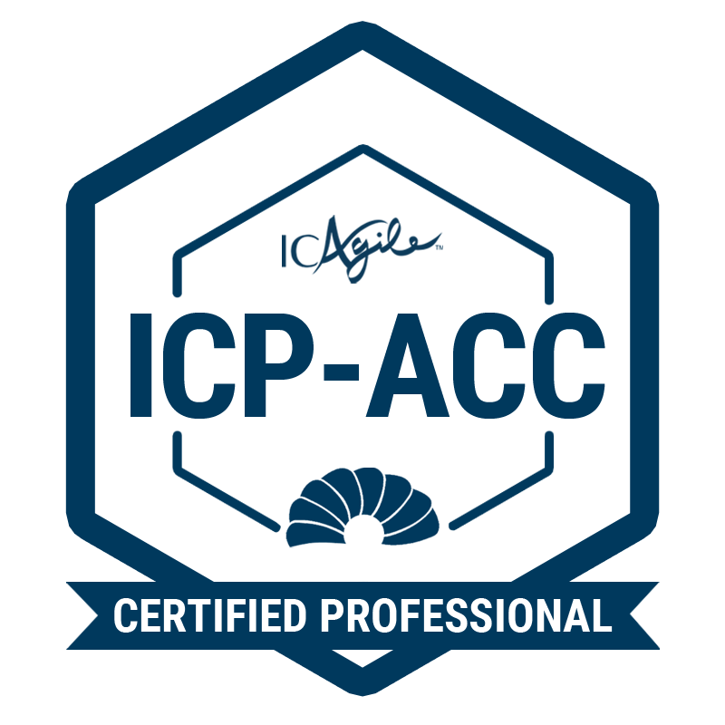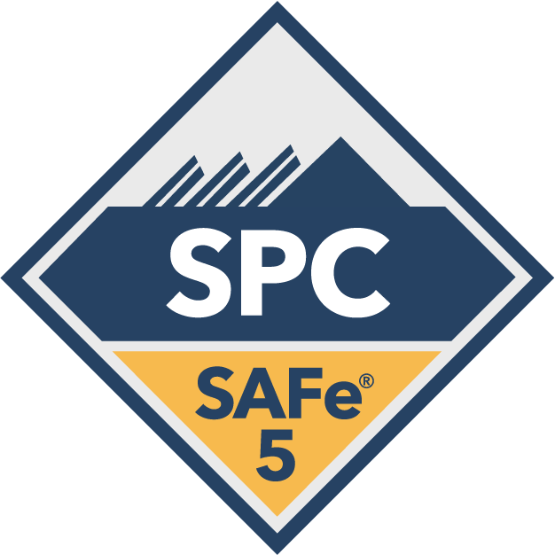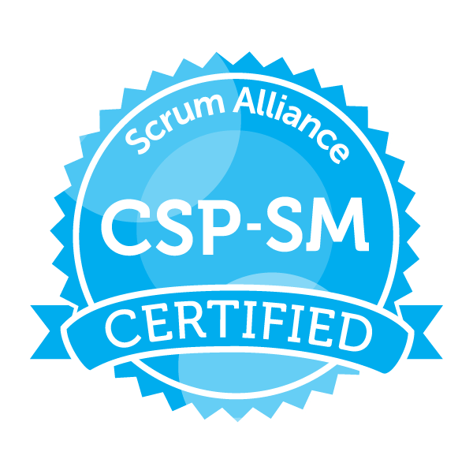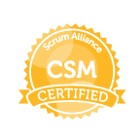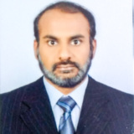
E-Mail:ranjitpallerla@gmail.com Location: Hyderabad Cell #: +918374898866
--------------------------------------------------------------------------------------------------------------------------------
Career spanning around 17 years in IT industry
ICAgile certified Agile coach/SAFe Program Consultant(SPC 5.0) skilled in handling Agile program management & project management and Agile/Scaled Agile Transformation engagements

- As a Certified Agile Coach/SAFe Program Consultant with around 9 years in handling Agile projects by facilitating PI Planning, daily scrum, Sprint planning, Sprint review/System demos, Inspect & Adapt /Retrospective meetings for Scrum and ScrumBan, collaboration with Business Leaders/RTEs/ Product owners and Development team
- Over six years of experience as Scrum Master and two years of experience as Agile Coach
- Over two years of solid experience in Scaled Agile Framework (SAFe)
- Active member of LACE (Lean Agile Center of excellence) in current organization and been part of Organizations transforming to Agile by delivering trainings/conducting workshops
- Experienced in various models like Agile and Scaled Agile frameworks: Scrum/Kanban, Iterative, Waterfall and RUP software development methodologies
- Safeguard Development team from outside distractions, help eliminate impediments or team conflicts, and maintain focus on the sprint goal
- Work closely with product owner in backlog management (grooming, prioritizing) and continuous delivery of features
- Suggest and Setup frameworks, Agile metrics & dashboards; designed communication protocols, reporting formats and dashboards
- Worked with Leadership/Stakeholders in understanding and persuading them towards Agile adoption and implementation
- Ensured all the Retrospective items are tracked to logical closure by coordinating with different levels of Leadership/Management/other teams
- Analyze current state of Agile practices and suggest improvement plans
- Expertise in onboarding new teams into Agile projects, train and encourage them towards Lean-Agile thinking and foster continuous improvement
- Coach teams in adopting engineering practices like Pair Programming/Continuous Integration/Refactoring/Test Driven Development/Collective Code ownership etc
- Setup Work-In-Progress limits, setup explicit policies, Metrics for Kanban and ScrumBan teams
- Build/Configure/Manage Scrum, ScrumBan and Kanban dashboards in JIRA
- Analyze and track Burndown charts, Sprint Reports, CFDs and Kanban reports to make informed decisions
- Monitored project status by collecting metrics at each phase and expertize in performing Root cause analysis/5-WHY techniques and Value Stream Mapping
- Resource Management /Performance Management including Mentoring and guiding team members, conduct performance appraisals, regular one-on-ones
- Demonstrated ability to easily transcend cultural differences; multi-cultural work exposure with multiple IT service companies and clients located across USA, Canada and India. Has multiple onsite visits experience and dealing with customers directly
- Adept at handling remote teams viz: Onsite-Offshore models
- Good Knowledge and understanding of client/server, web-based applications built on SharePoint, .Net, Java platforms and cloud based, technical know-how in MongoDB, SQL Server, Oracle databases
- Good Knowledge on Devops methodology with hands-on experience on implementation and integration of CI/CD tools ex: Git, maven, Jenkins, chef etc and Confluence

Significant Certifications achieved and trainings undergone:
- SAFe Program Consultant 5.0 - CERTIFICATE ID: 90037868-0533
- ICAgile Certified Agile Coach (ICP-ACC)
- Certified SAFe Agilist (SA)
- Certified Scrum Master (CSM)
- Certified Scrum Professional – Scrum Master (CSP-SM)
- Agile Certified Practitioner(PMI-ACP) training in Nov 2017
- Project Management Professional (PMP) training in Oct 2014
- Kanban and DevOps Transformation training in Deloitte University in Jan 2013

Work Experience:
- Currently working with UST(previously Cotiviti) Hyderabad as Agile Coach/Scrum Master from April 2019
- Worked as Rimini Street as Agile Consultant from SDB Systems and Solutions since Oct 2017 to April 2019
- Worked as Agile Project Manager in EPAM systems India Pvt Ltd.(formerly Alliance Global Services) From Aug 2015 till June 2017
- Worked as Project Manager in Deloitte Support Services Pvt Ltd. From Sep 2011 till Oct 2014
- Worked as Test Manager in Planetsoft Pvt Ltd,(Currently known as EBIX) Hyderabad from Oct’ 07 till Aug’11
- Worked as Test Lead in AztecSoft Ltd (Currently known as Mindtree) Hyderabad from Aug’04 till Sep’07
- Worked as a Senior Software Engineer in Netkraft Pvt Ltd., (Currently known as Adea Solutions) Bangalore from May ’03 to Aug’04

Achievements/Accolades:
- Received Monthly employee Award at Cotiviti for June 2020
- Awarded “Applause”, “GTS Spot light award” in the area of ‘Operational Excellence’ for leading Test Automation for four products in Deloitte
- Awarded “Star Performer” for demonstrating exceptional contribution and commitment towards success in Planet Soft
- Received the “The Big Pat on Back” award for consistently exceeding management expectations throughout the year displaying superlative skills in my area of expertise and upholding the core values of company in AztecSoft
- Awarded Best Employee in Netkraft Pvt Ltd. in November’2003 for going beyond the expectations and winning Customer appreciation.

Project Experience:

Cotiviti and Riministreet

Responsibilities:
- Agile Coach/Scrum Master for PMT and Annocoder teams
- Conducted SAFe POPM (Product Owner Product Manager) and Agile/Scrum/Kanban/ScrumBan/JIRA trainings internally for Cotiviti and Riministreet for Product Owners and Development teams
- Leads Scrum Master Community of Practice (COP) and ensure best practices are shared and leverage the knowledge across organization
- Worked closely with Business Leaders/RTEs/Product Manager/SharedServices teams during PI Planning and execution
- Has led Agile teams in around seven PI Planning events and with a PPM(Program Predictability Measure) of over 90% consistently in all Program Increments (PI)
- Diagnose current state of Agile practices, and suggest improvement actions
- Worked with the Product owner on Artifacts such as Release backlog, Sprint backlog and User Story Breakdown
- Arranged daily stand-up meetings, facilitate meetings, schedule meetings, demo and decision-making processes in order to ensure quick inspection and proper use of adaptation process
- Work with RTEs/SMs by participating in Scrum of Scrum calls and bring traction to the Risks/Issues/concerns etc
- Worked with Product Management team to prioritize the requirements for the Release/Sprint and helped them split the User stories
- Worked with Development team to self-organize and practice Autonomy
- Worked with Agile Coach/fellow scrum masters and share best practices /challenges/learnings
- Involved in resolving team impediment/risks and helping in eliminating them
- Conducted various Agile related trainings/workshops for internal teams in the Organisation
- Worked with Leadership in understanding and persuading them towards Agile adoption/transformation
- Ensured all the Retrospective items are tracked to logical closure by coordinating with different levels of Leadership/Management/other teams
- Coach teams towards Lean-Agile thinking/Kanban principles/XP practices/CI-CD adoption
- Setup Work-In-Progress limits , setup explicit policies for Kanban team
- Build/Configure/Manage Scrum and Kanban dashboards in JIRA
- Trained multiple team members on Scrum Master roles/responsibilities
- Conduct monthly Scrum Refresher/Kanban Refresher/JIRA trainings and workshops to the Labs team
- Collaborate with Tools team(JIRA team etc) to fix issues with JIRA implementation
- Track the impediments along with details like Aging/dependency etc on Confluence Page
- Share best practices and provide suggestions/solutions to the points raised in Agile COP meetings
- Anchoring the Combined Sprint Review meeting and ensure the teams prioritize their completed items and provide demo to the Stakeholders

EPAM Systems India Pvt. Ltd.

Responsibilities:
- Agile Coach/Scrum Master for AmeriGas and EDMC applications
- Defined and Implemented Agile dashboards(Scrum and Kanban) using JIRA
- Managed multiple scrum and Kanban teams concurrently
- Work with the Product owner on Artifacts such as Product backlog, Sprint backlog and User Story Breakdown
- Worked with Product owner/PPO/BA to prioritize the requirements for the Release/Sprint
- Help team self-organize and practice Autonomy
- Involved in resolving team impediment/risks and helping in eliminating them
- Conducted various Agile related trainings/workshops for internal teams in the Organisation
- Worked with Leadership in understanding and persuading them towards Agile adoption
- Ensured all the Retrospective items are tracked to logical closure by coordinating with different levels of Leadership/Management/other teams
- Encouraged teams towards Lean-Agile thinking and Kanban principles
- Setup Work-In-Progress limits , setup explicit policies for Kanban team and measure Lead time/cycle time etc
- Build/Configure/Manage Scrum and Kanban dashboards in JIRA
- Work closely with SQA team(Process team) to identify and implement right Agile Metrics suitable for the projects
- Monitor and Control the billing(cost) hours using PMC tool and review them before sending to Account Manager/Customer for approval
- Presenting Delivery status Dashboard to Leadership team on a weekly basis highlighting the status of the projects and risks
- Presenting Quarterly Business Review decks to the Customer highlighting the progress of the projects

Deloitte Support Services India Pvt. Ltd.

Responsibilities:
- Agile Project Manager/Scrum Master for multiple projects under Consulting Program
- Facilitate Sprint planning, Daily Standup, Sprint review and Sprint retrospective and product backlog refinement meetings
- Involve in Scrum of Scrums for projects involving multiple subarea teams
- Work with the Product owner on Artifacts such as product backlog, sprint backlog and User Story breakdown
- Work with Product owner/BA to prioritize the requirements for the Release/Sprint
- Enable team to self-organize and practice Autonomy
- Provide visibility to team impediment/risks and helping in eliminating them
- Ensure feedback from the Sprint Reviews are discussed/incorporated in upcoming Sprints
- Ensure all the Retrospective items are tracked to logical closure by coordinating with different levels of Leadership/Management/other teams
- Keep the team together all the time to ensure successful sprints
- Encouraged and trained teams towards Lean-Agile thinking and Kanban principles
- Encouraging the team to come up with reusable components and use the best practices
- Build/Configure/Manage Scrum and Kanban dashboards in JIRA
- Setup Work-In-Progress limits , setup explicit policies for Kanban team and measure Lead time/cycle time etc
- Radiating the progress of the team and ensuring that they are highly visible to the product owner and stakeholders
- Been active part of the Agile and DevOps transformation of GTS division
- Been part of Pilot projects for DevOps that were run on Google Cloud Platform
- Setting up Contractors team of 11 in Global Technology Services(GTS) team
- Integration of GIT/Maven/Jenkins with Automation tool

Educational Qualification:
- Bachelor of Technology(B.Tech) in Electronics & Communications Engineering from Nagarjuna University(Acharya Nagarjuna University ) Bapatla, Andhra Pradesh in First Division

