Sarfaraz Siddiqui SFDC Developer

+91-9867039406

[Sarfarazsiddiqui1994@gmail.com](mailto:Sarfarazsiddiqui1994@gmail.com)

 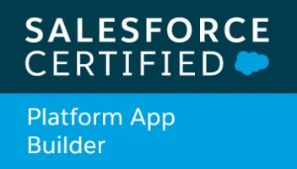  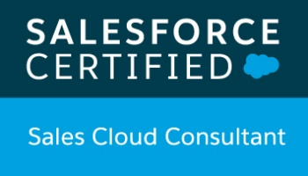

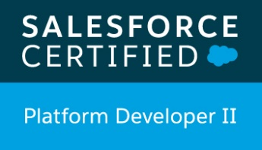

**Summary**

* Has 3.9 years of total IT experience with 2.5 year’s hands on experience in SFDC.

Salesforce Force.com App Builder.

* Efficient domain knowledge and skill set to customize Salesforce CRM applications, Salesforce Sales cloud, Reports, Dashboard, Data loader.
* Experience in Salesforce configuration, Apex, Visualforce, Lightning Aura framework.
* Performed administration tasks such as creating Profiles, Permission Sets, defining fields, maintaining pick list values, maintaining users, roles, security, profiles, workflow rules, sharing settings etc.
* Experience in developing Lightning Components, configuring flexi Pages from Lightning App Builder.
* Hands on experience in REST Web services for Product and Customer Integration.

**Certifications**

* Salesforce Administrator I
* Salesforce Platform App Builder
* Salesforce Platform Developer I
* Salesforce Sales Cloud Consultant
* Salesforce Platform Developer II

**Employment Details**

|  |  |  |
| --- | --- | --- |
| Organization | **Position** | **Duration** |
| Tata consultancy Services Ltd. | System Engineer – SFDC | Oct-2016 to Till Date |

**Education**

|  |  |  |  |
| --- | --- | --- | --- |
| Degree and Date | **University** | **Institute** | **Major and Specialization** |
| Bachelor of Engineering in Electronics & Telecommunication 2016 | Mumbai University | Vidyalankar IOT Wadala | EXTC |

**Technology**

|  |  |
| --- | --- |
| **Business Area** | CRM, Salesforce (PAAS), Salesforce Sales cloud, SAP DBMS |
| **CRM** | Salesforce.com, SAP.com |
| **Languages** | Apex, Visual Force, Lightning Aura Framework, Java Script, Linux Shell |
| **Database(s)** | Salesforce Database, HANA, SYBASE, MAXDB, DB2, ORACLE, MSSQL |
| **Tools** | Developer Console, IntelliJ IDEA with Illuminated Cloud, Data Loader, Workbench, Visual Studio Code with SFDX, GitHub, Gear Set, MS Office |

**Assignments**

|  |  |
| --- | --- |
| **Customer** | US based B2B multinational Adhesive and Label manufacturer and distributor company |
| **Project** | Support, Enhancement and Development for Salesforce as per client requirement and my role change. |
| Period | Apr-2018 to till now |
| Description | Client has well known presence in manufacturing and distributing adhesive materials, apparel branding labels and tags. It provides pressure-sensitive adhesive materials, Labels and Tags worldwide. |
| Role & Responsibility | **Salesforce Developer**   * Develop Lightning component using Aura Framework, writing Apex Classes and configuring flexi Pages from app builder as per requirement. * Implemented Rest Web services based Inbound Integration for product and Customer information. * Implement Apex Classes, Apex Triggers, custom settings and custom metadata to achieve customization related requirements. * Implement Batch, Scheduled, @future and @Invocable Apex class as per requirement. * Implement Visualforce pages as per the requirement. * Worked on configuration like Custom Objects, Custom Fields, formula, page layout, Translation Workbench and creating custom Repot Types. * Configure Sharing Settings, Profiles, Permission Sets, Roles, Public Groups. * WF Rules, Process builder, Approval process, Validation Rules, Assignment rules, Escalation Rules, Email Alert, Email Template, HTML Template, VisualForce Email Template. * Involved in uploading Customer’s data in CRM application, Product update, PricebookEntries update, opportunity deletion,   Updating Multicurrency Rates, Activate/deactivate user, create and Enabling community user and upgrading Managed Package Application like B2B Commerce (Cloud Craze).   * Involved in refreshing sandbox for SIT, UAT, Pre-Prod Environment from Production. * Bug fixing and debugging the code. * Handling Change Requests. * Deployment using Change sets, GitHub and Gear Set. |
| Tools | Salesforce CRM, IntelliJ IDEA with Illuminated Cloud, Data Loader, Workbench, Visual Studio Code with SFDX, GitHub, Gear Set. |

|  |  |
| --- | --- |
| **Customer** | Germany based multinational CRM company |
| **Project** | SAP-Internal |
| Period | Jan-2017 to Mar-2018 |
| Description | Client has well known presence in ERP solution industry. We were maintaining Databases for various clients. We were configuring backup, scheduling backup, restored file systems, Restore Databases systems, apply patch for multiple databases like HANA, SYBASE, DB2, MAXDB, ORACLE, MSSQL. |
| Role & Responsibility | **SAP Database Management**   * Creating backup/restore Client and connecting to Data Domain Server. Allowing access for To-and-Fro Transfer of data from one system to another. * Configuring File system backup for Linux, Windows and SunOS based system. * Configuring Database backup (Single or Multi-tenant) for Databases like HANA, SYBASE, DB2, MAXDB, ORACLE and MSSQL. * Scheduled backup using Cron configuration for Linux and Windows based Databases. * Restoration of File based system with its data from data domain of SAP to the required timestamp from the Data Domain. * Restoration of Databases from data domain of SAP when it gets down to its required timestamp using Data stored from Data domain and its offline log as well as Online log. * Cross platform restoration of file system as well as database. * Have done Automation of backup installation for various databases like HANA, SYBASE, DB2, MaxDB using shell script. * Bug fixing and applying the required patch for the new version of databases. * Handling Change Requests. |
| Tools | Putty, Remote Desktop Connection, SAP Internal Tools like BWI, MS Office |

**Personal information**

Date of birth: 07-Nov-1994

Marital status: Single

Language known: English, Hindi

Nationality: Indian

Present address: Sangharsh Nagar, Andheri East,

Division: Mumbai North East, Dt: Mumbai,

State – Maharashtra, INDIA.

Pin: 400072

**Declaration**

I hereby declare that all the above information is true to the best of my knowledge.

Place: Mumbai Date: 12-09-2020