Aurobroto Choudhury

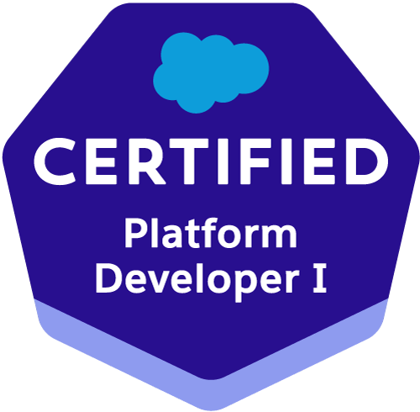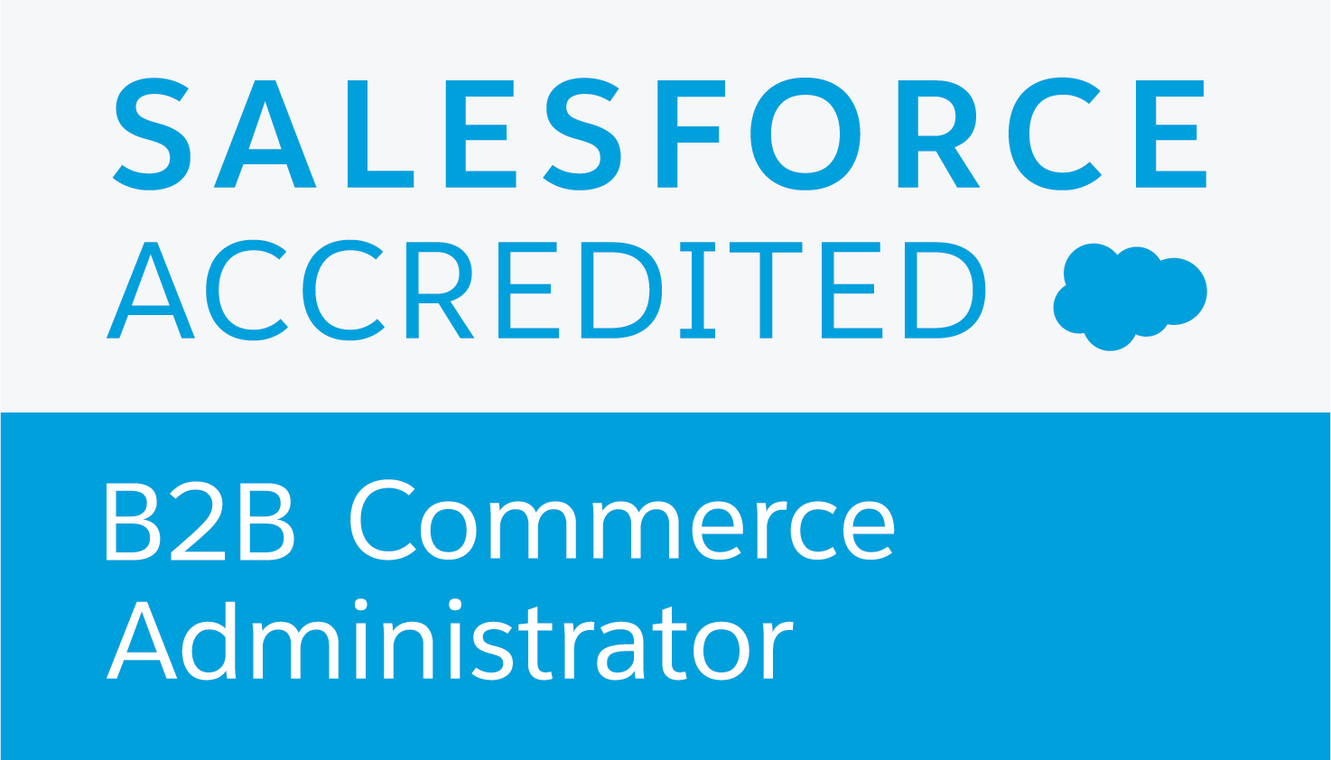

Contact: (+91) 9903274229 (M) E-Mail: auro.sfdc@gmail.com

Passport No: J7591112
Seeking assignments in Software Development with a growth oriented organisation

Preferred Location: Bangalore

Professional Synopsis
- A dynamic professional with more than 13 years of experience in Software Development with SFDC (Salesforce), Java and J2EE . Expertise in B2B Commerce(Cloudcraze), Apex, Visual Force, triggers, Handlebar js and Backbone js.

- Salesforce Certified Platform Developer I

- Salesforce Accredited B2B Commerce Admiistrator
- Presently associated with HCL Technologies Pvt. Ltd., Bengaluru as a Technical Lead.
- Adept in end-to-end development of application from requirement analysis to system study, designing, coding, testing and de-bugging.
- Proficient in grasping new technical concepts and utilising them in an effective manner.
- Possess a clear understanding of software development life cycle.
- An effective communicator with excellent relationship building & interpersonal skills. Strong analytical, problem solving & organisational abilities.

Organisational Experience
HCL Technologies | September 2013 - present
Labvantage Solutions Pvt. Ltd. | July 2011 – September 2013
PricewaterhouseCoopers | March 2011 - July 2011
Techna Digital Services Pvt. Ltd | July 2010 – March 2011
Aunwesha Knowledge Technologies Pvt. Ltd. | April 2008 - June 2010,

KEY DELIVERABLES

Technical
SFDC : Apex, Visual Force, S-Controls, APEX/Trigger development.
JavaScript Frameworks: Jquery, Backbone build on node.js, Angular JS
Databases : Oracle 10.2,MS SQL Server 2005/2008,MySQL 4.x/ 5.x., IBM DB2
Other Tools : ServiceNow, JIRA, HP ALM
Functional

Release Management

System Analysis

Software Development
- Release Management, Change Mangement, attending CAB meetings
- Interacting with client for requirement gathering, system study & analysis.
- Designing, developing, testing, troubleshooting & debugging of applications.
- Providing the post-implementation, enhancement and maintenance support to client for application.
- Participating dynamically in team’s various phases of application development.

Project Executed
Title : OSRAM AMS B2B Implemetation
Organisation : HCL Technologies.
Position : Technical Lead.
Technology : SFDC, B2B Commerce(CloudCraze), JQuery, Handlebar js, Backbone js ,Apex, VisualForce, Triggers, Components
Description : Implemetation of B2B Commerce cloud.

Highlights
- Attending daily client meetings and gather requirements.
- Working on development of new enhancements/ change requests and tracking the same in JIRA

Project Executed
Title : DB Private Wealth Management (ADM_ PWM IT US_L3 Maintenance)
Organisation : HCL Technologies.
Position : Technical Lead.
Technology : SFDC, Apex, VisualForce, S-Controls, Triggers, Workflows, Components
Description : DBForce-PB application is used for Customer management, sales, marketing, workflow and hold mail application (only for PWM) to support the US Onshore private wealth management business and Asset Management. It uses Salesforce.com core features to maintain Leads, Customers, Contacts, Cases and Opportunities. It also uses custom modules to maintain KYC for clients/potential clients and to process banking transaction requests with complex approval processes.

Highlights
- Attending daily client meetings and gather requirements.
- Working on development of new enhancements/ change requests and tracking the same in JIRA
- Release and Deployment Management activities, creating Change Tickets in ServiceNow, attending CAB meetings, liaison between various teams involved in release activities, preparing and collating documents for release.

Title : SOS Services Web for Caterpillar Inc.
Organisation : HCL Technologies.
Position : Senior Developer.
Technology : SFDC, Apex, VisualForce, Java Spring Rest WS, javascript, Backbone JS, JQuery
Description : SOS Services Web(SOSSW) is a Salesforce based web application being used by the CAT dealers, customers and internal CAT users to find information regarding their equipment, and lookup sample related information being generated in the SOS Labware system. They can also compare data, generate graphs, trend charts and Reports. The SOSSW app is integrated with the Labware product using a Java application as a middle layer and making use Restful Web Services. The view portion is entirely customized for CAT using Backbone JS. The users can also generate Samples for their equipment and generate Barcode Labels for the same.
Highlights
- Attending daily client meetings and gather requirements.
- Developing new functionalities using Apex code, VisualForce, Backbone JS and Java Web Services.
- Built Visual Force Pages, embedded JavaScript into VF pages.
- Built js pages using backbone.js framework build on node.js.
- Involved in consuming web services using Restful API.
- Enhancing existing features.
- Fixing bugs on existing features.
- Migrating data from Labware Database to Salesforce.
- Provide solutions to improve application performance.

Title : Quest Diagnostics Specimen Management System (QDSMAS)
Organisation : HCL Technologies.
Position : Senior Developer.
Technology : Sapphire Framework, Oracle 10.2, JBOSS
Description : Worked on Release 3.1.1 to develop a functionality to generate adhoc and monthly reports for specimens billed during a specific period and filtered according to Study and Sponsor.
Highlights
- Coding to generate the functionality using Oracle PL/SQL and java.
- Configuration in Saphhire to create web pages and writing javascript validations.

Title : GSK LIFT
Organisation : LabVantage Solutions.
Position : Associate Solution Engineer.
Technology : Sapphire Framework, Oracle 10.2, Websphere 6.1
Description : The LIFT (Laboratory Information for Tomorrow) project looked to put in place a centralised architecture with LabVantage’s Sapphire LIMS as the central platform installed at GSK house in the UK. In order to aggregate the data and harmonise it in a common format, GSK employed Waters’ NuGenesis SDMS. The SDMS parses the data and uploads it into LIMS, which ultimately produces certificates of analysis that are sent back to the manufacturing site to release the product. The LIFT architecture means it is virtually impossible to have a transcription error, because it’s all carried out automatically.
Highlights
- Went onsite to GSK UK to attend a series of meetings and requirement gathering.
- Analysis and resolution of issues raised.
- Attending and/or conducting weekly meeting with the GSK LIFT team in UK.
- Liaison between the LIFT development team and GSK.

Title : UNILEVER Fusion 2.0
Organisation : LabVantage Solutions.
Position : Associate Solution Engineer.
Technology : Sapphire Framework, Spring IOC, MS SQL Server 2008, JBOSS 5.1
Description : Unilever Shanghai is a LIMS application system which includes a Stability module as well as a system for Unilever Research Labs to Formulate new Recipes for its ice cream products, create new experiments for a project, test the new formulation and ingredients, create batches and lots based on the experiments. It also included a new module called Navigator which is a generic way to view data objects in a hierarchical tree view
Highlights
- Coding and configuration of the Ice Cream module.
- Responsible for Implementation of the Navigator module using SQL Queries, Stored Procedures and Functions.

Title : NAK (Nederlandse Algemene Keuringsdienst)
Organisation : LabVantage Solutions.
Position : Associate Solution Engineer.
Technology : Sapphire Framework, Oracle 10g, Weblogic
Description : The NAK, the Netherlands General Inspection Service for Agricultural Seeds and Seed Potatoes (nak.nl), inspects agricultural seeds and seed potatoes by order of the Dutch Minister of Agriculture, Nature Food Quality. The NAK LABVANATGE LIMS configuration is designed to replace the currently used in-house developed “VWO” system.

Highlights
- Coding and configuration of the Import Requestors and Invoice calculation functionality.

Title : MRPL
Organisation : LabVantage Solutions.
Position : Associate Solution Engineer.
Technology : Sapphire Framework, Oracle 10.2, Jaguar Application Server
Description : The LIMS/RTDBMS interface is a tool to facilitate transfer of specific information from Laboratory information management system (LIMS) to Real-time Database Management System (RTDBMS) designed for use across various departments of MRPL. This data retrieval & transfer system enables you to:
Select laboratory data attributes about samples, the tests performed on them, and the results
Validate these data before transfer to RTDBMS and transfer the same automatically on a near real-time basis
Facilitate manual intervention in case there is a failure in automatic data transmission from LIMS to RTDBMS.

Highlights
- Coding and implementation of the RTDBMS transfer from LIMS.

Title : Metlife US
Organisation : PricewaterhouseCoopers.
Position : Software Developer(Contractor).
Technology : Spring, Hibernate, JAXB, Tridion SDL, DOJO, IBM DB2 and deployment on Websphere 6.1 .
Description : This is a portal for Metlife US where a consumer is directly able to purchase an insurance policy online after providing answers to various personal, health related and general questions. A consumer is able to proceed to purchase the policy only if he meets certain predefined conditions and also on the basis of answers provided.
Highlights
- Dealing with change requests and issues from client as well as internal issues.

Title : PAMS
Organisation : PricewaterhouseCoopers
Position : Software Developer(Contractor).
Technology : Struts 1.3, Spring 3.0, MS SQL Server, Jboss 4.3
Description : PAMS is a PWC internal application for their partners yearly rating, financial calculations and partners document management for Central European Region.

Highlights
- Dealing with change requests and issues from client as well as internal issues.

Title : Learn.org
Organisation : Techna Digital Services Pvt. Ltd., Kolkata.
Position : Consultant.
Role : Team Leader.
Software : Core java, JSP, Struts 2, Hibernate, jquery and AJAX , Tomcat and MySQL 5.0 Database.
Description : Learn is a website being created for online learning and offering online video lectures from various sources and universities such as MIT and Harvard,etc. A user can also register and create study groups and join forums.

Highlights
- Planning, designing and functioned as overall In-charge of development.

Title : Students Information System.
Organisation : Aunwesha Knowledge Technologies Pvt. Ltd., Kolkata.
Position : Junior Consultant.
Role : Team Member.
Client : Jadavpur University, Kalyani University.
Software : Core java, Servlets, JSP, Tomcat and MySQL 5.0 Database.
Description : The Students Information System is a J2EE based application designed to cater to the needs of an educational institution. It allows admission of students, enrollment into different courses and semesters and promotion processing. It also helps in accepting fees and keeps track of fees due from students.

Highlights
- Participated in the requirement analysis and designing for Jadavpur University and Kalyani University.
- Created the receipts module (Students receipt and other receipts) and the student’s enrollment module.
- Generated various financial and MIS reports in PDF form using itext-1.4.4 and BIRT (Business Intelligence Reporting Tool).
- Supported and maintained the software.

Title : Online Admission.
Organisation : Aunwesha Knowledge Technologies Pvt. Ltd., Kolkata.
Position : Junior Consultant.
Role : Team Member.
Client : Jadavpur University.
Software : Core java, Servlets, JSP, Tomcat and MySQL 5.0 database.
Description: The Online Admission System is a web application to handle the entire admission process. The students can fill up the forms online and the entire eligibility processing, filtering, issue of admit cards for admission tests and registration is done by the system. The system is currently being used by Jadavpur University for admission to its Post Graduate courses.

Highlights
- Involved in the development of portions relating to:-
  - Eligibility processing.
  - Issue of admit cards for eligible candidates.
  - Final transfer of selected candidates for admission.

Title : Financial Accounting System.
Organisation : Aunwesha Knowledge Technologies Pvt. Ltd., Kolkata.
Position : Junior Consultant.
Role : Team Member.
Client : Core java, Servlets, JSP, Tomcat and MySQL 5.0 database.
Description : The Financial Accounting System is a J2EE based accounting software designed for automated management and external reporting of general ledger and other sub-ledger accounts with a user defined chart of accounts.

Highlights
- Participated in the requirement analysis, design and functioned as overall In-charge of development.

Personal Details

Date of Birth : 18th July, 1981
Address : No. 11, 13th Cross Mahadeshwara Nagar BTM 2nd Stage, Bengaluru - 560076
Linguistic Abilities : English, Hindi and Bengali
Passport : J7591112 Valid till 11/07/2021.

