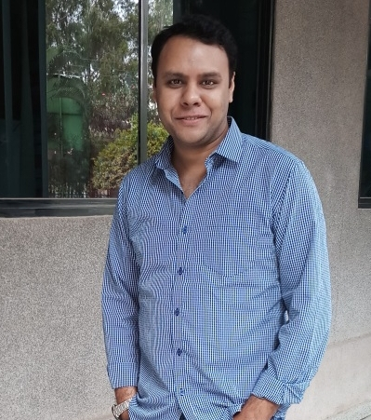 |  | EDUCATION
Master of Computer Applications
CDAC Pune
72%
2002

B.Com
University of Rajasthan
58%
2000
Ashish gupta  Project Management  PERSONAL DETAILS  9610600200  ashishguptah05may@gmail.com  www.linkedin.com/in/ashishguptag  Address: Whitefield, Bangalore, 560048  05/05/1978  PROFILE  I have got 10 years of experience in Project Management including 6 years of Team Lead experience. I have Managed a Team of 10 Members. I have worked on Upgradation, Support, Enhancement and Transition of Projects in Telecom Domain and in SAP CRM Technology. I have worked on both Agile Scrum and Waterfall. Client Interaction and Requirement Gathering. Mapping the Requirements to Functional Specification. Manage the Project Development Life Cycle. Do User Accepted Testing, Functional Testing and Regression Testing. Manage Build, Release, Delivery and Transition of Application. Prepare Software Requirement Specification, Functional Requirement Specification and Project Traceability Matrix. IT Service Management and Stakeholder Management. Troubleshooting of SAP CRM Functional Issues. Create Project Status Reports, Operational Dashboard and MIS Reports. Identity and Access Management. |  | WORK EXPERIENCE

1. Senior Consultant at ATOS Bangalore (2015 – 2018)

Project Name – Nokia

Project Details – Nokia Project developed in SAP CRM Technology as per Agile Scrum for Nokia Global Sales and Marketing Team. Nokia Global Sales and Marketing Team use this SAP CRM Application across Globe for Sales Order Management, Invoice and Purchase Order Management, Opportunities Management, Bidding Management, Sales Process Management, Org Structure Management and Revenue Forecast Management in Sales and Marketing Cluster and in Services Module.

Job Profile – Manage a team of 5 members. Client Interaction and Requirement Gathering. Mapping the Requirements to Functional Specification. Pass on the Requirements to Technical Team for Development. Manage the Project Development Life Cycle as per Agile Scrum. Work Closely with Technical Team to Clarify the Issues and Monitor the Development. Feasibility Analysis and Effort Estimations. Do User Accepted Testing, Functional Testing and Regression Testing. Manage Build, Release, Delivery and Transition of Application. Manage Upgradation, Support, Enhancement and Transition of Projects. Prepare Software Requirement Specification, Functional Requirement Specification and Project Traceability Matrix. Provide IT Service Management and Stakeholder Management. Troubleshooting of SAP CRM Functional Issues in Service Now Ticketing Tool. Provide Sales Order Management, Invoice and Purchase Order Management, Opportunities Management, Bidding Management, Sales Process and Sales Team Management, Identity and Access Management, Organization Structure Management and Customer Master Record Management. Create Project Status Reports, Operational Dashboard Reports and MIS Reports.

Team Size – 20

Technology – SAP CRM

Domain – Telecom

Tools – Microsoft Project, SAP CRM, SQL, Service Now, Advance Excel

2. Project Leader at IBM New Delhi (2009 – 2014)

Project Name – Vodafone

Project Details – Vodafone Project developed in SAP CRM Technology as per Waterfall Methodology for Vodafone Global Sales and Marketing Team. Vodafone Global Sales and Marketing Team use this SAP CRM Application across Globe for Sales Order Management, Invoice and Purchase Order Management, Opportunities Management, Bidding Management, Sales Process Management and Revenue Forecast Management in Sales and Marketing Cluster and in Services Module.

Job Profile – Manage a team of 10 members. Client Interaction and Requirement Gathering. Mapping the Requirements to Functional Specification. Pass on the Requirements to Technical Team for Development. Manage the Project Development Life Cycle as per Waterfall Methodology. Work Closely with Technical Team to Clarify the Issues and Monitor the Development. Feasibility Analysis and Effort Estimations. Do User Accepted Testing, Functional Testing and Regression Testing. Manage Build, Release, Delivery and Transition of Application. Manage Upgradation, Support, Enhancement and Transition of Projects. Prepare Software Requirement Specification, Functional Requirement Specification and Project Traceability Matrix. Provide IT Service Management and Stakeholder Management. Provide Custom Design Solutions and Troubleshooting of SAP CRM Functional Issues in BMC Remedy Ticketing Tool. Provide Sales Order Management, Invoice and Purchase Order Management, Opportunities Management, Bidding Management, Sales Process and Sales Team Management, Identity and Access Management, Organization Structure Management and Customer Master Record Management. Create Project Status Reports, Operational Dashboard Reports and MIS Reports.

Role – Project Leader (Manage a Team of 10 Members)

Team Size – 15

Technology – SAP CRM

Domain – Telecom

Tools – Microsoft Project, SAP CRM, SQL, BMC Remedy, Advance Excel

 |  | SKILLS and software tools
- Project Management, Project Delivery and Project Transition

- Business Analysis and Business Support System

- Agile Scrum Methodology and Waterfall Methodology

- Client Interaction and Requirement Gathering

- Team Management and Work Force Management

- User Accepted Testing, Functional Testing and Regression Testing

- Microsoft Project, SAP CRM, SQL, BMC Remedy, Service Now, Excel

