Praveenkumar J.  Email ID:- praveenkumarj9417@gmail.com  Mobile No:- +91-8129931931 | 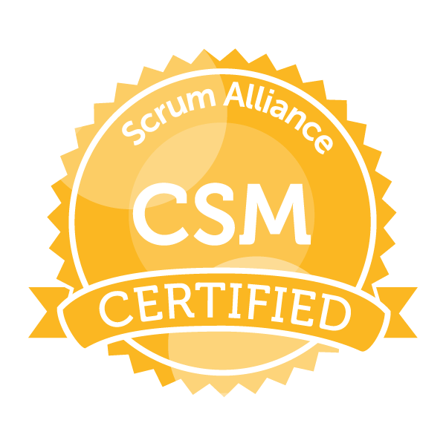
Profile Summary  - Around 5.9 years of experience in QA testing that includes as a QA Lead and extensively involved in Test Planning Creation, developing & executing test cases, reviewing and monitoring progress, planning & managing dependencies, risks and resources, schedules, estimates, test reports in Banking & Financial, Pharma and Telecom domains.  - 4 + years of experience as a QA in Siebel, Salesforce.com CRM and Oracle CPQ Cloud, ServiceMax mainly with Leads, Contacts, Accounts, Cases, Campaigns, Opportunities, Orders and Services entities in Service & Sales applications.  - Robort Programming Automation testing using UiPath.  - Experience with Database management tool such as Terradata and front end design scripts such as ActionScript and Strong experience with Database SQL queries.  - FDA Validation testing.  - ServiceMax – SFDC – Navision and other conventional ERP integration.  - More than 2 years of experience as a Admin in Siebel CRM.  - Experience with Siebel Account, Opportunity, Contact, Asset, Product, Pricing and Order management/fulfillment modules.  - Good understanding of Software Development Life Cycle (SDLC) and all stages of QA and Defect Life Cycles  - Experience with Waterfall, Agile software development (Scrum) and SOA process.  - Experience in both manual and automation testing with UiPath, Selenium and QTP.  - Experience working with SQL queries to perform the Database testing  - Experience in developing test plans, test cases, defect logging and deployment  - Extensive experience on JD Edwards (Order Management, Manufacturing Management, Customer Relationship Management, Sales Managament, CSMS, Financials/GL, Distribution/Logistics, Manufacturing, Transportation, Real Estate Management, HRMS modules.)  - Actively involved in GUI, Functional, Integration, System, Regression, End to End testing, User acceptance, and Database testing  - Familiarity of Quality Assurance standards, processes methodologies and strategies  - Strong in analyzing business requirements and specifications and development of test plans, test scripts, test cases and executing them  - Experience in leading a testing team, assigning and tracking tasks provided to team members  - Self - motivated, team-oriented individual with strong problem solving abilities  - Worked with leading players in the markets including UST Global, QuEST Global and Vaisesika Consulting Pvt Ltd.  - Pursuing Product Management courses – good exposure and expertise with Business user coordination.  - Good understanding on Collection and interpretation of data, analysing results and worked with Data analytics team.  Work Experience  Test Lead - (Salesforce)/CRM Salesforce + Oracle CPQ Clound Tester  Responsibilities:  - Leading or coordinating the Clients, Business Analysts with off shore team. Preparation of Test Plan and approach based on the Business requirements  - Lead and provide appropriate knowledge transfer to offshore testers to assist in efforts. Develop and maintain test data as necessary to support testing efforts  - Mostly worked with Cases, Contacts, Accounts, Solutions and Reports entities in Service cloud application  - Verification & validation of Inbound Emails as converting as Cases. Validating the Assignment rules of Cases  - Checking the functionalities of Escalation rules of Cases. Testing the Flow functionality of the Cases by using the Call Guides  - Verification of Target and Non-Target Account functionalities. Verification of Inbound and Outbound Cases requirements  - Validated the pick list vales based on the Record type layouts. Thoroughly validating the validation and business rules  - We followed the Scrum SDLC approach to implement the project. Execution of Test scripts and Defects rising in HP QC/ALM  - Formulated and executed analytics strategies for properties.  - Analyzed and reported latest industry trends for business implications.  - Prepared and documented specifications for business intelligence reports.  - Maintained and reviewed technical designs for development of reporting solutions.  - Participated in market research analysis for determination of commerce trends.  - Provided assistance in online campaigns and online marketing strategy execution.  - Installed, tested and reviewed web analytics tags for quality purpose.  - Maintain test environments to support testing efforts. Review requirements, designs, and other documentation to ensure testability  - Conduct testing to ensure that GUI, functionality, usability, reliability, and performance of IT solutions are consistent with requirements and established acceptance criteria  - Report and manage defects to ensure that all issues are resolved according to established guidelines and expectations  - Assist development team in troubleshooting and determining root-cause of application defects and issues  - Document test results and communicate to Project Management and other Project Stakeholders  - Work with upstream and downstream application teams to execute E2E test cases. Attend and collaborate in all stand ups, planning and design  - Preparing the Traceability Matrix between Requirements & Test cases  Senior QA Tester/SFDC Tester + Oracle CPQ cloud Admin  Responsibilities:  - Develop, execute, and maintain test designs, including test cases and test scripts. Develop and maintain test data as necessary to support testing efforts  - Execution of Test scripts and Defects rising in HPQC  - Mostly worked with Leads, Contacts, Campaigns, Accounts, Opportunities & Report entities in Sales cloud application  - Written the test scripts based on the Siebel to SFDC Migration Mapping sheets  - Once it is loading from the Siebel to Staging are then need to validate the date based on the mappings  - Prepared the test data by using SQL queries, mappings and legacy Seibel applications  - Once loading the data from Staging to SFDC application, we used to test the functionality and GUI testing  - Prepared Test scripts with crucial functionalities for Go-No Go decision and executed in Pre- production environment  - Complex Services testing is majorly done based on different Final Products like Half circuit & Full circuit etc.  - Verification & validation of conversion of Web - Leads functionality  - Validating the Assignment rules of Leads  - Report and manage defects to ensure that all issues are resolved according to established guidelines and expectations  - Assist development team in troubleshooting and determining root-cause of application defects and issues  - Document test results and communicate to Project Management and other Project Stakeholders  - Work with upstream and downstream application teams to execute E2E test cases  - Attend and collaborate in all stand ups, planning and design  - Execute System and Regression Testing  - Gain user acceptance of test results. Preparing the Traceability Matrix between Requirements & Test cases  QA Tester /Salesforce.com + Oracle CPQ Cloud  Responsibilities:  - Develop, execute, and maintain test designs, including test cases and test scripts. Develop and maintain test data as necessary to support testing efforts  - Execution of Test scripts and Defects rising in HPQC  - Written the Test cases based on the Mapping sheets & Business requirements. Verification Data values with Legacy Siebel application to Sales force application  - Validating all GUI alignment and column level data in SFDC application. Done the products like Half & Full circuit complex functionality testing  - Main entities involved in this assignment are Solutions, Orders, Leads, Contacts, Opportunities, Quotes, Campaigns and Sites  - Written some complex SQL queries by using Joins, Group by functions to do the data validations  - Verification of all conversion rules and Calculations  - Helping to UAT testers by giving the Screen shots of the functionalities and Test cases flow.  - Worked on shift basis to do the tasks for Pre-production testing for Go-No go decision. Also tested the Cases functionalities which is loaded by using the TOAD interface  - Work with upstream and downstream application teams to execute E2E test cases. Preparing the Traceability Matrix between Requirements & Test case  Education  B.Tech. from N.S.S. Engineering College Palakkad, Kerala |  | Key Skills and Knowledge  Test Lead  Test Management Tools:  HP ALM, JIRA, TFS  SDLC Methods:  AGILE, Waterfall  IDE:  Eclipse,Netbeans  Database:  MySQL, Quality Center and Oracle database  Languages:  Java, C, C++,PHP, Apex Language, Visual Force  Other:  RPA (UiPath), Selenium – cucumber framework with JAVA, Saleforce.com platform, ServiceMax, Navision, Data Loader, , JD Edwards, Apex Triggers, Jenkins and Mavens  Web analytics platforms:  - Omniture Site Catalyst  - Google Analytics

