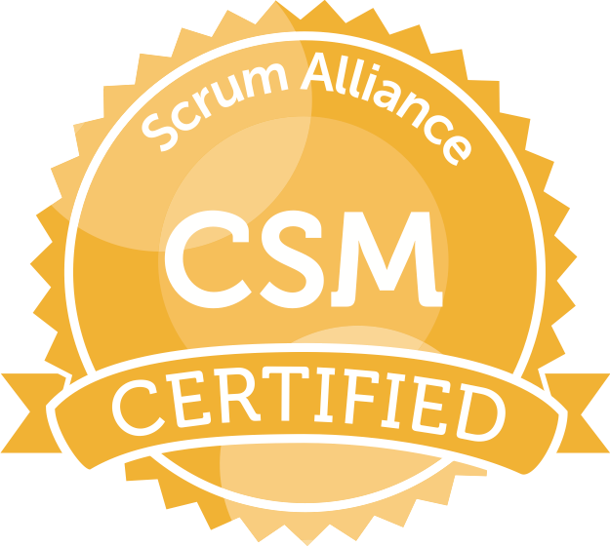**KRISHNA D. L**

Business Analyst / Scrum Harshal@adroitassociates.com

1732-813-0364

Self-motivated, determined and result oriented business analyst proficient in collaborating with cross functional and self- organizing teams in IT project implementation and delivery across different SDLC phases and methodologies ranging from Traditional Waterfall to Agile. Adept in elicitating and converting the requirements into different business artifacts and Proficient in establishing and maintaining liaison relationships with the business and technical stakeholders and help teams foster success by providing servant leadership.

**Professional Summary:**

* In-depth knowledge and hands-on expertise in implementation of project life cycle in various phases and stages of Software Development Life Cycle (SDLC) in Waterfall, Agile (Scrum) and Hybrid (Waterfall-Scrum) methodologies.
* Proficient in understanding business needs, including how data is used and managed, and functional design and prepare relevant business artifacts that are used throughout SDLC, such as BRD, FRD, SRS and RTM.
* Experienced in Analyzing and documenting RBAC requirements for various IAM domains such as Access Management, Identity Life cycle Management, Privileged Access Management, Reporting, and analytics.
* Experience with SailPoint IAM control systems Access provisioning, Joiners/Movers/Leavers lifecycle events, access review and certifications, segregation of duties and Role mining.
* Proven skills in converting requirements into UML Diagrams including use-cases, activity diagrams, wireframes.
* Exceptionally skilled as a Scrum Master in facilitating scrum process and Scrum Ceremonies including Daily Scrum, Sprint Planning, Sprint review, Sprint retrospective and Backlog Refinement meeting.
* Adept at backlog prioritizing techniques (MOSCOw, Business Value, Kano and Technical Risk) and Estimation techniques (Planning Poker and T-Shirt sizing) to help product owner in prioritizing product backlog items (PBI’s) to commit them in the Sprints.
* Proficient in using Atlassian products and perform JQL queries for reporting and design of JIRA project boards.
* Experienced in project management skills like Planning, Scoping, Management, Team Leadership, interacting with executive management, issue resolution, scope and defect tracking and handling team dynamics.
* Supported holistic testing efforts for multiple projects and software releases, including integration, system, regression, performance and user-acceptance testing as a part of Agile/ Scrum teams.
* Participated in User Acceptance Test (UAT), Regression testing, End-to-End testing and Integration testing.
* Collaborated with QA Team in reviewing Test Procedures while creating and executing test cases, test plans and test scripts and efficiently prioritizing and managing defects using Defect Tracking Systems like JIRA, HP QC and HP ALM.
* Successful as a team player with excellent problem solving, team building, decision making skills coupled with good communication skills to work in conjunction with DBA's, testers, developers, and other team members.

**ACADEMICS**

**Education:** Master’s Information Technology Management (University of Dallas - Texas)

Bachelor’s Electrical and Communication Engineering (VIT University – INDIA)

**Certifications :** Safe Scrum Master (SSM) ; Certified Scrum Master (CSM)

**TECHNICAL SKILLS:**

|  |  |
| --- | --- |
| SDLC Methodologies | Waterfall, Agile-Scrum, Waterfall-Scrum Hybrid |
| Management Tools | JIRA, Confluence, MS project, Rally, SharePoint, MS Office |
| IAM Tool | SailPoint |
| Data Warehousing | OLTP, OLAP, Multidimensional Analysis. |
| Testing Tools | HPQC, HP ALM |
| Business Skills | Six Sigma, Change Management, Impact Analysis, JAD sessions, SWOT analysis, Project Planning, Scheduling and Budgeting, Business Process Modelling |
| Operating Systems | Windows XP, Vista, 7,8,10, Mac OS, Linux |

**PROFESSIONAL EXPERIENCE**

**Client: World Bank Group, Washington, DC June 2019- Present**

**Role: Business Analyst/ Scrum Master (IAM)**

**Responsibilities:**

* Responsible for leading the product meetings to obtain a sense of momentum, refine the product backlog, split stories, and prioritize stories based on dependencies, lead the sprint retrospective and planning session, Maintaining the Agile Sprint board and assist the PO in the grooming of the product backlog.
* Perform the role of an analyst in executing and assisting on day-to-day IAM control activities including provisioning, de-provisioning, modifying, access reviews and certification of identity accounts.
* Collaborate and elicitate requirements from stakeholders and create a product vision and write user stories to empower SailPoint development teams to develop and deliver the highest value features to users in a PSPI .
* Assist IAM test team in the development and configuration and Co-ordination in testing of the application configurations across different IAM test regions and supervise UAT by assisting the stakeholders with relevant user-guides and how-to documentation.
* Manage risk by creating user stories that account user, business, and technical debt and perform SWOT analysis to minimize risk.
* Identify data and process improvement and provide cross functional servant leadership in improving the maturity of the IGA groups access governance service.

**Client: Charter Communication, St. Louis, MO March 2017- April 2019**

**Role: Business Analyst / Scrum Master**

**Responsibilities:**

* Collaborated with charter’s call center business stakeholders to elicitate and integrate application information on call center agent’s IAM application; Integration of business processes and RBAC requirements and participated on all stages of systems development lifecycle, from requirement gathering to production releases.
* Planned, defined, and designed business artifacts utilizing Six-sigma principals and charters Role mining and Role structuring principles and created business process model required for creating required reporting dashboards.
* Worked as Scrum Master in facilitating and managing the requirements across the Hybrid-Scrum development lifecycle and leveraged Jira as an issue management tool.
* Assisted the QA testing and ensured that business requirements were being addressed in the test plans.
* Worked with the business stakeholders in planning, validating and managing the UAT test execution.
* Provided direction and servant leadership to the stakeholders and to the team supporting them whenever required.

**Client: State of Idaho (Health &Welfare), Boise, ID March 2016- March 2017**

**Role: Scrum Master**

**Responsibilities:**

* Conducted JAD sessions and performed GAP analysis in evaluating the current and proposed system.
* Worked in Hybrid Agile development environment, involved in elicitating the requirements and decomposing the gathered requirements into user stories and leveraged Jira for issue tracking, user story management, requirement traceability, and velocity of the team.
* Analyzed and prepared the business rules and worked with the development team in implementing the rules.
* Supervised the UAT to test the usability of the application and was involved in static and dynamic testing.

**Client: Silicon Valley Bank, Santa Clara, CA Aug 2014- Nov 2015**

**Role: Business Analyst / Scrum Master**

**Responsibilities:**

* Analyzed the objective and scope of the project and existing artifacts to understand the system and business rules.
* Gathered and documented requirements using JIRA resulting in detailed business rules, functional requirements, and process design.
* Decomposed the scope from the BRD into user stories by conducting a story writing session with the product owner and then decided upon the acceptance criteria for the PSPI with business users.
* Assisted the Product Owner to prioritize the PBI using MoSCoW technique for developing a PSPI. Helped the team in estimating the user stories using Planning Poker Technique.
* As a Scrum Master facilitated various Scrum ceremonies, tracked team velocity, and Sprint progress using Sprint burn down chart and Release burn down chart and resolved impediments.

**Client: SSC Technologies, Hyderabad, India May 2011- July 2013**

**Role: Business Analyst**

**Responsibilities:**

* Gathered business and functional requirements by conducting interviews with users, stakeholders, and SME’s.
* Identified and developed Use Cases from the business and systems requirements and Documented high level and detailed Use Cases to include all the functionalities of the new system.
* Created UML Diagrams including Use Cases Diagrams, Activity Diagrams, Sequence Diagrams.
* Designed and implemented basic SQL queries for QA testing and report/ data validation.
* Worked with the QA team for designing Test Plan, Test Cases, and Requirement Traceability Matrix for the User Acceptance Testing (UAT) and regression testing.