


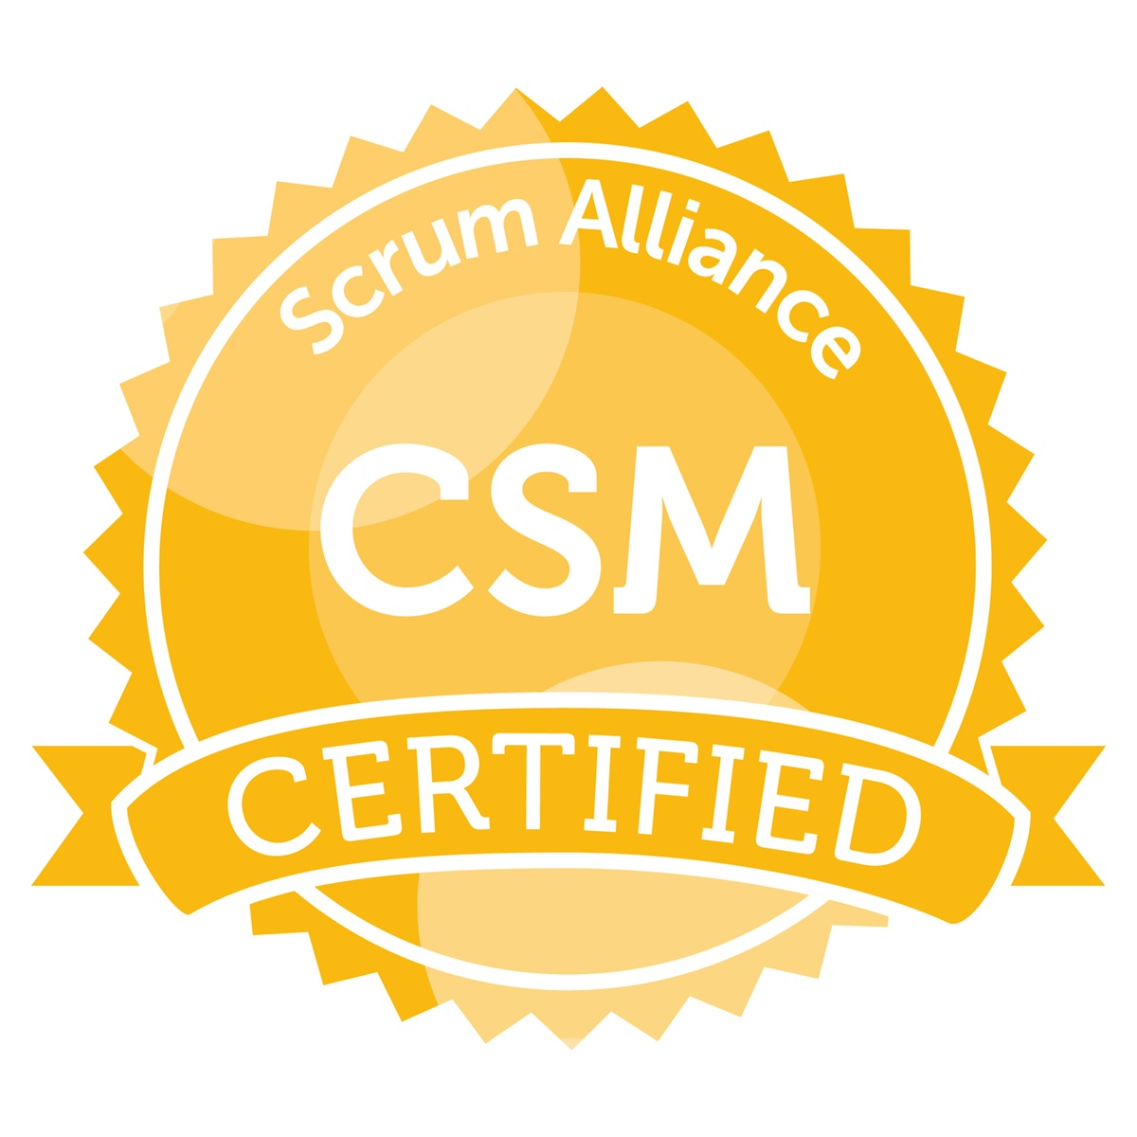

UMESH PATIL

ADDRESS: E-mail: umeshpatil2204@gmail.com
Flat no 19, Nirjara Park society, Contact no: +91- 8308075096
Baliraj colony, Rahatani, Pune-411017

PERSONAL SUMMARY
Experienced and Certified Scrum Master and Agile Coach helping teams and organization for Agile transformation. Have a proven track record of delivering high-quality software, on-time and within budget. An accomplished and fluent communicator with strong investigation, problem-solving and decision-making skills, combined with a pragmatic approach and sound business acumen. Highly accomplished with a verifiable track record in fields such as business requirement analysis and gathering, business process mapping and the development of interactive prototypes.
CAREER HISTORY
Organization | Location | Designation | Duration
Globant | Pune | Agile Project manager | Dec 2019 - till present
L&T InfoTech | Pune | Associate Consultant | Dec 2017 - Dec 2019
Atos | Pune | System Analyst | June 2015 - Dec 2017
Aloha Technology Pvt Ltd | Pune | Business Analyst | Dec 2014 - May 2015
Blue chip Computer Consultants Pvt Ltd | Bangalore | Business Analyst | Oct 2011 - Nov 2014

- Managing the work from initial request through estimation, approval, requirements, build and implementation.
- Developed crucial functional requirement specifications, creating detailed use cases and process flow diagrams to support functional specifications.
- Conducted meticulous GAP analysis while successfully re-engineering key business processes to increase operational efficiency and alignment of business unit objectives
- Writing User stories to capture requirements for upcoming product releases
- Facilitate sprint planning, daily scrums, retrospectives, stakeholder meetings, and software demonstrations.
- Facilitated user interviews and workshops to gather and analyze user stories.
- Protect development team from outside distractions, impediments or team conflicts, and maintain focus on product backlog and project timeline.
- Work closely with project management in backlog management and continuous delivery of features.
- Educate and reinforce scrum methodology and agile framework to team members and key stakeholders.
- Delivered Functional and User Acceptance Testing.
- Strategic analysis undertaken and delivered to inform, manage and drive stakeholder expectations.
- Involved in workshops / training / presentations.
KEY COMPETENCIES AND SKILLS
Business Analysis | Supporting Strategy Rollout | Change management
Agile Estimation and planning | Agile coaching | Certified Scrum Master (CSM)
Processes optimization | Business process modeling | UAT and Testing
User stories | Safe Agilist | Removing Impediments
TOOLS & TECHNOLOGIES
Visio, MS-SQL, MS-Word, Excel, PowerPoint, MS-Project, Jira, Azure (VSTS/TFS), Confluence, Contour, Axure, Service Now

PROJECT PROFILE

PROJECT TITLE : Glow
Role : Scrum Master

Description : It is a cloud based platform that helps the members of an organization do all the operational activities that are required as a backbone of running the different set of projects by handling all the activities like staffing, Project management, Talent management, Travel, Evaluations, Financials, etc.

PROJECT TITLE : Globant PODs
Role : Scrum Master

Description : It is a mobile based app that allows client users to provide timely feedback about he teams they are working with. Such data is then used by the account handlers to make appropriate actionable goals for the team.

PROJECT TITLE : ISG InformX
Role : Scrum Master / Agile Coach

Description : It is a cloud based platform that provides real time global IT data, insights and modelling to help you compare, optimize and transform your IT organization.

PROJECT TITLE : Market Intelligence Platform
Role : Scrum Master / SAFe Agilist

Description : Market Intelligence Platform is a web-based platform which digs deep to deliver solutions that are sector-specific, data-rich, and hyper-targeted for evolving needs.
PROJECT TITLE : E-commerce Exception Processing Tool (EEPT)
Role : Scrum Master / Business Analyst

Description : E-commerce Exception Processing Tool (EEPT) is a tool for improving automated order-to-invoice processes in NSN customer interface. The tool is used in e-commerce interface with system-to-system (S2S) integrations that usually utilize e-commerce messaging standards such as Rosetta-Net or EDI. The tool is used by NSN internal people, mainly by Sales Assistants, Logistics Controllers and Finance personnel.

PROJECT TITLE : Infiniti Pricing Tool (IPT)
Role : Business Analyst

Description : Pricing tool is a system designed for an automobile company to help them carry out pricing of their vehicles depending on the model and country. The system helps to manage taxation rules applied in the country and also to generate various reports.

PROJECT TITLE : HRMS.
Role : Business Analyst/ Project Lead
Description : HRMS i.e. Human Resource Management System , is a systemized approach to people management which understands and captures the functions of HR department and converts the same into a workflow. It can be accessed through a web browser within the network or outside the network by hosting the application in Internet.

PROJECT TITLE : Payroll.
Role : Business Analyst/ Project Lead
Description : This system provides solution to process the payroll based on the business processes involved for the respective industrial unit that deals with the employee management. This system works as an intranet web application. It can also be accessed from outside the network by hosting the application in Internet.

PROJECT TITLE : Syteline ERP
Role : Business Analyst
Description : Infor SyteLine ERP software provides the means to connect sales, marketing, manufacturing, financials, suppliers, customers and service providers.

PROFESSIONAL EXPERIENCE
- Understanding service objectives and capturing business requirements through active listening & questioning techniques.
- Collaborated closely with SMEs to identify and analyze core requirements
- Facilitated Daily Scrum Meetings and Monthly Reviews meetings. Conducted sprint retrospective and followed up on action items for continuous improvement
- Prepared extensive cost - benefit analysis to support system and process changes
- Facilitated sprint and release planning, daily stand-ups and retrospectives
- Managed impediment backlog and motivated team members to identify necessary action
- Initiated product backlog and developed user stories with clear acceptance criteria
- Able to prepare written proposals, requirements specifications, invitations to tender and solution specifications.
- Able to identify business & systems process improvements from Big Picture to detail level.
- Excellent communication skills to manage and liaise with business and technical consultants to explore business process improvement opportunities.

ACADEMIC QUALIFICATIONS
Course | INSTITUTE | University/Board | Year of passing | Percentage
MBA  IT & Systems | I.M.E.D., Pune | Bharati Vidyapeeth Deemed University | 2011 | 67
B.E.  Computer Science | S.R.S.I.T, Bangalore | Visvesvaraya Technological University | 2009 | 58

CERTIFICATIONS
CERTIFICATION NAME | INSTITUTE | Certificant ID | Year of passing
Agile Coach | ICAgile | NA | 2021
Certified Safe 5 PO/PM | Scaled Agile | 98684071-3242 | 2020
Certified Safe 5 Agilist | Scaled Agile | 37145457-2200 | 2019
Certified Scrum Master (CSM) | SCRUM ALLIANCE | 000640981 | 2017

EXTRA-CURRICULAR ACTIVITIES
- Played in Under-14 Football team at district level and also played in college cricket team.
- As an Event manager for IT Club, arranged various IT events.
- Lead the management committee for arranging several cultural & sports events.

AWARDS/ACHIEVEMENTS
- Bagged 1st Prize in Science Competition 2001, Bharuch District, Gujarat.
- Secured 2nd Prize in On-spot Programming Competition 2006 in Technical Fest, SRSIT.
- Secured 2nd Prize in Quiz Competition 2007 in College Fest, SRSIT.
- Secured 2nd Prize in Manthan- Presentation Competition organized by BA FORUM, IMED.
- Secured 2nd Prize in Volley-Ball Interclass Tournament 2010 in IMED.

PERSONAL DETAILS
Date of Birth : 22nd April 1985
Sex : Male
Marital Status : Married
Language Known : English, Hindi, Gujarati, Marathi.
Interest : Travelling, Dance, Sports.

Umesh Patil

