Name : T Laxman.  Emal:tlaxman0@gmail.com  Mobile: +91 9912421314 | 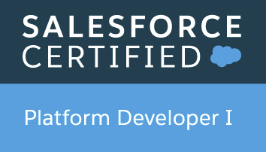  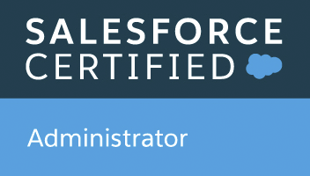
Profile Summary  - Overall, 9.6 total years of Experience in IT Experience and 6.3 years in Salesforce.com  - Highly Proficient in SFDC Cloud Application, Planning, Analysis, Design, Configuration, Administration, Coordination and Supervision of Deployment of the Software Solutions in SFDC.  - Worked in Sales cloud, service cloud.  - Experience in implementing Communities.  - Experience and implemented the FSL –Field Service Lightning in salesforce.com.  - Experience in Profile creation ,Roles, Permission sets, Email alerts, Email Templates, Workflows, Approval process, Flows, Process Builders, Validation Rules and Reports and Dashboards.  - Experience using data migration using Dataloader.io, Data loader, Workbench etc.  - Experience on Apex, Visual Force, Triggers, Batch apex, test classes, Rest API.  - Experience in deployment using Autorabit, Change sets, Eclipse, GitHub, Bitbucket and SourceTree  - Experience in working with Agile Methodology and SDLC process.  EDUCATION  Master of computer applications – 2012  MVSR Engineering Collage Hyderabad  CERTIFICATIONS  Salesforce.com Platform Developer | (PD1) Certified,  Salesforce.com Administrator (201) Certified,  Salesforce.com Platform Developer ||(PD2) Certified,  Salesforce.com Service cloud Consultant,  Salesforce.com Sales cloud Consultant  Salesforce App builder  EXPERIENCE  Accenture.: Worked as Salesforce Consultant from 2013 to 2018  Wipro: Worked as Salesforce Lead Developer from 2018 to 2021.  IBM Indian Pvt Ltd.: Started Working as a Lead from 2021 to till date.  PROJECTS  Philips cCRM  Role: Lead Developer  Specification: This application is used to originate order for Philips product from various market  Role: Responsible for the following  • Requirement Understanding and Analysis  • Worked as platform tech lead.  • Handling all platform level quires for entire Philips.  • Coding, Unit testing, Integration testing.  • Drive PO alignments call.  • Drive Requirement call with all international markets.  • Worked with multiple market like North America, Iberia, Germany, RCA, China, Benelux etc.  • Worked with Salesforce Solution manager for better design of product  • Technically assisting all team members.  • Handling the cutover plans and Release plan for entire Philips all programs.  • Gathering requirement from client, Design, analyzing impact and development.  • Creating mobile compatible applications using SLDS and lightning components.  • Developed Apex Classes, Visualforce pages.  • Creating different validations and writing test classes.  • KT and sessions to new joiners.  Colgate HR Management  Role: Senior Salesforce Developer  Client: Colgate  Specification: This application is used to internal employees related to Leave policy, Compensation, Termination policy, onboarding Process, Exit process etc.….  Role: Responsible for the following  • Requirement Understanding & Analysis.  • Gathering requirement from client, Design, analyzing impact and development.  • Core Development using Salesforce  • Creating mobile compatible applications using SLDS and lightning components.  • Developed Apex Classes, Visualforce pages.  • Creating different validations and writing test classes.  • KT and sessions to new joiners.  Momentive Enhancements  Role: Developer  Specification: Momentive is a Chemicals based Company, it has a range of products like Quartz, Ceramics, Silanes, Sealants etc.  Role: Responsible for the following  - Worked as a Developer on sales cloud Implementation. Worked mainly on Lead Management.  - Have written Triggers, Apex Classes, VF Pages, Validation Rules, and JavaScript.  - Used the tool Eclipse for Deployment. Used an Accenture Internal Tool Nova Suite to check the Code Quality and Implemented Best Practices in Code.  - Have customized visual force pages as per the business need.  - Have created appropriate Visual force components and its controllers to interact with Web service classes.  - Have customized the. Lead Conversion process.  - Have written test classes for the apex classes to make sure the code coverage.  - Written Web Service Integration Classes and Exception handlers.  - Was involved in all the communications with the Onsite Counter parts right from Requirement Analysis till deployment to production. |  | SKILLS  Salesforce.com  Sales Cloud, Service Cloud, Community, FSL etc.…  Lightning  LWC  Apex  Triggers  Visualforce  Flows  Workflows  Approvals  Profiles  Apex Data Loader  Force.com IDE  Other  JavaScript  HTML  Tools  Eclipse IDE  Source tree  Bit Bucket  Jenkins  DevOps  VS Code

