Akash Lahoti Email: akashlahoti1990@gmail.com  Ph No. - 9999063667 | 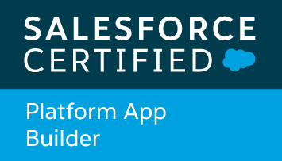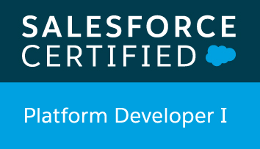  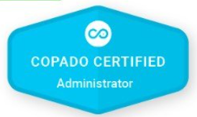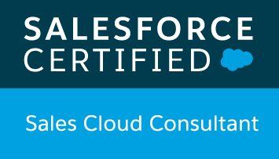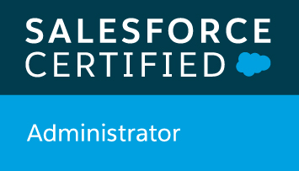 | 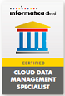

TECHNICAL EXPERTISE  Cloud CRM  Salesforce.com  Cloud Platform  force.com  Special Skills  Delivered Salesforce customization & force.com Development projects, Informatica Cloud Connector  Data Migration Apps  Apex Data Loader, Informatica Cloud  Programming Languages  Apex, Visualforce, HTML (Basic)  Query Languages:  SOQL, SOSL  Development Environment:  Force.com, Eclipse, Visual Studio Code  Scripting Languages:  Java Script  Web Services:  REST API  Deployment Tools:  Git Hub, Auto Rabbit | PROFESSIONAL EXPERIENCE  I am BTECH CS and currently working as Advisory Consultant with IBM INDIA PVT LTD. having IT experience of almost 7 years in Development, analysis, design, deployement & application integration.  Proficient in Force.com, Informatica Cloud, web applications  Cloud based Salesforce CRM: Customization and Development  HIGHLIGHTS  - Expertise in design, development, deployments and configuration of complex SFDC projects.  - Worked on REST API Integrations.  - Worked in creating lightning aura components and lightning web components.  - Expertise in design, development and coding of Cloud based applications, informatica connector development.  - Worked on Einstein analytics creating datasets & recipes.  - Excellent ability to multitasking, problem solving, produce high quality results under tight schedule and deadlines, and work extremely well in team environment.  - Quick learner and adaptive to new and challenging technological environments  EDUCATIONS  - B.Tech from Uttar Pradesh Technical University(UPTU), U.P. (India)  Professional experience summary  Company – IBM INDIA PVT LTD.  PROJECT NAME: ILLUMINA  Responsibilities:  - Working on Service Max product.  - Working on Git and Auto Rabbit for Deployments.  - Analysing the requirements by interacting with the client  - Creating SFM Wizards and configurations around work orders, part orders, products etc.  PROJECT NAME: SONY PICTURES NETWORK  Responsibilities:  - Working as Module Lead for implementation of Sales Cloud  - Analysing the requirements by interacting with the client and managed team of associate developers for requirement breakdown and designing solutions  - Worked on creating lightning component  - Went to client location for End User Training of the application  - Worked on Einstein analytics, datasets, recipes, REST Api Integration.  Company – FISERV INDIA PVT LTD.  Responsibilities:  - Working with JIRA for story assignments and logging working hours  - Working with GIT and bit bucket for version controlling and code merge  - Working on enhancement using batch class, trigger and apex class extensively  Company – NTT Data Services(Formerly known as Dell International Services)  Responsibilities:  - Implementing Service Cloud with customization.  - Providing customized knowledge solution to the client to move to SF.  - Implementing complex business logic using Apex Classes and Triggers.  - Requirement gathering, feasibility study of those as per the existing SF project implementation.  Company – Mansa Systems, LLC  Made visualforce pages for adding the products as a opportunity line items on opportunities.  Created visualforce pages for adding quote and for license agreement number under opportunities.  Data Migration for several custom objects using Apex Data Loader.  Understanding the deliverables and making sure the project is completed within expected  Timeframe.  Participated in technical aspects of APEX, Visual Force development with the team  - Given support to client to make them understand the code and flow of application.  • Customized/Configured CloudDrop based on clients requirement.

