**RESUME**

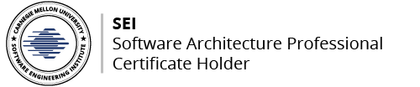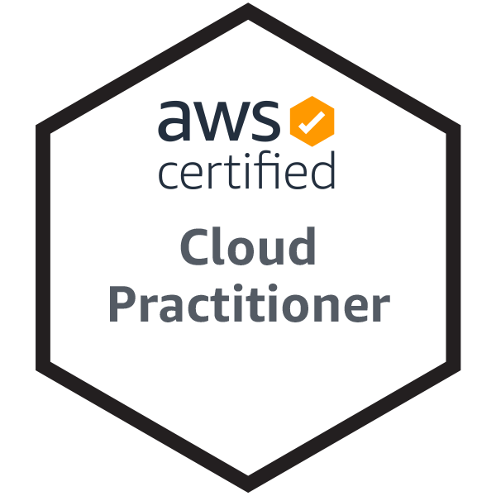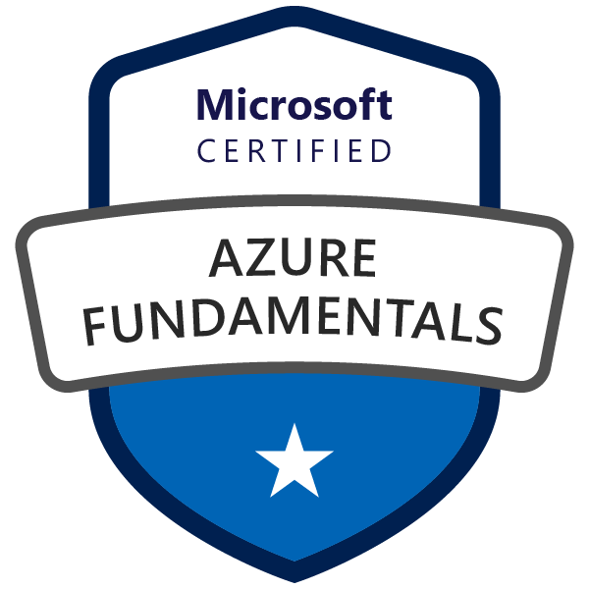

**VV S Satyanarayana Murthy Akella**

House No. 42-260/94/A,

Shramika Nagar, Moula Ali,

Moula Ali Hill Road,

Near John Rogers High School, Contact No: +91-7205212653

Hyderabad–500040, Telangana. Email ID: [murthymet@gmail.com](mailto:murthymet@gmail.com)

**SUMMARY:**

* **Lead Software Engineer with Eight (8+)  years’** experience in Analysis, Design, Development, Testing and Implementation of various internet-based applications.
* Results-oriented Software Engineer comfortable switching between Architecture, Design and Implementation with thorough hands-on experience in all levels of Testing, including Performance, Functional, Integration, System, Regression and User Acceptance Testing.
* Specialized in back end (RESTful) and front end development.
* Experienced with all stages of the development cycle for dynamic web projects.
* Well-versed in JAVA programming language and Spring Framework.
* Strong background in management and leadership.

**SKILL SET:**

**Technology / Tools expertise**

* **Programming Languages** – JAVA, Linux Shell Scripting, Python, C#, C++, C
* **Technology/Frameworks** – Core Java, POJO, J2EE (EJB, MDB, Servlets, JSP, JMS), Spring(MVC, Batch, Boot, Security, Integration, Data JPA/JDBC), Spring Cloud(Config, OpenFeign, Stream/App Starters, Security - OAuth2/JWT, Function), RESTful Web services, Quartz Scheduler, JSTL, JavaScript,JQuery, XML, HTML-4,5, CSS, AJAX
* **Server Software** – Apache Tomcat, ApacheTomEE, JBossEAP,JBoss AS/WildFly, Oracle Weblogic Server (11g & 12c), Apache Kafka, Rabbit MQ, Azure Service Bus, Amazon SQS/SNS
* **Tools** – PuTTY, WinSCP, Toad, Tora,Postman, IBM WebSphere MQ, DBeaver, MySQL Workbench, MS SQL Management Studio, Squirrel SQL Client
* **Databases** – Oracle SQL, Postgres, MySQL, MS SQL, MS Access, IBM DB2
* **Container Platform** – Docker, Kubernetes (K8s)
* **Cloud Computing Services** – Azure (Microsoft Cloud Services),AWS (Amazon Web Services), GCP (Google Cloud Platform), RedhatOpenShift
* **Operating Systems** – Windows (XP, Vista, 7, 8, 10, Server 2012), Linux (RHEL, Oracle, CentOS)
* **Development Tools –** Eclipse IDE, Visual Studio, IBM RAD
* **Build Tools –** Apace Maven/ANT, Jenkins, Azure DevOps, Gradle
* **SCM Tools -** TFS, Clear Case, Tortoise SVN, GitHub
* **Big Data Technologies –** Hadoop/Hive, Kafka, Sqoop, PIG, Apache Spark, Data Lake

**INDUSTRY/DOMIAN EXPERTISE**

* Financial Services
* Health Insurance
* Retail (Supply Chain Management)
* Intellectual Property (IP Cell)

**PROCESS EXPERTISE**

* SDLC – Waterfall, Agile Methodology

**ACCOMPLISHMENTS:**

* Developed several internal tools to automate mundane tasks that were quickly adopted by other developers.
* Designed, developed and produced different products, which were successfully implemented by **Infosys** Clients.
* Several **appreciations** received from the Senior Project Manager and Project Manager for the tools developed by me.
* Successfully completed cross training in other platforms like **Angular JS, Type Script,CICS, COBOL** and **DOT (.) NET** for project requirements.
* Awarded **OUTSTANDING Award – 2019, 2020** by the senior project management team,for the impact which I created on the successfully execution of the project.
* Awarded **APPLAUSE Award – 2019, 2020** in recognizing the effort which I spent on completing the POC’s which are required for the project to kickoff.

**EXPERIENCE:**

Lead Software Engineer **09/2021 to till date**

**Wells Fargo International Solutions Pvt. Ltd.** Hyderabad, Telangana

**About Wells Fargo:**

Wells Fargo & Company is an American multinational financial services company with corporate headquarters in San Francisco, California, operational headquarters in Manhattan, and managerial offices throughout the United States and internationally. The company has operations in 35 countries with over 70 million customers globally.

Application Secure Data Exchange (ASDE) platform of Wells Fargo Technology (WFT) Division allows customers to control the data they share outside of Wells Fargo while still providing them the ability to use their data as they see fit.Provides end user with greater control over their personal data, including fine-grained consent settings for sharing data. Offers availability of other Wells Fargo APIs and additional bank features not obtainable through other data sources.

**Duration**: September 2021 to till date

**Technology**: Java 11, Microservices, RESTful Web Services, Spring Boot, Spring Cloud

**Cloud Service Provider**: Microsoft Azure (Azure), Google Cloud Platform (GCP)

**Database:**Oracle 19c, Azure SQL Server

* Senior Member of ASDE team, responsible for implementation of the solution.
* Drove continual improvement by performing design review and code review of the modules present in the application.
* Implemented new API’s for deployment and integration with third parties like other WFT API’s.
* Supervised the work of **entire QA, API and UI Dev Teams**. Drafted technical and POC documents.
* Single Point of Contact for entire application for any kind of troubleshooting.
* Build and Deploy Docker Images. Configure Build and Release Pipelines in the Azure DevOps/Jenkins.
* Deploy the containers on the Azure Kubernetes Cluster (AKS) and writing the ARM templates for the IaC.
* Developed Azure Functions using Spring Cloud Function f/w for the batch jobs to run of daily basis.

Senior Software Engineer **05/2021 to09/2021**

**EPAM Systems India Pvt. Ltd.** Hyderabad, Telangana

**About Client:**

EBSCO Information Services is a division of **EBSCO Industries, Inc.**, one of the largest privately held and family-owned companies in the United States. EBSCO Industries, Inc. has been in business since 1944. Starting out as a small subscription agency, EBSCO quickly became a pioneer in the library services industry.From research, acquisition management, subscription services and discovery to clinical decision support and patient care, learning, and research and development, EBSCO provides libraries, health care and medical institutions, corporations and government agencies with access to content and resources to serve the information and workflow needs of their users and organizations.

**Duration**: May 2021 to till date

**Technology**: Java 8, Microservices, RESTful Web Services, Spring Boot, Spring Cloud

**Cloud Service Provider**: Amazon Web Services (AWS)

**Database:** AWS RDS, AWS Aurora (PostgreSQL), AWS Dynamo DB

* Member of Clinical Decisions team, responsible for implementation of the solution.
* Drove continual improvement by performing design review and code review of the modules present in the application.
* Implemented new API for deployment and integration with third parties like AWS API’s.
* Supervised the work of **entire QA, API and UI Dev Teams**. Drafted technical and POC documents.
* Single Point of Contact for entire application for any kind of troubleshooting.
* Build and Deploy Docker Images. Configure Build and Release Pipelines in the AWS Code Build.
* Deploy the containers on the AWS EKS and writing the Cloud Formation templates for the IaC.
* Developed AWS Lambdas/Step Functionsusing Spring Cloud Function f/w for the batch jobs to run of daily basis which generates different forms of encoded files which are used by the client teams.

Consultant **02/2019 to 04/2021**

**Deloitte Consulting India Pvt. Ltd.** Hyderabad, Telangana

**About Client**

The largest American multinational retail corporation that operates a chain of hypermarkets, discount department stores, and grocery stores, headquartered in Bentonville, Arkansas. The company was founded by Sam Walton in 1962 and incorporated on October 31, 1969.

**Duration**: February 2019 to till date

**Technology**: Java/J2EE, Java 8,Microservices, Azure DevOps, Big Data Technologies

**Cloud Service Provider**: Microsoft Azure (Azure), Amazon Web Services (AWS)

**Database:**Azure SQL Server/Azure SQL DW, HIVE, RDS, AWS Aurora, MySQL

* Member of Application Architecture team, responsible for Design of the solution.
* Drove continual improvement by performing design review and code review of the modules present in the application.
* Coordinated with QA testers for end-to-end unit testing and post-production testing.
* Managed the road map for product design, development and production approval.
* Implemented new API for deployment and integration with third parties like Microsoft Azure API’s.Involved with client for gathering requirements and demoing of the functionalities.
* Supervised the work of **entire QA, API and UI Dev Teams**. Drafted technical and POC documents.
* Single Point of Contact for entire application for any kind of troubleshooting.
* One of the few members who was working in the application since its inception was responsible for entire cloud architecture deployment of the application.
* Build and Deploy Docker Images. Configure Build and Release Pipelines in the Azure DevOps.
* Performance Tuning of the SQLDW. Setting up the azure infrastructure for the application.
* Deploy the containers on the Azure Web Apps and writing the ARM templates for the automated style of deployment.
* Developed Security Module for the entire application using Spring Security.
* Developed Spring Cloud Streams POC for the batch jobs to run of daily basis which generates different forms of encoded files which are used by the client teams.

Technology Analyst **06/2014 to 02/2019**

**Infosys Pvt. Ltd.** Hyderabad, Telangana

**About Infosys IP/PaaS (Infosys Labs):**

Cloud computing is providing developers and IT departments with the ability to focus on what matters most and avoid undifferentiated work like procurement, maintenance, and capacity planning. As cloud computing has grown in popularity, several different models and deployment strategies have emerged to help meet specific needs of different users. Each type of cloud service, and deployment method, provides you with different levels of control, flexibility, and management.

**Duration**: April 2017 to February 2019

**Cloud Service Provider (CSP)**: Microsoft Azure, AWS

**Technology**: Java 7/8, RESTful Web Services, AJAX

**Database**: MySQL, Oracle, SQL Server, Postgres

**Cloud Computing Model:** Platform as a service (PaaS)

* PaaS is a deployment and development environment within the cloud that delivers simple cloud-based apps to complex, cloud-enabled applications.
* PaaS is designed to support the complete web application lifecycle of building, testing, deploying, managing, and updating.
* PaaS includes a complete infrastructure of servers, storages, networking, and middleware development tools like business intelligence services (BI), database management systems, etc.
* A complete platform is offered in PaaS in which the client can host their applications without the need to worry about the maintenance of the servers and its operating systems.
* However, the user of the PaaS service should look after the implementation of the developed application to decide whether to scale it up or down depending on the traffic that the application receives.
* The PaaS backbone utilizes virtualization techniques, where the virtual machine is independent of the actual hardware that hosts it.
* End to end creation and deployment of Infosys IP on Azure Container Services (AKS).
* Do not have to worry about the OS or even the server, just run your application.
* Server configuration, like scaling happens automatically.
* Container Orchestration using Kubernetes - manage multiple Containers and their workloads, performing orchestration of deployments.
* Infosys IP Docker images uploaded to the Azure Container Registry (ACR) and deployed on AKS cluster.
* Scale an application and update Infosys IP application running on Kubernetes.

**About Infosys IP Cell:**

Infosys helps global customers capitalize on emerging technologies by creating Intellectual Property (IP) and building platforms for new products, services and solutions through Software Engineering and Technology Labs (Infosys Labs).

**Duration**: June 2016 to February 2017

**Technology**: Java/J2EE (EJB Injection), Eclipse link for JPA, Spring MVC, Spring Batch

**Database:**Oracle SQL, Postgres

* Drove continual improvement to system architecture by refactoring old legacy code.
* Coordinated with QA testers for end-to-end unit testing and post-production testing.
* Managed the road map for product design and development.
* Implemented new API for deployment and integration with third parties.Involved with client for gathering requirements and demoing of the functionalities.
* Supervised the work of **two(2)** other software engineers. Drafted technical documents.
* Updated, modified and expanded existing software programs.Instrumented and modified unit and integration tests to improve software quality and reliability.
* Analyzed requirements and used systematic approaches to implement and document the tasks.
* Recommended and executed plans to improve development tools and processes.
* Oversaw deployment, configuration and documentation procedures.
* Implemented and tested enhancement feature requests to enhance product functionality.
* Resolved customer issues by establishing workarounds and solutions and by debugging and creating defect fixes.
* Performed functional, non-functional, regression and performance tests.
* Coded user-customizable applications that converted raw data from design engine to easily understandable graphical formats.
* Creating Azure Load Balancers to load balance workloads.
* Azure PostgreSQL Integration.

**About Client:**

The largest American managed health care company, which sells traditional, and consumer directed health care insurance plans and related services, such as medical, pharmaceutical, dental, behavioral health, long-term care, and disability plans. Aetna is a member of the Fortune 100. Its headquarters is inHartford, Connecticut, U.S.

**Duration**: October 2014 (mid) to April 2016

**Technology**: COBOL, CICS, Java/J2EE

**Database: IBM** DB2

**About Infosys ETA (Mysore):**

Infosys helps the newly recruited employees to understand about the software industry its technologies, architecture and design through a series of well-planned trainings for a couple months with assessments included at the planned intervals with securing the cut offpercentage is mandatory.

**Duration**: June 2014 to October 2014 (mid)

**Technology**: Core Java /J2EE

**Database: Oracle** SQL

* Have successfully completed the training in JAVA Programming by securing an aggregate of 78%.

**EDUCATIONAL QUALIFICATIONS**:

|  |  |  |  |  |
| --- | --- | --- | --- | --- |
| **Discipline/Specialization** | **School/College** | **Board/University** | **Year of passing** | **Percentage** |
| B.E.  (Metallurgical engineering) | Andhra University  (College of Engineering), Visakhapatnam | Andhra University | 2014 | 93.2 |
| XII Standard | Mega Junior College, Visakhapatnam | Board of Intermediate Education,A.P | 2010 | 96.4 |
| X Standard | Belmont High School, Visakhapatnam | School of Secondary Education (SSC) | 2008 | 81.8 |

**CERTIFICATIONS:**

* **SEI Software Architecture Professional**
* **AWS Certified Cloud Practitioner**
* **Microsoft Certified Azure Fundamentals**

**PERSONAL INFORMATION:**

* **Father’s Name**: A.S.Deekshit
* **Mother’s Name**: A.V.S.Manikyamba
* **D.O.B**: 29-JULY-1993
* **Languages Known:** English, Hindi, Telugu
* **Marital Status**: Married

**DECLARATION**:

I hereby declare that all the above information mentioned by me is true and correct.

Date: 18th July 2022

Place: Hyderabad A.V.V.S.S.Murthy