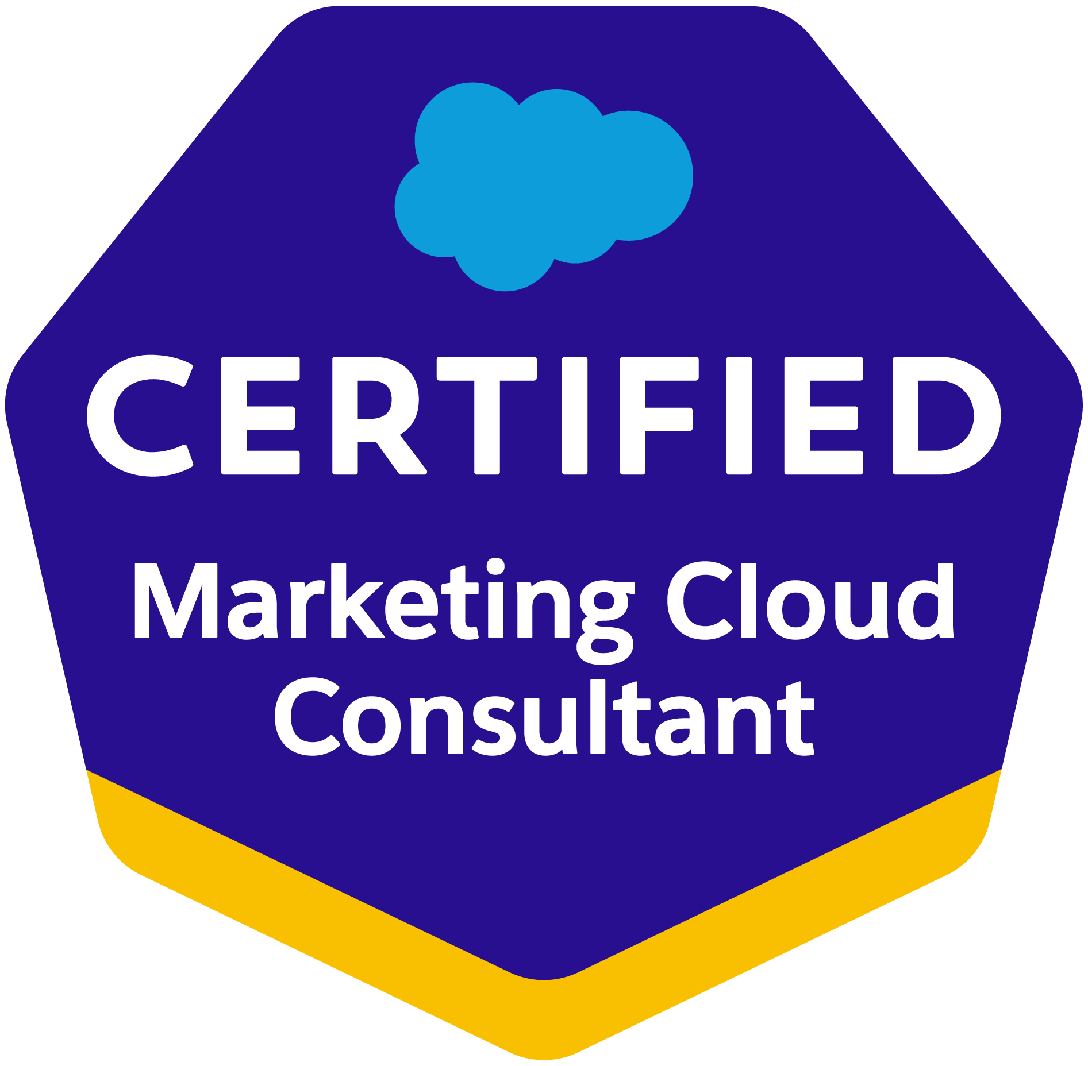


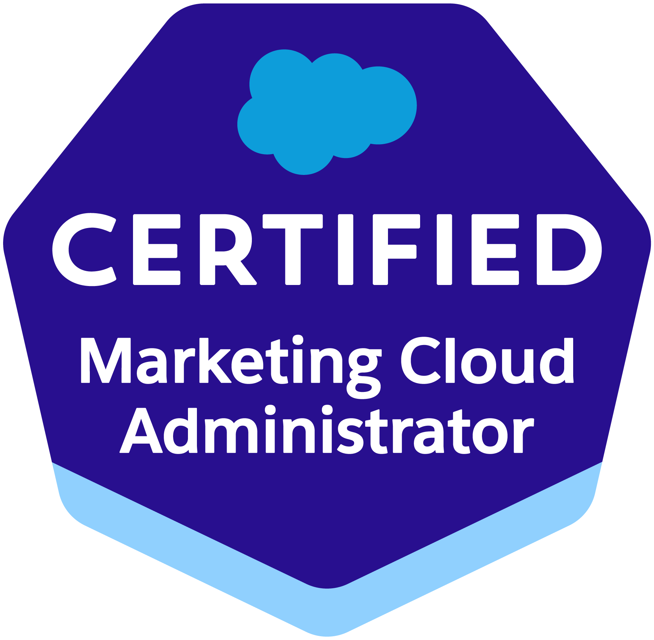
Vijayan Govindaramanujam
Sr. Salesforce Marketing Cloud Consultant/Architect
vijayan.govindaramanujam@gmail.com
(+91) 9600098464

OBJECTIVE
I am seeking employment with/for an organization that can provide me the opportunity to enhance my technical and functional skills by providing a challenging and rewarding environment. I look forward to adding value to the organization with my technical skills, expertise, passion for learning and desire to excel.
PROFILE SUMMARY
- I am currently associated with TekSystems Pvt. Ltd. as a Sr. Salesforce Technical Consultant and deputed in IQVIA as a Sr. Salesforce Marketing Cloud Consultant/Developer, proven capabilities of the Planning/implementing end-to-end salesforce Marketing cloud solutions, IT roadmap for the organization, process set up and management, project estimations, and team management and rapid development using agile/scrum methodology.
- I am an accomplished and integrity-driven professional offering close to 7+ years of experience in salesforce marketing cloud and Salesforce.com, and overall, of 17+ years of experience. Extensive experience in Support, Custom Automation, Migration, Custom Journeys & planning/implementing end-to-end Salesforce Marketing cloud solutions.
- I am certified in Marketing Cloud Email Specialist and Cloud Consultant. With in-depth knowledge of business and solution designing across multiple domains such as Health Care, Pharma, Retail, Entertainment, Manufacturing, Financial Services.
- I am well versed with Salesforce Marketing Cloud platform and have had good hands on in Salesforce.com Administration, Approvals, Cloud pages, API function calls, Payloads, Automation studio, Journey Builder, Multi-org integration, CRM integration.
- I have got expertise in Business Processes Re-engineering, Solution Designing & Estimation, Salesforce Marketing Cloud, and Requirement Gathering, System Integration. Also, have had delivered sessions in training for Train-the -Trainer & End user Training program.
- I have been able to setup and deliver exceptional custom support on Salesforce Marketing Cloud platform. With Deep inside knowledge of Salesforce Marketing Cloud product offerings and business challenges faced by customer users.
- I can deliver 100% from the managed service program setup for the customers. Handled the team and been individual contributor while supporting end users of clients.
SKILLS
Salesforce Marketing Cloud/  Salesforce.com | Salesforce Marketing Cloud (SFMC), Journey/Email/Automation/Mobile Studio/Mobile Push, Audience Builder, SSJS, AMP Script
Web Technologies | ASP.NET 2.0/3.0/3.5, MVC 4, Entity Framework 5.0, WCF, ASP, HTML
Development/Productivity Tools | ADO.NET, Visual Studio.NET 2010/12, Crystal Reports, MS (Project/Visio/VSS, TFS), UML
Programming/ Script Languages | C#, VB.NET, HTML, Visual Basic, XML, JavaScript, jQuery.

CERTIFICATIONS ACEHIVED
Year | Certifications | Certified by
2021 | Salesforce Marketing Cloud Administrator | Salesforce
2019 | Salesforce Marketing Cloud Consultant | Salesforce
2018 | Salesforce Marketing Cloud Email Specialist | Salesforce
2008 | Microsoft Certified Professional (MCP) | Microsoft Corporation

PROFESSIONAL WORK EXPERIENCE

IQVIA/TEKsystems (From Jun’20 to till date)
Project: OCE Digital
Role: Sr. Salesforce Marketing Cloud Consultant/Sr. Developer
Project Details
IQVIA is a world leader in using data, technology, advanced analytics, and expertise to help customers drive healthcare - and human health - forward. Together with the companies we serve, we are enabling a more modern, more effective, and more efficient healthcare system, and creating breakthrough solutions that transform business and patient outcomes.
Working as a Sr. Technical consultant and lead of marketing cloud and sales cloud projects execution and provided necessary support and solution, migrating from different CRM to SFMC platform to send email, SMS to customers through SOAP/REST API and customer data handling.
Responsibilities
Requirement gathering and define a scope of the project, preparing blueprint and discussion with client on technical design/solution.
Created and managed custom objects and its relationships, reports, and dashboards.
Implementing end-to-end Salesforce include discovery of project, project estimation and project management.
Handling migration projects from the scratch level.
Managing 8 team members and mentoring towards technical as well as delivery aspects.
Creating contact attributes and synchronized sales/service objects into marketing cloud platform to use Journey through Automation.
Writing/consuming API services to enable third-party integration with Salesforce marketing cloud.
Developing/Configuring complex Custom Automations, Journey Builder (using Salesforce objects and reports as entry source) for defining customer event journey, Mobile connects, Email creation, contact builder
Migrating Consumer and HCP data between CDP and Salesforce Marketing Cloud environment

Intuit/Altimetrik (Aug’19 to Jun’20)
Project: Tech4i
Role: Sr. Salesforce Technical Consultant
Project Details
Intuit Inc. is an American business and financial software company that develops and sells financial, accounting, and tax preparation software and related services for small businesses, accountants, and individuals. Working as a Technical consultant and lead of marketing cloud and sales cloud projects execution and provided necessary support and solution, migrating from different CRM to SFMC platform to send email to customers through SOAP API.
Responsibilities
Requirement gathering and define a scope of the project, preparing blueprint and discussion with client on technical design/solution.
Created and managed custom objects and its relationships, reports, and dashboards.
Design and maintain user interfaces using Visualforce pages
Developed lightening components and integrate the components in the applications.
Managing 5 team members and mentoring towards technical as well as delivery aspects.
Implementing end-to-end salesforce include discovery of project, project estimation and project management.
Handling migration projects from the scratch level.
Creating contact attributes and synchronized sales/service objects into marketing cloud platform to use Journey through Automation.
Writing/consuming API services to enable third-party integration with Salesforce
Writing/Configuring Automations, Journey Builder (using salesforce objects and reports as entry source) for defining customer event journey, Mobile connects, Email creation, contact builder

Theorem (Sep’16-Aug’19)
Project: Ignite Digital, Australia
Role: Sr. Salesforce Technical Consultant
Project Details
Ignite Digital is an Australian based company and Theorem will support them to providing solution, end-to-end SFMC implementation for them. Working as a Sr. Technical Consultant and taking care of all SFMC, Service Cloud and Sales Cloud projects execution, provided solution, Configuration, and end-to-end Implementation. Handling team of 15 dedicated resources.
Responsibilities
Requirement gathering and define a scope of the project, preparing blueprint and discussion with client on technical design/solution.
Implementing end-to-end salesforce include discovery of project, project estimation and project management.
Handling migration projects from the scratch level.
Creating contact attributes and synchronized sales/service objects into marketing cloud platform to use Journey through Automation.
Creating cloud pages in place of microsites, performing IP Warm up and consuming sales/service cloud data into marketing cloud with generating unique ID.
Managing 4 team members and mentoring towards technical as well as delivery aspects.
Customizing and configuring the Salesforce platform as per client’s needs.
Creating Multi-Org connection using Marketing Cloud Connect (MCC) to achieve sales/service and MC integration.
Writing SQL Queries, AMPScript, SSJS and other salesforce specific technical components to enable business processes and customer engagement.
Writing/consuming API services to enable third-party integration with Salesforce
Writing/Configuring Automations, Journey Builder (using salesforce objects and reports as entry source) for defining customer event journey, Mobile connects, Email creation, contact builder
Project: Aberdeen and Glasgow Airports, UK
Project: Oxford Bio Labs, UK
Project: Neyber, UK
Project: The First Club, UK
Project: MSM, UK
Role: Sr. Salesforce Technical Consultant
Responsibilities
Requirement gathering and define a scope of the project, preparing blueprint and discussion with client on technical design/solution.
Implementing end-to-end salesforce include discovery of project, project estimation and project management.
Handling migration projects from the scratch level.
Creating contact attributes and synchronized sales/service objects into marketing cloud platform to use Journey through Automation.
Creating cloud pages in place of microsites, performing IP Warm up and consuming sales/service cloud data into marketing cloud with generating unique ID.
Customizing and configuring the Salesforce platform as per client’s needs.
Managing 8 team members and mentoring towards technical as well as delivery aspects.
Creating Multi-Org connection using Marketing Cloud Connect (MCC) to achieve sales/service and MC integration.
Writing complex SQL Queries, AMPScript, SSJS and other salesforce specific technical components to enable business processes and customer engagement.
Writing/consuming API services to enable third-party integration with Salesforce
Writing/Configuring Automations, Journey Builder (using salesforce objects and reports as entry source) for defining customer event journey, Mobile connects, Email creation, contact builder
Integration of Sales/Service Cloud with Marketing Cloud using Marketing Cloud Connector.
Supporting testing phases, user training, project handover, etc.
Designed Enterprise level Salesforce Marketing Cloud Architecture managing integrations with external systems such as Salesforce Sales Cloud.
Successfully delivered solutions involved using Emails, Triggered Sends, Landing Pages, Cloud Pages, Scripting languages, Automation Studio, Web Analytics Connector, Salesforce Marketing Cloud Connector, Audience Builder, Journey Builder, Mobile Connect, Personalization Builder, Contact Builder, Social Studio, Advertising Studio, Discover reports, etc.

HTC Global Solutions (Jun’14-Aug’16)
Project: Business Integrated Planning Optimization System (BiPOS)
Project: Recall - Billing Engine, USA
Role: Technical lead/Sr. Developer
Technologies: ASP.NET MVC 4, EF 5, UOW Pattern, jQuery, Web Service, SQL Server
Responsibilities
Involving Technical Architect design for BiPOS which is aimed to incorporate with existing application.
Delivered modernized application meeting end to end customer requirement
Trained end-users by means of verbal personal instruction and specially designed documentation.
Managing 10+ team members and mentoring towards technical as well as delivery aspects.
Requirement gathering from client and analyzing the scope and estimate of the project.
Analyze requirements and prioritize the tasks to the team and get it done within timeline.
Done for code review, System and Unit test cases.

Tesla/BCT (Oct’12-May’14)
Project: Recall - Warp Drive (WD), Tesla Motors, San Francisco
Project: Gate 8 / Just In Time Web Application, Tesla Motors, San Francisco
Role: Technical lead/Onsite-Offshore Manager/Sr. Developer
Technologies: C#.Net, ASP.NET 3.5, MVC 3, EF 4, Telerik, jQuery, WCF, Web Service, SQL Server 2008
Responsibilities
Delivered modernized application meeting end to end customer requirement
Involved design and development and support activities.
Managing 15+ team members and mentoring towards technical as well as delivery aspects.
Requirement gathering from client and analyzing the scope and estimate of the project.
Analyze requirements and prioritize the tasks to the team at offshore/onsite and get it done within timeline.

Wipro (Nov’07-Sep’10)
Project: Universal weather and aviation (FlightPak), USA
Project: ZonePRO 32/64 application, Harman Music Group, USA
Project: Loss Prevention Solution (LPS), USA,
Project: COFEE West Ordering System (FTTPWest), Verizon, USA
Project: Genisys, UK
Role: Technical lead/Onsite-Offshore Co-Coordinator/Sr. Developer
Technologies: ASP.NET 3.5, C#, jQuery, MVC, WCF, Entity Framework 4.0, SSRS, SQL Server 2008 R2
Responsibilities
Requirement gathering from client and analyzing the scope and estimate of the project, managed 10+ team members.
Analyze requirements and prioritize the tasks to the team at offshore/onsite.
Interact with client and conducted scrum meeting with team members. Drive the client status meeting.
Tracking post release defects (PRD), problem tickets
Involve Coding, Code reviews and Unit & Integration testing. Use Test Case & System Test Case preparation.

Rushmore Consultancy Services (Jan’04 to Oct’07)
Project: Internet Banking for Card division, USA
Project: CaseStack Inc, USA
Role: Software Engineer/Sr. Software Engineer
Technologies: ASP.NET, VB.NET, ADO.NET, Java Script, SQLServer 2000

Responsibilities
Developing business logic in VB.NET, Detailed Design Document, UTC & STC preparation, Coding, Code reviews and Unit Testing. Developing BO and PO in C#.NET and UI design in ASP.NET 2.0, handling the team and assign the task. Use Test Case & System Test Case preparation, Coding, Code reviews and Unit & Integration testing.

EDUCATION
2011 | Master of Business Administration (MBA-Distance) | Marketing | Bharathiar University
2001 | Bachelor of Computer Science and Engineering (BE) | Computer Science | Bharathiar University

TRAININGS ACEHIVED
Year | Trainings | Category | Organized by
2011 | Interviewer Certification Program (ICP) | Certification | Wipro Technologies
2010 | Future Management Program (FMP) | Certification | Wipro Technologies
2009 | The Emerging Leader Program (ELP), Customer Leadership Interface Program, Power Consulting | Certification | Wipro Technologies
2008 | Hands-on Leaders Program, Agile Scrum Methodologies training | Certification | Wipro Technologies

