[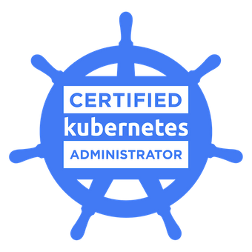](https://www.youracclaim.com/badges/63b5777a-dfbb-4699-9077-1dd4211458d5)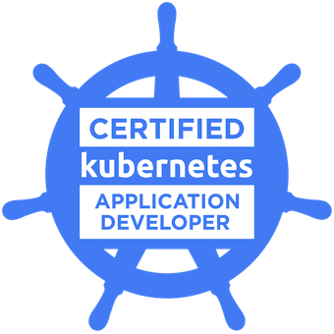

**Kumaresan Periyasamy DevOps Engineer**

* +91-8667824478
* +91-7411457505

Free Mail Icon, Symbol. Download in PNG, SVG format. kumaresanperiyasamy68@gmail.com

Hormavu, Bangalore.

# Profile:

Skilled Devops Engineer with 5.7 years of hands-on experience supporting, automating, and optimizing critical deployments in CI/CD, configuration management, DevOps processes. Experience with AWS services, Docker, kubernetes and open source automation tools. Proven ability to demonstrate the benefits of cost effective IT solutions to solve major business issues.

# Technical Expertise:

* Automating dynamic provisioning of EC2
* Installed, configured and managed Jenkins, and Artifactory for building the pipeline supporting end to end deployment process.
* More than 1 year of experience on kubernetes. Hand-on knowledge on the concepts like Deployments, service-mess, Replicasets, PV ( Portworx )
* Experience in Deploying applications using Helm-v3
* Worked on creation of custom Docker container images using docker-compose and pushing the images to the Jfrog Artifactory repo.
* Good knowledge on managing and maintain code in Git/Gitlab repositories.
* Good knowledge on writing ansible playbook, hand-on experience on ansible tower for automating deployment process in CICD pipeline.
* Good Knowledge on managing Slatstack cluster for config management
* Good knowledge on migration of on-premise services to AWS cloud
* Worked on VPC in order to create public and private subnets for respective module in the project.
* Good knowledge on setting up kubernetes cluster management with monitoring service mesh with isto and ELK
* Hands-on knowledge on IAM, EC2, S3
* Good in Automation using shell scripting and Python with Chatops
* Maintained the build and deployment process documentation for future reference.

# Professional Experience

# Nvidia Graphics Pvt ltd, Bangalore

DevOps Engineer – May 2018 to Current

## Roles & Responsibilities:

* Working closely with Storage, development and IT teams to implement new application/environment related requirements
* Architecting and Deploying Nvidia DGX supercomputer on-premises clusters
* Planning and deploying new releases using Gitlab CI / Jenkins CI tools
* Deploying Data migration plans from on-premises to Cloud ( AWS )
* Building Server/Infrastructure automation CLI tools using shell & python for Linux clusters
* Evaluating Opensource tool for future infrastructure deployments
* Archiving historical metrics data to aws s3 buckets for backup
* Implemented the microservice architecture for the kubernetes platform making it highly available, scalable and data redundant.
* Hand-on experience on Perforce & Gitlab version control system.
* Set up of CICD end to end process to automate the deployments using by utilizing Jenkins, for new releases.
* Managing Kubernetes cluster deployments using Rancher
* Developing custom reporting tools, setting up automated health monitoring and alerting for builds and environments.
* Good experience in creating and configuring new build jobs, plugins management and other admin

level tasks in Gitlab CI/CD.

* Maintaining Large scale Linux infrastructure
* Working on server end to end support and Hardware cases (HP and Dell , Nvidia DGX)

**Qualcomm, Bangalore.**

**IT Engineer -** July 2016 to Mar 2018

## Roles & Responsibilities:

* Managing and building LSF compute servers
* Managing and troubleshooting issue on Linux display technologies ( Nomachine, OVDC, VNC )
* Provisioning Virtual servers using VMware based on user request
* Opensource tools installation and maintaining up-to-date with latest release on AFS
* Collecting metrics data with using SPLUK for monitoring
* Troubleshooting Linux server Hardware related issues

**Nixserv IT solutions Pvt Ltd, Bangalore**

Linux &Web Hosting Admin – May 2015 to July 2016

## Roles & Responsibilities:

* + Installation and Troubleshooting server of various Virtualization such as XEN source, OpenVZ.
  + OS / Patch upgrades with release patches by planning down time with end users.
  + Experience on user administration.
  + Managing LVM with disk resize
  + Mail Servers - Installation of mail servers like Exim, Postfix and SendMail POP & IMAP with configuration.
  + Server Hardening - Complete server hardening techniques, Securing server, Wheel user setup.
  + Control Panel's – cPanel/WHM, Plesk, DirectAdmin. SolusVM.
  + MySQL - Repairing tables if crashed, error logging, database Maintenance, Taking dumps, ensuring remote MySQL availability.
  + Monitoring Tools – Managing and monitoring servers using Nagios.
  + Handling troubleshooting issues relates to servers and networks.
  + Maintaining Service Manager and WHMCS ticketing tickets in order to track the incidents

& Request relates to servers.

* + Installing and Updating Packages using RPM/Yum and APT.

# Technical Skills:

|  |  |
| --- | --- |
| **Cloud Platforms / Virtualization** | **Amazon AWS:** EC2, S3, IAM, VPC, ELB, Amazon Route 53, Auto Scaling. [ Terraform ]  **Private cloud:** Vmware, OpenVZ, KVM  Kubernetes [ Helm ] |
| **Operating Systems** | Linux: RHEL, CentOS 6/7, Ubuntu 18/20, Windows: 2008/2012 server. |
| **Configuration Management** | Ansible, Salt stack |
| **Scripting** | YAML, Shell scripting, Python |
| **Automation & Build tools** | Perforce, Gitlab, Jenkins, Docker, Kubernetes |
| **Network/Infrastructure** | TCP/IP, DNS, DHCP |
| **Storage** | NFS, AFS, Lustre, IBM GPFS |

**Education:**

|  |  |  |  |
| --- | --- | --- | --- |
| **Qualification** | **Institute / Board** | **Year** | **Percentage** |
| B.Tech | Sri Krishna College of Technology | 2015 | 61.9% |

# Certifications & Training's:

* Kubernetes Certified Administrator
* Kubernetes Certified Developer
* Cisco Certified Network Associate ( expired 2019 )
* Slurm Cluster Administrator Training
* Mellanox infiniband Training
* Winner of “**Star Achiever”** award at Nvidia Quarterly award 2020 Q1.

# Personal Details:

* + Date of Birth : 10th Sep 1994
  + Gender : Male
  + Marital Status : Single
  + Nationality : Indian

# Declaration:

I hereby declare that all the above given information is true to the best of my knowledge and belief. Place: Bangalore