Shivangi Mishra  Mobile No: +91 8588832901  shivangionline2013@gmail.com | 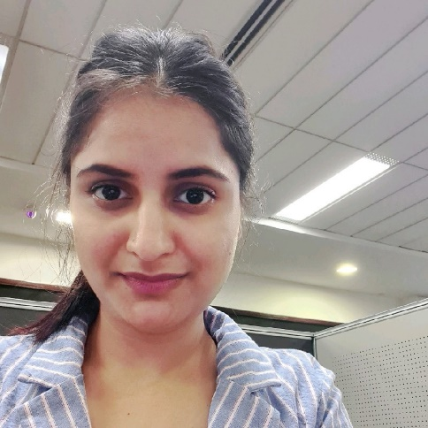

Objective
To seek a position in an organization, where I can utilize my skills and experience to enhance myself in all aspects of an individual as well as help the organization in the process.

Summary
- Total 8+ years of competitive experience in Operation.
- Experience of working in the complete operations life cycle involving planning, Control, coordination, execution, process development and Performance improvement.
- Working on latest trends like Tableau, Power BI, and advance excel for data analysis and visualization.
- Trained Six sigma strategies with green belt certified.
- Good work ethics with excellent communication and interpersonal skills.
- Capable to delve into the new leading processes.
- Ability to work well in both a team environment and individual environment.

Work Experience Summary
- Working as Assistant Manager - Operations in Wave Infratech Pvt. Ltd., Noida since August 2014.
- Worked as Sr. Executive HR in Selvon Instruments Pvt. Ltd, Delhi from October 2012 – July 2014.

Technical Skills
Tableau | 3 years’ experience
Power BI | 1.5 Years
Advance Excel | 6 Years
SAP | End user
SQL | Basic
Microsoft Power Point | 8 Years
Managerial Skill | Data analytics, Data visualization, Corporate operation
 | Process management, People Management, Market research, Auditing
 | Business Operation, Cost Control, Business Analytics,
Process & Related tools | Six Sigma Green belt certified, MS Visio.

Education:

Postgraduate (Master of business administration) Full Time - UPTU (2008 – 2010).
Graduate (Bachelor of Science) Full time- M.J.P. Rohilkhand University (2005-2008).
Intermediate (Math ,Science) -Uttar Pradesh Board(2003-2005)

Achievements

Process improvement.
Performance Tracking system was implemented.
Introduced data Analysis tools to the team for better analysis and performance.
Employee of the month Three times in (Wave Group) tenure
National level winner of science project in NATIONAL CHILDREN’S SCIENCE CONGRESS’ and awarded by Mr. A.P.J. Abdul Kalam in 2010.

Significant Work Experience:

Organization : Wave Infratech Pvt. Ltd
Tenure : (August’ 2014 – till date)
Skill : Data Analysis, Data Visualization, MIS Reporting, Coordination, Auditing,
Operation management, Project management, People Management, Budgeting,
Vendor Management.
Role : Assistant Manager Operations

Industry Description:

The Wave group, a Rs. 15,000-crore diversified conglomerate, group boasts of an impressive business portfolio, including Real Estate, Manufacturing, Entertainment, Education, Healthcare, Beverages and Agriculture. The business model has evolved significantly through strategic investments in services and technologies. I am on the payroll of Mall and multiplexes division.

Responsibilities:
- Develop spreadsheets, diagrams and process maps to document needs
- Analyze and interpret trends or patterns based on the data on Spend, customer demographics, preferences, and trends using Tableau, Power BI, and Advance Excel.
- Act as facilitator/scrum master in the scrum process
- Recommend strategies and develop new procedures, Circulate all new plans and policies to all the sites.
- Develop a detailed project plan to monitor and track progress
- Create and maintain comprehensive project documentation
- Managing the daily revenue report, weekly recovery report, monthly operational report, cinema parameter report, monthly P&L review, outstanding review.
- Assisting in setting and reviewing budgets and managing cost on monthly basis.
- Report and escalate to management as needed
- Coordinate internal resources and third parties/vendors for the flawless execution of projects
- Audit of sites and present the Audit report to management.
- Conduct investigative internal audits and create reports of findings.
- Tracking, overseeing inventory audits and maintaining reports of purchases and pricing.
- Time to time Clearance the non-movable items when it comes to dead stock.
- Forecast requirements; prepare an annual budget; schedule expenditures; analyze variances; initiating corrective actions
- Manage relationships with key operations vendors.

Organization : Selvon Instrument Pvt. Ltd
Tenure : (October 2012 to July’ 2014)
Skill : HRIS, Strategic Management, Employee engagement.
Role : Senior Executive HR

Industry Description:

The SELVON INSTRUMENTS PVT. LTD existing in the market last from the past three decades provides end to end extensive solutions to the power requirements through their expertise. They have big clients list of corporate as well as government sites.

Responsibilities:

- Verification of Documents.
- Completion of Joining formalities & Documentation work of the new employee.
- Familiarizing them with the HR Policies, attendance, leave policy, etc.
- Full & Final settlement Process documentation.
- Handling full recruitment cycle.
- Restructuring of departments based on business needs
- Preparing and presenting HR dashboards.
- Organizational diagnostic based on analysis of organizational history (manpower strength and cost history comparison.
- Revenue per employee, attrition analysis. Formulating HR budget and tracking it on monthly, Quarterly and Annual basis for Actual vs. budgeted comparison.
- Support employee development, appraisal & promotions for entire zone.
Talent Management & Development through Career Progression Programs & other HR interventions.
- Manage Employee Engagement Programs, Rewards & recognition, Fun at work etc.
- Identifying attrition root cause and working proactively with business & finding a resolution.
Participate in HR Policies Implementation
- Handling Employee Grievance
- Handling external surveys.

Personal Information:

Date of Birth : 01 July 1988
Address : Civitech Sampriti, Sector- 77,
Noida - 201301 (U.P.)
Marital Status : Married
Languages known : English and Hindi

Signature:

Date: References:
Available on request.

