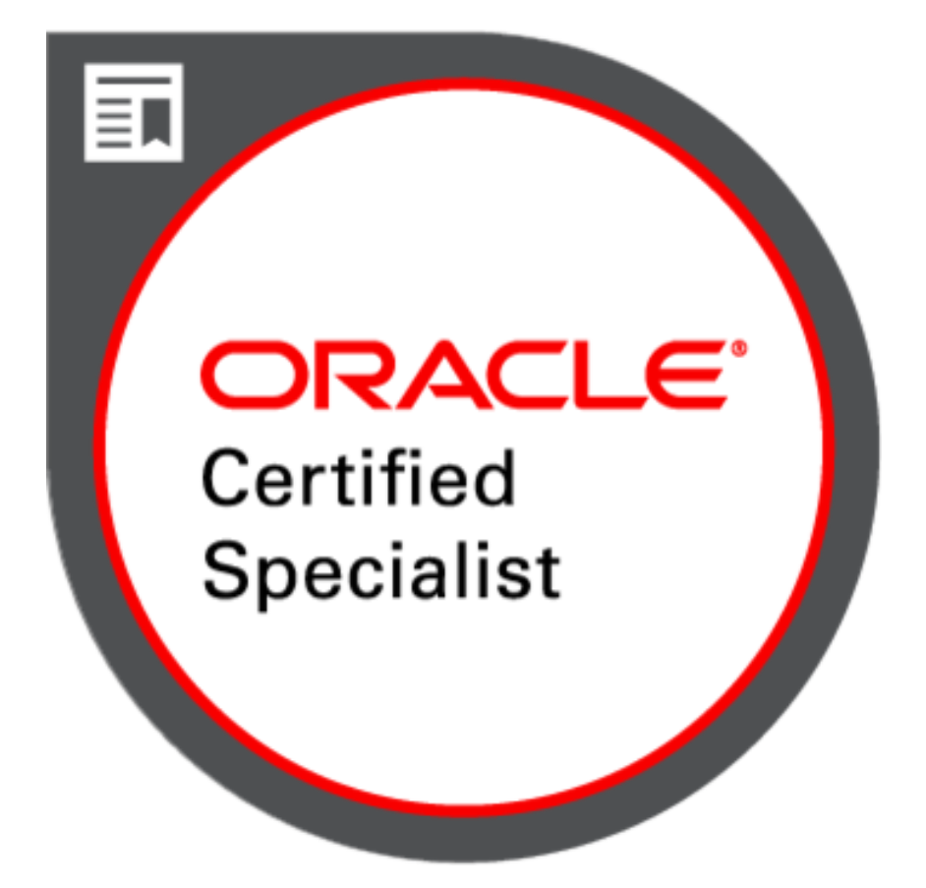 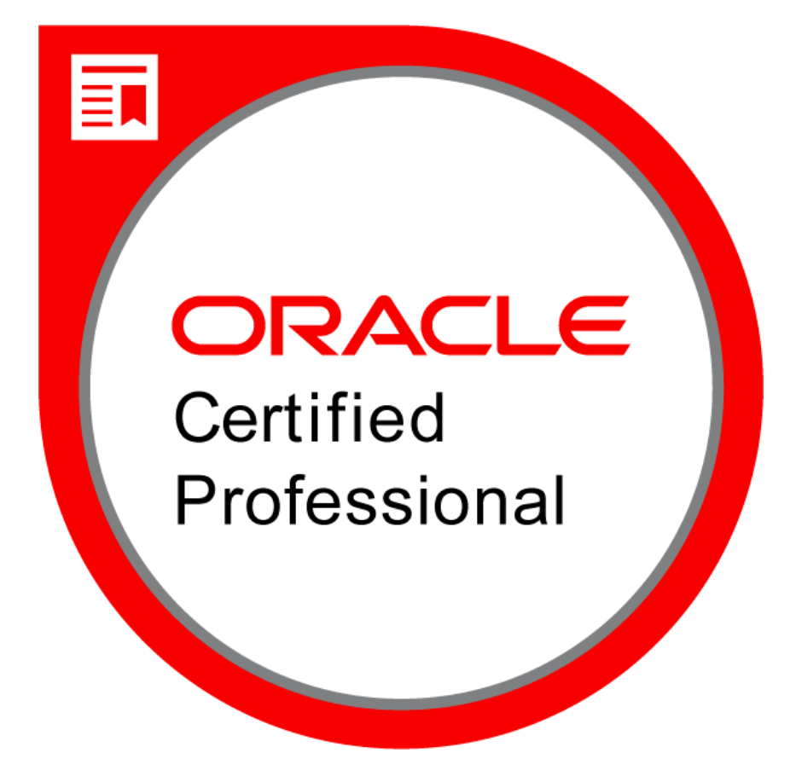 **SHARAD SHETTY**

**Mobile**: (**661) 236 1003** **E-mail: sharad.shetty5@gmail.com**

­

**Summary**

* Over 12+ years of experience as an **Oracle** DBA, **Cloud** DBA, **Oracle RAC** DBAand **Teradata** DBAwith Excellent Knowledge on **Oracle Exadata, Oracle Cloud Infrastructure, AWS, Azure**
* Proficient in administering and maintaining Oracle databases, **24X7** Production Database Support
* Expertise with **Amazon SCT** for schema conversion and migrating **on premise** Oracle database to **AWS** **Cloud** using **DMS**
* Expertise in **Installation**, **configuration** of Oracle 19c/18c/12c/11g/10g/9i on Windows and Linux platform
* Proficient in Oracle version **Upgrades** and **Patching** Oracle (19c/18c/12c/11g/10g) **RAC** databases
* Proficientin implementing **backup** **and recovery** **strategies** for Non-RAC and RAC databases using **RMAN** and **NAS** **Storage snapshots**
* Proficient in implementing **High Availability** oracle solutions using **Data Guard** and maintaining **standby database** using **DG Broker**
* Expertise in developing **shell scripts** for Monitoring and database health checks
* Expertise in Oracle **Golden Gate** implementation of both integrated and classic capture/replication and troubleshooting **conflict** resolution and **replication** issues
* Proficient in working on **SQL Loader** and **Data Pump** Utility
* Experience in **Database hardening** and maintain database security
* Proficient in **Cloning** and **refresh** of Database using **RMAN and Other Backup utilities**
* Experience in migrating database from normal file system to **ASM** file system
* Expertise in **database tuning** at various levels such as **Application Tuning**, **Memory Tuning**, **SQL Tuning** and **Database Contention** by using **Explain Plan, SQL Trace, SPM, SQL Advisor, ASH, AWR** and **ADDM**
* Analysis of **ADDM**, **AWR**, **ASH** & **SQLT** report to troubleshoot and identify database contention and Query performance, additionally perform **10046** and **10053** trace analysis for **Query optimization**
* Expertise in **OEM13c** Installation and Configuration**.** Expertise in configuring different types of report using **Cloud** Control to help DBA’s day to day tasks. Ex: - Backup, Filesystem report, CPU/Memory/Disk IO report
* Working with Oracle Support for resolving **critical** database **issues**
* Experience in Managing other Database Variants like **Teradata**, **MSSQL Server**, **Postgres SQL**
* Excellent **communication skills**, with strong **troubleshooting**, and **problem-solving** ability. Motivated to take independent responsibility as well as to contribute to be a productive team member. **Strong** Team building and **mentoring** **skills** and excellent **Team** **leadership** capability.
* Strong team player and be able to work alone. Highly **self-motivated** and able to adapt and learn **new technologies** quickly
* Efficient team member to provide **24x7** on call support of critical production databases

**Working Experience**

* Working for **LNT InfoTech** as Sr. Oracle DBA Jan 2010 to till Date
* Worked for **Ingram micro** **Ind Pvt Ltd** as a **Software Engineer** from April 2008 to Jan 2010
* Worked for **Supreme Ind Ltd**, Mumbai as **IT Professional** from Jan 2007 to Feb April 2008

**Skill sets**

Operating Systems : Red hat Linux, Windows, AIX, SUSE Linux

Tools/Utilities : Oracle RMAN, OEM Cloud Control(12C/13C), Exp/Imp Data pump, SQL Loader, Toad, SQL Developer, tkprof, oratop, AWR, ADDM, ASH, SQLT, SQL Tuning Advisor, Oracle Golden Gate, SSMS, Teradata Assistant, Teradata Administrator, SPLUNK

RDBMS : Oracle 9I, 10g, 11g, 12c, 18c, 19c, Teradata 15, 16

Skills : Database Administration, Performance Tuning, Migration, Cloning, Backup, Upgrades, Patching 10G to 19c RAC and Single Instance Database, Cloud Architect, Cloud Database Specialist

**Professional Experience**

**Larsen & Toubro Infotech Ltd**

Project : Production and development DBA Support for oracle 12c, 11g, 10g RAC/Non-RAC databases

Role : Oracle DBA, Cloud DBA & RAC DBA

Environment : Oracle 10g, 11g, 12c on RHEL 5 & RHEL 6

Duration : May 2014 to till Date

#### Responsibilities:

**Chevron, Bakersfield, CA**

**Senior Oracle DBA, Teradata DBA & GoldenGate Administrator**

* **Supporting** day to day activities in **24/7** Prod DBA Env. **Managing** team of DBAs involved in **Production support, Development activities** and provide essential **technical guidance**
* **Plan, Install, configure** and **maintain Oracle** RDBMS **and Teradata** Database System
* **Patch** databases with latest **security patch** **and** Upgrade **CRS**, **ASM** and **Database** to latest version (11g to 12c to 19c)
* **Supporting** day to day **Teradata** DBA activities along with on-going development tasks
* Build, configure **HA Solution** by implementing **Standby** **DR** database for **Standalone** and **RAC** databases; Managing **DG** environment using **Data Guard** **Broker**
* ImplementedOracle **Active Data guard** for **production** database server
* Implementedand **Configured** Oracle **OEM 12C/13C Cloud Control**
* Expertise in **Upgrade** from **OEM 12**.**1** to **13.3**. Expertise in Central and target agent upgrade
* Implemented Oracle **Golden Gate** integrated and classic capture/replication; Working on troubleshooting of **conflict resolution** and replication **performance issues**
* Setup **OEM Software library** for **database provisioning** using **OEM 12C/13C**
* **Build backup** & **recovery** strategies for single instance and RAC databases
* Created and implemented **RMAN backup** and **recovery** scripts and several other monitoring scripts
* Worked with **AWS** consultant to move **on premise** databases to **AWS Cloud using DMS**
* Worked with **AWS Schema Conversion tool** to migrated from **Oracle** to **PostgreSQL**
* **Performance** **tuning** of databases including **instance tuning**, **query tuning** of bad SQL queries using **Explain PLAN** andother utilities
* Provided **instance level** performance monitoring and **tuning** for **Wait Events**, **latches**, **Sessions**, **Physical** and **Logical IO** and Memory Usage using **ADDM, AWR, ASH, SQLT**
* Worked with **Oracle support** for improving regressed queries, interpret **10046** trace files. Understanding the **10053** trace to find the **bad queries** in upgraded databases
* Worked with Oracle support to troubleshoot and fix **Wrong result issues** due to **internal bug** in upgraded databases
* Performance and regression solutions by recommending **SQL profiles**, **Outlines**, **new indexes** and **Materialized Views**. Experience of SQL plan management (**SPM**), **SQL Plan Baseline** and advisor tools such as **SQL Tuning Advisor**, **SQL Access Advisor**, **SQL Performance Analyzer**, **SQL Tuning Set** and Advisors to generate tuning recommendations; reviewing, analyzing and providing solutions
* Provide **support** through **daily** **operations** of Oracle Databases
* **Manage** day to day Azure **Cloud** database support activities
* **Develop** and maintain **technical** & **process** documentation
* Working closely with Application team for **application upgrade** and enhancement activity
* Maintain **security** and **integrity controls** for hardening of database
* Maintain **Chevron** **policies**, **procedures** and **standards** during all database activities
* Perform day-to-day **troubleshooting** of issues related to Oracle client/server connectivity
* Troubleshoot issues/errors/incidents, Collaborate with Oracle support for **bugs & issues resolutions**

**Ingram Micro, Santa Ana, CA**

**Senior Oracle DBA & GoldenGate Administrator**

* Maintaining large **Production, UAT, QA, SANDBOX, TEST** and **DEV** **SAP** environments
* Applied database **PSU** and **SAP Bundle patches** on **RAC** and **NONRAC** Databases
* Implemented Oracle Database 11g two node Real Application Cluster (**RAC**) on a AIX system
* Configuring Oracle **Golden gate** for schema and Table level replication, Bi-Directional replication
* Troubleshooting **Golden gate** replication problems such as unique key violation / long transaction abend by using GGSCI / Log dump / discard file analysis
* Performance Tuning OGG in extremely high data volume environments
* Cloning from **Cluster** database to **Standalone** database for test environment
* Managing of **Tablespace** for different **User** by Granting Quota on Default & Temporary Tablespace
* Written **Stored procedure** for monthly table **partitioning** activities
* Installed and setup 11g Oracle Enterprise Manager Grid Control (11.2.0.1) and Mass Agent Deployment on several hosts
* Developed database monitoring/**health** check / **Alert** Monitoring/ **Tablespace** scripts, and sizing issues using grid control (**OEM**)
* Performed **manual** **recovery** using archived logs, **RMAN**-**managed** backup, operating system backup, cold and **hot** backup, **full** backup, **incremental** and **cumulative** backups
* Implemented **Data Guard** with high availability and performance configurations and participated in Data Guard Fail over tests
* Configuration and Maintenance of physical standby databases with DG BROKER
* Monitor **tablespace** **growth** and take proper actions like resizing datafiles, adding new data files
* Recommending **indexes** and other performance benefits for **SQL query** which helps for query optimization on production databases
* Performed **table reorganization** using **dbms_redefinition** package
* Performed **Schema/Database Refresh** from Production to QA, UAT and Development databases
* Working on real time production database for **performance** issues on the database
* Implemented data transfer using **Export/Import** utilities and Data Pump
* Configuring database backup report, File system threshold report, CPU Memory, Disk I/O report using **Grid/Cloud Control**

**Ingram Micro Ind Pvt. Ltd**

Project : ERP – Adonis Application Support

Role : Application Support, DBA

Environment : Sun OS, Universe DB, Mainframe, MS SQL server, Oracle database

Duration : April 2008 to Jan 2010

#### Responsibilities:

* **Monitoring** phantom **process** of **Daily Backup** and ensure that Backup is completed properly and the required Business reports are generated
* **Monitoring** routine **process** which is crucial for daily business activities
* **Restoration** of Invoice Filefromtape for restoring missing Invoices
* Performing **Backups** (Cold and Hot) Oracle **RMAN** & **Export/Import** Tools and utilities
* Creation of database objects like **Tables, Indexes, Views, Users**, etc
* Managing **tablespaces**, user **profiles**, **storage** parameters
* Database installation, support and administration
* Important and major contribution in Implementation & Support activity of **Sales, Purchase & Inventory Modules** at “**Ingram Micro Private Limited**” for New Zealand (Primary) and Australia (Secondary) User’s
* **Monitoring** the **record locks** and clearing the locks if record is locked by inactive sessions
* Handle’s the **Technical** operations and provides support for the various **ERP** modules
* Preparation of **Requirement documents**, **User manuals** of different **ERP Modules** for reference
* **Managing database** login credentials for **E-commerce** Website Login’s and Temporary Website Login’s for **End Users** and **Customer’s**, so that they can place online orders
* **Uploading** database of E-commerce **Website** using SQL server 2000 **Import/Export** Utility in case of technical failure

**The Supreme Ind Ltd**

Project : ERP Implementation & Support and ITM40 – RF Gun Implementation

Role : Application Support, DBA

Environment : ITM40 ERP System, DB2, Oracle

Duration : Jan 2007 to April 2008

#### Responsibilities:

* Creating **Table,** **Table Partitions** for Inventory Data
* Creating **Table Indexes** and **Views**
* Performed different method of **backups** like COLD, HOT using **RMAN** and **OS**
* **Monitoring tablespace** & their growth and took appropriate actions
* Mapping RF Gun with **online Database** for proper capturing of Inventory information
* **Testing** real time data with different types of transactions for proper data mapping
* Mapping with current ERP system for proper flow of transaction
* **Preparation of Error Reports & Test Cases**
* **Training and implementation of Sales, Purchase & Manufacturing Modules of ERP - ITM 40** (Integrated Trading and Manufacturing) at various Plants & Corporate offices of “**The Supreme Industry Limited**” across INDIA for streamlining the operations of various functional areas viz., Sales, Purchase & Manufacturing
* **Managing Tablespace** for Different User by **Granting** Quota on default & temporary tablespace
* **Monitoring alert log** files and fixing critical errors
* **Granting and revoking Permissions** to/from the users as per request
* **Space management** which includes tablespace creation, adding and resizing datafiles
* **Cloning & Refresh of Database using RMAN tools**
* **Creating Table Partitions and Archiving Old data (Ex. Invoice Table purging)**
* **Handling Database activities like Table creation, updating and alteration**
* **Managing Database by providing access to New User’s, along with required Access rights as per mentioned by their Head of Department**
* Achieved substantial reduction in rate of mistakes through **monitoring** and **analyzing** the accuracy and the mistakes done by the users
* Streamline the needs of various reports for **MIS** Generation by maximum utilization of Business Intelligence Tools i.e. **BI-TOOLS**

**Educational Qualifications**

* **B.sc** Computer Science **(2003-06)** from Mumbai University, Maharashtra, India

**Achievements/Awards**

|  |  |
| --- | --- |
| Sr. No | **Achievements / Awards** |
| 1. | Certified Oracle Database 9i/11G/12C OCP Professional |
| 2. | Certified Oracle Autonomous Database Specialist - 2019 |
| 3. | Certified Oracle Cloud Infrastructure Architect Associate – 2019 |
| 4. | Spot Award at LNT InfoTech for best performance in 2011. |
| 5. | Valuable performance award for the year 2012. |
| 6. | Spot Award at LNT Infotech for best performance in 2014. |
| 7. | 2016 Best performer award |