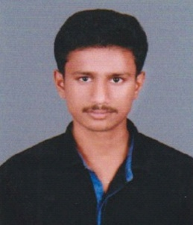

E-mail : sakthitamil254@gmail.com.

Mobile : 7904186061.  **S.SIVASAKTHI.**

**OBJECTIVE**

Seeking a position of Programmer/Developer in the field of IT where fresh talent will add value to operations and utilize my skills and abilities.

**ACADEMIC PROFILE**

|  |  |  |  |  |
| --- | --- | --- | --- | --- |
| **DEGREE**  **/COURSE** | **INSTITUTE** | **UNIVERSITY / BOARD** | **Aggregate %** | **Year of passing** |
| M.C.A | SASTRA University, Thanjavur | SASTRA University | 7.8 CGPA | 2021 |
| B.C.A | Meenaakshi Ramasamy Arts and Science College, Thathanur | Bharathidasan University | 78.9% | 2018 |
| H.S.C | Govt Higher Secondary School, Jayankondam | State Board of School Examination Govt. of Tamil Nadu | 69% | 2015 |
| S.S.L.C. | Govt Higher School, Paranam | State Board of School Examination Govt. of Tamil Nadu | 84.6% | 2013 |

**ADDITIONAL PROFILE**

* Cloud Computing.
* DCH-Diploma Computer Hardware.
* D.Co-op- Diploma Co-operative Management.

**PROJECTS**

* **Android App Development on Lens on Expenses**

Gained practical knowledge by doing projects on website development and currently

Working on Android Application development.

**TECHNICAL SKILL**

Operating Systems : Windows , linux.

Database : My SQL , MS Access.

Languages : JAVA, Python, PHP, Java script

Web Development and Android Devops .

**PERSONAL DETAILS**

Father's Name : Sundaresan.K

Date of Birth : 06-05-1998

Gender : Male

Marital status : Unmarried

Mother Tongue : Tamil

Languages : Tamil, English

Communication Address : 47/20,Ayyasami pillai Street,

Udayarpalayam (PO),

Udayarpalayam (Tk),

Ariyalur (DT),

Pin 621804.

**DECLARATION**

I here by declare that, the above information furnished by me is correct up to my knowledge

and i bear the responsibility for the correctness of the above mentioned particulars.

Place: Udayarpalayam.

**SIGNATURE**

Date:  **(S.SIVASAKTHI)**