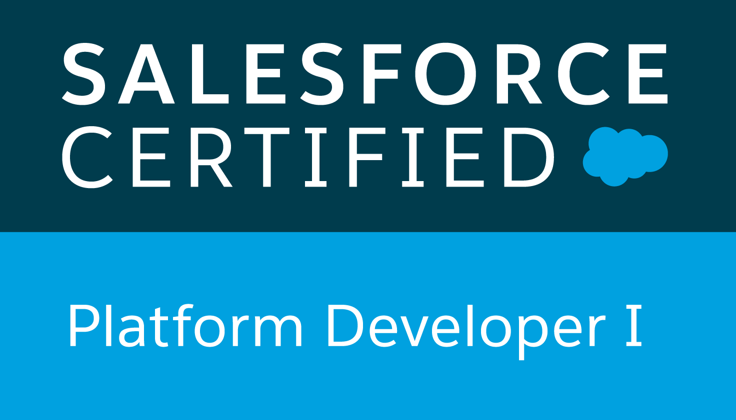

**Udaya Katta**

**M: +91 8308036360**

**Email:** [udaykumarkatta@gmail.com](mailto:udaykumarkatta@gmail.com)

**Salesforce/Lightning Developer**

**Skills Summary:**

* Salesforce developer with 7 years of professional experience in Software Development with strong technical skills in Salesforce.com and Force.com platform both as a developer and an administrator.
* Experience in Configuration, Implementation, Aura, Lightning Web Component Framework and support experience with Salesforce platform.
* Strong knowledge on Salesforce DX and Scratch Orgs for creating lightning apps.
* Strong knowledge on Java Script Redux Actions, Reducers, Store.
* Worked on App Exchange apps like Informatica Cloud Real Time (Cloud Extend), Remedyforce etc .,
* Experience in Salesforce Customization, Security Access, Workflow Approvals, Data Validation, data utilities, Analytics, sales, Marketing, Customer Service, and Support Administration.
* Experience in integrating external web systems with salesforce using REST and SOAP web services.
* Expertise in SFDC Development using Lightning Components, Apex Language, Visualforce Pages, Classes, Controllers, Triggers, Tabs, Apex Web services, Custom Objects, Reports and Dashboards, Profiles, Creating Roles, Page Layouts, Org - Wide default, Sharing rules, Work Flows.
* Used Data loader for Data migration on force.com platform.
* Worked on Lightning Process builder, Visual Flows.
* Hands on experience in writing queries using SOQL and SOSL in Apex Classes and Triggers.
* Creating Custom Apps, Custom fields, Profiles, Applying Sharing Rules, Handling Page Layouts, Search Layouts, and Related List and defining Field Dependencies, custom buttons, Validation Rules, workflows, approval processes.
* Ensured data integrity through the appropriate use of duplicate rules, loading, and exporting tools, for bulk of data using Data Loader.
* Extensive experience with various Salesforce deployment methodologies including COPADO, Change sets and Eclipse.
* Strong knowledge of SFDC standard data structures and familiarity with Force.com Explorer, Data loader and Import Wizard.
* Involved in support for Salesforce end users by explaining and training functionality, troubleshooting issues, identifying system enhancement opportunities and working with internal development/implementation team to resolve issues and incorporate functionality into the roadmap.
* Good interpersonal skills, committed, result oriented, hard working with a quest and zeal to learn new technologies.
* Flexible to adapt to any new environment.
* Strong analytical, troubleshooting, problem-solving abilities.

**Acquaintance:**

**SFDC Utilities :** Apex Data Loader, Eclipse, Force.com Explorer, Cloud Extend

**Office Tools :** MS Word, MS Excel

**ETL Tools :** Apex Data Loader, Eclipse IDE

**Languages :** APEX, Visualforce, HTML, Java Script, CSS

**Database :** SQL, SOQL, SOSL

**Testing Tools :** Manual Testing

**Certifications:**

* Salesforce.com Certified Force.com Platform Developer-1.

**Education:**

* Completed Bachelor of Engineering in 2009 from Anna University.

**Employment Experience:**

* Currently working as a Senior Software Engineer in TekClan Solutions from June 2020 to till date.
* Worked as a Technology Lead in Infosys from June 2017 to June 2020.
* Worked as a Principal Engineer in Aurionpro Solutions Limited from Oct 2013 to May 2017.

PROJECTS - SUMMARY:

Project Management

**Duration : 06/2020 – Present**

**Position : Senior Software Engineer**

**Role :** Developer

**Team Size :** 2

**Applications :** Salesforce.com

**Tools :** Apex, Force.com IDE, Salesforce Lightning, SOQL, HTML, Data loader

**Description:**

It’s a custom construction, property management application targeted for builders and Infra companies help track their progress and timeline in real-time. It provides various features for Work Order management, change orders and labour management.

**Responsibilities:**

* Involved in creating the bar chart for showcasing the projects statuses using d3 js library.
* Worked extensively on Lightning Components, Lightning Events, Lightning Web Components.
* Involved in a PoC for integration between salesforce and DocStudio application
* Developed Apex Classes, Controller Classes and Apex Triggers for various scenarios in the application.
* Participated in weekly salesforce training sessions.
* Strong hold on code deployments to different environments using Copado, Eclipse force.com IDE, Change Sets.

Partner Marketplace

**Duration : 01/2019 – 06/2020**

**Position : Technology Lead**

**Client : Intel**

**Role :** Developer

**Team Size :** 6

**Applications :** Salesforce.com, Communities

**Tools :** Apex, Force.com IDE, SOQL, HTML, Data loader, GitHub (BitBucket), Rally

**Client Description:**

It is the world's second largest and second highest valued semiconductor chip manufacturer. Intel supplies processors for computer system manufacturers such as Apple, Lenovo, HP, and Dell. Intel also manufactures motherboard chipsets, network interface controllers and integrated circuits, flash memory, graphics chips, embedded processors and other devices related to communications and computing.

**Responsibilities:**

* Worked extensively on Lightning Components, Lightning Events and Lightning Methods.
* Enabled and published Lightning Partner Communities for partners.
* Developed Apex Classes, Controller Classes and Apex Triggers for various functional needs in the application.
* Experienced using Force.com IDE for creating, modifying, testing, and deploying Force.com Applications.
* Worked on Record Types, Validation Rules and Page Layouts.
* Implemented the salesforce.com applications using Agile Scrum Methodology.
* Strong hold on code deployments to different environments using Copado, Eclipse force.com IDE, Change Sets.

xRM Sales

**Duration : 08/2017 – 12/2018**

**Position : Technology Analyst**

**Client : Cisco**

**Role :** Developer

**Team Size :** 10

**Applications :** Salesforce.com

**Tools :** Apex, Visualforce, Force.com IDE, SOQL, HTML, Data loader, GitHub (BitBucket), Rally

**Client Description:**

Cisco is the largest networking company in the world that develops, manufactures and sells networking hardware, telecommunications equipment and other high-technology services and products. Through its numerous acquired subsidiaries, such as OpenDNS, WebEx, Jabber and Jasper, Cisco specializes into specific tech markets, such as Internet of Things (IoT), domain security and energy management.

**Responsibilities:**

* Performed the roles of Salesforce.com Developer in the organization.
* Worked extensively on Lightning Components, Lightning Events and Lightning Methods.
* Developed Apex Classes, Visualforce pages, Controller Classes and Apex Triggers for various functional needs in the application.
* Experienced using Force.com IDE for creating, modifying, testing, and deploying Force.com Applications.
* Worked on fixing the SCAVA (CheckMarx) issues to avoid security risks (vulnerabilities).
* Used Data Loader for bulk data loading, data correction, data export in force.com platform.
* Written scheduling apex to schedule the email reminders to group of users.
* Written Batch Apex for bulk record processing.
* Provided post-implementation support involving fixing issues, implementing enhancement requests and administrative tasks.
* Deployed several components Visualforce pages, Apex classes and Triggers from Sandbox to Production.
* Involved in Unit testing of all the classes and triggers (via test methods) ensuring the smooth deployment of the project to production.
* Implemented the salesforce.com applications using Agile Scrum Methodology.
* Involved in daily standup meetings, Scrum. This resulted to bring good solution to the business requirement.
* Integrated the Web Services for sending the JSON Payload to external system.
* Interacted with Business users for analysis, requirements gathering and development.

Merchant Cash Advance

**Duration : 10/2014 – 05/2017**

**Position : Principal Engineer**

**Client : Capify (**formerly **AmeriMerchant LLC)**

**Role :** Administrator & Developer & Support

**Team Size :** 3

**Applications :** Salesforce.com

**Tools :** Apex, Visualforce, Force.com IDE, Cloud Extend

**Client Description:**

A merchant cash advance is a business cash advance program that provides you with a sum of capital by purchasing a set amount of your future credit/debit card sales. Instead of making fixed monthly payments, AmeriMerchant works with your natural cash flow, automatically deducting a small percentage from your credit/debit card sales until the cash advance is repaid in full. This allows businesses the flexibility to make lower payments during periods when cash flow slows down.

**Responsibilities:**

* Creating guides that help sales people interacting real time with customers.
* Efficient in monitoring Apex asynchronous processing using future methods, batch apex, controlling processes with queueable apex and scheduling jobs using apex scheduler.
* Excellent code optimization with reference to governor limits of Salesforce.
* Experience in APEX Programming by creating Custom Triggers and perform Asynchronous calls to implement the business logic as per the requirements.
* Involved in integrating Salesforce with other systems using REST and SOAP API.
* Experienced in deployments of Apex and VF pages across DEV, Test and Production instances.
* Involved in Creating Custom Objects, fields, Formula fields, Validation Rules, Workflows, Process Builder, Approval processes, Flows, security related setting, custom setting, custom label.
* Created custom controllers and controller extensions while developing Visualforce pages.
* Used Data Loader for bulk data loading, data correction, data export in force.com platform.
* Provided post-implementation support involving fixing issues, implementing enhancement requests and administrative tasks.
* Deployed several components Visualforce pages, Apex classes and Triggers from Sandbox to Production.
* Customized Salesforce CRM beyond native functionality with Visualforce and Apex code as per the requirements.
* Developed Test classes and maintained the proper code coverage to deploy into the production.

Timecard Tracking System

**Duration : 10/2013 – 10/2014**

**Position : Software Engineer**

**Client : Aurionpro**

**Role :** Administrator & Developer & Support

**Team Size :** 4

**Applications :** Salesforce.com

**Tools :** Apex, Visualforce, Force.com IDE, SOQL, HTML, Data loader

**Client Description:**

Aurionpro is a publicly traded technology company providing software products and expert level consulting services to an extensive global customer base. Aurionpro develops world-class software platforms and delivers award-winning consulting services. Our cloud-based and packaged software, technology and domain expertise, and passion for ensuring the success of every implementation help to advance the businesses of our customers and partners.

**Responsibilities:**

* Developed Apex Classes, Visualforce pages, Controller Classes and Apex Triggers for various functional needs in the application.
* Developed custom and visualforce email templates and used it at various levels.
* Worked on Record Types, Validation Rules and Page Layouts.
* Worked on Reports and dashboards.
* Used Data Loader for bulk data loading, data correction, data export in force.com platform.
* Written scheduling apex to schedule the email reminders to group of users.
* Written Batch Apex for bulk record processing.
* Provided post-implementation support involving fixing issues, implementing enhancement requests and administrative tasks.
* Deployed several components Visualforce pages, Apex classes and Triggers from Sandbox to Production.
* Involved in Unit testing of all the classes and triggers (via test methods) ensuring the smooth deployment of the project to production.
* Responsible for bug fixing in the application.
* Responsible for providing direct support to users on production issues.