Shalini Singh

Shalinisingh111293@gmail.com
(+91) 8594970873

Professional Profile
- Having 4+ yrs. of Experience as Business Analyst II, development and process solution.
- Salesforce 3x Certificate Expert.
- Copado certified Administrator
- Extensively worked on, Salesforce CRM Administrator, Service and Sales cloud
- Have been playing Release manager role for all sprint releases.
- Excellent facilitation skills in conducting walkthroughs, interviews, KT, Functional Development and Deployment.

Skills:

Salesforce Skills 
Autorabit
COPADO
Business Analysis
VSTS 
MS Tools
JIRA
Service Now
Analytics Skills
Communication

Relevant Work Experience

December 3rd – Till Date |  | S&P Global  Business Analyst II – Hyderabad, India  - Understanding user stories assigned and working on it.  - Attending daily stand up and grooming process.  - Train new hires on process and salesforce process.  - Maintaining documents on user stories.  - Handling release process and components using AutoRABIT, Changesets, and COPADO.  - Worked on debugging major bug related tasks.  - Used data loader and workbench for the same.  - Worked on Salesforce sales cloud, service cloud, knowledge article, communities, process builder, validation rules, workflows, user management.  - Given knowledge transfer on familiar issues and resolutions.  - Active part of support team in order to keep SLA.
June 20th 2016– November 30th 2018 |  | INFOSYS Limited  Senior Systems Engineer- Hyderabad, India  - Worked as a salesforce developer for 2.5years.  - Have contributed to the two major projects and also worked as Release manager for the complete project release.  - Have worked on tools like JIRA, Change Sets, Autorabit, bit bucket, Eclipse, Force.- com IDE.  - Experienced in design of Visualforce Pages, Apex classes, Controllers & Triggers, designing Custom objects, Custom fields, Page layouts, Custom tabs, Custom reports and various other components as per the client and application requirements.

Education
2012 – 2016 |  | National Institute of Science & Technology(NIST)  Computer Science & Engineering
2000 - 2011 |  | D.A.V. Kapildev Public School Kadru, Ranchi

Certifications:

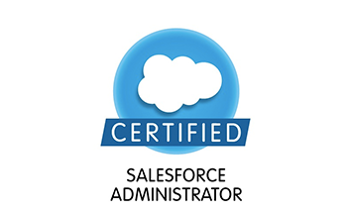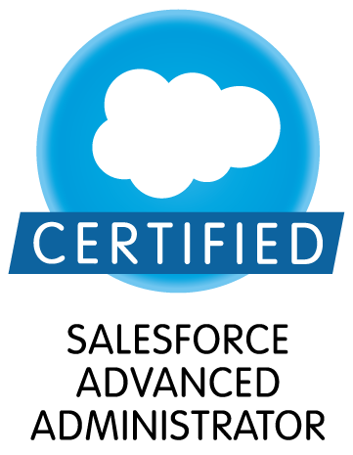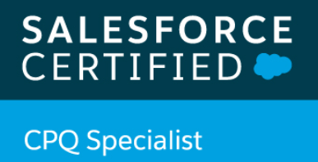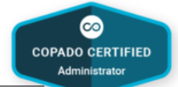

Leadership Activities and Awards

2018 – 2020 |  |  | Won 2 times SPOT award for my outstanding performance at S&P global.
2016 – 2018 |  |  | Won INSTA Award at INFOSYS for exceptional performance in the project.

I hereby declare that the information furnished above is true to the best of my knowledge
Shalini Singh
Place: Hyderabad
Date-02/11/2020

