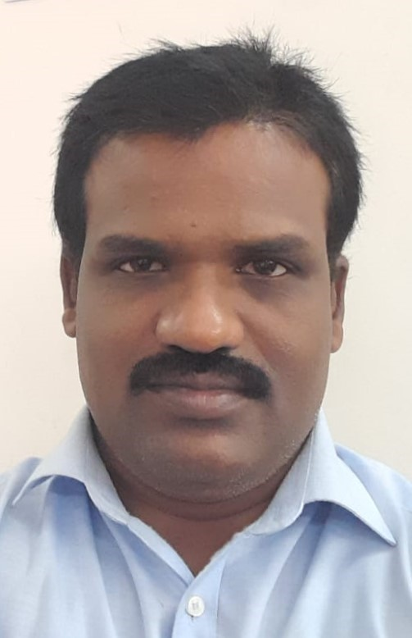

Phone:

+91 9 551 651 751
+91 9 840 144 727

E-Mail:
panneer.selvam.r.k@gmial.com

Address:

No 180, F2, Victory Viswhwa,
Ista chithi Vinayakar Kovil Street,
Venkateswara Nagar,
Pozhlichalur Chennai 600074

Education:

M.C.A – 81 %( Regular)
S.R.N.M College, Sattur2002-2005.

B.sc (CS) – 66% (Regular)
S.R.N.M College, Sattur (1999-2002).

HSC -70%
A.V.Hr Sec School, Sattur.1999.

SSLC – 68.4%
A.V.Hr Sec School, Sattur.1997

Currently Working:

Team Leader
SolvEdge Technology Pvt Ltd
Chennai

- RecoveryCOACH Project.
- Health care Domain, US Based Hospitals
- J2EE,JDBC,Spring Boot wih Hibernate.
- SQL Server DB.
- Eclipse,Jenkins,Docker,Tomcat,AWS.
- WPS Report tool
- Tech Support head.
- Start from Feb 2016 to till Date

LWD: Nov 29.2022

PANNEER SELVAM.K
Team Leader specializing in back end development. Experienced with all stages of the development cycle for dynamic web application. Well-versed in numerous programming languages and well experienced in team handling.

Professional Summary
Technically sound Software Engineer developing in web applications for the past 10+ years. Value teamwork over individual brilliance. Believes in the people-first approach not only in tech but in collaboration too.
Highly-skilled Software Team Leader has a strong background in more programming languages and platforms. Professional offers excellent supervisory and leadership abilities combined with a technical mind and Master’s degree in Computer Programming
- Over 10+ year of professional experience in development and deployment of various Object oriented and web - based Enterprise Applications using Java/J2EE technologies and working on the complete System Development Life Cycle SDLC
- Having very good understanding in HealthCare and ERP domain.
- Proficient in n-tier application design and development using Java, J2EE, JSP, Servlets, , Spring, Hibernate and SQL Server
- Good knowledge of Design patterns like Model View Controller.
- Working Knowledge in JSON and XML technologies, parsers like DOM
- Responsible for creating and maintaining architecture for Restful API using Spring Boot
- Worked in Development teams under various roles such as Developer and Group Leader, Team Leader
- Good working knowledge on SVN and Git for version control.
- End to end development support of the application till the final rollout of the application.
- Proficient in using AWS (Amazon Web Services), S3.
- Active participation in entire lifecycle of software development. Activities include study of system.
- Conceptual design as well as detailed design, coding, unit testing, system integration testing and support, and also supported software configuration management.
- Pack build and deploy experience in Jenkins and Docker.
- Strong debugging skills using Firebug.

Experience Summary
- 5+ years of Professional experience as Team Lead in Development, DevOps, and Technical Support of multiple project.

- 5 years of Professional Experience as Senior Software Developer in Design, Development of multiple project.

- 3 years of Professional experience as Software Programmer in Design, Development maintenance and customer interactions.

- 1 year Professional Experience as Technical Guide in training institute
Core functions
- Preformed requirements analysis.
- Estimate time calculation for requirements.
- Software Development, Application security.
- Prioritizes programming work and assigns tasks to team.
- Appropriately deals with problems in the team.
- Part of DevOps functions.
- Product deliverable.
- Collaborates closely with PMO and other team.
- Monitors timeliness of attendance at team meetings
- Manage the Technical Support tasks and team
- Collaborates with IT team about application & Server status

Technical Skills
- Lagunage : C, C++, Core Java, VB, SQL
- J2EE Technologies : Servlet, JSP, Applets, Singleton Java Bean, HTML, JavaScript,
JDBC, Design Pattern, Collections, Multithreading etc.
- Web Framework : Spring MVC, Spring Boot, Hibernate.
- Servers : Apache-Tomcat, JBoss.
- IDE& Build Tools : Eclipse, Jenkins, Docker
- Reporting Tools : MS-Excel, MS-PowerPoint, WPS.
- Version Control Tools : SVN, GIT.
- Testing Tools & Logging : Junit, Log4j2.
- Database : SQL Server , PostgreSQL,Oracle
- Operating Systems : Windows XP/7/10, Linux

- Over All 10+Experience
- SolvEdge History
Reimagining healthcare delivery for our clients across the globe, history of simplifying healthcare goes way back to 2004. SolvEdge is trusted by a broad spectrum of clients including 450+ Hospitals, 3500+ Physician Practices and millions of Patients - by solving their most complex challenges and helping them deliver consistent, cohesive and collaborative care.
- SolvEdge Products
RecoveryCOACH
HRO
PRO
DOC CENTRAL etc…..

- Tech Skills
Java 1.8,
MVC Framework
Spring Boot
Hibernate
JDBC
Apache Tomcat 9.0
J2EE Technologies

Working Experience

- Feb 01/2016 till date - Team Lead
SolvEdge Technology Pvt Ltd Chennai.
No. 90, 200 Feet Road, Zamin Pallavaram, Chennai – 117.
- April 2014 to Dec 2015 - Senior Software Developer
NIC (National Informatics Center). Besant Nagar, Chennai,
Through Neelkanth Digital Infonet Pvt.Ltd, Gurgaon.
- Jan 2010 to March 2014 - Programmer
NIC (National Informatics Center). Besant Nagar, Chennai.
Through IAP Company Private Limited New Delhi.
- Jan 2007 to Dec 2009 - Programmer
Lastech System Pvt Ltd, Chennai.
- Jun 2005 to Dec 2006 - Technical Guide
Computer Software College (CSC) – SankarnKovil
Academic Project Experience
- MCA - BASF Java Struts, MySQL
- MCA - Time scheduling for Aircraft in HAL (Hindustan Aeronautics Ltd).
- B.Sc. (CS) - Medical Management for Rani Medical done with VB & Access

Project Experience

SolvEdge Technology Pvt Ltd, Chennai. (Feb 2016 to till now).

1. RecoveryCOACH

Domain : Health Care for US based Hospital
Technology : Java, spring boot, Hibernate, SQL Server, Angular, IOS, Android.

dfdfdfdfdfdfdfdfdfdf

Sss

sdsdsdsd

Role : Team Lead, analysis and designing forms, Code Develop, Generating Reports, Deployment the application to server and Maintenances and interact with team
Description : The RecoveryCOACH system will guide patient surgical journey them with tailored patient education and activities. Patient can access the RecoveryCOACH Application through web, android and IOS. This includes instructions, exercise videos, direct access to patient care family, and integration with apple Health Kit activity data and the best way to prepare for surgery, understand what to expect, and navigate patient recovery process.
Modules :Patient enrollment, Survey, Message, Appointment, Office Staff To-do, Dashboard, EMR Process, Data Lake Report, IOS Device, Android.

2. PRO (Patient Reported Outcomes)

Domain : Health Care
Technology : Java, spring boot, Hibernate, SQL Server, Angular, IOS, Android.
Role : Team Lead, analysis and designing forms, Code Develop, Generating Reports, deployment the application to server and Maintenances and interact with team
Description : Patients Survey system for Orthopedic with IPAD and Web.
Modules : Hospital Admin, Patient Survey IPAD, Online Survey, Reports

Other Project Details
1. RCM (Revenue Collection Management) – Insurance Based
2. CRM - Customer Relationship Management
3. SPARK - Employee task tracking
4. Internal Tools
1. Well be automation
2. Spine REHB
5. TIE – Employee task tracking system & Project Development Tracking
The All Project builds in MVC framework and back end using SQL Server.

National Informatics Center. Chennai. Jan 2010 to Dec 2015

3. TWAD NEST (E-Governance System)

Technologies : Java, Servlet, JSP, Java Bean, Ajax, JavaScript, ORACLE.
Role : Designing forms, Code Develop, Generating Reports, deployment the application to Server and Maintenances and, Interact with Client, prepare the CR Report and submitted to project leader.

Description : The Intranet system for TWAD Board facilitates centralized data storage and retrieval besides information analysis pertaining to Project Monitoring, Financial Accounting, HR Management and Water Quality. This system is accessible by the offices of TWAD Board through a network connecting the Head Office with all the Regions, Circles and Divisions.
Modules Involved
  - Demand Collection Balance (DCB)
  - Annual Maintenance Estimate (AME)
  - Project Monitoring System (PMS)
Other Modules
  - Financial Accounting System (FAS)
  - Human Resource Management System(HRMS)
  - Water Quality System (WQS)

Lastech System Pvt Ltd, Chennai. Jan 2007 – Dec 2009

4. E-Governance II– TamilNadu Textbook Corporation

Domain : E-Governance
Technology : Java, Servlet, JSP, Java Bean, Ajax, JavaScript, Postgres Sql, IReport
Role : Collect user requirement and prepare high level documentation for SRS, Forms design, Code Develop, Generating Reports, deployment the application to
Server and Maintenances and, Interact with Client, prepare the CR Report and submitted to project leader.
Description : This e-Gov Project involves Development of ERP enabled Web Application for TamilNadu Textbook Corporation centralized data storage and retrieval besides information analysis pertaining. Financial Accounting, HR Management Process.
Modules : Financial Accounting System
The Financial Accounting System (FAS) is an on-line integrated financial accounting system that records, monitors and maintains all accounting and financial transactions of the for the TamilNadu Text Book Corporation(TNTBC) Chennai.
Personnel Information Management
The Personnel Information Management System for managing personnel information in a large department with their employees spread at dispersed locations. It was developed for the TamilNadu Text Book Corporation (TNTBC) Chennai.

5. E-Governance I– TNTBC

Domain : E-Governance
Technology : Java, Servlet, JSP, Java Bean, Ajax, JavaScript, PostgreSQL, IReport
Role : Designing Forms, Code Develop, Generating Reports, deployment the application to Server and Maintenances and, Interact with Client, prepare the CR Report and submitted to project leader.
Description : This e-Gov Project involves Development of ERP enabled Web Application for TamilNadu Textbook Corporation. Centralized data collect and retrieval besides information analysis pertaining to printing process of this concern and issues to textbook and notebooks to Schools, and retails sales.
Modules
  - Textbook Monitoring (TB)
  - Notebook Monitoring (NB) , Retails Sales (RS)

6. ID Card to Government Organization [ELCOT]

Domain : E-Governance
Technology : Java, Servlet, JSP, Ajax, JavaScript, PostgreSQL, IReport
Role : Generating Reports, Interact with Client, prepare the CR Report and submitted to project leader.
Description : To print ID card to requested Government Organization.
Modules
  - Card Print
  - Receipt and Payment
COMPETENCIES
- Willingness to learn new technologies and concepts.
- Excellent leadership qualities and interpersonal skills. Systematic, Diligent, Hard-working and Productive
- Language:
  - English, Tamil

Declaration
I hereby declare that all the details furnished above are true to the best of my knowledge.
Date :
Place : Chennai (K.Panneer Selvam)

