**Shashikanta Patowary**

**Email** shashi.patu@gmail.com **Mobile**. **No** : +91-9972810360, +41-779963050,

Bangalore, India

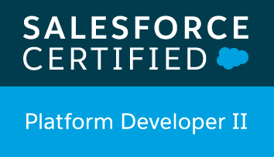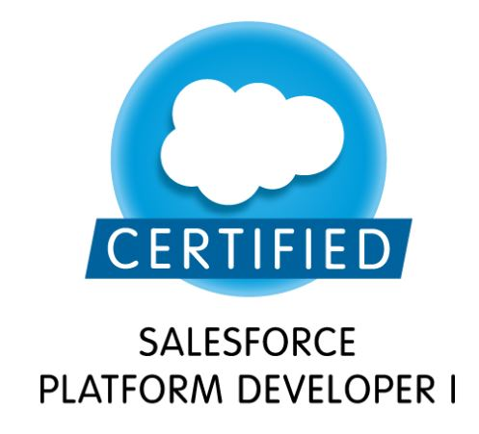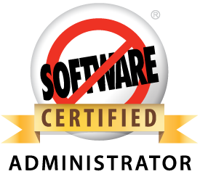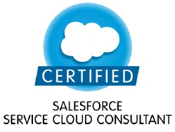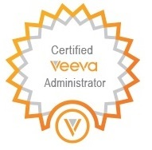

**Trailhead profile: https://trailhead.salesforce.com/en/me/0055000000617FdAAI**

|  |  |
| --- | --- |
| Skill / Experience Summary | My 10 years of experience involves CRM and application software development and integration. With virtuous working Involvement in Salsesforce.com, Force.com platform, Lightning Components, Salesforce Mobile SDK, Veeva CRM, Webservice, Integration using APIs, Oracle and Java.  I have been practicing in CRM software development (Salesforce.com) for last 9+ years as a technical consultant for service industry. Stirring experience and exposure to various verticals of industry.  Currently I am working as an SME in Salesforce Garage in IBM providing solutions across multiple projects. Having complete knowledge of CRM Implementation life cycle and the processes followed, from the requirement analysis till the deployment. Strong communication skills facilitated a high level of collaboration within the team.  In addition to this, I am an active member of SFDC Competency team which works closely with leadership to provide them with useful POCs/Assets that can be demoed to our new clients.   * Proficient in Salesforce.com, Force.com platform Development, Salesforce Integration, Veeva CRM * Proficient in Apex, Visualforce, Trigger, Workflow and Approval, Report/Dashboard * Proficient in Lightning Components, Lightning App Builder, Lightning Experience , Lightning Web Components * Experienced Salesforce administrator and developer having successfully worked on projects with varied complexities * Proficiency in SFDC Administrative tasks like creating Profiles, Roles, Users, Page Layouts, Email Services, Approvals, Workflows, Reports, Dashboards, Tasks and actions. * Hands on experience on Salesforce DevOps * Proficient in AGILE methodology – OpenUP,Waterfall model * Possess a flexible & detail oriented attitude. |

Employment Summary

|  |  |  |
| --- | --- | --- |
| **Dates** | **Organization** | **Role** |
| **Feb 2018 – Till date** | The Global Fund (Client Location from IBM), Geneva | Salesforce Admin &Developer/Salesforce Deployment Manager |
| **March 2015 – Till date** | IBM India | Technical Lead/SaaS SME |
| **August 2011 – March 2015** | Accenture Services | Team Lead /SaaS SME |
| **May 2010 –August 2011** | Acteva Solutions | Senior Software Engineer |
| **February, 2008 – May, 2010** | NCR Corporation | Software Engineer |

Education Summary

|  |  |  |
| --- | --- | --- |
| **Degree and Date** | **Institute** | **Major and Specialization** |
| MCA, Feb 2007 | Dibrugarh University | Master of Computer Applications |
| BSc, Oct,2004 | Gauhati University | Science |
| 10 + 2, March 2000 | AHSEC | Science (PCM) |
| Matriculation, March 1997 | SEBA | All CBSE subjects |

Technology Experience

|  |  |
| --- | --- |
| Languages | Force.com Platform, Apex, Visualforce, Lightning Components, Trigger, Java (J2SDK 1.5) |
| Cloud Computing/CRM | Salesforce.com development, Force.com Deployment,Veeva CRM, Veeva Vault, Customization, Data Migration, Salesforce Mobile SDK 2.0,Service Cloud,Force.com Automation |
| IDE | Force.com IDE,Eclipse 3.1.1, NetBeans 5.5 |
| Framework | MVC, Struts 1.2, Struts 2, Spring1.2.9, Sitemesh |
| Web Technologies | Javascript,HTML 5.0,AJAX,JQuery,JSON,Prototype js, Jquery Mobile |
| Middle-tier technologies | Web Services, Cast Iron,SOAP,XML, Apache Axis 2, Sonic Workbench 7.5,Hibernate 3.0 |
| **Tools** | Apex Data loader, GIT, Jitterbit ,RCLM, SVN |
| **Operating System** | Win XP/2000/2003,Linux,Unix |
| **Corporate Trainings/ Certifications** | 1. Salesforce.com Architect Training.  2. Veeva certification Training. Veeva Certified.  3. Six sigma, CMM, Process championship workshops  4. Attended Teradata Corporate training in 2009  5. Packaged Application training in 2011 in Accenture. |

Achievements:

* Salesforce.com Certified Platform Developer1 (Dev 450)
* Salesforce.com Certified Force.com Developer (Dev 401)
* Salesforce.com Certified Administrator (ADM 201)
* Salesforce.com Certified Service Cloud Consultant
* Salesforce.com Certified Shrining and Visibility Designer
* IBM - Eminence and Excellence Cash Award – 2018 - Dare to create original ideas
* Accenture Celebrates Excellency Award - Client Champion (Individual Q3)
* Contributed to multiple asset as an active member of the LS Asset team
* Star of the month in August,2012 in DU level
* Star of the Month in April,2013 in DU level
* Veeva Certified Administrator
* Participated in Industry Asset showcase,2013 (Life Sciences, Accenture) and won 3rd prize as a team

Professional Experience

**Mar-2015 – Till date, Technical Lead/CRM Consultant - IBM India Pvt. Ltd.**

As a Technical Lead/CRM Consultant responsible for Requirement gathering, Analysis, design, development, testing and implementation of customized CRM solutions for new implementations and upgrades for our IBM customers like The Global Fund(TGF), Janalakshmi Financial Services (JFS)

* Responsible for leading a team technically in delivering solution to our customer in the Banking sector,NGO
* Deliver new and complex high quality solutions to clients in response to varying business requirements - individual contribution
* Responsible for effective communication between the development team and the customer.
* Translate customer requirements into formal requirements and design documents, establish specific solutions, and leading the efforts including programming and testing that culminate in client acceptance of the results.
* Utilize in-depth knowledge of functional and Technical experience in Salesforce.com and other leading-edge products and technology in conjunction with industry and business skills to deliver solutions to customer.
* Establish Quality Procedure for the team technically and continuously monitoring and refactoring the code to ensure code quality
* Responsible for managing Github and deployment of the project

Environment: Salesforce.com,Apex,Visualforce page,Lighning Components,Apex trigger,Apptus for Excel,Apptus for Word,Gridbuddy, Apex data loader, Github, Gearset,Service Now,DevOps

Team Size : 10 - 15

**Aug-2011 – Mar-2015, Technical Lead/SaaS SME - Accenture India, India**

As a technical lead/SME/Architect I worked multiple projects with varied complexities for prestigious clients like The Coca-Cola Company, Novartis, Pfizer,Astrazeneca,Roche,Shire,Takeda,Nuffield Health etc. My role is as follows:

* Responsible for managing offshore Rollout team and supporting the onshore team to Analyse and provide solutions for UAT issues and then if feasible fixing the issues in CRM environment. Provided client support for deployed countries.
* Provide SME support to other projects in critical stage and help them to get back in track
* As an Integration specialist provided numerous solutions to projects involving Payment gateway Soap WS, REST API etc.
* Co-ordinate with other projects to implement SaaS-SFDC tools like Accenture Software Engineering Suite for Salesforce (Novasuite) and ARTL -Accenture Reuse Technical Library
* Coordinate and communicate tasks with developers
* Ensure that development is performed as per requirements
* Worked closely with Accenture leadership to provide them with useful POCs/Assets that can be demoed to our new clients.
* Communicate activities/progress to project managers, business development, business analysts and clients
* To analyze the quality code and best practices using the Accenture Software Engineering Suite for Salesforce (Novasuite) and refactoring the code if necessary
* Develop complex Interfaces to interact with different source systems\interfaces.
* Provide innovative reports and dashboards to customers using force.com platform

**Environment:** Salesforce.com, Force.com platform, Veeva CRM,Veeva Vault,SFDC Mobile SDK 2.0,Apex data loader,Webservices,Soap,REST, Oracle 10g, Novasuite,ARTL

**Achievements**: Accenture Celebrates Excellency Award - Client Champion (Individual Q3)

Participated in Industry Asset showcase,2013 (Life Sciences, Accenture) and won 3rd prize as a team

**May-2010 – Aug-2011, Technical Lead/Senior Developer Acteva Solution,India -**

As a Technical lead/Senior Developer worked on designing a complex event management software and its seamless integration with Salesforce.com

* Handled Multiple roles and responsibilities; Technical Lead, Developer, CRM specialist in the Acteva Tiger and Acteva RSVP3.0 projects, to deliver a multifunctional event management system and its seamless integration with Salesforce.com
* Technical Lead - requirements and design phases; developed a robust yet easy-to-use product using various open source technologies
* Analysed requirements and developed customized solution in force.com platform to meet quality management requirements
* Designed and setup CRON batch jobs across various clients to provide event information
* Performance tuning, SQL query enhancements, code enhancements to achieve performance targets
* Designed a rich UI in force.com platform for easy handling of event attendees
* Developed metrics and dashboards to show event progress and attendance

**Environment:** Salesforce.com, Struts2.0, Spring 1.3,Hibernate3.0,Oracle 9i,Webservices,Agile Scrum

**Feb 2008 – May 11, Senior Analyst/ Application Developer NCR Corporation, India**

Analysis, design, development and implementation of customized Customer Online application for new implementations and upgrades throughout NCR’s Systemedia division

* Requirement gathering and discussing updates of development through daily stand up meeting
* Preparation of Design docs and creation and execution of Test cases based on requirements.
* Coding and Automated testing using the testing tool JUnit.
* Maintenance of codebase using version control tool SVN.
* Provided technical and investigative support for functional users on interfaces, defects, change requests, debugging issues, testing and ad-hoc report requirements
* Designed and developed interfaces to legacy systems
* Implemented complex US service tax system using PL/SQL in Oracle9i

**Environment**: Struts 1.1, Java 1.4, Oracle 9i, Weblogic 8.1, JMS, Tortoise SVN, Eclipse 3.2,Trilium,Force.com platform,Salesforce.com, Agile OpenUp

**Environment: Java 1.4,Servet 2.3,JSP 2.0,Struts 1.2,Oracle 9i,BIRT tool**

**Training/Certification:**

* Salesforce.com certified Developer
* Salesforce.com certified Administrator
* Salesforce.com certified Service Cloud Consultant
* Veeva certified Administrator
* Cloud sense tool/Application training from Cloud sense
* Veeva CRM admin training from Veeva Inc.
* Veeva Vault training from Veeva Inc.
* Advanced Java training at NCR Corporation

**References:** Available upon request

Personal Details

|  |  |
| --- | --- |
| Nationality | Indian |
| Gender | Male |
| Marital Status | Married |