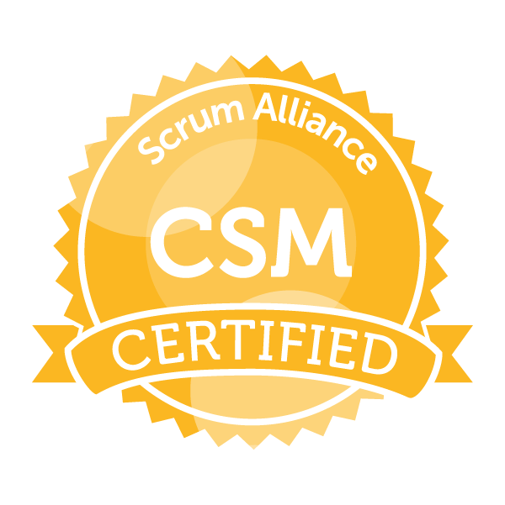
Mr. Ashok R. Khot
Project Lead ~ Innovator & Strategist Phone - +91-957-987-5899
Location Preference - Pune Mail Id - ashokkhot@gmail.com

Job Objective
High-performing, results-focused Technical Project Lead & CSM with 13 plus years of experience in New Product Software Dev. Projects, Engg. Services Projects & Software Testing. Strong background in Agile methodology and Project Mgmt.
Profile Summary

- Certified Scrum Master (CSM®) with Scrum Alliance and doing further certifications in Agile and Project Mgmt.
- Along with handling multiple Projects, I have used Agile methodology and Scrum Master facilitation to efficiently complete the work in time with incorporating all required changes. Used JIRA in Agile Project Mgmt.
- Monitored and tracked project progress and performance against project plans, reporting status to project stakeholders and client, Managed risks to delivery. Established and actively managed all the projects and key stakeholders.
- The ability to work under pressure and deliver quality results. Facilitate meetings and coaching Agile practices. Implemented Scrum principles and practices, facilitated continuous improvement, and identified and removed team impediments reduced the wastage. Supported for the documentation of User Stories and Acceptance criteria. Monitored team backlog daily and ensured it accurately reflects the current state of the sprint.
- Performing Project Plan, scheduling, status report submission, regular client interaction, timely project submission.
- Worked for New Product Dev. for understanding customer needs in CAD, CAM, CAE, PLM, MAT, Cloud from Aero & Auto domains software but not limited to and doing project planning from objective def. to client satisfaction.
- Rich experience working with OEMs and Tier-1 customers form United States, France and Japan.

Core Competencies
- Project Management, Certified Scrum Master, Agile methodology, handling New Soft. Product Development, Services Projects and worked a lot on Soft. Testing (Manual & Automated) done in field of CAD/CAM/CAE/PLM/MAT/Cloud but not limited to only these fields and Efficiently delivering project on time, Client and Stakeholder Handling, Requirement Gathering, Design & Development, Liaison & Coordination, Reporting & Documentation.
Soft Skills
- Communicator, Innovator, Problem-solving, Team Player, Analytical

Knowledge Purview
- Knowledge of JIRA, Confluence, Hawkeye, Microsoft Project, Scrum, Kanban, Lean, eXtreme Programming, SAFe, DevOps and completed 16 PDU's of project Mgmt. PMI-PMP, PPM.
- Best in Agile (Scrum Master), Experience in design and dev. of web based applications & product based applications.
- Expertise in Aero & Auto Domain but not limited to, for understanding customer need and providing solutions to it
- High customer focus, Change Management, People Management, Stakeholder Management. Efficient team Mgmt
- Effective communication skills in cross function teams, Highly motivated with Go-Getter and Can Do attitude
- Created the working software related to process automation incorporating innovative solutions, reducing west and pain of the client by introducing web based applications or product based applications to them.

IT Skills
Programming Languages: C, C++, VB
OS: Dos, Unix, Windows and Linux
Professional Courses: Certified Scrum Master (CSM®), ANSYS, and CAD/CAM
Scripting: VBA script, java script, PCL script, APDL, soft. specific customization script, interface creation, etc.
Organizational Experience

Jun’13 - till date
Sutra Systems, Pune India, (Onsite - Tokyo, Japan - 5.5 Years).
Project Lead Engineer
Key Result Areas:
- Project plan creation with Agile Framework incorporating the resource, time and skill level requirements, for various Software Development. Project names are Falcon, WebFalcon, WFAS- 3 to 6, TDAP, SLMA, 787 process Automation and many more. Successfully monitored executed and submitted to client on Time.
- As a domain expert, I do discussion with the client and create the story points, do its mapping and grooming activities and give best support to dev. team for various software development projects. Few of them are
- WFAS project - The complete and Automatic Analysis solution of welded joints used in Automotive, start from giving welding dimension and end with getting the Analysis results in multiple solvers. This is done here through web application. Along with facilitating team as Scrum master, I technically supported for the team for their work. Testing developed code on Windows and Linux and present it to the customer for the acceptance. Take feedback and change requests and distribute it in the team for the next sprint, for development.
- SLMA (Selective laser melting Analysis) - Software creation for automatic mesh model creation from simple dimensions and SLMA with Coupled Structural and Thermal Analysis with moving heat source is completed on Micro Mechanical Components and its results are shown effectively. Project is created in Java and result are shown on web
- Web Falcon - It is a pre and post processing tool to Simulation. With the help of WebFalcon we can generate the simulation result on web. It is java project and with client server, we can use it worldwide by secure web link.
- TDAP - This is created in the Visual C. This project is submitted to the Japanese client for doing Simulation on the custom solver. Input and output format of the pre and post processing tool is completely different
- And other software projects like Falcon, Hexa, and small team efficiency improving tools creation etc.
- ANSYS Workbench Projects - Steady-State Thermal and Static Structural analysis of Aero Engine Casing - Mitsubishi heavy industries project with scripting. And many other Projects with Japanese client
- NASTRAN Projects -
- Worked on process automation of structural analysis and Composite Stress Analysis of Air Craft Interior Components such as Galley, Closet, Lavatory, Stowage, class divider, bar unit and seats of Boeing 787 Dreamliner Airplane
- Generated various Automated tools for Reports generation as per aviation std. FAA and generated reports get checked and submitted to Boeing Seattle US
- Creating scripts in VBA to automate the tasks for increasing team efficiency; developing methodology for new analysis project and provide technical oversight to the junior employees

Role and responsibilities:
Role: Scrum Master (Soft. Development Projects - Java, VC, C++, Python, scripting)
Responsibilities:
- Planning the Sprints based on release, sprint scope
- Facilitate Sprint Planning, Daily Scrums, Sprint Reviews and retrospective meetings
- Identify and eliminate impediments that prevent the team from achieving their goals
- Prepare metrics, burn-down charts and schedule completion reports
- Ensure crystal clear communication among everyone involved in the project
- Serve as a coach and mentor to members of the Team
- Maintain the focus of the Team
- Daily communications and status reporting to onshore leadership.
- User Stories estimation, CI, ATDD, TDD, Continuous Testing, Pairing, Automated Testing
- Strong knowledge of Scrum theory, rules and practices and Expert coach on implementation of agile scrum

Role: Project lead (Soft. Development in Java, VC, C++, Python, scripting and Engg. Ser. Projects)
Responsibilities:
- Managing Time, Cost and Project Scope. Giving timely report to mgmt. including Scope & Schedule - Gantt Chart, Earned values, Milestones & respective CPI, SPI, BAC, EAC, ETC, Customer top 3 Issues, Top 3 Risks and High level Customer feedback with his satisfaction rate.
- Design reviews with project and Responsible for client's technical work, presentations & feedback.
- Involved in creation of SOWs for the multiple Customer engagements to define Project Scope, objectives, resources, Projects Time, its cost aspect, deliverables and getting approvals from the customer
- Evaluating customer specific requirements, define and carry out internal actions to fulfill the customer's expectations along with following best engineering & organization practices for team.
- Created and managed Customer process-related documentation, including training documents, knowledge database and project plans. Ensuring smooth and timely delivery of projects and day to day activities
- Preparation of Regular Project Status Reports and submitting it to client to track deliveries to make sure that deadlines are met on time every time
- Conducting weekly cross-functional quality sessions & track / drive root cause analysis & corrective actions for systems & processes.
- Proficient in handling the most complex of tech. development concepts, latest software tools and technologies
- Effectively lead teams and inspire others to achieve goals through innovation, quality and excellence.

Nov’11-Jun’13
Harman Connected Services Corporation India Pvt. Ltd., Pune as Lead - Professional Services
Significant Accomplishments:
As a Lead Responsible to analyze, follow-up and respond to client requirements / suggestions / complaints in cooperation with quality organization to ensure timely resolution of quality problems and timely project delivery.
- Managed Quality Assurance of the SimManager (Simulation plus PLM), SimMaterial and SimExpert
- Responsible for Material Data Migration Project - Writing the xmls as per the SimMaterial Databank requirements for material migration work and creating the mapping files. Got recognition from Top Management.
- Responsible for Industrial Analysis Data Creation Project in Patran and Nastran Applications for putting it in SimManager to create actual Industrial scenarios
- Patran UI Customization for adding new feature with PCL scripting and Java.
- Auto Report Creation Project: Automatic one click industrial FEA report creation in SimManager for any Analysis with auto extracted result images and animations using PCL script and Java.
Mar’08-Oct’11
3DPLM Software Solution Ltd. (DS), Pune as Industrial Analyst
Significant Accomplishments:
- Received “Team Excellence Award” from Dassault Systems for contribution towards Innovation and Technology
- Lead the team and responsible for the quality of CATIA Material, CATIA Analysis V5 and CATIA V6 Analysis Module from CATIA V5R18SP2 to V5R21 release.
- Along with this lead role, supported for Manual and Automated testing of software like Abaqus for Catia, Designer Product (Abaqus Solver) and CATIA V6 Analysis Module (Enovia - PLM platform).
- Deliver the excellent quality of product in time and Validate the Results across the releases.
- Deliver knowledge sharing sessions for critical problems encountered and to build the team competency.

Mar’07- Mar’08
Sungrace Computers, Pune as CAE-QA Engg.
Significant Accomplishments:
- Worked on Caesar and Autodesk Inventor Manual and Automated software testing
- Created presentations for the ANSYS Workbench - client ANSYS US.

Dissertation
Title: ME Dissertation at R & DE (Engineers), DRDO, India
Software used: ANSYS, C Language
Period: Jun’05-Jul’06
Project Details: This was ME dissertation work sponsored by R & DE (Engineers), Defense Research and Development Organization of India (DRDO).
- Successfully worked and submitted the dissertation work on the topic ‘Squeeze Film Damping of MEMS Accelerometer’

Presentation Skill
- Project Presentation with clients and
- Many well recognized Knowledge Sharing sessions with the team, brain storming sessions and mind mapping sessions.
- Paper on “Squeeze film damping in MEMS structure” in ICAMDIA- International Conference
- Paper on “MEMS” in Nirmiti, State level paper organization and won 2nd Prize
- Paper on “Robot Soccer: A plat form for system engineering” in NCRTC -National conference
Academic Details

- Masters in Design Engineering from Shivaji University, Maharashtra in 2006
- BE (Mechanical Engineering) from Shivaji University, Maharashtra in 2004
Personal Details

Date of Birth:10th October 1980
Languages : English, Hindi, Marathi, Kannada, Sanskrit, Japanese (learning)
Gender : Male
Permanent Address: B206, Dreams Belle Vue, Behind Crystal Honda showroom, Bavdhan Bk, Pune, Maharastra, India 411021

