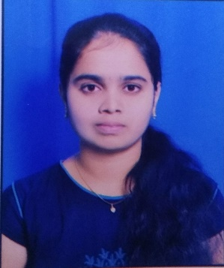 **CURRICULUM VITAE**

Pillalamarri.Shivani

**Email:Sunitha.pillalamarri123@gmail.com**

**Mobile: 8977556698**

**CAREER OBJECTIVE:**

As a forward-thinking individual with refined interpersonal and multitasking skills. Looking forward to work for an organisation which provides me the opportunity to improve my skills and knowledge to growth along with the organisation objective.

**PERSONAL PROFILE:**

* DOB: 13-04-1999
* NATIONALITY: INDIAN
* HOBBIES: Browsing, writing diary& cooking
* LANGUAGES KNOWN: English, Telugu

**EDUCATIONAL QUALIFICATIONS:**

|  |  |  |  |  |
| --- | --- | --- | --- | --- |
| **QUALIFICATION** | **INSTITUTION** | **PERCENTAGE** | **GROUP** | **YEAR OF COMPLETION** |
| **B.Tech** | **Sree Chaitanya College of Engineering** | **72 %** | **Electrical and Electronics Eng.** | **2020** |
| **Inter** | **Sri Vivekananda Junior college Jagtial** | **95 %** | **MPC** | **2016** |
| **SSC** | **Jyothi High School Jagtial** | **97 %** |  | **2014** |

**SKILLS:**

* Technical skills
* Communication & Listening skills
* Leadership ability
* MS Office
* Typing skills
* Software Testing

**STRENGTHS:**

* Self motivation
* Quick learning
* I prefer smart work rather than hard work
* Creativity
* Team work
* Time and Stress management

**ACHIEVEMENTS:**

* Participated in several power point presentations.
* Certified by CRT program
* Attended various seminars.

**DECLARATION:**

I do here by to declare that the above information is true to the best of my knowledge.

(Pillalamarri.Shivani)