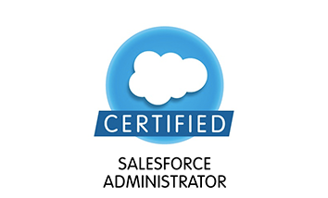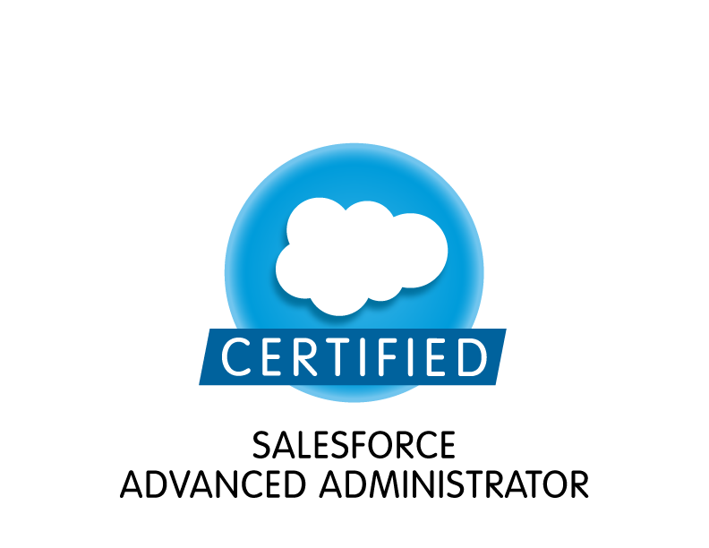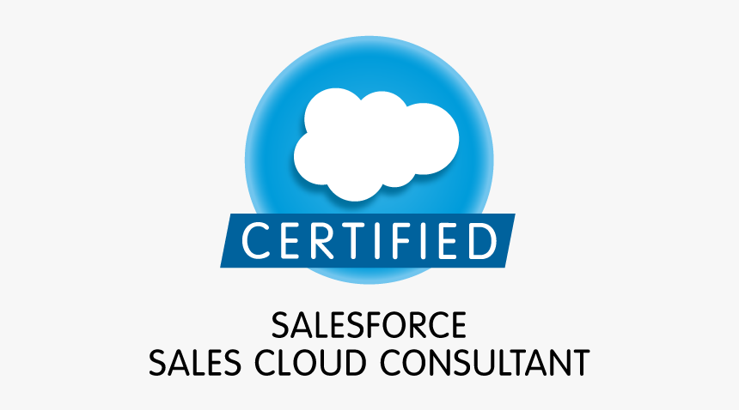
SRI KAVYA
E-mail: k.salesforce13@gmail.com
Phone: 978-795-4254
Sales force – Administrator/ Business Analyst

PROFESSIONAL SUMMARY
- Over 6+ years of IT experience with experience 5+ in the Salesforce.com CRM Platform both as Administrator and Business Analyst
- 5+ years’ experience in implementing salesforce.com for the sales and support user groups based on the user requirements.
- 5+ years of experience in Report Design, Development, Analysis, Testing and implementation of various multi Complex secure reports from multiple database In-depth knowledge and practical experience of using Waterfall, Agile, Scrums, Rational Unified Process, Business Process
- Experience in Salesforce Communities, Knowledge Articles, Content/Library, Sales & Service Cloud Features.
- Experience in different SDLC methodologies like Agile/Scrum, Waterfall, RUP and V Methodology.
- Highly proficient in writing User stories, creating Use Cases, BPMN 2.0, Swim Lanes, Use case diagrams, Decision Modelling, Workflow Diagrams, Sequence Diagrams, and Class Diagrams etc.
- Liaised with business units, stakeholders and technical teams.
- Providing functional and technical guidance of Salesforce Best Practices for Implementation to Business Project Leadership.
- Ability to effectively translate Salesforce data into business understandable metrics using Reports (Matrix, Summary, and Tabular), Analytical Snapshots, and Dash Boards (Static and dynamic).
- Experience in SFDC administrative work like Approval and Tasks, Dashboards, Data Loader, Email Services, Escalation rules, Roles, Profile, Creating Users, Page Layouts, Reports, Validation Rules and Workflow Rules.
- Experience in using Data Loader for bulk import or export of data from Salesforce.com Objects and data manipulation language for data migration.
- Experience with Validation Rules, Workflows, Approval Processes, Processes Builder, Field Updates and Email Generation per application requirements.
- Worked extensively on Accounts, Contacts, Leads, Opportunities, Products, Activities, other Standard Objects and Customized Objects for additional fields, Layouts, record types.
- Proficient in using Agile Scrum methodologies, performed roles of Product Owner, Scrum Master following sprint/standup sessions and used JIRA, CA Agile & Version One extensively to write Epics, User stories, analyzed the Iteration Burn Down charts and reviewed defects.
- Actively worked as a Product Owner with Stakeholders & Agile teams to monitor and prioritize product backlog on an ongoing basis to meet release timelines and value to the business.
- Emphasis on Elicitation of requirements through research, formal-informal sessions, JRP sessions and JAD sessions with SMEs (subject matter experts), Teams, Stakeholders and end users.
- Highly Proficient in SQL, RDBMS, Data Models, Data Mapping, Data Mining and Dashboards.
- Have good working knowledge in querying Salesforce.com database using SOQL SOSL queries using Force.com Explorer.
- Performed GAP Analysis, extensively studied the as-is state of the business model and generated to-be model, highlighting the specific benefits from the application.
- Extensive knowledge and experience in Software development life cycle (SDLC), Requirement Analysis and Software testing life cycle (STLC).
- Expert in Tracking and Managing Requirements using Requirement Traceability Matrix (RTM) to track bi-directional traceability across projects.
- Excellent Presentation skills with regards to communicating with both business and technical teams.
- Excellent communication skills and ability to quickly master new concepts and technologies and able to work under tough deadlines.
- Detail-oriented energetic team player, motivated with multi-tasking capabilities, problem solver, and hands-on leader with exceptional presentation and client/customer relation skills.
- In-depth understanding of the capabilities and constraints of the SFDC sCRM application and its various licensing types, coupled with a good understanding around business processes.
- environments as Data analyst
TECHNICAL SKILLS:
Salesforce Modules and Tools | Developer console, Force.com IDE, Apex Language, Classes, Triggers, SOQL, SOSL, Visual Force Pages, Apex Data Loader, Apex Web Services, Dashboards, Einstein Analytics, salesforce for outlook, Custom Objects, Case Management Automation, workbench, Form Assembly
Programming Languages | Apex, C, SQL, JavaScript, HTML, CSS, Source Control: Tortoise SVN, Team Foundation Server (TFS), SalesforceDX
Microsoft Office Tools | Microsoft Word 07/10, Excel, outlook, PowerPoint
Testing Tools and others | HP QC(ALM), QTP, Tableau, ServiceNow

Educational Qualifications

Masters of science in Information Technology, Indiana Institute of technology (Graduated)

Bachelors of engineering in Information Technology, Osmania University, INDIA(Graduated)

Professional Experience:
Insulet Corporation. - Acton, MA Sep 2019 – July 2020
Sales force Business analyst
Responsibilities:
- Worked on Agile Scrum Methodology for Salesforce implementation. Followed the iterative Agile scrum methodology throughout the SDLC – facilitated daily scrum meetings, sprint planning meetings, sprint review meetings, and sprint retrospective meetings.
- Engage client to gather software requirements/business rules, and ensure alignment with development teams
- Interacted with various business team members to gather the requirements and document the requirements.
- Provided detailed estimates of the level of effort associated to implement the technical portions of a project.
- Analyzed as-is process to identify the gaps in the existing flows and documented the same.
- Designed future state process flows and presented it to the business team and engaged them to review and provide feedback for changes
- Built CRM solutions as per business requirement for Sales lifecycle management.
- Leveraged Jira to enter user stories and track the progress of stories.
- Groomed user stories on a daily basis with the vendors and business identify gaps or changes required to existing requirements.
- Integrated, supported and administration of Salesforce Platform tools, including Collaborative, Mobile and Cloud options
- Configured Salesforce one app and Setup SSO for mobile sign in
- Worked on Cloud option on Sales and Service cloud.
- Worked on Collaborative - Leveraged Salesforce Chatter for the teams to communicate with each other.
- Configured library and provided access to users to share documents internally to individual or group and also share externally.
- Described the territory management in salesforce and how it would improve the efficiency of the system.
- Designed the security model in Salesforce and configured profiles, permissions sets and Role hierarchy.
- Analyzed and responded to any issues in salesforce from the sales and marketing teams.
- Worked with sales team to streamline Opportunity management and activity reporting
- Created various approval process and workflows.
- Service Now including knowledge of application functionality, architecture, configuration and customization methods as well as integration techniques.
- Worked on ServcieNow integration.
- Tracked tickets using ServiceNow.
- Designed Email templates that was used in workflow rules and time-triggered workflows.
- Responsible for data migration using Apex Data Loader in Salesforce.com.
- Worked with QA team to identify bugs and log the same in Jira.
- Tracked bugs logged in Jira and communicated the same with the developers and partners to resolve the bugs.
- In charge of conducting the UAT with the Business users, and gathering feedback and providing the same to the Development team.
- Supporting UAT with testers
- Resolve issues during and after the Go-live of the technical solution.

Amgen – California LA Dec 2017 – Aug 2019
Salesforce Business Analyst
Responsibilities:
- Participated in the creation of Business Process Workflow in creating and understanding the process.
- Involved throughout the Software Development Life Cycle (SDLC).
- Followed Agile methodology guidelines and principles all through the SDLC process
- Conducted Business Process Review and Modelling, GAP analysis to develop, document and analyze “As is” and “To be” business processes – to develop migration strategy for transitioning from legacy-to-new platform
- Organized Joint Application Development (JAD) sessions with end users, developers, project manager, and quality analysts to resolve conflicts, schedule releases, prioritize tasks, and design the proposed application
- Conducted various of project management activities such as Work Breakdown structure, Schedule Management, Budget forecast models, Resources & Deliverables Planning, and Scope Management
- Conducted meetings with business users and SMEs to identify and gather Business Requirements.
- Created Business Requirement Documents (BRD) and converted them into Functional Specification.
- Translate Functional Requirements into Use Cases from a system prospective.
- Worked on various Salesforce.com Standard objects like Accounts, Contacts, Opportunities, Leads, and Campaign.
- Coordinated with legacy application team for integrating data flow with Salesforce as centralized system
- Assisted and created the requirements management plan for the project
- Worked on Apttus CPQ, Contract Management, Advanced Approval and Revenue.
- Plan projects according to the weekly deadlines
- Design project lifecycle flow for newly created team
- Mentor interns on daily activities and development of a team website
- Write user stories for the developer team
- Create resourceful documents and manuals for users to resolve issues and increase
- technician's efficiency and productivity
- Collaborate with architects and stakeholder for approvals of proposed design
- Create mockups of the proposed product
- Created various Custom objects, Tabs, Workflows, Reports, Apex triggers and validation rules for the application.
- Created Email templates in Text, HTML and Visual Force necessary for the application.
- Analyzed and Created Custom Profiles as required for the business needs and implemented Object level, Field level and Record level security
- Developed workflow rules, validation rules, approval processes and customizations within Salesforce.com
- Deployed, configured and supported the prototype application for its demo /UAT for various line of business from various cities , prepared deck for UAT & gathered feedback and followed up with further updates on the prototype and related documents.
- Customized Page Layouts for Salesforce.com Standard and Custom objects. Defined various Validation rules to validate the data in the application.
- Created custom report types and generated report using the report types.
- Good experience in Salesforce.com Configuration of roles, profiles, user accounts, implemented role hierarchies, sharing rules and record level permissions to provide shared access among different users.
- Analyzed performance reports, point out the problem areas and troubleshoot the issues.
- Coordinated with Administrators, Business Analysts, Subject Matter Experts and QA Team.

Environment: Saleforce.com platform, Data Loader, HTML, Java Script, Workflow & Approvals, Reports, Custom Objects, Custom Tabs, Email Services, Security Controls, Eclipse IDE Plug-in.

PG&E California San Ramon July 2015 – Dec 2017
Salesforce Business Analyst
Responsibilities:
- Served as a liaison between Business Team and the Project Team by assisting the business in identifying, understanding, and documenting their business needs.
- Facilitated Joint Application Development (JAD) sessions with the Management, financial team to make sure everyone in sync with the business requirement processes.
- Worked on Salesforce setup menu, Configuration, Administration and Data Migration of applications to Force.com platform.
- Worked on SFDC Sales Cloud, Service Cloud to enhance and track CRM capabilities.
- Worked on managing the data, Contacts, Leads, Opportunities, Quotes and Dashboards.
- built and maintained effective client-focused relationships with internal and external stakeholders and vendors
- Pulled reports from Salesforce on a weekly basis, exported data into Excel, and formatted reports as needed to be shared out with other teams.
- Gathered Requirements and documented the proposed additional extension to the existing application.
- Performed GAP analysis to understand the gap between the actual and potential performance or requirements with the sole objective of identifying customization/enhancement needs
- Was responsible for conducting the Vendor Analysis
- Assisted the Quality Team in designing the Test Plans, Test Scenarios and Test Cases
- Conducted regular meetings with senior project managers and business sponsors to discuss any technical and operational issues and updates on the current project status.
- Participated in Business Modeling by understanding the needs of the business, and also documenting Business Use Cases as well as System Use Cases.
- Used MS Visio to create Use Cases, activity, Sequence and Data Flow Diagrams.
- Assisted development team to translate requirements into Business, Functional and technical specifications documents.
- Created and Maintained the Requirement Traceability Matrix (RTM).
- Initiated Test Plans, developed and executed test cases and scenarios, worked with users to develop specific acceptance criteria and prepare test exhibits.
- Conducted User Acceptance Testing (UAT) sessions with business users and prepared document for enhancements and bug fixes.
- Used HP Quality Center to report any bugs found and communicate to the developers and product support team.
- Assisted in development of User Guides, training materials and SOPs.
- Involved in defect triaging and managing change management issues.
- Analyzed and evaluated User Interface Designs, Technical Design Documents and Quality Assurance Test condition the performance of the application from various dimensions.
- Helped create the 'Business Glossary' to facilitate efficient understanding of the Business process amongst the other teams.

Environment: Salesforce, SFDC Sales Cloud, Service Cloud, Agile, Smart Draw, Forec.com IDE, Power Designer, Data Loader, Test.

Bitra Net Hyderabad, India Feb 13 - Mar 14
Jr. Business Analyst/ Salesforce
Responsibilities:
- Participated in SDLC requirement gathering, converted business requirements to technical specifications, designed, tested and deployed applications following proper release management approval processes
- Worked closely with PMO, architects, development & quality teams to ensure timely delivery of sprints and projects
- Performed administration of Salesforce apps which included user management and customization of objects, fields, page layouts, formulas, workflows, approval process, profiles, permission sets, validation rules, sharing rules, reports, dashboards, compact layout etc.
- Responsible for deployment of App Exchange third-party packages & executing data loader jobs
- Performed monitoring and timely analysis of technical issues with Salesforce platform
- Defined dependencies and field level security in Salesforce CRM
- Developed SQL queries to extract, manipulate and validate the target data against source data
- Managed issues (stories, bugs) reported by the business using Jira ticket management
- Verified Requirements Traceability Matrix (RTM) document as part of QA
- Worked as single point of functional contact for OTM (Oracle transportation management) for Canada implementation
- Conducted KT sessions for Offshore resources and documented Knowledge on OTM processes
- Closely worked with Salesforce consultants while implementing the solutions for the needs of organization.
- Worked with Solution Architecture and product teams to identify and define the business needs and find the solutions to fulfill business requirements.
- Interacted with various business user groups for gathering the requirements for Salesforce implementation.
- Managed day-to-day of business; bringing in new clients and maintaining relationships; creating custom digital marketing strategies and advising clients; writing copy and creating effective content; managing social media accounts; working closely with designer on websites, videos, graphics, and more.
- Created and deployed several Salesforce reports for different user profiles based on the need in the organization.
- Worked with Service Cloud technology and on premise infrastructure integration for Salesforce.com.
- Implemented new customer support solution using Salesforce.com Service Cloud. Maintained and improved existing Salesforce implementation.
- Worked with SME's of Corporate Actions to better understand the impact and document the Business Requirement Specifications.
- Created Use Case Scenarios and maintained the Use Cases (Business Use Cases, System Use Cases) and modeled Use Case Diagrams, Activity Diagrams, Business Flow Diagrams, revised functional specifications and other core materials throughout the System Life Cycle making all necessary revisions for defect correction and requirement clarification and refinement.
- Performed Gap Analysis for the modules in production, conducted feasibility study and performed impact analysis for proposed enhancements.
- Worked with stakeholders to obtain deliverable sign-offs. Provided functional direction to other systems analysts and used the meta-data definition and workflow needs and how these functions map to business processes.
- Conducted UAT and Coordinated with the QA Team in the sign-off process before deployment.
- Acted as a liaison between business and functional teams on SAP CRM upgrade project
- Collaborated on requirements gathering, development of business processes to ensure high data quality standards for end-user records in SAP CRM
- Assisted in managing data quality of five million end-user records and transactional data for 500+ dealers in SAP CRM
- Collaborated with dealer mentors to investigate, resolve, and train independent dealership personnel regarding system issues
- Executed verification and validation rules to process SAP IDocs and collaboratively discussed failures and resolutions with cross-functional teams
- Wrote test cases and executed end-to-end functional testing to ensure optimal progress and product stability for end users
- HP Quality Center expertise in defect tracking, and documenting use cases for continuous improvement
- Recognized as most valued team member of the month on several occasions

Environment: Agile, Salesforce, Service cloud, Workflows, WSDL, Windows XP, MS VISIO, MS office, HP QC, JIRA

