Name: Gopal M 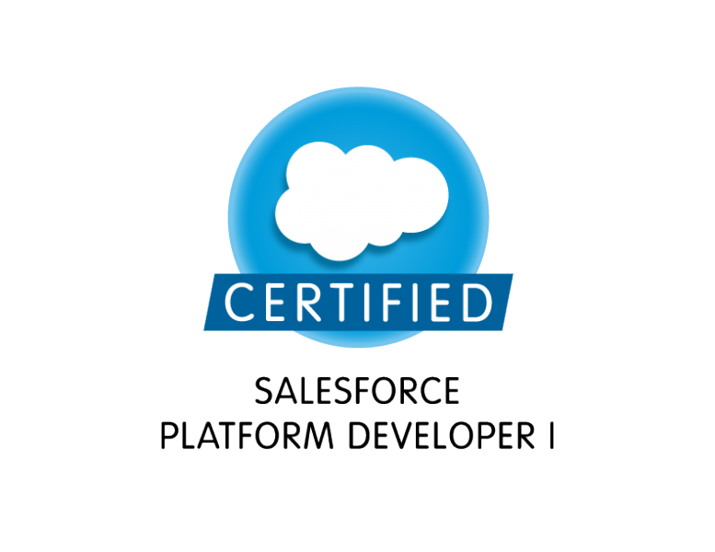
Email:mgopal.sfdc@gmail.com ph:+91 8919556503
A highly motivated and result focused Engineer with experience of over 4.3 years as a Software Developer in IT sector. Proficient in performing under demanding and diverse professional environment. Looking forward for a challenging position assignment in a growth-oriented organization in software development.
SYNOPSIS
- Expert Level understanding of Salesforce.com CRM and its Development Life Cycle.
- SFDC Configurations/Customizations – User Interface, Page Layouts, Tabs, Custom fields, Custom objects, Validation Rules,etc.Experience in SFDC related technologies such as Apex, Visual Force.
- Extensive experience over creating workflows, approval processes, validation rules and sharing & security rules
- Working knowledge in generating Reports, Dashboards, customized reports and analyzing the data in SalesForce.
- Data Load for SFDC Standard objects and Custom objects
- Used different data tools – Apex Data Loader,Import Wizard, SFDC Data Export, Mass Delete etc.
- Worked On Salesforce CPQ & Apttus CPQ.
- Worked on Lead to Invoice genaration
- Ability to handle the client calls independently.
- Experience in Worked in ANT Deployment.
- Experience in Worked in Copodo Deployment.
- Commit changes in Git within Salesforce.
- Compare file differences between Git branches.
- Merge and keep Git branches in sync with Org`s metadata.
- Experience in Worked in CI/CD Deployments.

TECHNICAL SKILLS

Salesforce.com : Apex, Visual Force, SOQL, SOSL, Apex Triggers, Workflows, Approvals,
Email Templates, Formulas, Validation Rules, Eclipse,
Salesforce.com, Force.com IDE, ApexDataLoader, Roles & Profiles.
Languages : Core Java, XML, Apex.
Tools : Copodo, Force.com IDE, ANT, CI/CD
Salesforce CPQ : Product Rules, Pricing Rules , MDQ , Guided Selling, Pricing Attributes, Order Creations,Contracts, Pricing Methods, Quotes , Quote Lines.

apttus CPQ : Products, Product Selection, and Bundle Configurations, Orders, Contracts, and Renewals, Pricing Mathods, Quotes, Conga Template.

EDUCATIONAL QULIFICATIONS
- M.Tech in Computer networks in Vijyanagaram in 2015.
- B.Tech in Computer Science & Engeneering in kavali in 2013.
- Intermediate in Govt junioar College Alur, in 2009.
- 10th from Govt Boys High School, Alur in 2007.

PROFESSIONAL EXPERIENCE

Infosys (june 2019 to Till Date).

PRODUCT EXECUTED
Verizon:

Client | Verizon (Customers)
Role | Developer & Deployements
Team size | 8
Duration | June 2019 – Till Date
Application Platform | Developer Force,sandbox edition
Skills | Sales force Apex Class, Triggers, and Visual Force Pages
Tools | Copodo , ANT, CI/CD, Change sets.X-Author Migration.
Brief | A retail QHP applicant has a due date to pay 100 percent of the first month’s premium or the application is withdrawn. The off-exchange due date is by either the coverage effective start date or 30 days from when we first request payment, whichever date is later. The on-exchange due date is by either the coverage effective start date or 25 business days from the application receipt date, whichever date is later. Here are some first month premium payment tips as well as a payment overview chart.
Responsibilities | - Worked on Orders, Contracts , Products & Renewals  - Worked on Templates and Order forms.  - Migrating the Templates and Products , usig X-Author For Excell and X-author Migration Tools.  - Configure the Standlone products and Bundle Products.  - Worked On CPQ Flows  - Worked on Lead to Invoice genaration  - Worked on Conga Templates.  - Commit changes in Git within Salesforce.  - Compare file differences between Git branches.  - Merge and keep Git branches in sync with Org`s metadata.  - Speed up merges with the auto-resolve conflict feature.  - Deploy User Stories with metadata, git commits and deployment task.

Incapsulate India pvt ltd (Sep2018 to June 2019).

PRODUCT EXECUTED
INSPECTION & LICENCING

Client | Inspection (Customers)
Role | Developer & Deployements
Team size | 8
Duration | Sep2018 – May 2019
Application Platform | Developer Force,sandbox edition
Skills | Sales force Apex Class, Triggers, and Visual Force Pages
Tools | Copodo , ANT, CICD, Change Sets.
Brief | An inspection determines if the material or item is in proper quantity and condition, and if it conforms to the applicable or specified requirements. Inspection is generally divided into three categories: (1) Receiving inspection, (2) In-process inspection, and (3) Final inspection. In quality control (which is guided by the principle that "Quality cannot be inspected into a product") the role of inspection is to verify and validate the variance data; it does not involve separating the good from the bad.
Responsibilities | - Worked on Products Attribute Rules and Pricing.  - Commit changes in Git within Salesforce.  - Compare file differences between Git branches.  - Merge and keep Git branches in sync with Org`s metadata.  - Speed up merges with the auto-resolve conflict feature.  - Deploy User Stories with metadata, git commits and deployment task.

Accenture Services pvt ltd (Dec-2016- Aug2018)
PROJECTS EXECUTED
JDE (Jacobs Douwe Egberts)

Client | JDE
Role | Developer
Team size | 8
Duration | dec 2017 – Sep 2018
Application Platform | Developer Force,sandbox edition
Skills | Sales force Apex Class, Triggers, and Visual Force Pages
Tools | Copodo , ANT
Brief | JACOBS DOUWE EGBERTS (JDE) For more than 265 years, we have been inspired by the belief that it’s amazing what can happen over a cup of coffee. Today our coffee & tea portfolio is available in over 100 countries around the world through iconic household names including Jacobs, Tassimo, Moccona, Senseo, L’OR, Douwe Egberts, TiÓra, Super, Kenco, Pilao & Gevalia.
Responsibilities | - Commit changes in Git within Salesforce.  - Compare file differences between Git branches.  - Merge and keep Git branches in sync with Org`s metadata.  - Speed up merges with the auto-resolve conflict feature.  - Deploy User Stories with metadata, git commits and deployment tasks.

PROJECTS EXECUTED
R7B
Client | ABB
Role | Developer
Team size | 8
Duration | dec 2016 – dec-2017.
Application Platform | Developer Force,sandbox edition
Skills | Sales force Apex Class, Triggers, and Visual Force Pages
Tools | Data Loader, ANT COPADO
Brief | ABB ia an operating mainly in robotics and the power and automation technology areas.ABB is one of the largest engineering companies as well as one of the largest conglomerates in the world.This app mainly developed to the Custamer Community Portel.External Community user using this app, creating cases, feedback and soultions.
Responsibilities | - Application developer for offshore SFDC implementation–an end– end Force.com customized solution.  - Requirement understanding and Analysis, implementation.  - Implementing the Customer Community portal  - Worked on assignment Rules, Worked on workflow Rules.  - Implanting the Customer community pages.  - Worked on apex triggers.  - In ABB worked as customer Community portal.  - Worked with costumer Community portal.  - Worked on Deployement using ANT tool.
APPRECIATIONS & RECOGNITIONS
- Appreciated by the entire team for lending any kind of help when required.
- Consistently received individual appreciations from my manager, team lead and tem members.
- Salesforce Platform Developer-1 Certificate number(17366349).

PERSONAL INFORMATION
Date of Birth : 2st July 1992
Marital Status : Single
Nationality : Indian
Address : Adoni, Kurnool ,AP, India.
DECLARATION

I do hereby declare that the above statements are correct and true to the best of my knowledge.
Place: Hyderabad (Gopal M)
Date:

