• Contact  Delhi, DL, 110051  844 625 7394  Saloni23.salesforce@gmail.com  https://www.linkedin.com/in/salonia347  • Skills  Workflow Rules  Page Layouts  Record Types  Omni Channel  Live Web Chat  Change Sets  Process Builder  Data Loader , Data Import Wizard  Asynchronous Apex  Roles, Profiles , Permission Sets  Salesforce Configuration  Approval Processes  Lightning Components  Sales Cloud  Service Cloud  Rally  JIRA  HPE ALM |  | 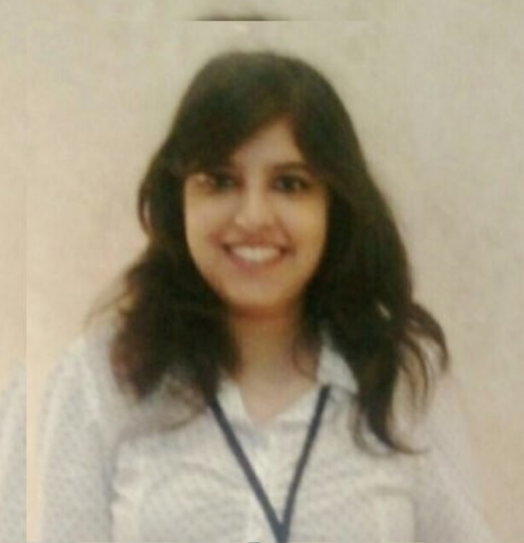 Saloni Arora Senior Consultant- Salesforce  Certified Salesforce Professional with ~5.5 years of IT experience, with expertise in salesforce(SFDC) application and currently working for Deloitte,Gurugram. She has worked on configuration , testing , customization , implementation and deployment on salesforce CRM .She is a trailhead Ranger who has achieved 8x certifications around the salesforce ecosystem.  • Work History  March 2021- Current Senior Consultant- salesforce Deloitte , Gurugram - Led offshore development team to carry out enhancements. - Performed as a Scrum master for planning ,requirements gathering, UAT ,estimation and designing of user stories . - Proficient in using tools like Rally ,JIRA, GitHub , HPE ALM ,data loader , data import wizard and workbench. - Involved in User Acceptance testing with users . - Experience of implementing live web chat along with omni-channel queue based routing model. - Worked on customization i.e Apex Code , Visualforce Pages, Asynchronous apex, Order of Execution , Lightning Components, custom setting ,SOQL.SOSL,Sharing rules ,REST API integration, aura components and custom metadata.  Apr 2016- March 2021 Salesforce Developer/Administrator Accenture , Pune - Proficiency in SFDC Configuration actions like creating profiles , Roles, Users , Page Layouts ,Approval process , Workflow rules ,Process Builder, Validation Rules. - Expertise in Salesforce.com security - Object level , Record Level , and Field Level , OWD. - Hands on experience in testing methods like unit , sanity , regression and progression testing . - Responsible for designing , solutioning of the new implementation and developing highly scalable salesforce applications . - Contribute in a highly collaborative, team-oriented environment. - Experience in working on agile and Waterfall models.  • Education  2011- 2015 Bachelor of Technology: Electronics & Instrumentation Galgotias College Of Engineering & Technology ,Gr. Noida  • Accomplishments  - Trailhead Double Ranger ( achieved 200+ badges on salesforce trailhead learning platform)  - CMT APEX Award Individual Category FY19 Q2,Q3  - Accenture Celebrates Excellence(ACE) Award FY16  - Accenture Celebrates Excellence(ACE) Award FY17 Q4  - Winner of Salesforce Goodies exclusively provided by salesforce.com  • Certifications  - Salesforce Certified Administrator (ADM-201)  - Salesforce Certified Advanced Administrator  - Salesforce Certified Platform Developer 1  - Salesforce Certified Service Cloud Consultant  - Service Max SVMX101 Certified Administrator  - Certified Vlocity Developer  - Copado Certified Administrator  - Copado Certified Developer
.

