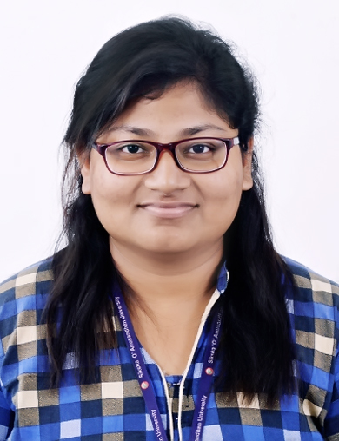

**Career Objective:** To use the best of my knowledge and skills to learn new technologies and work towards solving real life problems and challenges.

**education**

|  |  |  |  |  |
| --- | --- | --- | --- | --- |
|  | **Institute** | **Stream** | **Year of Passing** | **Marks Obtained** |
| **B.TECH** | Institute of Technical Education and Research | Electronics and Communication Engineering. | 2019 | 7.03 CGPA |
| **12th Standard** | SHAILABALA WOMEN’S COLLEGE CUTTACK | Science | 2015 | 54.9 |
| **10th Standard** | DAV PUBLIC SCHOOL,Sector-6,CDA,CUTTACK | - | 2013 | 8.2 CGPA |

**Career**

* Analyst at R1RCM Gurugram Haryana(May2019-September2019)

**PROJECTS**

* Designed an Motion detector Circuit

Under guidance of- MRS SIKHA DAS, Assistant Professor ,Dept. Of ECE ,ITER

* Designed an Echo Compensation System

Under guidance of Mr.Arabindo Sahoo, Assistant Professor ,Dept. Of ECE ,ITER

**Training and certifications**

* Oct17,2020-Jan28,2021: VLSI Design Methodologies
* May 15,2018-June15 2018 : Vocational Training at OPTCL
* May22,2017-June20, 2017: Vocational Training at BSNL
* June24,2017-July24.2017: Core Java
* May 10,2016-June 10,2016 : C++
* June15,2016-July 15,2016 : C

**ACHIEVEMENTS**

* ‘RAJYA PURARASKA’ Awardee in ‘THE BHARAT SCOUT AND GUIDES’
* Won 3rd prize in interschool Debate competition Cuttack in 2010
* Won interschool essay competition in 2009
* 3 Times got certificate of merit holder in ‘ORISSA STATE LEVEL DRAWING COMPITION

**SOUMYA SURYASNATA**

CURRICULUM VITAE

**COnTACT DETAILS**

**Phone :** +919438167670

**Email id:** [soumyamallick37@gmail.com](mailto:soumyamallick37@gmail.com)

**Linkedin** <https://www.linkedin.com/>in/soumya-suryasnata-866867167

**technical skills**

**Programming Languages**:

C,C++,Java

**SKILLS**

Team Player

Communication

Analytic

Time and Work Management

Quick Learner

**personal details**

**DOB**: 02nd ,APRIL , 1998

**Languages**: English, Hindi,

Odia

**Hobbies**:

Writing(,script,story etc),

Reading,Event Management,

Painting

|  |
| --- |
| **EXtra curricular activities**   * Senior Member at SLC(SOA LITERACY CLUB) * Senior Member at TONEELSTUK THE STAGE PIECE (SOA DRAMATICS CLUB) * Senior Member at SRISTI (SOA ART CLUB)   **DECLARATION**  I hereby declare that the above mentioned information is true to the best of my knowledge and belief.  SOUMYA SURYASNATA |