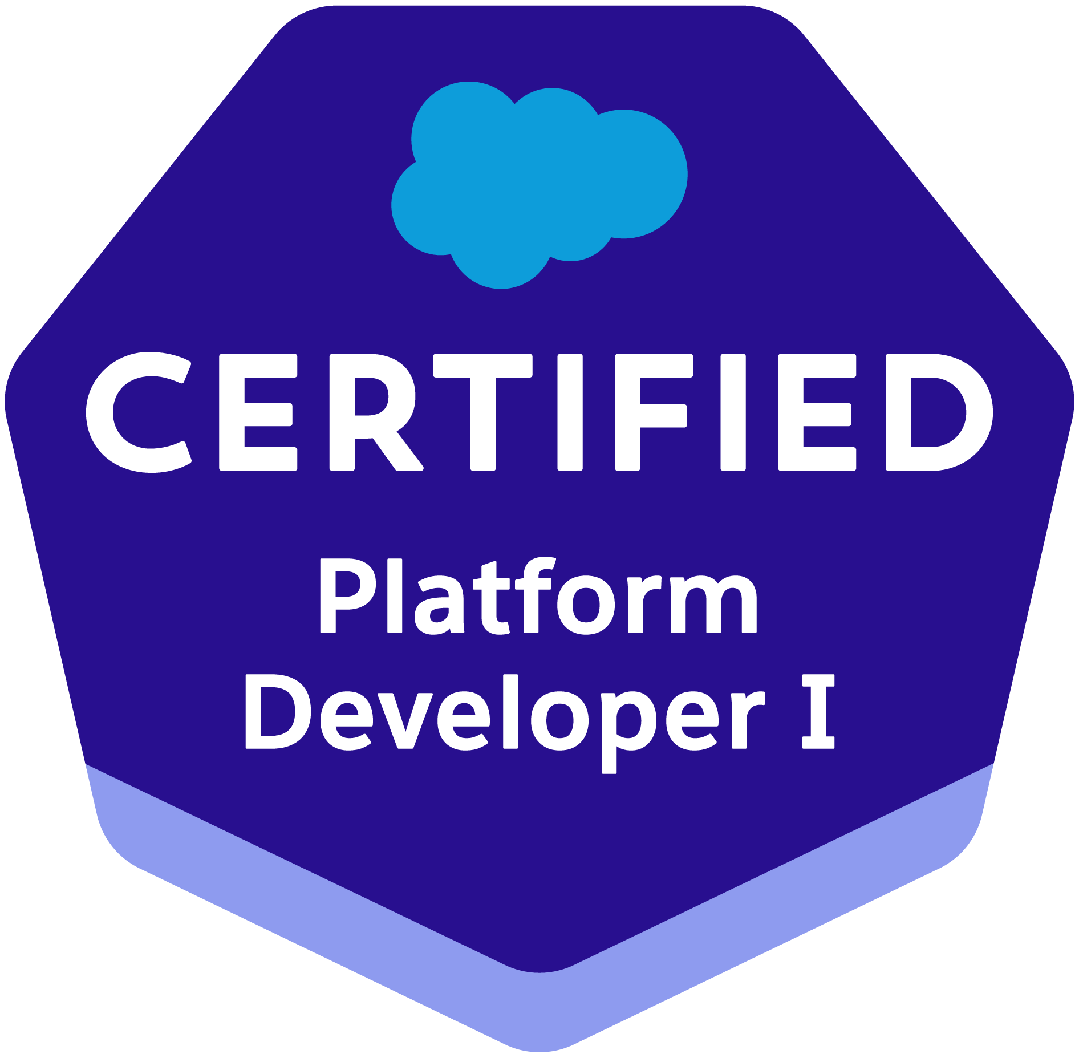**Waris Nawaz Khan**

E-mail: wariskhan1555@gmail.com



Contact: 8297301555

**Career Objective:**

To play a key role in developing groundbreaking products by utilizing my technical and creative skills.

**Professional Experience:**

**Total 7 Years 2 months of working experience with recognized MNC's.**

**ValueLabs LLP. (2021 – Present)**

**Roles:** Senior SalesforceDeveloper

**Project 1:  
Roles And Responsibilties:**

* Project involves mainly on **Banking domain on FSC(Financial Service Cloud).**
* Extensive knowledge in business applications development, implementation and customization of Salesforce applications.
* Excellent project management skills and a positive attitude.
* Responsible for developing in Apex, Lightning Web Components, and other technologies to build customized solutions. Technical leadership, setting best practices including integration and application development, deployment, testing (unit and systems), and iterative refinement
* Currently working on Lightning Web Components framework leveraging advanced ES6 features to develop applications for clients.
* Integrated **Elevate and Stripe Payment API using LWC for NPSP(NonProfit Success Pack).**
* Understand and worked on the Lead management process.
* Worked on customization of **Page Layouts, Field Level Security, Organization Wide Defaults and Sharing rules, Profile Settings, Validation rules and Workflows.**
* **Triggers Development using Apex Programming.**
* Worked extensively in areas of implementation, customization of business model.
* Developed application using **Apex Controller, LWC and Aura Components**.
* Involved in Automated business process by using **Workflow Rules, Process Builder, Flows and Approval Process** for automated alerts, field updates and email generation according to application requirement.
* Involved in creating and customizing **Lightning Email template using Enhanced Letterheads.**



**Infosys Limited (2015 – 2021)**

**Roles:** Salesforce Admin/Developer

**Project 1:**

Extensive knowledge in business applications development, implementation and customization of Salesforce applications.

**Integrated Elevate and Stripe Payment API using LWC for NPSP(NonProfit Success Pack).**

* Experience with Salesforce data model, including the underlying data model of established Nonprofit or Higher Ed solutions such as NGO Connect, AdvancementConnect, Nonprofit Success Pack (NPSP) or the Higher Education Data Architecture (HEDA).
* Familiar with Salesforce Lightning Design System and SFDX
* Strong business analysis and functional experience, including requirements gathering, creating solutions, and/or deploying solutions to end users
* Technical project management experience
* Strong attention to detail and excellent problem solving skills
* Strong verbal and written communication and data presentation skills, including an ability to effectively communicate with both business and technical teams
* Understanding of and experience with **Salesforce architecture and API**
* **Experience integrating Salesforce with other applications**

Expert Level understanding of Salesforce.com CRM and its Development Life Cycle Worked with end user group for requirement gathering throughout the planning and

implementation.

Currently working on **Lightning Web Components** framework leveraging advanced ES6 features to develop applications for clients.

Experienced in SalesForce.com **Apex Classes, Apex triggers, Visual Force**.

Experience working on data model and **SOQL, DML** statements.

Effective team member with good communication and interpersonal skills.

Extensive experience in profile based page layouts, **Workflow Alerts and Actions**

**Validation Rules, Approval Processes, Custom Tabs, Design of Visual Force Pages, Email Templates**.

|  |  |
| --- | --- |
| **Duration** | Jan 2017 – Feb 2021 |
|  |  |
| **Description** | Currently working on Doctor Sole Application. Leveraging the existing classic module to LWC(Lightning Web Component) |
| **Role And** | Currently working on **Lightning Web Components** framework |
| **Responsibilities** | leveraging advanced ES6 features to develop applications for |
|  | clients. |
|  | Developed various **Triggers, Apex Classes, VisualForce pages** to |
|  | fulfill business requirements. |
|  | Customized **Page Layouts for Standard/Custom objects** and |
|  | assigned **Record Types**. |
|  | Created **Data Validation rules, Formulas and Metadata** as per |
|  | business requirement. |
|  | Created and used Email templates in **HTML and VisualForce**. |
|  | Used **SOQL & SOSL** with consideration to Governor Limits for |
|  | data manipulation needs. |
|  | Developed **Batch classes and scheduled classes** to automate |
|  | business process. |
|  | Worked with **custom settings, custom labels and custom** |
|  | **permission** to avoid hard coding. |
|  | Provided ongoing SalesForce.com maintenance and administration |
|  | services including periodic data cleansing, custom objects, |
|  | workflow. |
|  | Designed and modified Approval processes and created Approval |
|  | steps which used email alerts and field updates. |
|  | Developed test classes to ensure that the code is working as |
|  | expected by maintaining code coverage 85% |
|  |  |

|  |  |
| --- | --- |
| **Project II** | DPM(Deal Pursuit Management) |
|  |  |
| **Client** | CISCO |
|  |  |
| **Duration** | Aug 2015 – May 2017 |
|  |  |
| **Description** | Opportunity is dependent on Sales input on SFDC. So this project aims in |
|  | simplifying the opportunity entry without admin work. Hence Deal Pursuit |
|  | Management called as DPM segment is accomplished where Sales can add |
|  | a new opportunity with the right level of visibility and commitment. In a |
|  | single location, Delivery is able to manage incoming opportunities, track |
|  | them and do all their scoping work online. |
|  | The overall crux is to import an end to end Workflow that helps to simplify |
|  | and capture all opportunity pipeline activities without the need to replicate |
|  | data in different tools. |
|  |  |
| **Role And** | Working on development using **Apex classes and Triggers, Visual** |
| **Responsibilities** | **Force Pages and Controllers, Force.com IDE, SOQL**. |
|  | Working on SFDC Administrative tasks like creating **Custom**  **Objects, Profiles, Roles, Users, Page Layouts, Workflows, Reports, Dashboards, Tasks and Events, setting up Security (Sharing Rules, Organization Wide Defaults) etc**.  Working in data migration of Legacy application using **Data Loader**.  Working with Agile methodology and attending Scrum calls.  Implemented **Test Classes with adequate Code Coverage Percentage**.  Involved in implementing batch classes for inserting and deleting bulk records from the objects |
|  |  |

.

**Academic Qualifications:**

|  |  |  |  |  |  |  |  |  |  |
| --- | --- | --- | --- | --- | --- | --- | --- | --- | --- |
| **Course** |  | **Institution/Board** | |  |  | **Year of** | | **Percentage** |  |
|  |  |  | **Passing** | |  |
|  |  |  |  |  |  |  |  |
|  |  |  |  |  |  |  |  |  |  |
| B. Tech. |  | National Institute Of Science & Technology, Berhampur | |  |  | 2014 |  | 72.2 |  |
| (CSE) |  | Biju Patnaik University Tech. | |  |  |  |  |
|  |  |  |  |  |  |  |
|  |  |  |  |  |  |  |  |  |  |
| Intermediate |  | DAV Public School, Bokaro | |  |  | 2010 |  | 62.8 |  |
| (PCM) |  | Central Board of Secondary Education | | |  |  |  |
|  |  |  |  |  |  |
|  |  |  |  |  |  |  |  |  |  |
| 10th |  | DAV Public School, Gidi | |  |  | 2007 |  | 82.2 |  |
|  | Central Board of Secondary Education | | |  |  |  |
|  |  |  |  |  |  |  |
|  |  |  |  |  |  |  |  |  |  |

**Participation:**

* An Executive Member of IEEE Students Chapter, National Institute Of Science & Tech.
* Participated in Microsoft AppFest 2013, a National Level Windows 8 App Development Challenge held at KMIT in the month of February.
* Inter Collegiate E-Plus Club Challenge – 2012.

**Extra-Curricular Activities:**

Head of the Student Web Committee at SANKALP 2K13 & SANKALP 2K14 at National Level Technical Fest at NIST, Berhampur.

Developed the promotional video for CIENCIA 2K12 & CIENCIA 2K13 and also the I'm a self-motivated person with desire to learn, excel and with an initiative to go that extra mile with my leadership qualities and technical abilities. I also have accomplished some certification to document my abilities and have worked on some of the most complex and challenging projects on Salesforce, Java/J2EE, SQL, Informatica and PowerShell. I would like to describe myself as a dynamic learner with zeal to learn and explore new things at every mile of the life. I have been a good team player, team lead/mentor and have showcased some outstanding leadership qualities.