**G.Manikanta**

**Mobile: +91 8885323290**

**Email:gmanikanta1307@gmail.com** 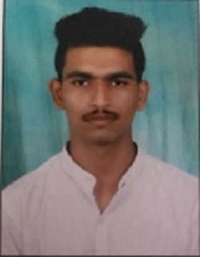

**Seeking to work with a result oriented team which provides a challenging, innovative and efficient work environment in the capacity of a Software Engineer.**

**Areas of Functional Expertise**

|  |
| --- |
| Basics of C, C++, JAVA, python. |

**Technical Skills**

* **Languages:** C, C++, JAVA, HTML.
* **Database:**SQL
* **Microsoft Office :** Microsoft Office Excel, Word, PowerPoint
* **Operating Systems :** MS DOS, Windows98/2000/XP/Unix

**Occupational Contour**

**Experienced** in translating the **Complex business needs into clear and concise Design document,** which will help the developers clearly understand the requirements.

**Excellent time management, communication** *(Both Verbal & Email)***, decision-making, leadership and planning skills** with the **ability of Quick Learning & Multitasking** in a fast-paced environment.

**Academic Credentials**

|  |  |  |  |  |
| --- | --- | --- | --- | --- |
| **Degree** | **College/University** | **Major** | **Year** | **Percentage** |
| B. Tech ( CSE ) | Sri Indu College of Engineering And Technology (JNTU) | Pursuing | pursuing | 7.4CGPA |
| Intermediate (+2) | Narayana Junior College | MPC | 2017 | 93.1% |
| SSC (10th) | Bhashyam School | - | 2015 | 8.5GPA |

**Achievements:**

1. Was Chief Student Representative in the conduct of Technostav a National level event conducted by SriIndu College of Engineering and Technology.

**Certifications:**

1. Completed Introduction to Relational Database and SQL.
2. Completed Introduction to python.
3. Completed Programming Essentials in C++.

**Personal Profile**

|  |  |
| --- | --- |
| **Date of Birth** | 13th July 1999. |
| **Nationality** | Indian. |
| **Languages Known** | English, Hindi, Telugu. |
| **Marital Status** | Single. |
| **Interests** | Listening to songs and playing games. |
| **Address** | Tankara , Mahaboobnagar. |

**Declaration** :

I Hereby declare that the above information & particular are true & correct to the best of My Knowledge & belief.

(G.Manikanta)