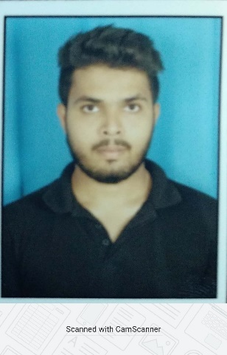
PAVAN PRAKASH NAIK
SALESFORCE DEVELOPER
Email:pavanjusha88@gmail.com
Contact No: +91-6361620665

Profile Summary

- Result oriented software professional with overall 2 years of progressive experience in designing developing using Salesforce.com tool and open source technologies
- Currently working on the FSL implemented project, Having knowledge of FSL configuration
- Expertise in configuration & development using Lightning, Apex classes, Triggers , SOQL & SOSL, Apex Integration Services, BitBucket & ANT in salesforce platform
- Strong Experience of Deployments - using Workbench, Ant.
- Well versed with agile methodologies and certified agile development from Coursera.
- Knowledge of Roles, Profiles, Flows, Process Builder Standard and Custom Objects, Custom Label, Custom Metadata, Custom setting, Page Layouts, and Record Types.
- Excellent coding and problem solving skills.
- Adept problem solver with good Communication and Interpersonal skills

Work Experience

- Currently working as Senior Analyst in Capgemini from December 2018.

Education

- B.E in Information Science Engineering from Jawaharlal Nehru National college of engineering, Shimoga (2014-2018)

CERTIFICATIONS

- Salesforce Certified Admin
- Certified Salesforce Platform Developer 1

Project Details

Project: GBE Development JUNE 2019 –Present
Client : NATIONAL GRID
Role : Junior Developer
Job Responsibilities:
- Worked as an Junior developer and managed the release management activities using the Bitbucket , Ant tool and workbench
- Worked on around more than 150 defects, 50 plus incidents and couple of stories resolved before SLA time.
- Worked on Change requests which are assigned in JIIRA.
- I have been leading the Daily onshore - offshore call with clients to discuss about the ongoing issues.
- Designed and developed Apex Classes and Lightning Components for various functional needs in the application.
- Part of deployment team for Maintenance release & Sprint releases.
- Created Flow Builder, Validation rules and Process Builder.
- Used Data Loader, workbench and dataloader.io for insert, update, and bulk import or export of data from Salesforce.com objects.
- Integrate Salesforce application with external applications. Create their own custom application using APEX Expose there apex methods as REST web services

PERSONAL PROFILE:

Father's name : Prakash Naik
Date of Birth :12/02/1997
Permanent Address : S/O Prakash Naik
#847/2 Ajjikatta, Neelampur
Ankola Uttar kannada
Karnataka 581314
Hobbies & Interests : Cricket, Volleyball, Table Tennis, Badminton, Chess and Travelling.
Language known : English, Kannada and Hindi

