**PROFILE WORK EXPERIENCE**

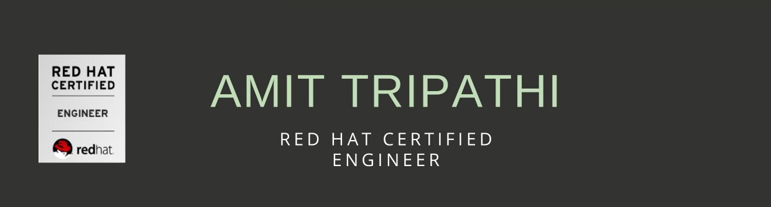Red Hat Certified Engineer skilled in RHEL, CENTOS, NAGIOS, AWS & RAID.

**ACHIEVEMENTS**

* Best Employee Award for Q1 and Q2 2020
* Fixed the application server booting issue during the migration of servers.
* Identified a bug in a service that synchronized the data on application server.
* Identified and fixed the major hardware issue in backup server under the SLA.
* Identified software issue in storage server and upgraded the firmware within a provided downtime.
* Solved application activation issue as they were near to release date.
* Worked with engineering team on a problem related to licensing application.
* Resolved an escalated activation issue with help of engineering team, where customer was not able to activate the product on either machine.
* Raised a critical issue with serial number for the product with order team which was appreciated by the TL.

**TECHNICAL SKILLS**

* Red Hat Certified Engineer (ID:180-053-225)
* Red Hat Certified System Administrator (ID:180-053-225)
* Business communication skills & Accent Neutralization Training

**CONTACT INFO**

Mobile: +91-7988233167  
Email: [tripathi2793amit@gmaiI.com](mailto:tripathi2793amit@gmaiI.com)   
City: Mysore

**Technical Support Specialist**

*Sapizon Technologies LL P Client: Flexera.lnc Sep 2019 - present*

* Creating tickets using Salesforce and Jira for the issues pertaining to software licensing and coordinating with core team to resolve within SLA.
* Diagnose and troubleshoot issues related to installation and activation of products on different platforms e.g., Linux, Windows.
* Troubleshooting issues related to customer account under the Salesforce portal.
* Escalating unresolved and critical issues to internal teams.
* Document technical knowledge in the form of manuals.

**System Administrator**

*Aforeserve. com Pvt. Ltd Client: LIC of India Sep 20I8 - Sep 2019*

* Configuring and troubleshooting servers.
* Performance monitoring and maintaining security of Servers in data Center in the HPE — LIC-EDMS Proj ect.
* Handling of User Admin & Group Admin responsibilities.
* Log file analysis and troubleshooting.
* Extensively worked upon qemu-kvm stack.
* Configuration and troubleshooting of NIC Bonding & NIC Teaming.
* Hardening of Linux OS & HTTPD, MYSQL Server.

**CORE SKILLS**

* Platforms: RHEL, Centos, Windows
* Application Servers: DNS, Apache, NFS, SAMBA, MAIL
* Package Management: YUM, RPM
* Security: Firewalls, iptables
* Linux: LVM, SWAP and LDAP, ISCSI and RAID
* AWS: EC2, S3, RDS, IAM, VPC

**EDUCATION**

Kurukshetra University, Kurukshetra

B.Tech in Computer Science Engineering