RAJ KUMAR SINGH (Valid B1 visa) 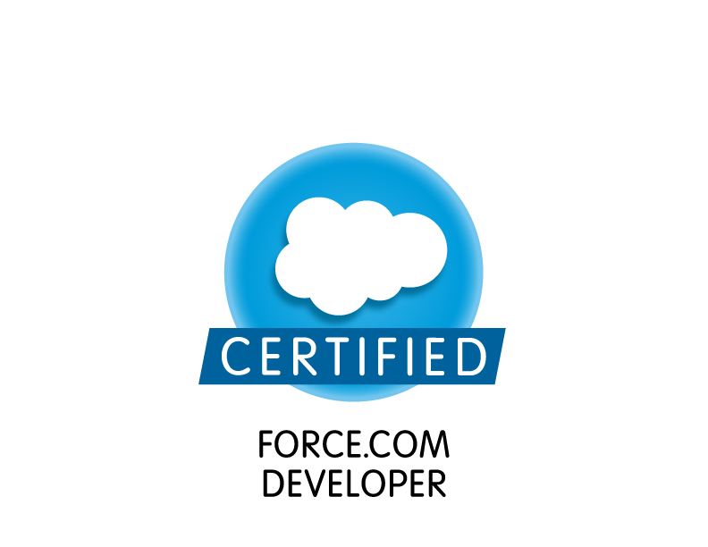
Mobile: +91-8076876129~ E-Mail: raj16singh@gmail.com, raj16_singh@yahoo.co.in,

Seeking senior level assignments in Implementation / Techno- functional with a leading organization of repute

PROFILE SUMMARY

An astute professional with 12+ years of experience in:

Implementation
Customer Relationship Management (CRM)
Marketing Automation
Techno-functional Consulting
Digital transformation
Project Management
Campaigns
Business Analyst
Reporting/Documentation

- Valid B1 visa
- PRINCE2® Foundation & Practitioner Certified
- SaaS implementations
- Extensive experience in Salesforce consultation and implementation, engagement management, onshore-offshore coordination, data management and maintaining entire CRM system
- Established the CRM support team across verticals that include administration, development and support
- Onsite exposure in Florida office for process and engagement improvement of salesforce (CRM) project
- Onsite exposure in Sweden and Spain for project implementation
- Excellent managerial capabilities in leading technical teams to support sales targets through Business Analysis, Solution Architecture and Design
- Proven abilities in driving sales & customer relationship management by understanding the customer business issues and delivering business value in the solution
- Demonstrated excellence in managing Salesforce Team in handling client’s request
- Skilled in administration, development, helpdesk and maintaining marketing database
- Rich exposure in campaign management, providing marketing support and creating enterprise reports and Dashboards
- An effective communicator with proven customer orientation, analytical & problem solving skills

CORE COMPETENCIES
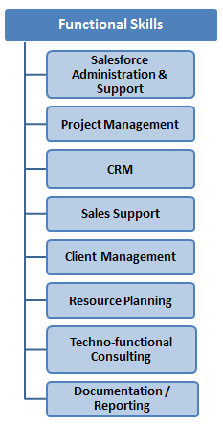
- Daily administering and supporting Salesforce/CRM including managing multiple user setup, profiles and roles, customisation of objects, fields, record types, page layouts and validations
- Data Migration & Data Clean-up. Data Management activities.
- Campaign management end to end support and report generation
- Working with management and end-users to create and manage complex workflow rules, data validation, and triggers
- Creating and documenting application requirements by working together with those involved in the development of program enhancements
- Developing reports, dashboards, and processes to continuously monitor data quality and integrity and assisting users with report design and management
- Devising training plans, materials, carrying out documentation for users, coordinating new user and on-going training sessions and training new and existing users
- Providing users with technical support on CRM & associated applications, and managing ongoing support requests and administrative needs of users
- Defining, communicating, and managing change management (release) process to develop & implement new applications and updates to existing applications
- Ensuring speedy resolution of queries & grievances, maintaining excellent relations with clients to generate avenues for additional business
- Leading teams, setting KRAs & monitoring their performance basis set parameters

ORGANIZATIONAL EXPERIENCE

Nov’19’ with LeadSquard Bangalore as Manager - Implementation

Role:
- Leading implementation team kick off meetings with cross-functional partners with various teams in different locations (US and India).
- Responsibilities include collaborating with the business lines, developing and executing project / product plans that embrace best practices, change management, quality management, effective communication plans, requirements management, and securing all necessary resources needed to achieve the project / product objectives.
- Plays a role of a key member of the Product Implementation team: understand strategic goals, client needs and business objectives of assigned clients; acts as liaison between the Product Development and Sales and cross-functional partners involved in implementation.
- Managing the team in terms of recruiting, mentoring and guiding to meet organizational objective
- Plans, documents and executes all phases of the project life cycle, including scope management, requirements management, work breakdown schedule and timeline management, priority and dependency management, and the assignment of roles and responsibilities.
- Manages multiple projects at once with team in various locations and shifts.
- Conducts and facilitates effective project meetings, including issue tracking, status reports, and executive communications Ensures problems are effectively escalated and crisis management activated, as needed.
- Lends subject matter expertise and knowledge management to the project team and stakeholders and ensures client satisfaction through quality and timely product delivery.
- Promotes change, process, and best practices to both the business and technical team members, providing training for the project management discipline.

Feb’19 – Aug’19 with Happiest Minds, Bangalore as PRODUCT CONSULTANT– CRM Practice
Role:
- Responsible for setting up the strategy for CRM and Marketing Automation Practice.
- Managing multi-year project, enterprise initiatives that have high degrees of complexity and are comprised of several sub projects.
- Provides program management for initiatives of large scope; develops and defines program strategy and approach
- Taking ownership of functional issues by identifying underlying problems, analysing solution potential solution and implementing system resolutions, including feasible workarounds
- Defines the initiative per the business need and creates momentum and support to drive forward, while managing the competing needs of multiple stakeholders.
- Responsible for cross functional program integrations for business support, delivering high impact strategic deployment result for the client, including sales transformation, roadmap and digital transformation journey via salesforce.com
- Manage activities between customer, senior management, implementation team, engineering and technical support to resolve critical issues during initial implementation and post go-live
- Leading the offshore development team with daily interaction to ensure timely progress and solution delivery to the client
- Application used in projects management
  - Jira
  - Confluence
  - SharePoint
  - Microsoft visio
- Application used in Project
  - Sales cloud
  - Service and marketing cloud
  - MAP

Dec’15- June’18 with Ericsson, Gurgaon as CRM Technology specialist
Role:
- Handling Microsoft Dynamics CRM instance of 2000+ user base, administration, enhancement, and reporting and data management.
- Ensuring speedy resolution of queries & grievances, maintaining excellent relations with clients to generate avenues for additional business
- I have been involved in Salesforce implementation and Marketo implementation in Ericsson. I was Part of Digital transformation team which done the implementation.
- I have been involved in all the technical discussion around this CRM and marketing automation practice within the organisation
- I was managing and supporting the world mobile Congress consecutive 2 years at Barcelona
- I was managing the support ticket
- Improving organizational efficiencies through automation of business process using Project management model
- Planning – Core team member in business requirement gathering and project planning for Sales & Marketing
- Analysis – Key player in process mapping, gap analysis and optimization
- Design – Solution design and identifying process improvement areas in CRM
- Implementation – Leading the team on CRM implementation
- Maintenance – Provided administration and level 2 support for users and providing training end users
- Development of training material, FAQs and audio-visual training videos
- Delivering audio-visual training through webex/Lync and classroom training
- Developing customized dashboards and reports for top management
- Manage multiple priorities and exhibit strong multi-tasking capabilities to drive process improvement initiatives.
- To develop effective working relationships with stakeholders and ability to communicate clearly with partners across geographical location.
- Campaign management end-to-end support
- Digital marketing: Email templates, Marketing list creation, campaign management, provide insight
- I am managing all the marketing automation tool for Ericsson
  - Marketo
  - HubSpot
  - ClickDimensions
- Supporting and managing Data Cleansing projects
  - Enhancing data quality, maintaining pipeline integrity
  - Manage reports, data management
  - Pipeline management
  - Working on GDPR project
- Vendor management: Managing TCS and another vendor for CRM
- Team Handling:
  - Monitoring And Evaluating Team Performance (Measure, track and meet SLA metrics)
  - Ensuring On-Going Team Coaching And Development that Motivates, Empowers And Retains Talent



Sep’10-Aug’15 with Fiserv, Noida as Lead (Salesforce)

Role:
- Established the Salesforce support team across verticals that include administration, development and support
- Playing a client facing role and working closely with the senior management in setting up Salesforce support for global sales operations in India office
- Gathering business requirements, converting them into functional requirements & design, delivering a comprehensive solution and providing application maintenance & support services to the client
- Accountable for:
- Executing multiple projects on CRM, Salesforce, data analysis, data cleaning, quality control, data cleaning and marketing database management
- Handling and managing client meetings, MOMs, and database related activities
- Lead, Account, Contacts, Products, Case and Opportunity Management
- Carrying out the implementation and instillation of data management and cleaning practices to ensure non- redundancy and accurate data
- Serving as an individual contributor and involving in project planning for Salesforce data migration and CRM
- Overseeing functions pertaining to:
- Creation of new user accounts and configuration of Salesforce.com to fit security needs
- Generation of different kind of reports & dashboards
- Exposure of using Apex Data Loader and Demand Tool
- Campaign management end-to-end support
- Directly reported to VP-sales and actively involved in Business Process Improvement discussions and meetings

Accomplishments:
- Recipient of “Shining Star” award in year 2011 and 2013 for the contribution in setting up the eCRM (salesforce.com) team and successfully running it for the last 4 years
- Recognized as “V I P” in 2011
- Joined Fiserv in 2010 as a Salesforce expert to drive a new CRM practice for the Global Sales function
- Merit of establishing an offshore Salesforce Team (development and support) to cater to the onsite client
- Successfully developed and maintained a stable CRM (Salesforce) solution over the years (which is today used by more than 2500 active users across Fiserv)
- Recipient of Living Proof Award for the outstanding commitment in providing CRM support to the Fiserv Global Sales Team


May’10-Sep’10 with Grail Research, Noida as Analyst- Salesforce
Role:
- Prepared & generated company-wide reports such as Revenue Report, Pipeline Report, Sales People Performance Report, Project Profitability Report and related reports
- Campaign management end-to-end support
- Implemented Salesforce and monitored the drive salesforce.com adoption among users
- Handled functions pertaining to report writing & maintenance of folders, dashboard creation & maintenance, tracking of User Change requests, data processing prior to uploads, monitoring of emails for adhoc queries, etc.
- Carrying out the monthly upload of key metrics from multiple sources into SFDC
- Exposure of using Apex Data Loader ,Demand Tool

Dec’08-Apr’10 with Accenture Services Pvt. Ltd., Gurgaon as Senior Assistant Database
Role:
- Ensured Database Management with SMT tool kit and salesforce.com
- Accountable for Salesforce.com customization and various other functions pertaining to:
- Handling user queries and providing solution within SLA
- Campaign management and report generation
- Database management using Apex Data Loader and Demand Tool
- Monitoring and driving salesforce.com adoption among users
- Developing and delivering end-user training
- Tracking key competitor activities in specific sector
- Conducting market study to analyze the latest industry and market trends

Accomplishment:
- Recipient of Bi-Annual “Extra Mile Encore Award” in 2010
- Successfully completed projects like:
- Products Salesforce Support
- Global Database Marketing Initiative
- Accenture Business Client Database
- Worked on Salesforce projects for Products and Services Divisions

PAST EXPERIENCE

Jan’08-Dec’08 with Daffodil software Ltd., Gurgoan as Data Analyst
Mar’06-Jan’08 with eDynamic Softech Solutions, Okhla Industrial Area as Data Mining (Sales Support)
Completed projects like Franchise Solutions, Pay day loan and Business Travel

ACADEMIC DETAILS


- MCA from Jaipur National University, Distance Education in 2012
- BCA from Birla Institute of Technology, Mesra Ranchi, Noida Campus in 2006 with 72%

TECHNICAL SKILLS

- Salesforce Certified Force.com Developer
- Well versed with CRM Tools such as:
- Salesforce.com: Sales cloud, Service cloud and Marketing cloud
- Managed package: Apttus and Cloud lending
- Microsoft Dynamics CRM 2016
- Open Source CRM
- PowerBI
- Project online
- Marketing automation tool:
  - Marketo
  - Pardot
  - HubSpot
  - Clickdimensions
- Conversant with Market Research Data Sources/Tools
- Skilled in Microsoft’s and Accenture’s Internal CRM Data sources/Tools like SMT( Sales and Marketing Toolkit) & CMT(Customer Maintenance Tool) with DE
- Expertise in MS Excel, MS Access, PowerPoint, MS Word - 2003 and 2007
- Proficient in Data Mining and Client Contact Management- Database Management

PERSONAL DETAILS
Date of birth: 5th July 1985
Permanent Address: D-3 Gauri Apartment, Dhanbad, Jharkhand, Pin-826004
Residential Address: Platinum City, Industrial Area,Stage 1, Yeshwanthpur, Bengaluru,
Languages Known: English & Hindi

Raj Kumar Singh

