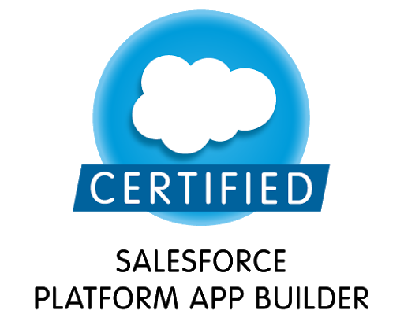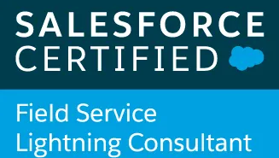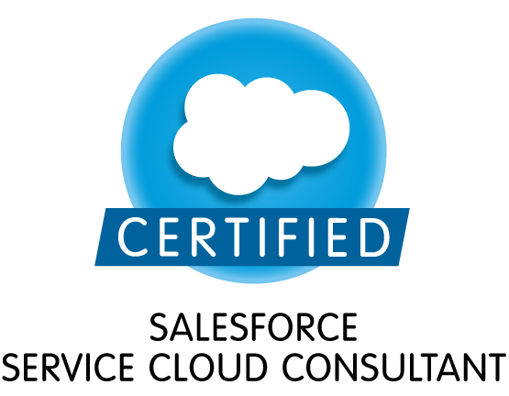

Hiten S (US Permanent Resident)
Authorized to work any employer
Email: Hitensalesforce@gmail.com | Phone: 732-737-8989
LinkdinId: https://www.linkedin.com/in/hiten-p-4a8a031b4/

Professional Summary

- Over 10+ years of experience as Salesforce Developer. Involved in various stages of Software Development Life Cycle (SDLC), aspiring to leverage technical and analytical skills to elicit, communicate and validate the business needs for recommending solutions that enable the organization to achieve its goals.
- Expertise in Customization, Security Access, Case Management, Data management (conversion/loading) and also Platform maintenance in Force.com, Sales and Service cloud.
- Designing of Custom Objects, Custom Fields, Pick lists, Record types, Page Layouts, Validation Rules.
- Expertise in designing Workflow Alerts and Actions, Approval Processes, Custom Reports types, Report Extractions to various formats and Dashboards.
- Configured user security permission in compliance with organizational need.
- Experience in SalesForce.com Apex Classes, Apex triggers, Visual force, Force.com API, complex SOQL & SOSL queries.
- Experience in Salesforce Lightning UI, building components, design standard and custom flexi Home, App and Record pages
- Implemented Live Agent Successfully and enabled Automated Invitation (Pro-active Chat) as part of Live-agent Console.
- Extensive experience working with Service cloud implementation mainly around Live Agent, Knowledge Implementation, Service console setup.
- Strong Knowledge in Salesforce Customization, Workflow Approvals, Data Validation, Sales, Marketing, Customer Service and Support Administration.
- Executed various levels of unit, integration and user acceptance testing using test cases to ensure that system conforms to specifications of business and quality requirements.

TECHNICAL SKILLS
Salesforce.com Technologies | Salesforce CRM, Apex Language, Apex Classes /Controllers, SOQL, SOSL, Visual Force Pages, S Controls, Apex Web Services, Lightning, Analytic Snapshots, Case Management Automation, Apex Data Loader
Salesforce.com Tools | Force.com Explorer, Force.com Data Loader, Force.com Platform
Operating Systems | Windows, UNIX, Linux
Web Technologies | HTML/XTML, Java Script, XML, AJAX, CSS, SOAP and WSDL
Certifications: | Salesforce Admin (201), Salesforce Developer (401)

PROFESSIONAL EXPERIENCE

Guardian Life Health Insurance, Frisco Tx
Role: Sr. Salesforce Lightning Developer Feb 2020 – Present
Responsibilities:

- Performed the role of Salesforce developer, lightning developer and interacted with various business user groups for gathering the requirements for Salesforce.com, Lightning and CRM implementation.
- Designed and developed SFA based Application on Force.com Platform in Salesforce.com environment with Apex programming language at backend and Visual-Force pages as user interface.
- Developed various Visual force Pages, Apex Triggers to include extra functionality and wrote Apex Classes and Controller to provide functionality to the visual pages.
- Designed, developed and deployed the Custom objects, Page layouts, Custom tabs, Components, Visual force Pages to suit to the needs of the application.
- Created workflow rules and defined related tasks, time-triggered tasks, email alerts, field updates to implement business logic.
- Ensured data integrity through the appropriate use of de-duping, loading and exporting tools, for bulk of data using Data Loader, Admin Garage and Lexi Loader.
- Worked on various Salesforce.com Standard objects, Custom Objects, Triggers, Classes, Pages, Reports and Dashboards.
- Used Data Loader for insert, update, and bulk import or export of data from Salesforce.com Objects. Used it to read, extract, and load data from comma-separated values (CSV) files.
- Developed dynamic Salesforce.com Visual force pages using Apex page functions and actions, designing them using HTML, CSS, and JavaScript.
- Build Lightening controllers with the AURA framework.
- Involved in developing Salesforce Lightening Apps, Components, Controllers and Events.
- Implemented Salesforce Lightning Components for small set of users for customizing reports and dashboards.
- Utilized Lightning Connect to get real time data from external system.
- Experience in Creating Roles, Profiles, Email Templates, Page Layouts, Workflows, Workflow Actions and Approval Process.
- Worked in Administration, Configuration, Implementation and Support of service max and Salesforce applications.
- Worked closely with sales team and business analysts and performed detailed analysis of business and technical requirements. Designed the solution by customizing various standard objects of Salesforce.com (SFDC).
- Worked with GENESYS Gplus adaptor for CTI integration, so agents can click-to-dial and screen pop capabilities.
- Used SOQL & SOSL for data manipulation needs of the application using platform database objects. Responsible for writing SOQL & SOSL queries with consideration to Governor Limits for data manipulation needs of the application using platform database objects.
- Created Batch Apex classes for batch execution and updating of related fields.
- Created various Reports (summary reports, matrix reports, pie charts, dashboards and graphics) and Report Folders to assist managers to better utilize Salesforce as a sales tool and configured various Reports and for different user profiles based on the need in the organization.
- Integrated the Web Services for extracting the data from external systems, and used the Sandbox for testing to ensure minimum code coverage for the application to be migrated to production.
- Involved in Agile methodology, Scrum which improved productivity and reduced errors.
Environment: Salesforce.com platform, Workflow and Approvals, Reports, Custom Objects, Tabs, Reports, Dashboards, Email Services, Apex Language, Visual force Pages, Components and Controller, Data Loader, Apex classes, Apex triggers, JavaScript.

Neustar, sterling Va
Role: Sr. Salesforce Lead Developer Sep 2019 to Jan 2020

Responsibilities:

- Integrated the Web Services for extracting the data from external systems, and used the Sandbox for testing to ensure minimum code coverage for the application to be migrated to production.
- Involved in various stages of Software Development Life Cycle (SDLC) including analysis, requirement engineering, architecture design, development.
- Worked on Lightning component development.
- Worked on App Exchange customization of lead generation app
- Worked on apex triggers to develop feature on user object.
- Built mobile application using new salesforce1 mobile app, developed Lightning Components, Controllers, Handlers, Events and Aura components.
- Involved in developing the Process Builders, Lightning flows and login flows.
- Developed a Sharing model for Insurance Lead, Quote and user objects
- Managing the offshore team.
- Developed Proof of Concept’s on Einstein Bot.
- Develop, document and enforce application standards and procedures.
- Implement customer-based solutions and develop products on the Force.com platform using Apex and Visual Force

Direct Tv, Sunnyvale CA
Role: Salesforce Developer Jan 2018 – Sep 2019

Responsibilities:

- Created new Apex Triggers, Apex Classes, Batch Classes and Schedule Classes, Email Services According to the Project Requirement.
- Interacted with various Business User Groups to gather the document requirements.
- Worked closely with Business Analysts to perform detailed analysis of business and technical requirements.
- Hands-on experience on Salesforce Cloud functional testing.
- Designed and deployed Custom tabs, Custom Objects, Components, Visual Force Pages, validation rules, Approval Processes and Auto-Response Rules for automating business logic.
- Worked with standard Salesforce.com objects like Accounts, Contacts, Leads, Cases and Opportunities.
- Created workflow rules and defined related tasks, email alerts, and field updates.
- Implemented pick lists, dependent pick lists, lookups, master detail relationships, validation and formula fields to the custom objects.
- Implemented Case Management Automation to track and solve Customer’s Issues.
- Designed and developed SFA based Application on Force.com Platform in Salesforce.com environment with Apex programming language at backend and Visual-Force pages as user interface.
- Used SOQL & SOSL with consideration to Governor Limits for data manipulation needs of the application using platform database objects.
- Created page layouts, search layouts to organize fields, custom links, related lists, and other components on record pages.
- Customized user Roles, Role hierarchies, Profiles and Sharing settings to ensure that the protected data is available only to the authorized users
- Used Force.com developer toolkit including Apex Classes, Apex Triggers and Visualforce pages to develop custom business logic.
- Integrated the Web Services for extracting the data from external systems to display in the pages of salesforce.com.
- Developed and configured Dashboards, Reports and Report Folders for different user profiles based on the need in the organization
- Used the sandbox for testing and migrated the code to the deployment instance after testing.
- Worked on Unit testing, for the customizations and developments done during the project.
- Provided the training to the internal business users to use the application and develop their own custom reports.
- Implemented SFDC CRM to deliver various reports in departments of Sales, Administration and Marketing etc.
- Interacted with various business team members to gather the requirements and documented the requirements.
- Created custom objects, Visual Force pages, triggers, validation rules to help track internal help desk cases, customize campaign budgeting and lead qualification.
- Created custom controllers implementing complex code for retrieval from Salesforce to VF pages.
- Worked with Apex Data loader for loading the Leads, Opportunities and their related activities into salesforce.com.
- Created various summary reports, matrix reports, pie charts, dashboards and setup report folders to authenticate users based on their profiles with permissions.

Liberty Mutual Dover NH
Role: Salesforce Developer Oct 2011 – Dec 2017
Responsibilities:
- Created new Apex Triggers, Apex Classes, Batch Classes and Schedule Classes, Email Services According to the Project Requirement.
- Conducted JAD sessions and interacted with Subject Matter Experts to gather requirements.
- Implemented the Salesforce application using AGILE SCRUM Methodology that involves iterative development methodology.
- Created Users, Roles, Profiles, Fields, Reports, Prioritize features based on needs.
- Configured Page layouts based on Users and Profiles.
- Integrated Salesforce CRM with Siebel CRM explicitly using web services API.
- Implemented Apex Classes & Triggers and linked them to manage the workflows Implemented in the system.
- Responsible for Implementing Salesforce.com for the Help Desk and Change Management Group.
- Created customized reports and Dashboards and created Queues, Public Groups and Email Templates.
- Configured Sharing settings and Delegated Admin to specify the level of access the users have to each other’s data. Provided record level and field level security.
- Customized various Formula fields, Master-Detail, Lookup relationships.
- Designed and deployed Custom tabs, validation rules, Approval Processes and Auto-Response for automating business logic.
- Implemented Live Agentsuccessfully and enabled Automated Invitation (Pro-active Chat) as part of Live-agent Console.
- Developed Cascading Style Sheets (CSS) for creating effects in Visual force pages.
- In charge of conducting the UAT with the Business users, and gathering feedback and providing the same to the development team.
- Created detailed Data Mapping, Schema Diagrams and documented the results for integrating various systems with Salesforce.com.
- Created the workflows for automated lead routing, Case Management, lead escalation, alerts and custom coaching plans.
- Developed APEX Classes & Triggers and linked them to manage the workflows developed in the system.
- Developed various Custom Reports and deployed them for different business user levels.

Environment:
Saleforce.com platform, Data Loader, Import Wizard, Visual Force Pages, XML, Triggers, Security Controls.

Intuz Solutions Private limited, Ahmadabad India
Role: Salesforce Developer June 2010 to Sep 2011

Responsibilities:
- Created new Apex Triggers, Apex Classes, Batch Classes and Schedule Classes, Email Services According to the Project Requirement.
- Actively involved in interacting with business users (subject matter experts), requirement gathering, defining functional and technical specifications.
- Performed the role of Salesforce.com Developer and Administrator in the organization. Also Participated in translating and documentation of business requirements into functional requirements.
- Perform detailed analysis of business and technical requirements and designed the solution by customizing various standard objects of SalesForce.com (SFDC) and other Platform based technologies like Visual Force, Force.com API.
- Customized Company Profile, Page layouts, record types, Security & Access Controls and Communication Templates as per the organization requirements.
- Designed high level customized visual force pages using extension controllers, custom controllers and standard controllers.
- Created case escalation rules to escalate cases automatically if they are not resolved within a certain period of time. Created templates using CSS, approval processes, approval page layouts and defined approval actions on them to automate the processes.
- Exported data from legacy system and imported into SFDC through Apex data loader for data migration.
- Created various Reports (summary reports, matrix reports, pie charts, dashboards and graphics) and Report Folders to assist managers to better utilize Salesforce as a sales tool and configured various Reports and for different user profiles.

Environment:
Saleforce.com, Security Controls, Escalation rules, Assignment rules, Record types, Custom objects and Fields, Workflows, Rules, Data loader.

