Raghavendra Bashetty Email: raaghavendra@gmail.com
Salesforce Vlocity Consultant Phone: +91 9949224001
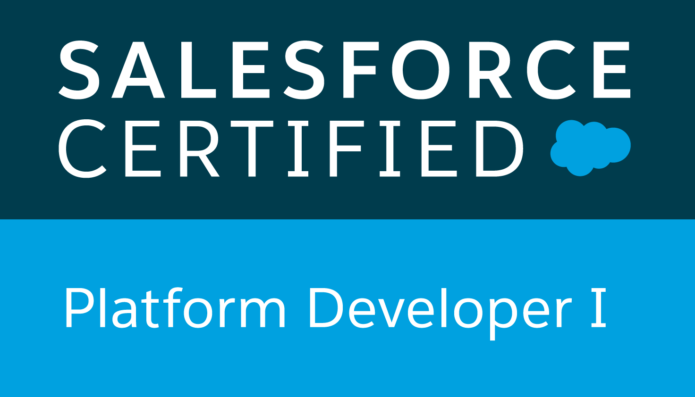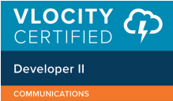

Professional Summary:
- Having 12+ years of overall professional experience in IT.
- Having 3+ years of strong experience in Salesforce, Vlocity Design & Development.
- Certified in Salesforce Platform Development (PD1),Vlocity Certified Proffessional (L2) ,Vlocity Developer Eseential & Vlcoity CPQ,
- Having 9+ years of experience in Siebel CRM Designing.
- Having strong experience in Telecom Domain (Order Management, Customer Management, Service Request Management) & Digital Transformation Projects.
- Having long term onsite experience ( ~ 3 yrs, Belgium, Saudi Arabia) and performed client facing roles in Techno Functional analyst roles.
- Having short term onsite experiences with USA, South African Clients .
- Having good Communication & Analytical skills.
Technical Experience:
- Strong experience in Salesforce Solution Designing & Vlocity Solution Designing in Cloud solutions.
- Strong experience in Siebel CRM Solution Designing.
- Having experience in requirement gathering & analysis, High level & Low level design, Development in Siebel CRM implementation.
- Having strong knowledge in Salesforce Admin, Apex, Integration.
- Having strong knowledge in Vlocity Omniscripts, Dataraptors, Integration Procedures, vlocity documents configuration, Cards & Layouts, Calculation Matrix.
Certifications:
- Vlocity Certified Proffessional Communications Developer II
- Vlocity Development Essentials
- Vlocity CPQ
- Salesforce PD1
Technical / Functional Skills:
Applications | Salesforce Salescloud & Service Cloud, Vlocity CPQ,Siebel ecommunications
Tools | Siebel 8.0/8.1/IP 15/IP 17/IP 18
Functional Skills | - Requirement gathering  - Solution Designing  - Telecom Knowledge

Projects Worked On :
Project Name | PMI Employee Experience Platform
Client | PMI,UK
Position | Salesforce Consultant
Responsibilities | - Participating in requirements discussions  - Design & Development  - SIT/UAT Support
Modules Worked On | Salesforce Admin & Apex , Salesforce Service Cloud
Technical Platform | Salesforce Service Cloud
Work location | Hyderabad, india

Project Name | British Telecom Digico Programme
Client | British Telecom, UK
Position | Salesforce Vlocity Consultant
Responsibilities | - Participating in requirements discussions  - Designing Vlocity CPQ requirements  - Mentoring the Jr Developers  - Support from Build phase to Go Live
Modules Worked On | Salesforce Admin & Apex , Vlocity
Technical Platform | Salesforce , Vlocity CMT
Work location | Hyderabad, india

Project Name | Verizon Partner Solutions (CX)
Client | Verizon, USA
Position | Salesforce Vlocity Consultant
Responsibilities | - Participating in User Story Discussions with BAs.  - Preparation of High Level Solution Designs.  - Salesforce & Vlocity Development.  - Supporting SIT,UAT,Go Live Phases.  - Module lead for few Sprints  - Mentoring & Reviewing of the work of development team.
Modules Worked On | Salesforce Admin & Apex, Community Portal, Vlocity CMT
Technical Platform | Salesforce , Vlocity CMT
Work location | Hyderabad, india

Project Name | MTN BSS Transformation Project
Client | MTN, South Africa
Position | Siebel Techno Functional Consultant
Modules Worked On | Customer Management, Assurance Management, Order Management
Technical Platform | Siebel IP 2018
Work location | Johannesburg, TCS

Project Name | Butterfly (Airtel Postpaid Siebel CRM Implementation)
Client | Airtel, India
Position | Siebel Technical Lead
Modules Worked On | Siebel Order Management
Technical Platform | Siebel 8.1.1.15
Work location | Hyderabad, TCS

Project Name | Saudi Telecom BSS Transformation
Client | Saudi Telecom, Saudi Arabia
Position | Siebel Designer
Modules Worked On | Siebel Order Management, Task Based UI
Technical Platform | Siebel 8.1.1.13
Work location | Hyderabad, TCS

Project Name | Belgacom One Selling CRM Application
Client | Belgacom(Proximus),Belgium
Position | Techno Functional Analyst
Modules Worked On | Siebel Order Management
Technical Platform | Siebel 8.1.1.13
Work location | TCS - Brussels

Project Name | Belgacom One Selling CRM Application
Client | Belgacom, Belgium
Position | Technical Analyst
Modules Worked On | Siebel Order Management
Technical Platform | Siebel 8.1.1.6
Work location | TCS - Hyderabad

Project Name | CITI GTS CRM
Client | CITI,UK
Position | Siebel Developer
Technical Platform | Siebel 8.1.1.5
Work location | Hyderabad, India

Project Name | NETAPP
Client, Loc | NETAPP, USA
Position | Siebel Developer
Technical Platform | Siebel 7.5
Work location | IBM-Banglore

Project Name | BSNL CDR CRM
Client | BSNL (Telecom),India
Position | Siebel Developer
Technical Platform | Siebel 8.0
Work location | TCS - Hyderabad

Education Qualifications:
Vellore Institute of Technology University
Master of technology (M.tech) in VLSI Design.
- Passed in May 2008 with an aggregate of 85.3%.
Jawaharlal Nehru Technological University
Bachelor of technology (B.tech) in Electronics & Communication Engineering.
- Passed in May 2006 with an aggregate of 73.1%.
A.P State Board Of Intermediate Education
Intermediate Education
- Passed in Apr 2001 with an aggregate of 84.1%
A.P State Board of Secondary Education
S.S.C – X Standard.
- Passed in Mar 1999 with an aggregate of 73.16 %
Achievements:
- Got Insta Award & Appreciations Mails in Infosys Career.
- Got Star of the Month, On The Spot, Best Team Award in TCS Career.
- Achieved “Spot Excellence” Award for Best Performer in Project in POLARIS career within 6 months of Joining and also got client appreciation for good work.
Training / Continuing Education Summary :
Year | Title | Location | Organised by
2008 | Siebel 8.0 Essentials | Hyderabad | TCS
2011 | Siebel Integration | Banglore | IBM
2017  2017  2018  2018  2019 | Oracle CPQ(BigMachine)  Salesforce Admin & Developer  Salesforce Developer  Vlocity Development & CPQ  Vlocity Order Management | Hyderabad  Hyderabad  Hyderabad  Hyderabad  Hyderabad | TCS  TCS  Infosys  Vlocity  Vlocity
Employment summary:
Employer | From | To
TATA consultancy services limited | 07/28/08 | 08/27/10
IBM India Limited | 09/15/10 | 01/23/12
Polaris Financial Technology | 01/25/12 | 01/04/13
TATA consultancy services limited | 01/09/13 | 14/09/18
Infosys Limited 24/09/18 Till Date

Personal Details :
Date of birth | 05-08-1984.
Sex | Male
Nationality | Indian
Passport | Z3980994
Martial Status | Married
Designation | Senior Consultant
Work Location | Hyderabad , India

Declaration:
I hereby declare that the above furnished information is true to best of my knowledge.

Bashetty Raghavendra

