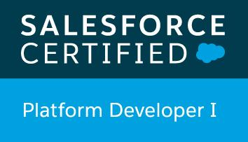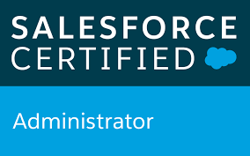  Sridhar Adhyatmabhattar  Certified Salesforce Consultant and Administrator  Summary:  - Over 5+ years of IT experience as a Salesforce Consultant and Administrator.  - A Salesforce Certified Platform Developer and Administrator with experience involving Salesforce Administration, Development, Configuration, Customization, Integration with External systems.  - Expert in working with Salesforce.com Service Cloud and Sales Cloud.  - Exposure in APTTUS Contract Lifecycle Management.  - Experience in SFDC Development implementing APEX classes, APEX triggers, Visualforce pages, FLOW, S - Control, SOQL, SOSL and Web Services (XML, SOAP and Rest)  - Expertise in Salesforce Deployment Tools (ANT and Changesets), Data Integration Tools (Data Loader and Workbench) and Version Control Tools (Git).  - Experience working in SDLC (AGILE and SCRUM) Methodologies.  - Experience in Collecting, Designing and implementing Requirements.  - Experience in Project Management Tools like Trello and Slack  - Good Exposure and understanding of Einstein Analytics  EXPERIENCE  Sodexo, Maryland, USA — Salesforce Consultant and Administrator  Aug 2019 - Sept 2020  - Worked on Collecting, Designing, implementing and testing the requirements in AGILE environment with the team.  - Worked on GAP analysis with the team to ensure accuracy in the designs.  - Worked in Customizing the salesforce application with configuration changes as per business needs.  - Worked on Automating business processes by using Salesforce automation tools and features.  - Developed Visual force pages using Apex, HTML, JavaScript and CSS programming on Force.com Platform.  - Worked on writing Triggers, Apex classes, Batch Apex class, Queueable class and future methods.  - Worked on Salesforce integration with 3rd party applications using APP Exchange and Rest API.  - ·Created and deployed Reports and dashboards using Salesforce.com platform and Einstein Analytics for business leaders.  - Worked on data import and export activities using Import Wizard and Data Loader for insert, update and delete  - Worked in installing, evaluating the AppExchange application under the salesforce.com platform.  - Responsible for developing Training videos and Documentation and training the end users for the new process in SFDC.  VMware Inc, Bangalore, INDIA — Salesforce Administrator  Nov 2013 - July 2017  - Worked in Service cloud and Sales cloud  - Involved in Configuring and Customizing of Salesforce applications for enterprise – wide implementation for over 10,000+ Users.  - Proficient in the point and click functionalities in salesforce using the Setup.  - Worked in creating Triggers and Visualforce pages.  - Involved in automating business processes by creating Workflows and Process builder  - Good understanding of the Salesforce best practices and Governor Limits.  - Handling and troubleshooting Production and Escalation Issues  - Generating and Analyzing standard and Custom Reports and Dashboard.  - Perform routine Salesforce data management/Cleanup task  - Spend up to 60% of the time resolving end-user issues and assisting in training.  EDUCATION  Monmouth University, West Long branch, USA — Master’s  Sept 2018 - Sept 2020  - Information Systems  Padma Bhushan Vasant dada Patil College of Engineering, Mumbai, INDIA — Bachelor’s  - Computer Science  CERTIFICATION  - Oracle SQL and PL/SQL Developer Certified Associate  - Salesforce Platform Developer 1 – Credential ID: 21497354  - Salesforce Certified Administrator – Credential ID: 21504720 | Address:  73 Cedar Avenue,  Apartment no.8,  Long Branch,  NJ,  07740.  Mobile: +1 646 - 314-1239  Email: sriadhy11@gmail.com  LinkedIn:  www.linkedin.com/in/srijaya11  SKILLS  Apex, Batch classes, Controllers, visual force pages, FLOW, lightning, data loader, API, JSON, Workbench, SOQL, SOSL, apex triggers and classes, APTTUS CLM, APP Exchange,  Einstein Analytics  LANGUAGES  HTML, CSS, JavaScript, APEX, SQL, SOQL, SOSL

