

M B A - M A R K E T I N G

**POOJA AGARWAL**

**GET IN CONTACT**

Mobile: 7744089100 email-id:agarwalpooja4298@gmail.com

A-401,mantri eternity society, Sandvik dapoodi pune-12

**INTERNSHIPS**

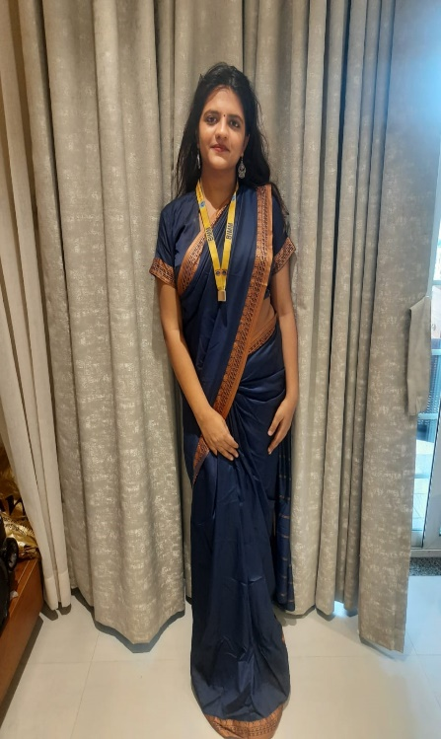

# PERSONAL PROFILE

MBA in marketing with keen interest in serving clients and fulfilling customer demand.

**PERSONAL DETAILS**

Date of birth:4/08/1997

Nationality: Indian Marital status: Single

**AREAS OF EXPERTISE**

Marketing Market Analysis

digital marketing

Advertising

Pre-sales

Timeline management

**OTHER SKILLS**

Tableau Microsoft Excel Power BI Python PowerPoint **Bulb and key, Pune( March2019-May2019)**

**DESIGNATION: Digital marketer**

* Designed and implemented strategies related to digital marketing and social media
* Designed creative and fresh approach to increase social media presence through posts and blogs
* Handled backlinking and SEO

**Tata steel Summer internship- (April2020-June2020)**

**DESIGNATION: Research project**

* Research title: Suggest ways to change the tat policies in covid-19 period
* Conducted competitor analysis
* Studies the various policies adopted by tata steel
* Studied the tata steel culture and HR practices and management policies
* Did qualitative research and secondary research
* Conducted primary research through questionnaire

**Infotech MH services  
 DESIGNATION: Social media intern**

* Handling social media posts and creating creative posts
* Formulating various creative social media strategies targeting new audiences and driving engagement
* Creating posts related to covid-19 awareness to engage the audience.

**Amura marketing technologies( sept 2020-nov2020)**

**DESIGNATION: Pre-Sales**

* Handled company pre-sales and customer acquisition
* Designed various marketing strategies related to cases
* Handled the media plan and account of clients
* Converted a lot of new clients for the 360 digital marketing services

# RESEARCH PAPERS

* Study on green consumer buying behavior towards cosmetic industry in India
* Study on suggesting to change the policies in tata steel during covid-19 period

**AWARDS RECEIVED**

Client appreciation for productive and timely work. Promoted to strategy level during internship for my creative inputs

National, state and district level certificates in dancing competition/

**HOBBIES AND INTERESTS**

Dancing

Meeting new people and understaffing new culture

Reading about different ad campaigns of various brand.

* Learning new courses

**LANGUAGES**

English Hindi German

**EDUCATION HISTORY**

**BALAJI INSTITUTE OF MODERN MANAGEMENT, PUNE**

**Master of Business Administration, 2019-2021**

Percentage: 71.30% (1st year)

* Conducted a through research and published my own research paper. Research topic: Understanding the green buying behavior towards cosmetic industry in India.
* Social media coordinator during the induction program
* Secured 1st position in the power point presentation among 1000 students.

**GARWARE COLLEGE OF COMMERCE,PUNE**

**Bachelor of commerce ( 2015-2018)**

Percentage: 68 %

* Participated in the cultural programs and competitions

**ST URSULA JUNIOR COLLEGE,PUNE**

**Secondary education(2013-2015)**

Percentage:89%

**D.A.V PUBLIC SCHOOL,PUNE**

**Primary education(CBSE BOARD)**

Percentage in 10th::95%

# LINKS

# https://www.linkedin.com/in/pooja-agarwal-aa0b57111/

**ACHEIVEMENTS**

* Secured 1st position in induction presentation in MBA among 1000 students
* Completed intermediate level of CA course
* Secured 3th and 4th region abacus and mental arithmetic competition
* 3rd position in file folder and spelling bee in 2012