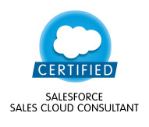 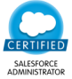 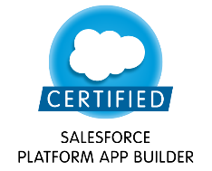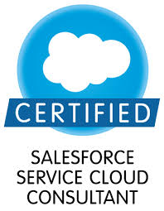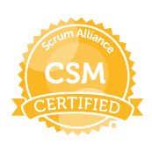 Rashmi Rathore
Cherry County, Techzone-4, Greater Noida West
Phone: 9599323952
pcky.rashmi@yahoo.com

Background

Experienced & Certified Sr. Salesforce Package Solution Consultant/Sr. Devloper.
(Total IT experience is 11+ years, inclusive of 6+ years experience in Salesforce.com platform)
Extensively worked on Lightning Projects/Lightning Migration.
Highly Skilled in lightning components( Aura Components) and Proficient in Lwc.
worked on Visual force, Apex classes, Integration (REST/SOAP),
Triggers, Asynchronous(Batch/Queuable/future), Flows and Configuration and so on.
Worked on SFDC Administrator Configurations - created Profiles/permission sets, Roles hierarchy, Users, Page Layouts, Email Services, Approvals, Workflows, Validation rules, Lightning App builder, Reports, Dashboards, Tasks and actions and so on.
Worked on Salesforce integration with LinkedIn Sales Navigation and MAPAnything tools and External Objects using lightning.
Proficient in Data Migration and Deployment.
Appexchange tools hands-on : MagicMover, Gridbuddy, Strike (grid), Docusign.

Skills / Expertise
- Salesforce Classic/ Lightning Application Development (Declarative and Programmatic)
- Integration (Rest and Soap).
- Lightning Components (Aura and LWC)/Events
- Data Migration and Deployment
- Language : APEX, Javascript
- Proficient in translating business requirements to technical Design.

Recent Training:

- Einstein Analytics Plus
Aug’11- Present Salesforce package solution consulatant IBM india Pvt Ltd.,

Experience in Salesforce
- Salesforce Garage projects

Kyocera Document Solutions :
Worked on SOAP integration to oracle services and lightning components.

NBCU universal :
Worked independently on both sales and service cloud apps customization (Enhancements) with lightning components. Magic Mover, Gridbuddy, Docusign.

Kyocera Document Solutions :
Worked on SOAP integration to oracle services and lightning components.

L’Oréal: Worked on existing Lightning Service Console application’s Customization that includes building new lightning component/ event. few visualforce pages, used Strike components, Custom metadata types,
Rest Integration.

British American Tobacco: Worked on Lightning Community with bolt solution. Created Profiles/page layouts/record types/Apex Sharing/Apex classes/test classes/Batches/Process Builder/Workflows/Custom metadata types/Lightning Components/Community domain set up and branding and other community customizations. Used JIRA for project tracking tool and KANBAN

Expedia, Role: Sr. Application Developer: Customized module for Case/ queues reassignment on a specific User type Activation and deactivation by implementing trigger and nested queueable. And sending email alerts.
Optimized apex classes and triggers for best practices. Built lightning components.
Created Visualforce pages and custom controllers. Worked on rest service integration (Enhancement).

Daikin/Nabor, Role: Sr. Application Developer : Build custom functionality using Visualforce pages using standard controller and extensions.
Rebuild the few existing Visualforce Pages to work for both Lighting , Classic and Console and Console LEX.

MVAA, Role: Sr. Application Developer : Created multiple state tax forms in Lightning Design System for existing Lighting Components for US region.

Lodha Builders : Developed 360 degree customer view. (POC)

- Other Projects/ Implementation :
2.1 JFS(Janalakshmi Financial Services), Role: Sr. Application Developer
To support ongoing development, I’ve worked on customizing new visualforce pages, triggers, batch classes and code optimization for existing New/existing Loan processes and HR Team Transfer application.
Managed security, users, roles, profiles, groups, queues and other Salesforce setup options as and when necessary/required.

Worked closely with client and attended daily meetings to finish tasks based on estimation.

2.1 AMEX (Export Blue):
Followed Agile. Worked on Salesforce Lightning and Classic both. Migrated the existing Visualforce pages to Lightning and build components for it. Worked on Salesforce integration with LinkedIn Sales Navigation and GeoMapping tool- MAPAnything. And did a POC on External Objects integration.
Worked extensively on Data Migration and Configuration on Wokflows, Validation Rules, Permission sets, sharing rules, Managed security, users, roles, profiles, groups, queues and other Salesforce setup options as and when necessary/required.
Worked closely with on-shore/off shore and multi-located teams and attended daily stand up meetings to finish tasks based on estimation.

Previous Experience (Microsoft technology (asp.net, C#, WCF, web services, MSSQL),Oracle,
)
S.No | Project /Account | Role/Responsibility
1. | Vodafone Ireland | Worked on Application development.: Coding, Mentoring team, Creating Technical Design Documents and Test Plan, High Level and low level design documents, Code reviews for team.
2. | National Grid(UK)
3. | Micron Technology(USA)

Dec’09–Aug’11 Technical Associate TechMahindra Ltd., India

Worked for “S Tel” and implemented S Tel Prepaid Solution as Dot Net Application Developer

Achievements:
1. Appreciation for providing UAT support at client site.
2. Received ‘Key Contributor Award’ from Client for exceptional performance in S-Tel Prepaid Launch.

Jan’07–Apr’08 Software Embedded Engineer Reltronics Technologies.

Worked on Product- SmartInstrument (RFID Middleware) as Programmer
Technologies/Tools: Python, C++, Embedded C, C# 2.0, RFID tags /readers integration and devices.
Achievements : Got appreciation award for security/alarming module.

Education
PG Certifcation in Embedded Systems Design & Development from Pune University, Dept. of Electronics Sc.

B.Tech in Electronics & Communication
UPTU university

