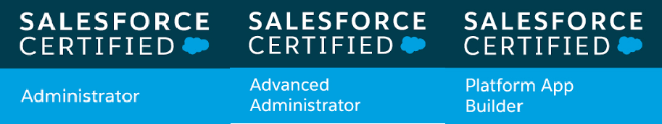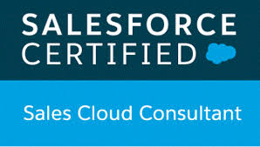

|  |  |  |
| --- | --- | --- |
|  | **RESUME** |  |
| **Name: Mayur Sarda. Phone:** 7972440081 |  | **Email:** [**mayursarda125@gmail.com**](mailto:mayursarda125@gmail.com) **Address:** Ravet, Pune 411057 |
| **Career Objective** |  |  |

To obtain a position that will allow me to utilize my Salesforce skills, knowledge and experience of 5+ years for advancement of company while learning and making myself grow with the company.

**Professional Summary**

**Organization 1: Claranet** (June 2023 – Till Date)

# Working as Senior Engineer (Senior Salesforce Administrator). Roles and Responsibilities:

* Administration of the Salesforce environment; implement changes within SFDC to applications, custom objects, custom fields, page layouts, flows, processes, validation rules, dashboards, reports, etc.
* Execute large-scale data improvement projects within our CRM and related systems such as ensuring customer-master data is clean and up to date.
* Continuously stay abreast of best practices and use those to suggest and create solutions that fit requirements and the overall platform.
* Presently working on Sales cloud, Service cloud, CPQ, Conga and Sales and Service cloud.

**Organization 2: Nagarro** (June 2021 – June 2023)

# Working as Senior Engineer (Senior Salesforce Administrator). Roles and Responsibilities:

* Experience Assisted Project Managers in Various Work Streams on Salesforce.com. Worked on complete Data Management for our primer client.
* Worked on SFDC Helpdesk in terms of cases that flow into System.
* Worked towards continues improvement of the system, have a good understanding of release process and deployments.
* Presently working on Sales cloud, Service cloud, CPQ, FSL and Experience cloud

**Organization 3: Cognizant Technologies India Ltd.** (Aug 2018 – June 2021)

# Roles and Responsibilities:

* Experience in setting up Sales Cloud, Service Cloud also implemented and resolved the ongoing client issue.
* Supporting direct Salesforce customers in troubleshooting/configuring Org Setup, Data management, Analytics, Automations, Einstein Analytics, User setup.
* Maintenance of User roles, Data security, Profiles and permissions, Approval process, Workflow rule, Email alerts, Data validation, Process Builder, building Reports and Dashboards for salesforce customers.
* Creating Quotes, Email Templates, Role Hierarchy, Perform bulk operations.

# Organization 4: Concentrix as Operations Executive (Aug 2017 – Aug 2018)

* Working with Salesforce Reports and Dashboards.

**Academic Qualification**

* BE graduate in ECE (Duration: 2011 - 2014 with 72%)
* CDAC – (Diploma in advance Computing 2015-2016)

**Trailhead**

* 2 Star Ranger on Salesforce Trailhead (**210+ badges and 100k+points)**

**Certifications**

* Salesforce Certified System Administrator – 201
* Salesforce Certified Advanced System Administrator – 211
* Salesforce Certified Platform App Builder
* Salesforce Certified Sales Cloud Consultant
* Salesforce Certified Associate

**Personal Information**

Date of birth:27-03-199 1

Gender: Male

Add: Sarda Building, Balaji Plot, Amravati- 444605 Languages Known: English, Hindi, Marathi

**Declaration**

I hereby declare that the particulars mentioned in this document are true to the best of my knowledge and belief.

# Date:

**Place:** (Mayur Sarda)

Recruiter comments: Mayur has 5.8 years of experience in salesforce administration. He was rewarded in his previous company in recognition of his work.

# 