

Though leader and IT Hardware & Software Asset Management professional offering nearly 8 years of rich experience in ramping up IT practices and implementing new IT Asset & Infrastructure initiatives with expertise in IT Hardware & Software Licenses Management, Software Compliance Management, IT Procurement/Negotiations and Risk Management

HAMEED HASSAIN SHAIK
shaikhameed.hassain@gmail.com +91-9346179539/9010678501

Executive Profile  - An Innovation & Transformation Specialist, with rich experience in driving IT Hardware & Software Asset and Service Management Operations and providing technological direction to the business  - Currently working with SoftwareONE India Pvt. Ltd., as SAM Associate Consultant and managing end-to-end software licensing, license management, license transfer, software license compliance audit and license database functions  - Recognised for helping clients in evangelizing best practices and process improvement initiatives through instituting IT Assets strategy & governance models to effectively manage security threats  - Exhibited leadership in enhancing the overall performance of the process by effectively migrating the application; installing the application on all the systems and maintained the server  - Recognised for identifying savings opportunities for renewals, software licensing and services; liaised with 200+ vendors and attained cost savings to the tune of 99% by effectively negotiating  - Documents Preparation: Hands-on expertise in preparing workflow process document, Trend Analysis Reports of Service Desk Request  - Rewards & recognition: Bagged ‘Associate of the month’ and ‘Team of the Month Award’  - Recognised recognition for timely providing Adobe, SAP, CAD and CAM related license support and group allocation  - Vendor Management expert: skilled in managing contracts and relationships to maximize value creation and uninterrupted services for software licensing, maintenance and service offerings through vendor scorecard, periodic performance review with vendor, timely renewal of AMC, support scope, rate contract  - Governance, Risk & Compliance specialist: Comprehensive experience in implementation of SAM / ISO 19770 certifications in complex multi-location environment; conducting gap analysis between current practices and baseline best practices to identify opportunities for quick wins and longer-term improvements  - Recognised for delivering a high-quality customer experience, elevated customer satisfaction, while adhering to the SLAs & work processes  - An effective leader with capabilities in motivating teams and maintaining deliverables as per the defined guidelines along with elevating service standards for operational excellence | Key Impact Areas    Budgeting & Forecasting  Flexera/Snow/X-formation/Slims  IT/ Software Asset Contract Mgmt.  Licensing & Compliance Mgmt.  Stakeholder/ Vendor Management  Team Building & Structuring  Documentation & Reporting  SLA Management & Governance  Process Improvement  Internal Audit / CMDB  Soft Skills    Soft Skills  Decision-maker  Communicator  Analytical  Motivator
Career Timeline
Since Aug’19: 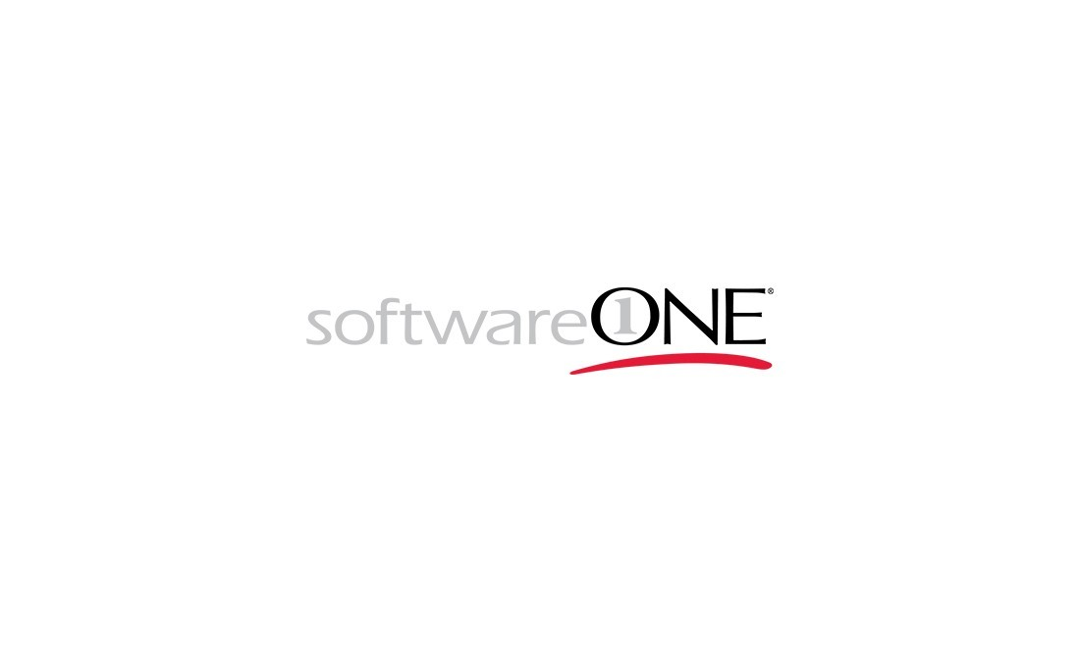
Jun’14 to Jun’16: 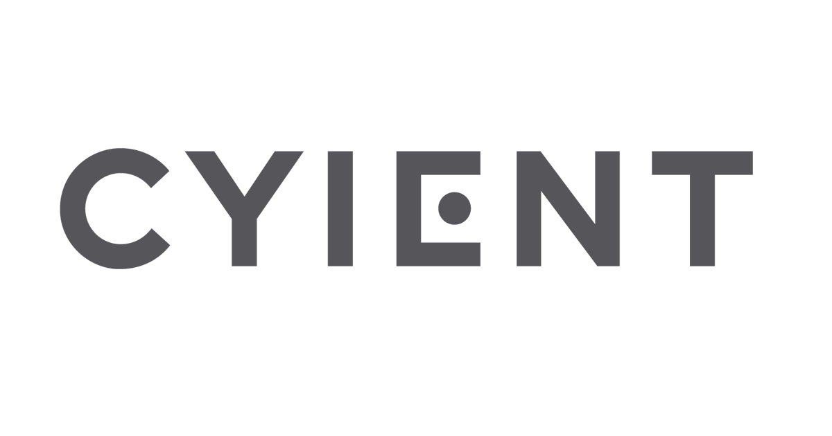
Jan’13 to Feb’14: 

Jul’16 to Aug’19: Soulpro Info Logix Pvt. Ltd.
Feb’14 to May’14: Precision Informatics
Education & Certifications

- 2012: BCA from Periyar University

Certification:
- ITIL Foundation Certificate in IT Service Management
- PROZM Certified SAM Professional
- BSA Vera Firm Certified

IT Skills
- Desktops & Laptops Configure and Troubleshooting
- Windows Xp, 7, 8, 10, and server: Windows 2003, 2008,2012 servers, Linux, Networking
- Flexlm tools: CATIA (IBM-AIX, DSLS), ArcGIS Server, AutoCAD, Ansys, UG, and Hyper Mesh, Arc FM
- SAP-Power Builder, Adobe, Microsoft, Lucid Chart, Workshare
- Implementation of SAM tools like Flexera (FNMEA, FNMS), Snow, Ivanti X-formation, Slims, LMS (License Management Systems)
- Procurement Tools: SAP, Proactis, Tnet
- Incident Management Tools: Ivanti, ServiceNow, BMC Remedy, Request Centre, Nimsoft

Professional Experience
Since Aug’19: SoftwareONE India Pvt. Ltd., Bangalore as SAM Associate Consultant
Key Result Areas:
- Maintaining information database to address budgeting, software compliance, inventory, contracts and cost; developing annual operating budget & capital budget for software purchase
- Improving quality and consistency of Information Technology related procurement activities by providing analytical support
- Implementing integration requirements for IT asset management process with managed service
- Ensuing timely renewal of AMC, support scope, rate contract and so on to ensure uninterrupted services
- Interfacing IT initiatives with various department to ensure corporate efficacy regarding planning, purchasing, installation, and management of hardware and software
- Preparing reports (daily, weekly and monthly) for client reference; monitoring and closing tickets within SLA (Approvals, Tasks, Incidents)
- Preparing workflow process document after completion of the purchase, installation, service desk resolution request resolution
- Drafting QBR Reports,Trend Analysis Reports of Service Desk Request
- Formulating & benchmarking functional best practices to focus on development of capabilities to meet present and future goals of organization
- Maintaining license database with all relevant information and providing timely alerts for individual users and project groups when licenses are to expire
- Coordinating with “owners” to decide upcoming contract renewals and updating SharePoint records accordingly
- Working with Cost Center Manager and providing approval for software purchase
- Analysing the licensing cost and chose the right licensing model which helped in reduction of IT infrastructure cost
- Managing software license metering & analysis of license usages, hardware and software transitions and related installations of IT equipment
- Conducting compliance checks on publishers, pulling out common reports from Flexera Tool; creating PO Templates and link with license in Flexera
- Consolidating the effective license positions of renewal publisher; preparing Processing & Troubleshoot Documents (KB) maintaining in share point
- Supervising dedicated team of 4 professionals; managing allocation of work across individual members within the team and monitoring performance for ensuring effectiveness of work

Previous Experience
Jul’16 to Aug’19: Soulpro Info Logix Pvt. Ltd., Hyderabad as IT Asset Analyst
Key Result Areas:
- Managed entire operations of Request Center for IT Assets with a team of 4 professionals ; coordinating with users for approving the tickets and escalating as per SLA
- Consolidated assets track sheet and updated the same in Ivanti tool
- Supervised vendor performance and established healthy relationship with them by ensuing conformity to contract performance, resolution of payment disputes, activity on critical dates (extensions, renewals, price adjustments)
- Actively participated in application audits, SLA/OLA discussions
- Attended after-hours (24×7) escalation on-call rotation and provided technical issue resolution via telephone, email, and other electronic communication methods
- Ascertained the administration of SOPs (standard operating procedures); maintained optimum levels of IT equipment, spare parts and so on
- Worked with Pro-Vigil, Rio Tinto customers

Highlights:
- Front led the entire gamut of operations including license usage, license allocation and reallocation of the licenses to teams
- Configured CAD/CAM floating license files in servers, reserving licenses to internal teams as per purchase data
- Prepared software data, LMS and software purchase records
- Received approval of GHD for the SW installations on the specific software
- Monitored Flex era (FNMEA), Slims, X-formation Tools
- Conceptualised periodical report on license usage & software purchases for management

Jun’14 to Jun’16: Cyient Ltd., Hyderabad as Software Asset Analyst
Key Result Areas:
- Managed end-to-end operations of license usage, license allocation and reallocation of the licenses to teams
- Configured CAD/CAM floating license files in servers, reserving licenses to internal teams as per purchase data
- Received approval of GHD for the SW installations on the specific software
- Monitored Flex era (FNMEA), Slims, X-formation Tools

Feb’14 to May’14: Precision Informatics, Hyderabad as Systems Engineer
Key Result Areas:
- Supervised the installation of operating systems and troubleshooting of tickets (USD, Remedy)
- Headed the migration of XP to Windows 7 CSC Project

Jan’13 to Feb’14: Sign Solution, Hyderabad as Hardware Engineer
Key Result Areas:
- Managed the configuration of Local Area Network; drafted daily and weekly work reports for the senior management
- Identified & resolved hardware, software & end users problems

Trainings Attended
- Prozm SAM Certified Professional
- BSA Vera Firm Certified
- CCNS: (CMS Certified Network Specialist)
- Diploma in Hardware, N+ from CMS
- MCSA (Microsoft Certified Solution Associate) from CMS
- CCNA & CCNP Trained from Zoom Tech
- Linux from CMS
- KPMG SAM Process
Personal Details
Date of Birth: 13th December 1989
Languages Known: English, Hindi, Telugu
Current Address: Marathalli, Bangalore
Passport No.: L2220901; valid till: Jun’23
Target Location: Bangalore/ Hyderabad



