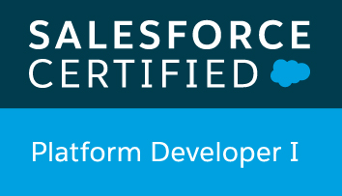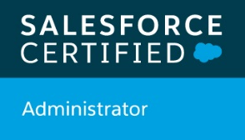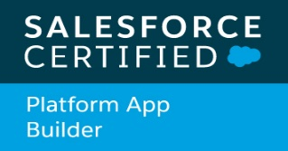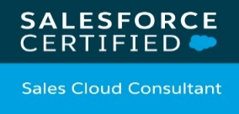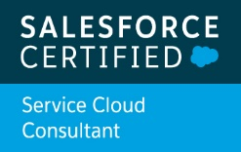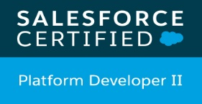  Firoz Sikandar Patel | H 801, Kalpataru Splendour , Wakad  Pune – 411057 ,Maharashtra, India  E –mail:  feroz.ptl@gmail.com  Mobile- +91-9173064020

Objective

- To learn and function effectively in an organization with my hard work to constantly upgrade my knowledge, experience and skills .And pursuing the unending goal of achieving excellence in all walks of life

Professional Experience

- Around 8 Years of overall extensive experience in IT industry in Finance, Banking, Telecom and Healthcare domain, currently working in APPIRIO (Wipro) as a Sr Consultant.
- Area of expertise are Salesforce, Vlocity and JAVA, with hands-on Salesforce Service cloud, force.com apps custom development, REST Integration, Lightning and Vlocity Development. Working experience at client location Australia.

- Recently had been to Australia Sydney at Telstra, worked closely with client to handle project development, release issue, gathering new requirements, production support and plan the release activity along with the development.

- Good hands on experience in Salesforce Customization including APEX classes, Triggers and lightning components.

- Understand the principles and best practices of Salesforce data modelling interface design, code development and testing, and can apply these principles in real-world development environments.

- Participating in relevant technical and verbal communication with the client/Product owner and analysing the requirement received from client.

- Have successfully handled various major projects viz. – Agent Console, Orion (Research on Clinical Data), Digital River (Platform payments), EPA, Offshore mutual funds.

- Migrated multiple Java / .Net based applications to force.com based Application as part of App Modernization.
- Strong analytical and logical thinking along with problem solving attitude.
- Learn and adapt quickly to new roles and responsibilities.

Technical Skills
- Programming Languages: SALESFORCE, Salesforce Lightning, Vlocity , JAVA,SQL, Spring MVC and Java Script (exposure on Angular)
- Databases: Oracle, MySQL
- Hands On experience on Salesforce DX and CI/CD process.
- Hands on experience on common integration pattern REST web services
- Lightning web component – LWC in current project
- Hands on experience on Vlocity integration procedure, Omniscript, Dataraptor,Card Layouts, Vlocity actions and Vlocity templates.
- Knowledge of Vlocity CPQ
- Hands on experience on different IDEs & Tools like Mavensmate, Submiletext , Eclipse, SQL Server Data Studio, APEX Data Loader , Visual Studio.
- Repository tools: GIT, Bit bucket, Apache SVN.
- Build tool – Jenkin, Bamboo, Ant Migration tool.
- Strong Collection framework, Data modification/Manipulation via efficient approach – playing with huge data of JSON,XML serialize/deserialize of data as per the solution.


Achievements

- Salesforce Certified Platform Developer I.
- Salesforce Certified Platform App Builder
- Salesforce Certified Administrator (ADM)
- Salesforce Certified Sales Cloud Consultant
- Salesforce Certified Service Cloud Consultant
- Salesforce Certified Platform Developer 2
- Delivered seminar on MAP-REDUCE Algorithm used in GOOGLE Search Engine.
- Achieved ‘Pat on The Back’ Certificate in the large audience of Wipro.

Professional Summary

- Apprio/Wipro Technologies | Pune | www.wipro.com Jan 2017 - Current
Consultant
- Cybage Software Pvt Ltd | Pune | www.cybage.com Dec 2014 – Dec 2016
Senior Software Engineer

- Sailfin Technologies Pvt Ltd Oct 2013 – Nov 2014
Senior Software Engineer

- Finlogic Technologies Pvt Ltd Nov 2011 – Oct 2013
Executive Java Developer

Educational Qualification

- B.E. IT from Sinhgad Academy Of Engineering , Pune University,2011 pass out with first class
- HSc. from Jai Bhavani Jr. College in 2007

- SSc. from K.P.B.D High School in 2005



Professional History

Roles & Responsibilities:

- Participating in relevant technical and verbal communication with the client/Product owner and analyzing the requirements received from the client

- Analysis, development, design, support and solving clients queries

- Major participation in the enhancement of the application in relation with the development
teams while ensuring that the applications are and remain in conformity with the defined
standards
- Contributing ideas leading to continual process improvement while mentoring team-members

1)
Project : B2C - Agent Console
Client : Telstra
Environment : Salesforce (Apex, triggers, REST API, Vlocity, Service console and lightning)
Role : Analysis on requirement and Development

Description: Agent Console is designed to provide Telstra retail (TSN and TLS) and GCC agents with a tool that provides them with easy to use dashboard-like view of customer information as well as providing some transactional capabilities to allow the agents to carry out tasks without leaving the console view. Customer, Agent would be able to perform different business operations and place an order through different Digital UI Channels such as My Telstra (Web App), Agent Console for activation purposes and through NATAMA for Assurance purposes. Customer, Agent performed business transaction will flow through different platforms such as P2O, Networks etc. For Da Vinci NBN (Voice, Internet, TTV) & Mobile products, both existing & new customers would be able to place business transactions through new My Telstra (Web, App) & Agent Console.

2)
Project : ORION (One Research Interface and Online Network)
Client : PHILIPS
Environment : Salesforce (Apex, VF, triggers, Lightning component)
Role : Analysis on requirement and Development

Description: ORION is a Force,com application it contains research on clinical data with various institution mapped with the projects and research through institution with various approval steps. Once research done there is Sdoc generation integrated to generate the template at each step of approver approves.

3)
Project : Enterprise Process Analytics (aka Smartview)
Client : GENPACT
Environment : Salesforce (Apex, VF ,triggers, Dashboards ,charts and Reports)
Role : Analysis on raw data and Development
Description: Implemented force.com based application for a professional services provider. This application gets P2P & O2C data from different source applications and present it in a dashboard and report format.

4)
Project : Platform Payments (E-commerce Payments domain)
Client : Digital River
Environment: Java and Salesforce
Role : Requirement Analysis and Development

Description : It is E-commerce application, wherein there are 3 modules the one to manage the sites and associate details for client those wanted to host their sites. And other module is the shopper side which is responsible for managing the shopper flow. And third module responsible for managing the dynamic data for the application like dynamic JSPs, email notifications, backend batch jobs etc.
Worked on Credit Card PCI Compliance and migration of existing credit cards millions of data through batch job.

5)
Project : Offshore MF (Trail, Upfront Process And Other MF terms)
Environment : Java/J2EE Spring Framework (MVC),JSP Servlet and JavaScript
Database: MySql and Oracle (Procedures, Triggers and Functions).
Role : Analysis and Development
Description :
Offshore is concept of MF (mutual fund) has various terminology in our organisation. It is mainly divided into two models NJ Non Omnibus and NJ Omnibus. In this AMC, Fund and Scheme level transaction getting placed via companies representative i.e. Partner to NJ. Transactions are Purchase, Switch and Redemption all are processed and verifies under the NJ. Client’s investment amount on particular scheme daily calculated According to daily NAV update .Clients profit is processed according to NAV value and no. Of units allotted to them.

Personal Summary

Date of Birth: 10 Oct1989
Age: 29 years
Gender: Male
Marital Status: Single
Languages Known: English, Hindi, Marathi and familiar with Gujarati and Arabic
Hobbies: Playing cricket, Swimming

Firoz Patel

