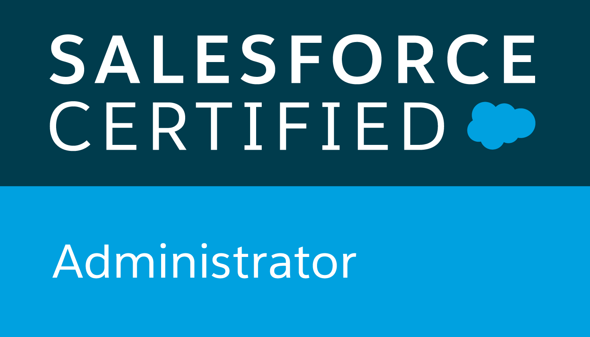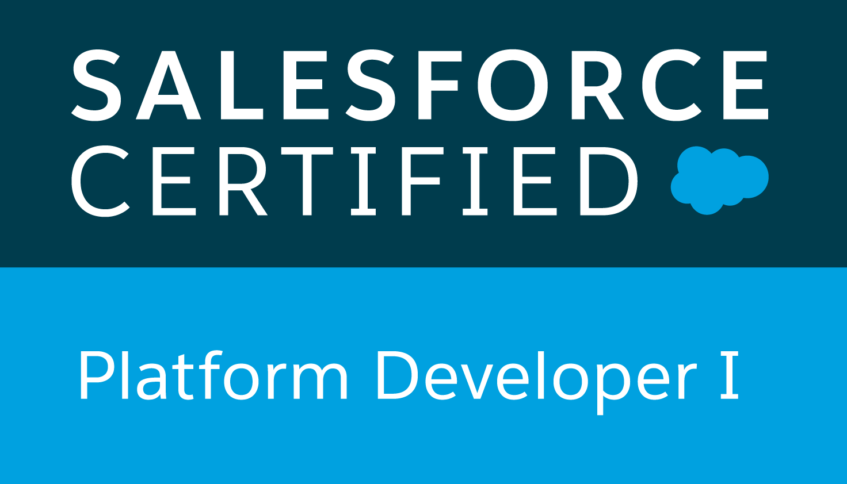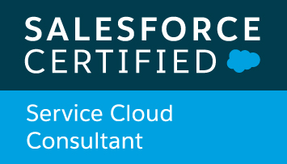
Sharat Rao
sharatraosfdc@gmail.com
Mobile: 657-246-2625
https://www.linkedin.com/in/sharatchandra-yadagiri-29368233/

Professional Summary:
- Over 10+ years of IT experience in Medical Life Sciences, Health Insurance, Credit cards and Banking domains.
- 5+ years in Salesforce CRM and Force.com platform. Implemented Service Cloud, Sales Cloud and custom applications.
- 3X Certified Salesforce Developer.
- Extensively worked on Salesforce Lightning development.
- Have developed new Lightning Web Components.
- Experience in SFDC Development using Apex, Triggers and Visual Force Page.
- Strong hands on experience with REST and SOAP API Integrations.
- Strong experience with Salesforce-Oracle, Salesforce-Navman, Salesforce-Tourmaline, Salesforce-Legacy systems Integration using REST API.
- Salesforce-Google API Integration to calculate distance between two Sites.
- Strong hands on experience in Oracle-Salesforce migration.
- Good Working experience in Salesforce Servicemax product.
- Having good experience in Lightning Framework and Components.
- Good knowledge with Lightning Web Components framework.
- Having experience in Salesforce DX for the Development.
- Good hands on experience with developing complex Visual Force using Apex Controllers.
- Developed Inbound Email Services, Batch Programs, Quable Apex etc.
- Strong hands on experience with Salesforce Security setup using Profiles, Permission Sets, OWD, Role Hierarchy and Sharing Rules.
- Developed SFDC Configurations/Customizations – User Interface, Page Layouts, Tabs, Custom fields, Custom objects, Record Types etc.
- Extensive experience in creating workflows, approval processes, validation rules
- Working knowledge in generating Reports, Dashboards, customized reports and analyzing the data in Salesforce.
- Good working experience in Single Sign on (SSO) with OKTA.
- Proficient in Data Migration from Traditional applications to Salesforce using Data loader Utility. D
- Strong Knowledge in App Exchange Applications for integrating with Third Party Applications.
- Experience in Object Oriented Analysis / Design / Development / Testing and Implementation, Client/Server Architecture.
- Hands on experience with Force.com deployment tools like Change set & Ant.
- Used different data tools – Apex Data Loader, Import Wizard, SFDC Data Export, Mass Delete etc.
- Knowledge in developing web-based applications using HTML, JavaScript, Ajax.
- Experience in working with Message Broker, BPM and ETL Data stage technologies.
- Experience in Creating Release cut over activities planning document like Pre-release and Release day activities and Post release activities for Integrated Release Implementation where different technologies teams participated.
- Having working experience in agile methodologies and scrum process and Waterfall model.
- Good working experience with Rally and JIRA Agile Tools.
- Extensive Experience in HP QC, HP ALM, SharePoint and HPSM tools.
- Ability to handle multiple projects at the same time
- Comprehensive problem-solving abilities.
- Self-motivated and a quick learner with strong analytical skills.
- Strong hands on experience in Endeavor, File aid and Sort utilities.
- Possess strong problem-solving and analytical skills with ability to follow project standards, documentation and procedures.
- Having experience in customer interaction.
- Experience in co-ordination with offshore team.
Certification:
- Salesforce ADMIN-201.
- Salesforce Platform Developer-1.
- Salesforce Service Cloud Consultant.

Skill Set:
SALESFORCE CRM | Salesforce CRM, Salesforce Service Cloud, Sales Cloud, Servicemax, Salesforce Admin, Service Cloud Console, SSO, Apex Language, Apex triggers, Visualforce Page, Aura Framework, Lightning components, Custom Settings, Custom Metadata Types, Outbound Messaging Salesforce.com Data Loader, Workflow & Approvals, Reports, Email Services, SOQL, SOSL, Data loader, Work Bench.
Database | DB2, Oracle
Programming Languages | Apex, HTML, Visual force, Java Script, Lightning components, AURA framework.
Salesforce Tools | Change sets, Ant Migration tools, Data Loader & Force.com Platform,
Scheduler & Workflow Tools | ESP, CA7
Operating Systems | Windows 2000/XP, MVS, OS/390
Methodology | Agile, Waterfall
Domains | Medical Device Life Science, US Health Care Insurance, Financial banking services  & Credit cards.

Professional Experience

Projects Profile
Project Name: Salesforce Service Max Field service July 2018 – Till Date
Client: Beckman Coulter Inc, Brea, CA
Role: Salesforce Developer

Project Description: Beckman Coulter Inc is dedicated to advancing and optimizing the clinical laboratory. Beckman Coulter Inc has comprehensive and unique range of diagnostic solutions, clinical data management tools and proven process management expertise. These solutions help healthcare professionals assess, diagnose and monitor conditions from cardiac disease to metabolic functions, blood disorders, infectious disease, cancer and more.

Responsibilities:
- Created multiple Lightning Components, added CSS and Design Parameters that makes the Lightning component look and feel better.
- Have developed new Lightning Web Components.
- Extensively Used Salesforce DX for the Development.
- Enabled Aura Framework, by adding Aura Attributes and Aura Handlers for Events to focus on Logic and Interactions in Lightning Applications.
- Minimized code in JavaScript Controllers by adding reusable functions in Helper Component.
- Updated the APEX Controller and Helper functions regularly making the Component Context Aware as per business requirement.
- Developed Apex Classes, Triggers, and Controller Classes for various functional needs in the application.
- Implemented the requirements on Salesforce.com platform using APEX and Visual Force HTML and JavaScript.
- Developed Real time integration b/n Salesforce and Oracle using SOAP.
- Developed Integrations b/n Salesforce and third-Party Applications using REST.
- Integration of one Salesforce Org with another Salesforce Org using Connected Apps.
- Created new Batch and Quable Apex Classes.
- ServiceMax and Navman GPS integration to receive GPS data to track FSE location during working hours, display FSE routing for current day with current GPS Location on the map and configure geo fences.
- Worked on Servicemax Managed product and configured SFM Wizards, SFM Transactions and Profile and Dispatch console settings etc.
- Developed Work Order and Case service Reports in Servicemax.
- Impact analysis of Salesforce release changes in Sandbox and Production.
- Worked on Oracle-Salesforce Migration for Salesforce rollout for multiple countries across the globe.
- Implemented Service cloud functionalities like Case Management, Case Assignment Rules, Case Escalation Rules, Case creation, CTI Configuration etc.
- Implemented Field Service Engineering in Service Cloud like Work order Management, FSE process, Service Contracts, Entitle Management, FSE Skills, Install Products etc.
- Worked with various salesforce.com objects like Leads, Accounts, Contacts, Opportunities.
- Developed various Custom Objects, Tabs, Components and Visual Force Pages and Controllers.
- Created Sharing rules, Validation rules and Approval process and other out of the box features.
- Developed email Services for Inbound email processing.
- Developed and deployed workflows and approval processes for opportunities.
- Created and used Email templates in HTML and Visual Force.
- Worked in Data Migration from Traditional Applications to Sales Force Using Data Loader Utility.
- Used the sandbox for testing and migrated the code to the deployment instance after testing.
- Designed Custom formulae fields, Workflow field updates, field dependencies and email generation as per the application requirements.
- Implemented Apex sharing on the custom object records as per the business requirement.
- Developed custom search functionality for accounts and contacts using SOSL.
- Supported Data Migration activities using Data loader as part of the project on Demand basis.
- Worked on creation of Territories and Territory assignment.
Environment: Salesforce Force.com (Service Cloud and Sales Cloud)

Project Name: Credit Application Processing System Sep 2016 – June 2018
Client: US Bank, USA
Role: Salesforce Developer

Project Description: US Bank is seventh largest bank in the United States. Credit application processing system is used to create, decision and book credit products including credit cards, loans and home equity lines of credit.

Responsibilities:
- Performed the roles of Salesforce.com Developer and Administrator in the organization.
- Developed Apex Classes, Triggers, and Controller Classes for various functional needs in the application.
- Implemented the requirements on Salesforce.com platform using APEX and Visual Force HTML and JavaScript.
- Worked with various salesforce.com objects like Leads, Accounts, Contacts, Opportunities.
- Created new Batch and Quable Apex Classes.
- Worked on integrating with third party systems using REST API’s.
- Developed integrations using SOAP Web Services.
- Developed various Custom Objects, Tabs, Components and Visual Force Pages and Controllers.
- Created Sharing rules, Validation rules and Approval process and other out of the box features.
- Developed Apex Classes, Triggers, and Controller Classes for various functional needs in the application.
- Developed email Services for Inbound email processing.
- Developed and deployed workflows and approval processes for opportunities.
- Created and used Email templates in HTML and Visual Force.
- Worked in Data Migration from Traditional Applications to Sales Force Using Data Loader Utility.
- Used the sandbox for testing and migrated the code to the deployment instance after testing.
- Designed Custom formulae fields, Work flow field updates, field dependencies and email generation as per the application requirements.
- Implemented Apex sharing on the custom object records as per the business requirement.
- Developed custom search functionality for accounts and contacts using SOSL.
- Supported Data Migration activities using Data loader as part of the project on Demand basis.
Environment: Salesforce Force.com

Project Name: Consumer Financial Integrator and Consumer Fund Management Services. Oct 2014 – Aug 2016
Client: Cigna Health Care, USA
Role: Salesforce Developer/Admin

Project Description: CIGNA is one of the leading Health Insurance providers in the United States. CIGNA serves the customers with various kinds of Health Insurance policies that cover Managed Care and Indemnity.

Responsibilities:
- Performed the roles of Salesforce.com Developer and Administrator in the organization.
- Coordinated requirement gathering along with Business Analysts and Super Users.
- Designed and deployed the Custom objects, Entity-Relationship data model, Formulas, Validation rules on the objects, Page layouts, Custom tabs and Components.
- Configured Security using Profiles, Permission Sets, OWD, Roles, and Sharing Rules, to suit to the needs of the application.
- Designed and Developed complex integrations using SOAP and REST API – Both Web Service Callouts and Publishing custom web Services.
- Performed Asynchronous Callouts using the Future Annotation and executed the future methods from Triggers.
- Developed Triggers to accommodate complex business logic.
- Designed and Developed Batch Classes to handle bulk logic
- Designed Visual Force Pages to display data dynamically and real time integration and worked on developing Client-side logic using Java Script and HTML.
- Developed Visual Force pages for Wizard Style functionality.
- Implemented the Single and Mass Email Messaging feature to automate the Emails based on business logic.
- Developed Test classes to support Code Coverage for deployment to production and performed smoke tests before QE Validation.
- Involved in Data Migration Activities to handle bulk loads using APEX Data Loader.
- Created Page Layouts, Record Types, and Search Layouts to organize fields, custom links, related lists, and other components on record pages.
- Performed deployments using Change Sets and Eclipse IDE as needed and validated the components before deployment to ensure a smooth process.
Environment: Salesforce Force.com

Project Name: Choice Fund Payment Systems May 2010 – Sep 2014
Client: Cigna Health Care, USA
Role: Lead Analyst

Project Description: The Client CIGNA is the one of the leading Group Health Insurance provider in the United States. CIGNA serves the customers with various kinds of Health Insurance policies that cover Managed Care and Indemnity. The types of coverage would be like Health, Vision, and Dental. Also provide coverage for the people who work outside of US.

Responsibilities:
- Prepare the high-level Design based on the business requirements.
- Involved in Design, Development, Unit Testing and Documentation.
- Involved in Coding using COBOL, DB2, JCL
- Preparation of Unit Test Plan and Carry out Unit Testing
- Having Experience in generating reports using Hyperion tool.
- Perform integrated testing with MQ and Message broker application.
- Deployment of Application code on Test and Production Server.
- Involved in Pre and post-production Implementation activities.
- Team lead for offshore team and assigning daily work to offshore.
- Conducting Design and Code walkthrough with all the required partners.
- Analyzing and fixing the production batch abends with in SLA time.
- Deployment of Hyperion code in Test and Production Environment.
- Involved in Creation order of activities document for production implementation.
- Coordinating with application/technical teams to know the code dependencies or impacts.
- Providing delivery support to QA team during System and Integration phase.
Environment: Message Broker, Mainframe, BPM and ETL Data stage

Project Name: DFS Card Member Posting and Billing Jan 2008 – April 2010
Client: Discover Financial Services, USA
Role: Associate Consultant

Project Description: Discover is one of the major credit card Network in US. CPB is the core application for Discover which stands for ‘Card member posting and Billing’. This is the one of core systems in discover, which gets the input from different systems, which actually posts the transactions, cycles the account and sends the input to different systems such as statements system for generating the statements for the customers.

Responsibilities:
- Analyzing business requirements and preparation of program specifications accordingly.
- Developed new batch programs, Jobs and Procs for imparting new business requirements.
- Preparation of Detailed design document and Unit testing cases.
- Involved in Coding using COBOL, DB2, JCL, VSAM
- Preparation of Unit Test Plan and Carry out Unit testing
- Developing of DB2 New Stored procedure
- Developing New database Triggers
- Deployment of Application code on Test and Production Server
- Working with Enhancements and SR’s
- Documents issues into the Problem Management system and conducts follow ups for proper resolutions
- Deployment of code in various test environments during QA testing phase.
- Preparing Internal project metrics for each release and publish them to Quality team.
- Fixing the QA defects on time and update the QC with all the required details.
- Performance tuning of SQL’s used in existing programs and also new programs with help of DBA.
- Perform Code reviews and update the comments in code review tracker.

Project Name: HSBC– Installment Lending March 2007 – Dec 2007
Client: HSBC, USA
Role: Software Developer

Project Description: HSBC is one of the largest bank in United states and also in the world. This project is intended to merge different loan portfolios House hold and Conumser loan mortgage systems into one single system.

Responsibilities:
- Development of new batch programs as per business requirements.
- Preparation of Unit Test Plans and Unit Testing.
- Ensuring timely deliveries of work requests.
- Developed New JCL’s and Proc’s.
- Enhancement of programs using COBOL,DB2
- Involved in system integration test paln Execution for Interface jobs.
- Worked on Scheduling of jobs in CA-7 for a complete Batch Cycle.
- Deployment of Application code on Test and Production Server.
- Monitoring System and Integration batch cycle and fixing the issues.
- Involved in Pre Production and Post Production Implemenation activies.
- Monitoring production batch after the Post Production implemenmtation.
- Involved in Preparing weekly status reports.
- Creating Packages in Changeman for production deployment.
- Working on the Defects and update the defect details in HP Quality Center.

Education:
Bachelor of Technology (B. Tech) in Computer Science and Engineering.

References:
- References will be provided upon request.

