T.R.KRISHNA
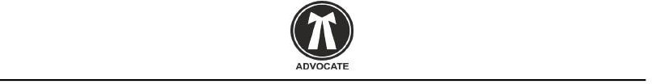
  - ,L.L.B ,Advocate

GUNTUR ANDHRAPRADESH

Reg. A.D. / O.C.

OFFICE NO:2 AAVULADODI BAZAR NEAR RAMAKRISHNA THEATRE
GUNTUR DT.

Date:12-2-2021

To,

Mr/Ms NIKHITHA
Adderss;THURAKAPALLI NIKHITHA D/O SADASIVARAO DOOR NUMBER 15-14-14-154 RTC COLONY 5TH LINE GUNTUR KOTHAPETA ANDHRA PRADESH-522001.
Under the specific instructions of my client of M/s. SHARP INFO SERVICES,addressed at,KRISHNA NAGAR 2ND LANE ,GUNTUR DISTRICT,ANDHRAPRADESH,INDIA; I am here by directed to send you this legal notice as under.

    - That my above-named client is doing business of Business Outsourcing Service (BPO) in the name and style of M/s. SHARP INFO SERVICES, at his above-mentioned address. You are
residing at your above mentioned address and are known to my client since you availed online BPO assignment of (FORM FILLING) from M/s. SHARP INFO SERVICES.

    - That, you as on dated 2021-2-1completed registration with my client

agreed upon the Terms & Conditions/Rules & Regulations by entering into Agreement on Non-
Judicial Stamp Paper of Rs. 10/- as on date Agreement Sent on 2021-2-4with my client with respect Data Outsourcing

Assignments (FORM FILLING) vide Project ID No: 9542924498
Now according to Agreement terms and conditions of said agreement entered into by you with my client i.e.

TAT (Turn Around Time): you have not submitted accuracy report to my client within stipulated period of 6 days mentioned in the agreement.

Or

ACCURACY (90%) you have failed to achieve your accuracy of 90% means your more than 80 forms from 800 forms are wrong.

    - Client informed you for the same by sending you an email with respect to the non-submission of work assigned to you and for the very reason you have made liable yourself for to pay the utility and maintenance charges to my client because of your default i.e. (non-submission or accuracy below 90% as per accuracy report).

    - In spite of consistent communications by my client through telecommunication and email you have not paid Rs. 4200/- of utility and maintenance charges and deliberately ignoring my client, knowing full well the grim consequences thereof. You are therefore liable for civil as well as criminal legal action.

    - By this notice, you are hereby instructed to pay the utility and maintenance charges of Rs. 4200/- within 1 days of the receipt of this notice, failing which, my client will straightway initiate legal
remedy (civil as well as criminal) at Guntur court and all the cost and consequences for the said proceedings/prosecution will be on your head of which take a serious note.

    - This notice is given to you because of your default and you are therefore liable to pay Rs. 1000/- as legal charges to my client.

    - Kindly Deposit Rs.4200/- + 1000/-.

This notice is sent to you by Regd. A.D

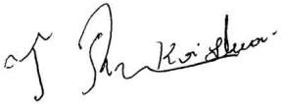


ADVOCATE.

